Canada SharePoint Migration
Tracking & Sync Architecture – v2
Prepared by Varun Jindal · September 25, 2026 · Draft for team feedback

1. Summary
The Canada team will track every site in one SharePoint register, synced daily from Emma O'Shea's master workbook, so every change we ask Emma's team to make is tracked until it appears in her sheet.
Emma's workbook and her way of working stay exactly as they are: we only read her sheet, and we send her requests by email. Steward outreach is started by the team, never on a timer, and every steward response and every delete confirmation is recorded as evidence.
Feedback requested: please add comments on any section. The decisions we most need are listed in section 10, Questions for team feedback.

2. What changed since v1
The September 24 review kept the core design (read-only master, one register, field ownership, update queue) and changed the timing, triggers and scope below.
Area | v1 | v2
Priority | Tracking plus steward notifications | Tracking and sync first; built so it can scale to the enterprise later
Import | Weekly (Monday) | Daily
Site key | Site ID or normalized URL | Emma's sheet has no Site ID: normalized URL path plus a Canada reference number
Steward outreach | Automated weekly digest | Team selects sites and message type in an outreach app; nothing sends automatically
Updates to Emma | Weekly batch | Daily batch by default, interval configurable; outstanding items repeat
Delete confirmations | Part of the batch | Separate evidence email per steward group, sent to Emma and both stewards
Guardrails | Stops on migration and validation steps | Stop on unconfirmed deletes: only the steward of record can confirm
Lifecycle | Through migration and legacy deletion | Ends when the decision is confirmed in Emma's sheet
ServiceNow / AvePoint | Shown in the diagram | Out of scope (post-migration)
Trevor's refresh | Retire | Keep running; the new process is built separately
Dashboard | List views or Power BI | List views

3. Target architecture
Everything new sits in a Canada layer that reads Emma's workbook daily and talks back to her team only by email.
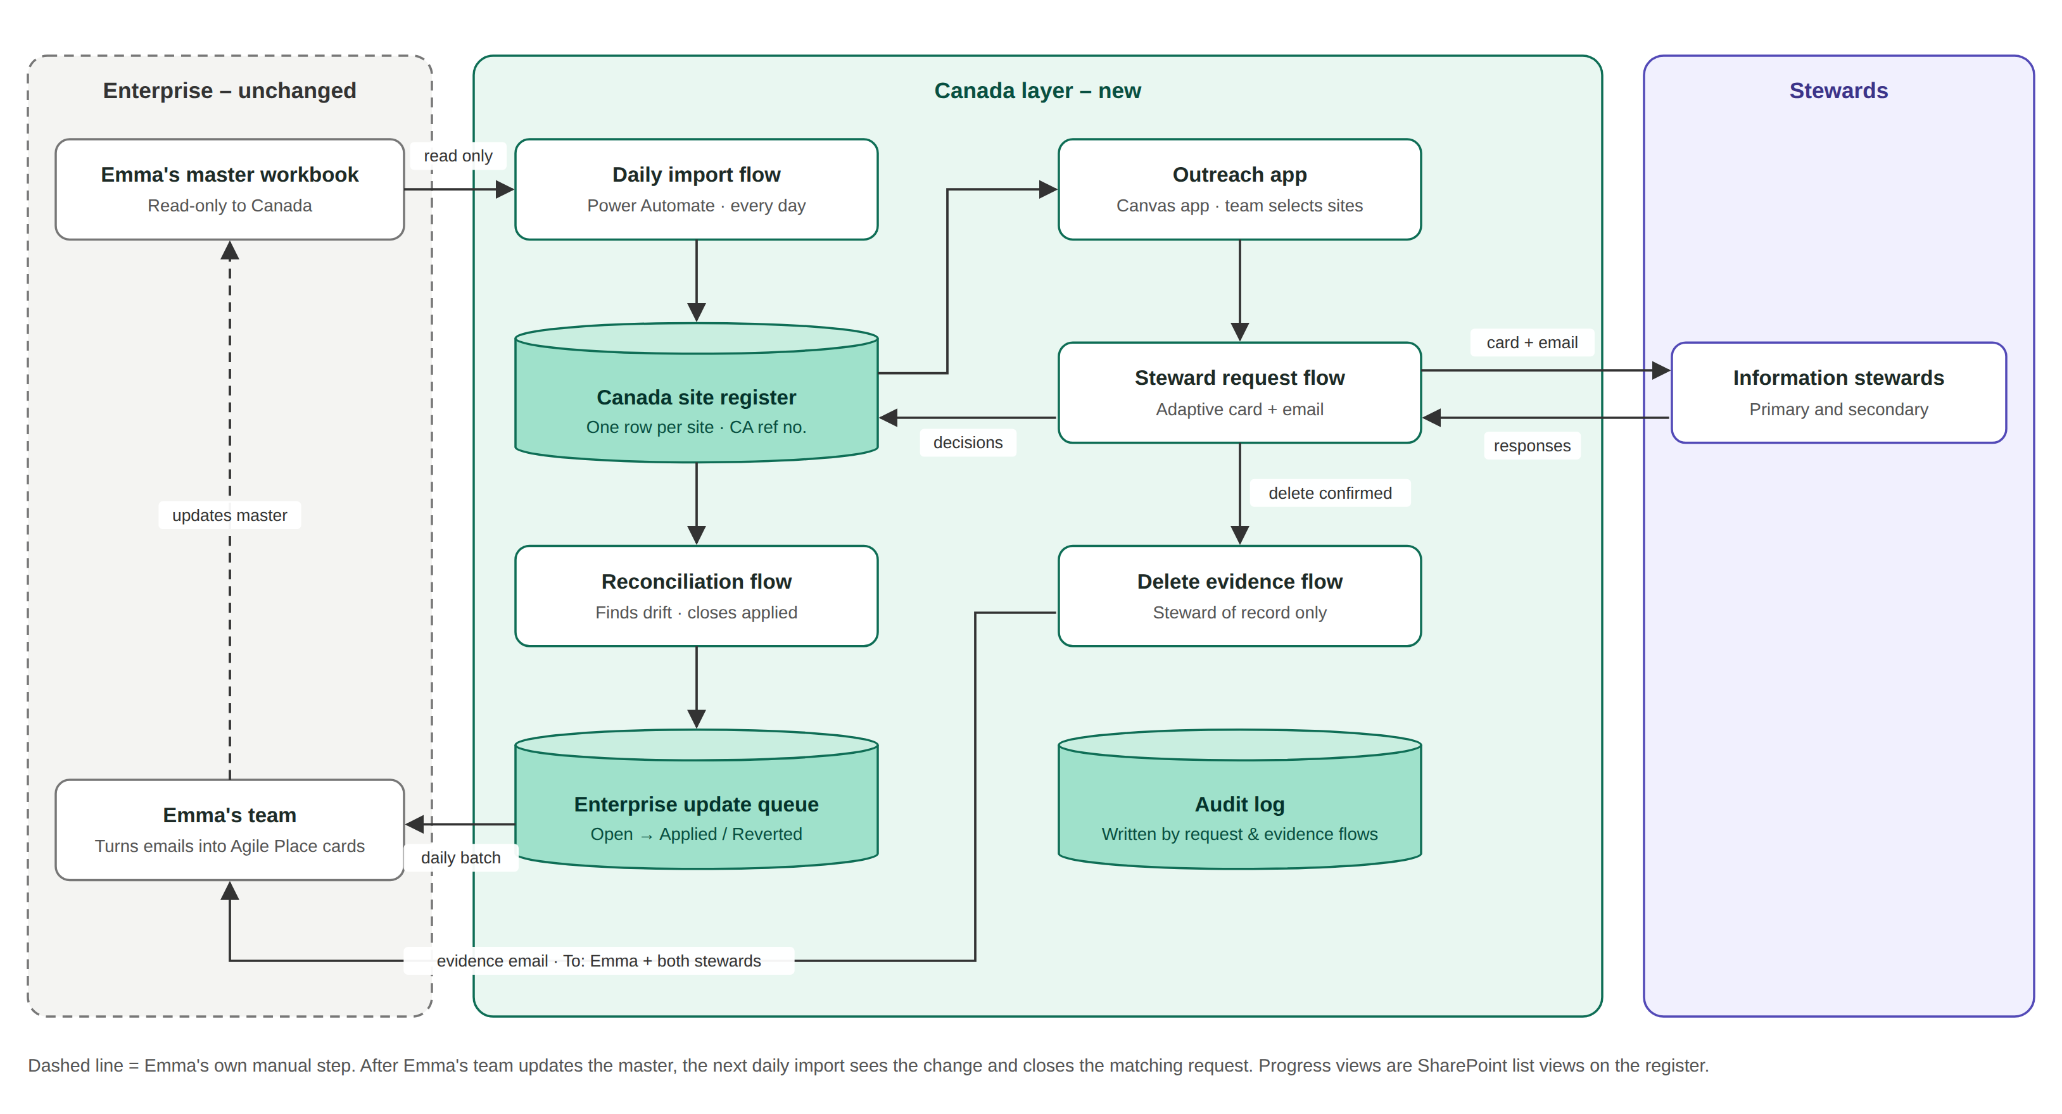

4. Components
Six components, all on standard Microsoft 365 tools (SharePoint, Power Automate, Power Apps, Teams, Outlook).
Component | Built with | What it does
Canada site register | SharePoint list | One row per site: Emma's values, Canada's values, decision, stage and history
Daily import | Power Automate, Excel Online (Business) connector | Reads Emma's workbook each day and refreshes only the columns copied from her sheet; logs every run
Reconciliation and update queue | Power Automate + SharePoint list | Finds where our values differ from Emma's, queues a request, sends the daily batch, closes requests once her sheet matches
Outreach app | Power Apps canvas app | Team filters the register (orphans, blocked, re-review), ticks sites, picks a message type and sends
Steward request flow | Power Automate, Teams adaptive card + email | One card per steward per message type; responses update the register and the audit log
Delete evidence flow | Power Automate, shared mailbox | Emails Emma proof that the steward of record confirmed each delete; sets status to Delete requested

Supporting lists
List | Holds
Enterprise update queue | Each change requested from Emma: field, her value, our value, date first sent, status (Open, Applied, Reverted, Withdrawn)
Outreach batches | Each send: message type, sites selected, stewards contacted, sent by, date
Audit log | Every card or email sent and every steward response: who, what, when
Import log | Each daily run: rows read, added, changed, missing from source, errors
Configuration | Batch interval for Emma, message templates, recipients, links

5. Data model
Every site gets a permanent Canada reference number, and every field has one owner, so a refresh from Emma can never overwrite Canada's work.

Keys
- Site key: the URL from /sites/ onwards, with encoded characters decoded (%20 becomes a space) and converted to lowercase. This is how each row is matched to Emma's sheet, which has no Site ID and no duplicate URLs.
- Canada reference number: assigned on the first full import (for example CA-000001) and never reused. A URL with no match gets the next number and starts at Triage.
- Renamed sites: a renamed URL looks like one site disappearing and a new one appearing. Both are flagged so the team can link them by hand.

Field ownership
For example, Emma's sheet says the information steward is Varun, but we learn it should be Scott. Emma's field keeps showing Varun and our field shows Scott. Until her sheet says Scott, the difference stays in the update queue.
Group | Written by | Example fields
Copied from Emma (Src_) | Daily import only | Site URL, collection, business group, Info Steward 1 and 2, owner, size, created, last modified, last accessed, action, status
Canada-owned | Team, outreach app, steward responses | Info Steward 1 and 2 (Canada), ownership status, decision, stage, PII status, re-review reason, notes, assigned to
System | Flows only | In source, last seen in import, change hash, drift flag, open update requests, last contacted, response count

The full field list will be circulated separately for review with Joseph.

6. Site lifecycle
A site's journey ends when its decision shows in Emma's sheet; migration itself happens later and outside this solution.
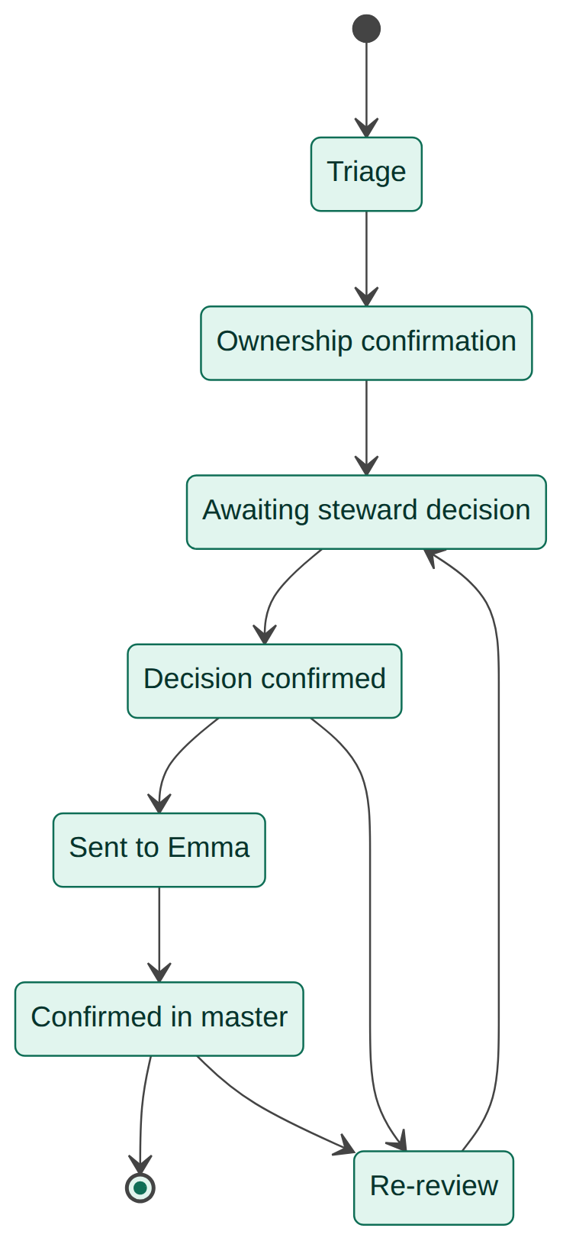
Decision | Meaning | What we send to Emma
Keep | Don't delete; queue for migration later, to any approved destination (not only SharePoint) | Update request in the daily batch
Delete | Steward of record confirms the site can go | Evidence email; status becomes Delete requested
Hold – PII | Contains personal information; needs a secure destination | Update request in the daily batch
Not my site | Returns to Triage for ownership work | Nothing until ownership is resolved

A site goes to Re-review when new activity appears on a site marked Delete. Sites that belong to other business groups but sit in a Canada hierarchy are also tracked, and the team can add sites to Canada's scope when another group hands them over.

7. Key flows

7.1 Daily sync and reconciliation
- The import reads Emma's workbook, matches rows by site key and refreshes only the Src_ fields.
- New URLs get a Canada reference number and start at Triage. URLs missing from her sheet are flagged, never deleted.
- Reconciliation compares Emma's fields with Canada's fields. Each difference opens or updates an item in the update queue.
- Queue items that now match Emma's sheet close as Applied. Items where her sheet goes back to an old value are flagged Reverted.
- Every open item goes to Emma's team in one batch email. It's daily by default and the interval can be set to 3 or 5 days. Items still open next time are sent again.

7.2 Steward outreach
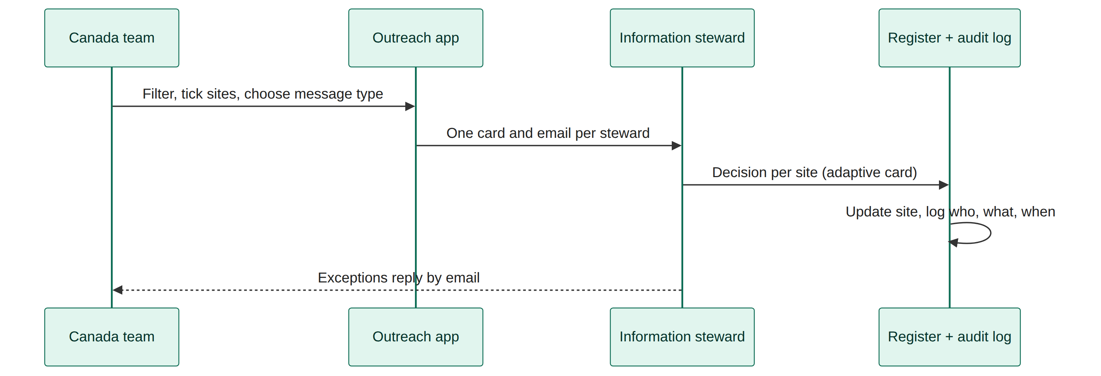
- Nothing sends on a schedule: a person always chooses the sites and the message.
- Different situations (for example, orphan and wrong business group) go out as separate messages.
- One steward with several sites gets one message listing all of them.

7.3 Delete evidence to Emma
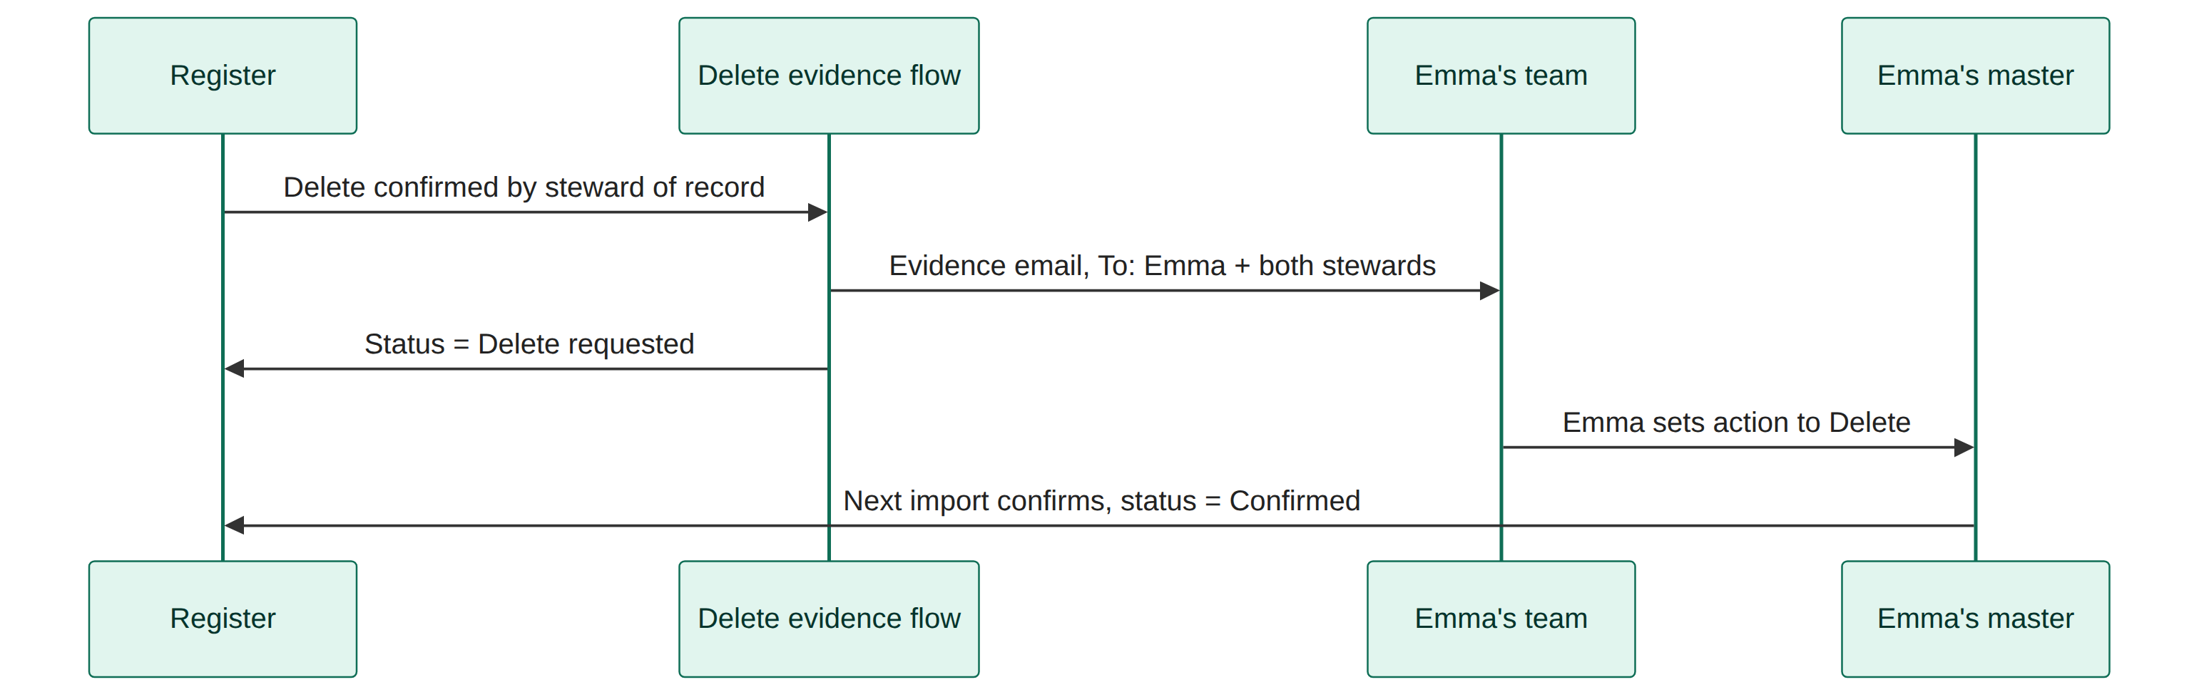
The email reads: We received confirmation from [steward] on [date] that the following sites can be deleted, followed by the list of URLs. Emma, Info Steward 1 and Info Steward 2 go in the To field, and the SharePoint Canada team is copied. Site owners aren't included, because Emma and Vincent confirmed that the information stewards are the owners. Sites are grouped by their steward pair, so each email covers sites that have the same two stewards.

8. Operating rhythm and guardrails
When | What happens | Automated or manual
Daily, early morning | Import and reconciliation | Automated
Daily (configurable) | Batch of open update requests to Emma's team | Automated
When the team decides | Select sites and send steward requests | Manual choice, automated send
When a delete is confirmed | Evidence email to Emma and both stewards | Automated, after the steward-of-record check
Weekly | Team review of flagged, reverted, blocked and missing sites | Manual

Guardrails
- Emma's workbook is never written to. The flows can only read it, and every change goes to her team as a tracked email request.
- Field ownership. The import writes only Src_ fields. Canada's fields are never overwritten.
- Steward of record. A delete goes to Emma only if the confirming person is Info Steward 1 or 2 on record. Anyone else must first be made the steward of record.
- Humans choose the audience. No steward message is sent without a person selecting the sites and the message.
- Hierarchy rule. A top-level site can't be sent as Keep or Delete while any of its sub-sites is undecided or has mixed ownership.
- Full audit trail. Every message sent, response received and email to Emma is logged.
- Scale. Key columns are indexed from day one, and the import pages through the workbook, so the register stays within SharePoint limits even with the full 13,000 rows.

9. Scope, prerequisites and access
In scope | Out of scope
Tracking every site and syncing it with Emma's workbook | Any change to Emma's workbook or her process
Update requests and delete evidence sent to Emma's team | ServiceNow and AvePoint (post-migration)
Team-selected steward outreach and capturing responses | Migration execution, validation and legacy deletion
Audit trail and progress views | Retiring Trevor's existing refresh and lists

Prerequisite | Status or owner
Dev SharePoint site (e.g. SPDM test), then production site | Joseph to request
PnP PowerShell to create the lists | Follow Julie Stewart's Sep 9 instructions; Joshua as backup
Power Automate with Excel Online (Business), SharePoint, Outlook, Teams | Standard connectors; confirm in our environment
Power Apps for the outreach app | Confirm licensing
Send As or Send on Behalf on the shared migration inbox | Chirag, in parallel
Sent emails saved in the shared mailbox's Sent Items | Exchange admin setting; Chirag to raise

10. Questions for team feedback
- Import scope: should we copy all ~13,000 rows from Emma's sheet, or only the ~4,000 Canada sites plus any hierarchy containing a Canada site?
- Message types: which steward messages do we need first (orphan, blocked, re-review deletion, wrong business group, keep or delete)? What should each one ask?
- Batch interval for Emma: start with daily as proposed, or with a longer interval?
- Canada reference number format: is CA-000001 acceptable?
- Existing Excel extracts: which of the current extracts (Group & Operations, PII holds) should become views on the register first?
- Anything missing: are there decisions, statuses or fields we track today that aren't covered here?

11. Delivery phases
Phase | Scope | Outcome
1. Data model | Field list, keys, stages and message types agreed with Joseph | Signed-off design
2. Register | Lists created with PnP in the dev site; first full import assigns reference numbers | One record per site
3. Sync | Daily import, reconciliation, update queue and batch email to Emma | Tracked, self-closing requests
4. Outreach | Canvas app, adaptive cards, audit log, delete evidence email | Team-driven steward contact with proof
5. Go-live | Move to production, views for current extracts, handover notes | In daily use

