**SOFTWARE PPROJECT MANAGEMENT**

**CSE 432**

**LAB FILE**



**Submitted by- Submitted to-**

**Mr. Roshan Lal**

Assistant Professor-III

Dept. of Computer Science and Engineering

**Vishesh Jindal**

**7CSE-8Y**

**A2305218539**

# DEPARTMENT OF COMPUTER SICENCE AND ENGINEERING

**AMITY SCHOOL OF ENGINEERING AND TECHNOLOGY**

**AMITY UNIVERSITY UTTAR PRADESH, NOIDA**

**2018-2022**

**INDEX**

|  |  |  |  |  |
| --- | --- | --- | --- | --- |
| **S. No** | **Experiment** | **Assigned Date** | **Submission Date** | **Remarks and Signature** |
| **1.** | Getting Familiar with Project Libre. | 20-07-2021 | 27-07-2021 |  |
| **2.** | Creating a new project with task name, duration, start and finish date | 20-07-2021 | 27-07-2021 |  |
| **3.** | Create a new project with task name, duration, start and finish date along with predecessors. | 27-07-2021 | 03-08-2021 |  |
| **4.** | Create a new project with task name, duration, start and finish date along with predecessor and resource name to tasks. | 03-08-2021 | 10-08-2021 |  |
| **5.** | Draw the Gantt chart for the software project. | 10-08-2021 | 17-08-2021 |  |
| **6.** | Using Project Planning Activities draw the PERT for the project. | 17-08-2021 | 24-08-2021 |  |
| **7.** | Activity – team work duration | 24-08-2021 | 31-08-2021 |  |
| **8.** | Activity – team work duration | 31-08-2021 | 7-09-2021 |  |
| **9.** | Activity – team work duration | 14-09-2021 | 21-09-2021 |  |
| **10.** | Work Breakdown Structure | 28-09-2021 | 4-10-2021 |  |

**EXPERIMENT -1**

### Introduction to ProjectLibre

ProjectLibre is an open source project management software solution developed as an alternative to Microsoft Project. As with other project management tools, ProjectLibre maintains a list of tasks for users and automatically organizes and tracks tasks and projects as progress is made or they’re completed.

ProjectLibre is designed to complement the [LibreOffice](https://www.webopedia.com/definitions/libreoffice/) and OpenOffice open source office suites, providing project managers and team leaders with a complete collection of productivity tools. In addition to the standard ProjectLibre software, cloud and server versions of ProjectLibre are in development and are expected to become available in 2014.

#### Features, Benefits, Product Strengths

* **MS Project Compatibility** – ProjectLibre is compatible with Microsoft Project 2003, 2007, and 2010, so it will open these files. It also has import/export capabilities. A similar ribbon UI allows users familiar with MS Project to easily transition to ProjectLibre. In creating a project plan, they can use a similar approach, such as listing and indenting a task list or work breakdown structure. They can set durations, links, predecessors, and resources in a similar manner. They can also create budgets and manage expenses with the software. The latest version is 1.8.0 modified in May 2018.
* **Core PM Functionality** – This open source alternative software includes features such as Gantt charts, network diagrams, work breakdown structure charts, resource breakdown structure charts, earned value costing, and resource histograms. These are also comparable to features in Microsoft Project. Users can set dependencies, create a project baseline, and use multiple calendar to define working and non-working days for different resources. It also has reporting functionality, such as for displaying project details, resource information, task information, and others.
* **Enterprise Cloud** – ProjectLibre is busy finalizing a cloud version. It will extend the open source desktop software to a cloud version that can be accessed anytime and anywhere. Unlike the single-user desktop version, the cloud version will be capable of handling multiple projects by multiple users. Thus, simple project portfolio management features will also be available. A team dashboard will allow project collaboration from members in different locations. Pricing will be offered on a simple monthly subscription.

### DIFFERENCE BETWEEN MS PROJECT AND PROJECTLIBRE

|  |  |  |
| --- | --- | --- |
| Systems | **Microsoft Project** [**X**](https://project-management.zone/system/projectlibre) | **ProjectLibre** [**X**](https://project-management.zone/system/microsoft-project) |
| Description | Project planning and tracking tools available in various editions: Standard, Pro, Server and Online. | ProjectLibre is a Javabased open source desktop project management tool. |
| Category | Project Planning | Project Planning |
| [Project Management Zone Ranking](https://project-management.zone/ranking)  [Ranking Trend](https://project-management.zone/ranking/trend/system/microsoft-project,projectlibre) | Score 1,051.54 Rank #2 | Score 8.66 Rank #81 |
| Developer | Microsoft |  |
| Website | [microsoft.com/microsoft365/project/projectmanagement-software](https://www.microsoft.com/microsoft-365/project/project-management-software) | [projectlibre.com](http://www.projectlibre.com/) |
| Initial release | 1984 | 2012 |
| License | Commercial  Web-based service  (SaaS) | Open Source |
| Web-based architecture | yes | no |
| Programming language |  | Java |
| Operating systems | Windows | Linux  OS X  Windows |

|  |  |  |  |
| --- | --- | --- | --- |
| **Internal Assessment (Mandatory Experiment) Sheet for Lab Experiment**  **Department of Computer Science & Engineering ASET, Amity University, Noida (U.P.)** | | | |
| Programme | B. Tech (CSE) | Course Name | Software Project Management |
| Course Code | CSE432 | Semester | 7 |
| Student Name | Vishesh Jindal | Enrollment No. | A2305218539 |
| **Marking Criteria** | | | |
| **Criteria** | **Total Marks** | **Marks**  **Obtained** | **Comments** |
| Concept (A) | 2 |  |  |
| Implementation (B) | 2 |  |  |
| Performance (C) | 2 |  |  |
| Total | 6 |  |  |

**EXPERIMENT 2**

**AIM-** create a new project in ProjectLibre

**SOFTWARE USED-** ProjectLibre / MS Project

### THEORY-

* Open ProjectLibre, click on new project button on the pop-up.
* Enter the basic details about the project which are essential for the creation of a new project.
* After you enter your project details you are ready to create your first task.
* As seen in the table above, type in the appropriate field, the task’s ‘Name‘, ‘Duration‘ and ‘Start‘ – the finish date is then calculated automatically.

### OUTPUT-

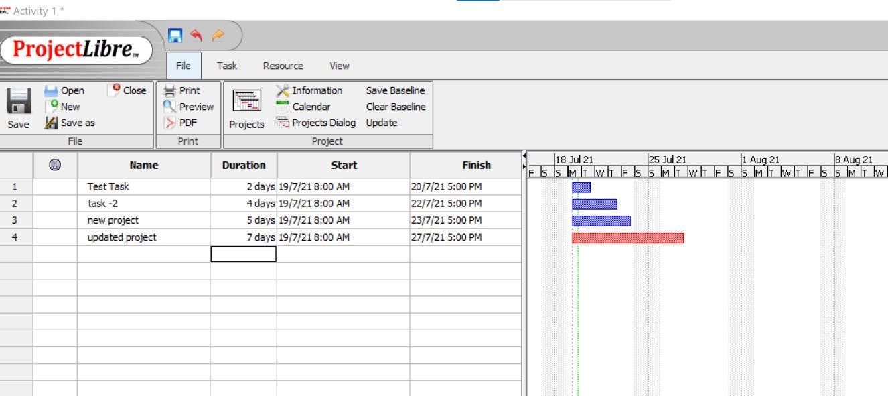

**RESULT:** In this experiment, we have drawn a new Project and the result is shown inscreenshots.

|  |  |  |  |
| --- | --- | --- | --- |
| **Internal Assessment (Mandatory Experiment) Sheet for Lab Experiment**  **Department of Computer Science & Engineering ASET, Amity University, Noida (U.P.)** | | | |
| Programme | B. Tech (CSE) | Course Name | Software Project Management |
| Course Code | CSE432 | Semester | 7 |
| Student Name | Vishesh Jindal | Enrollment No. | A2305218539 |
| **Marking Criteria** | | | |
| **Criteria** | **Total Marks** | **Marks**  **Obtained** | **Comments** |
| Concept (A) | 2 |  |  |
| Implementation (B) | 2 |  |  |
| Performance (C) | 2 |  |  |
| Total | 6 |  |  |

## EXPERIMENT 3

**AIM-** Create a new project with task name, duration, start and finish date along with predecessors.

**SOFTWARE USED-** ProjectLibre / MS Project

### THEORY-

Following are the steps to draw a Gantt chart for a project:

1. Create various tasks of the project after gathering and analysing all the requirements.
2. In each task, create some more tasks and indent them to make them sub tasks. Now, the completion of a task will be marked by completion of all its sub tasks.
3. Provide the sub tasks with their duration start and end dates and other attributes.
4. Using the predecessor property, link the sub tasks to each other and to the main tasks.
5. After setting all these properties, the Gantt chart is ready. Go to the view menu, click on the Gantt chart and the following view will be displayed.

### OUTPUT-

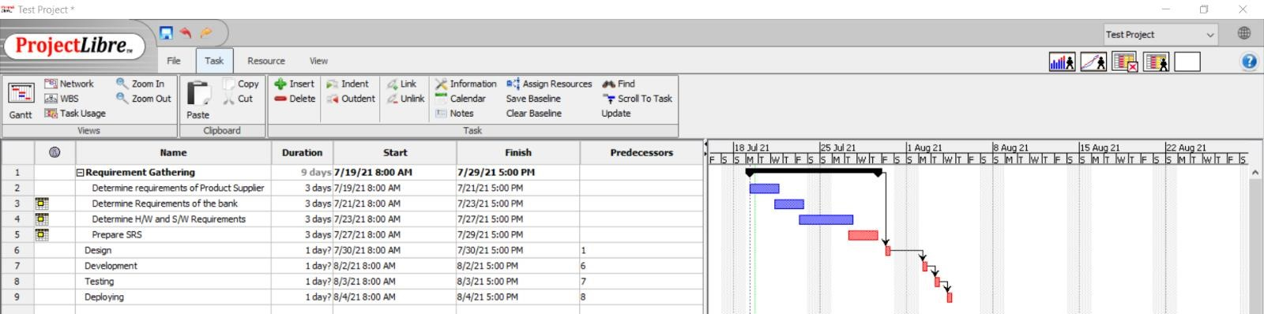

**RESULT:** In this experiment, we have drawn the required fields for a project and the result is shown inscreenshots.

|  |  |  |  |
| --- | --- | --- | --- |
| **Internal Assessment (Mandatory Experiment) Sheet for Lab Experiment**  **Department of Computer Science & Engineering ASET, Amity University, Noida (U.P.)** | | | |
| Programme | B. Tech (CSE) | Course Name | Software Project Management |
| Course Code | CSE432 | Semester | 7 |
| Student Name | Vishesh Jindal | Enrollment No. | A2305218539 |
| **Marking Criteria** | | | |
| **Criteria** | **Total Marks** | **Marks**  **Obtained** | **Comments** |
| Concept (A) | 2 |  |  |
| Implementation (B) | 2 |  |  |
| Performance (C) | 2 |  |  |
| Total | 6 |  |  |

## EXPERIMENT 4

**AIM-** Create a new project with task name, duration, start and finish date along with predecessor and resource name to tasks.

**SOFTWARE USED-** ProjectLibre / MS Project

### THEORY-

Following are the steps to draw a Gantt chart for a project:

1. Open MS Project.
2. Create a new Blank Project 3. Go on Task Menu
3. In the task sheet double click on the task number column.
4. A pop up window will open. Give the properties of the task and start and end date as follows:

* **General**: In these properties like Name of the task, Schedule Mode, Start date, end date etc are given.
* **Predecessor**: In this step the predecessors of the current task are mentioned. The current task can start only when its predecessors are finished.
* **Resources:** In this step, the details of the resources involved in the task are given.

### OUTPUT-

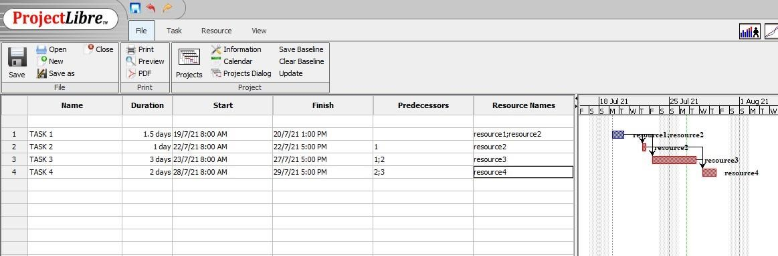

**RESULT:** In this experiment, we have drawn the required fields with resource names for a project and the result is shown inscreenshots.

|  |  |  |  |
| --- | --- | --- | --- |
| **Internal Assessment (Mandatory Experiment) Sheet for Lab Experiment**  **Department of Computer Science & Engineering ASET, Amity University, Noida (U.P.)** | | | |
| Programme | B. Tech (CSE) | Course Name | Software Project Management |
| Course Code | CSE432 | Semester | 7 |
| Student Name | Vishesh Jindal | Enrollment No. | A2305218539 |
| **Marking Criteria** | | | |
| **Criteria** | **Total Marks** | **Marks**  **Obtained** | **Comments** |
| Concept (A) | 2 |  |  |
| Implementation (B) | 2 |  |  |
| Performance (C) | 2 |  |  |
| Total | 6 |  |  |

## EXPERIMENT 5

**AIM-** Draw the Gantt chart for the software project.

**SOFTWARE USED-** ProjectLibre / MS Project

### THEORY-

Following are the steps to draw a Gantt chart for a project:

1. Create various tasks of the project after gathering and analysing all the requirements.

1. In each task, create some more tasks and indent them to make them sub tasks. Now, the completion of a task will be marked by completion of all its sub tasks.

1. Provide the sub tasks with their duration start and end dates and other attributes.

1. Using the predecessor property, link the sub tasks to each other and to the main tasks.

1. After setting all these properties, the Gantt chart is ready. Go to the view menu, click on the Gantt chart and the following view will be displayed.

### OUTPUT-

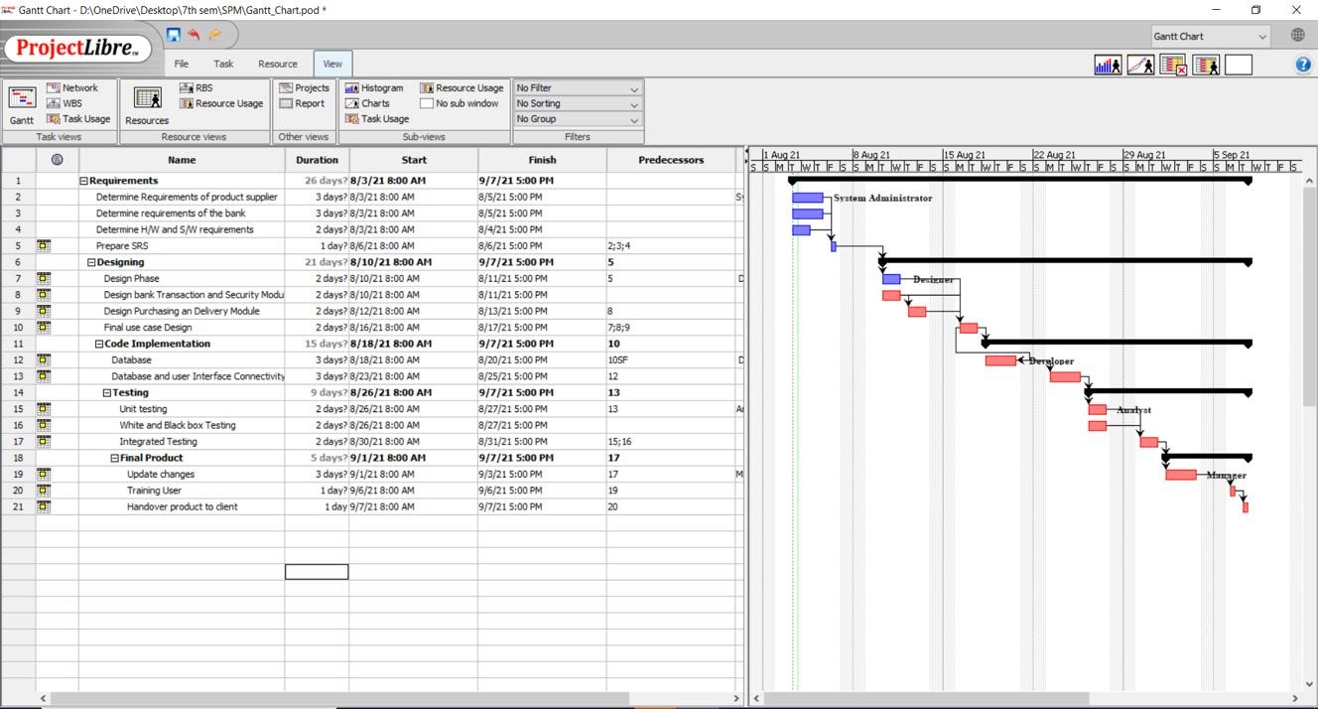

**RESULT:** In this experiment, we have drawn the Gantt chart for a project and the result is shown inscreenshots.

|  |  |  |  |
| --- | --- | --- | --- |
| **Internal Assessment (Mandatory Experiment) Sheet for Lab Experiment**  **Department of Computer Science & Engineering ASET, Amity University, Noida (U.P.)** | | | |
| Programme | B. Tech (CSE) | Course Name | Software Project Management |
| Course Code | CSE432 | Semester | 7 |
| Student Name | Vishesh Jindal | Enrollment No. | A2305218539 |
| **Marking Criteria** | | | |
| **Criteria** | **Total Marks** | **Marks**  **Obtained** | **Comments** |
| Concept (A) | 2 |  |  |
| Implementation (B) | 2 |  |  |
| Performance (C) | 2 |  |  |
| Total | 6 |  |  |

## EXPERIMENT 6

**AIM-** Using Project Planning Activities draw the PERT for the project.

**SOFTWARE USED-** ProjectLibre / MS Project

### THEORY-

Steps to create a PERT chart are as follows:

1. Create various tasks of the project after gathering and analysing all the requirements.

1. In each task, create some more tasks and indent them to make them sub tasks. Now, the completion of a task will be marked by completion of all its sub tasks.

1. Provide the sub tasks with their duration start and end dates and other attributes.

1. Using the predecessor property, link the sub tasks to each other and to the main tasks.

1. Now that the PERT chart is ready, go to the view menu, click on the Network Diagram tab and the following PERT chart will be displayed.

### OUTPUT-

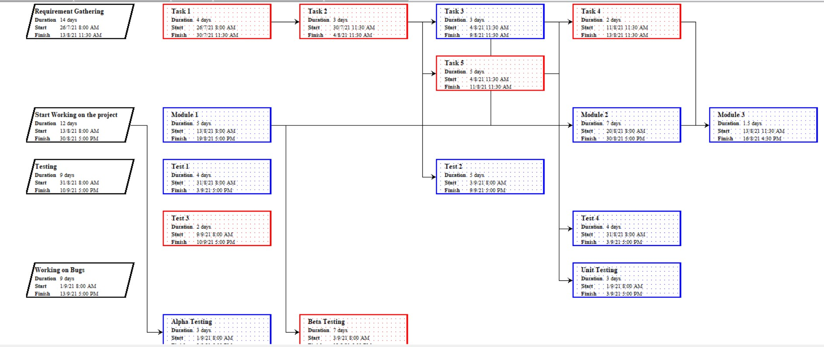

**RESULT:** In this experiment, we have drawn the PERT chart for a project and the result is shown inscreenshots.

|  |  |  |  |
| --- | --- | --- | --- |
| **Internal Assessment (Mandatory Experiment) Sheet for Lab Experiment**  **Department of Computer Science & Engineering ASET, Amity University, Noida (U.P.)** | | | |
| Programme | B. Tech (CSE) | Course Name | Software Project Management |
| Course Code | CSE432 | Semester | 7 |
| Student Name | Vishesh Jindal | Enrollment No. | A2305218539 |
| **Marking Criteria** | | | |
| **Criteria** | **Total Marks** | **Marks**  **Obtained** | **Comments** |
| Concept (A) | 2 |  |  |
| Implementation (B) | 2 |  |  |
| Performance (C) | 2 |  |  |
| Total | 6 |  |  |

## EXPERIMENT 7

**AIM-** Tam works 8 hours per day from Monday - Friday; You set the Task Type as Fixed Duration. If you have task with 4 day duration and task has been scheduled for 32 hours.

After you assign the task information as above, you realized that Tam will not available full time to work on this task. His availability is part time, he can work only 4 hours per day.

When you changed his units to 50%, Project keeps the duration fixed at 4 days, and recalculates work to be 16 hours.

**SOFTWARE USED-** ProjectLibre / MS Project

### THEORY-

Steps to create are as follows:

1. You set the Task Type as Fixed Duration. If you have task with 4 day duration and task has been scheduled for 32 hours.

After you assign the task information as above, you realized that Tam will not available full time to work on this task. His availability is part time, he can work only 4 hours per day.

When you changed his units to 50%, Project keeps the duration

### OUTPUT-

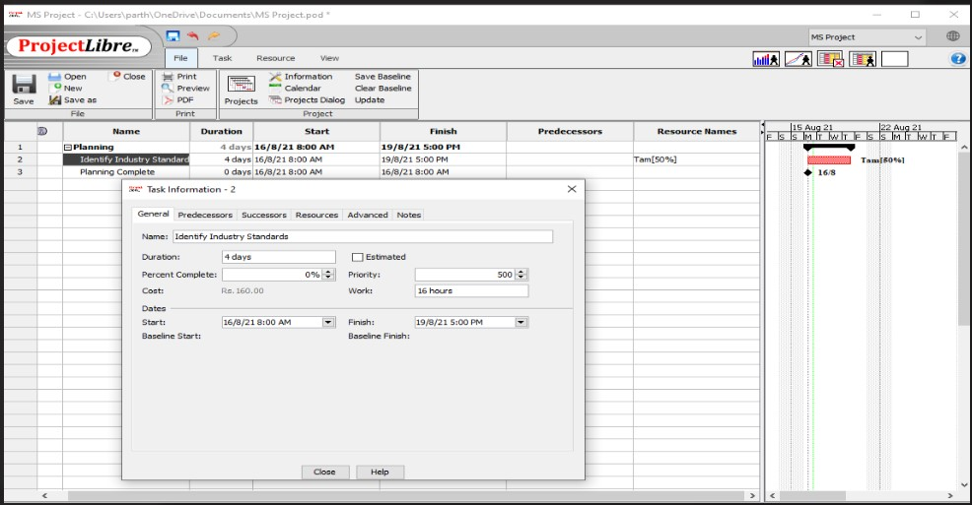

**RESULT:** In this experiment, we have updated the duration for a project and the result is shown inscreenshots.

|  |  |  |  |
| --- | --- | --- | --- |
| **Internal Assessment (Mandatory Experiment) Sheet for Lab Experiment**  **Department of Computer Science & Engineering ASET, Amity University, Noida (U.P.)** | | | |
| Programme | B. Tech (CSE) | Course Name | Software Project Management |
| Course Code | CSE432 | Semester | 7 |
| Student Name | Vishesh Jindal | Enrollment No. | A2305218539 |
| **Marking Criteria** | | | |
| **Criteria** | **Total Marks** | **Marks**  **Obtained** | **Comments** |
| Concept (A) | 2 |  |  |
| Implementation (B) | 2 |  |  |
| Performance (C) | 2 |  |  |
| Total | 6 |  |  |

## EXPERIMENT 8

**AIM** - Tam works 8 hours per day from Monday - Friday; You set the Task Type as Fixed Duration. If you have task with 4 day duration and task has been scheduled for 32 hours.

If you increase the work to 80 hours; Project keeps the duration same and it increases the units to complete the work. See below example, Tam is now showing up with 250% units.

**SOFTWARE USED-** ProjectLibre / MS Project

### THEORY-

Following are the steps to draw a Gantt chart for a project:

1. Create various tasks of the project after gathering and analysing all the requirements.

1. In each task, create some more tasks and indent them to make them sub tasks. Now, the completion of a task will be marked by completion of all its sub tasks.

1. Provide the sub tasks with their duration start and end dates and other attributes.

1. Using the predecessor property, link the sub tasks to each other and to the main tasks.

1. After setting all these properties, the Gantt chart is ready. Go to the view menu, click on the Gantt chart and the following view will be displayed.

### OUTPUT-

Before changing the work hours:-

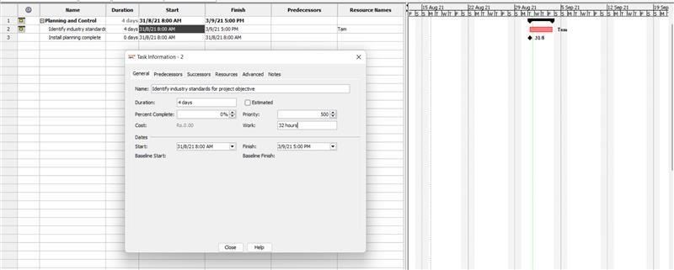

After Changing the work hour to 80 hours by keeping same duration:

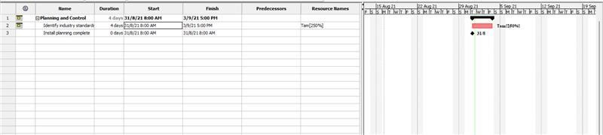

**RESULT:** In this experiment, we have updated the duration for a project and the result is shown inscreenshots.

|  |  |  |  |
| --- | --- | --- | --- |
| **Internal Assessment (Mandatory Experiment) Sheet for Lab Experiment**  **Department of Computer Science & Engineering ASET, Amity University, Noida (U.P.)** | | | |
| Programme | B. Tech (CSE) | Course Name | Software Project Management |
| Course Code | CSE432 | Semester | 7 |
| Student Name | Vishesh Jindal | Enrollment No. | A2305218539 |
| **Marking Criteria** | | | |
| **Criteria** | **Total Marks** | **Marks**  **Obtained** | **Comments** |
| Concept (A) | 2 |  |  |
| Implementation (B) | 2 |  |  |
| Performance (C) | 2 |  |  |
| Total | 6 |  |  |

## EXPERIMENT 9

**AIM** - Two painters are assigned full-time (100%) to paint the walls in 2 days (work equals 32 hours–16 hours per painter).

If you increase the duration of the task from 2 days to 4 days, Project sets each painter's assignment units to 50% so that each painter works only half-time and work remains constant at 32 hours.

**SOFTWARE USED-** ProjectLibre / MS Project

### THEORY-

Following are the steps to draw a Gantt chart for a project:

#### Duration = Work ÷ Resource Units

1. Set the task to Fixed Work when you want the amount of work to remain constant, regardless of any change in duration or resource units.
2. Remember, in Project, work is measured in time units, such as hours, and it is the amount of effort that a resource needs to complete a task. The total work for a task is the sum of all those time units, no matter how many resources are assigned to the task.

### OUTPUT-

**2**

**days’ time**

**g**

**iven:**

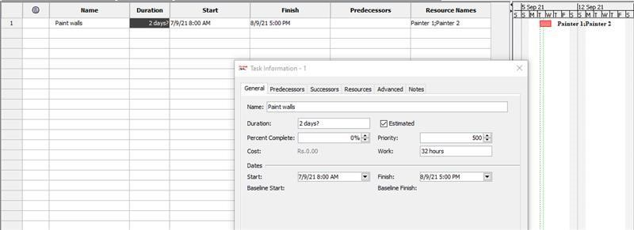

**4 days’ time given:**

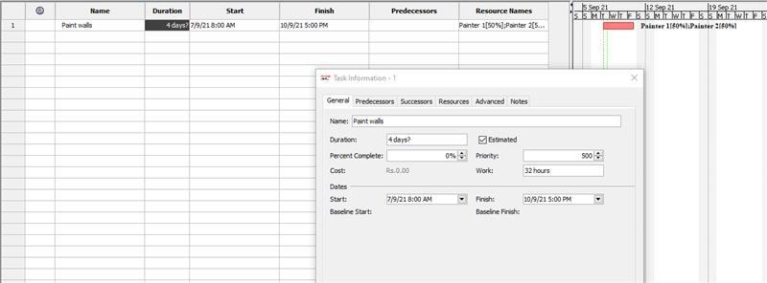

**RESULT:** In this experiment, we have updated the duration for a project and the result is shown inscreenshots.

|  |  |  |  |
| --- | --- | --- | --- |
| **Internal Assessment (Mandatory Experiment) Sheet for Lab Experiment**  **Department of Computer Science & Engineering ASET, Amity University, Noida (U.P.)** | | | |
| Programme | B. Tech (CSE) | Course Name | Software Project Management |
| Course Code | CSE432 | Semester | 7 |
| Student Name | Vishesh Jindal | Enrollment No. | A2305218539 |
| **Marking Criteria** | | | |
| **Criteria** | **Total Marks** | **Marks**  **Obtained** | **Comments** |
| Concept (A) | 2 |  |  |
| Implementation (B) | 2 |  |  |
| Performance (C) | 2 |  |  |
| Total | 6 |  |  |

## EXPERIMENT 10

**AIM** - Using project planning activities, draw the Work Breakdown Structure for the project.

**SOFTWARE USED-** ProjectLibre / MS Project

### THEORY-

Following are the steps to draw a Gantt chart for a project:

#### Duration = Work ÷ Resource Units

1. Set the task to Fixed Work when you want the amount of work to remain constant, regardless of any change in duration or resource units.
2. Remember, in Project, work is measured in time units, such as hours, and it is the amount of effort that a resource needs to complete a task. The total work for a task is the sum of all those time units, no matter how many resources are assigned to the task.

**OUTPUT**

**-**

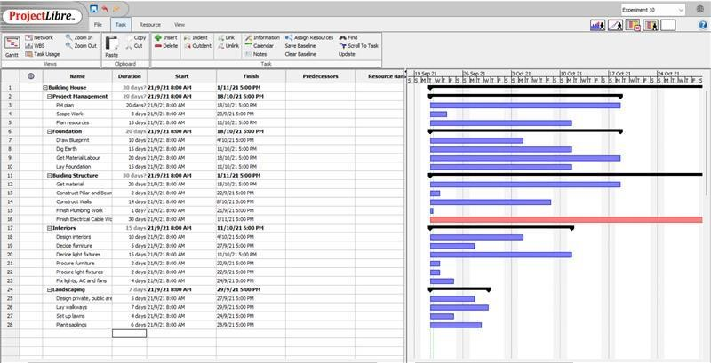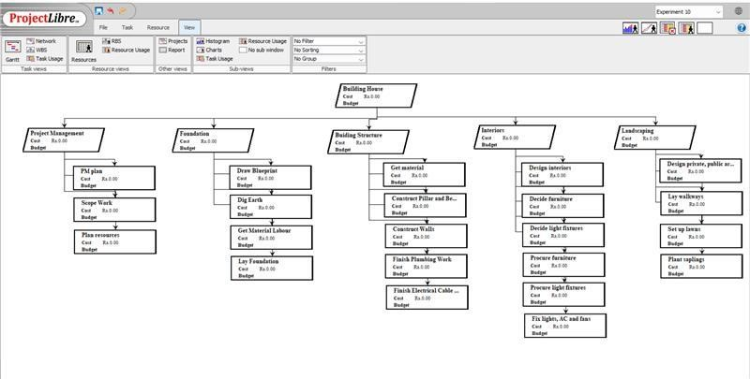

|  |  |  |  |
| --- | --- | --- | --- |
| **Internal Assessment (Mandatory Experiment) Sheet for Lab Experiment**  **Department of Computer Science & Engineering ASET, Amity University, Noida (U.P.)** | | | |
| Programme | B. Tech (CSE) | Course Name | Software Project Management |
| Course Code | CSE432 | Semester | 7 |
| Student Name | Vishesh Jindal | Enrollment No. | A2305218539 |
| **Marking Criteria** | | | |
| **Criteria** | **Total Marks** | **Marks**  **Obtained** | **Comments** |
| Concept (A) | 2 |  |  |
| Implementation (B) | 2 |  |  |
| Performance (C) | 2 |  |  |
| Total | 6 |  |  |

**RESULT:** In this experiment, we have drawn the Work Breakdown Structure and the result is shown inscreenshots.

**OPEN ENDED EXPERIMENT**

Understanding the critical path on your project is an important concept as the critical path drives your end date. If there is a single delay in any of the tasks on the project schedule, it will have a direct impact on the project end date. Applying the critical path methodology is one approach to understanding your project’s network sensitivity. This MS Project tutorial demonstrates how to view the critical path and critical tasks in Microsoft Project. Microsoft Project has a Gantt Chart wizard that will automatically format the Gantt chart to display the critical path. To use the Gantt Chart wizard, access the Gantt Chart view.

**Software Used**: Project Libre

**Theory**:

**Critical path**- It is the longest sequence of activities that must be finished on time in order for the entire project to be complete. Any delays in critical tasks will delay the rest of the project.

**Critical Task** - Tasks that cannot be delayed without affecting the project finish date are the critical tasks. In a typical project, many tasks have some slack and can therefore be delayed a bit without delaying other tasks or affecting the project finish date.

**OUTPUT:**

1. A screenshot of a computer

   Description automatically generated with medium confidence

**2.**

**RESULT**: Required result is shown in the screenshot.

|  |  |  |  |
| --- | --- | --- | --- |
| **Internal Assessment (Mandatory Experiment) Sheet for Lab Experiment**  **Department of Computer Science & Engineering ASET, Amity University, Noida (U.P.)** | | | |
| Programme | B. Tech (CSE) | Course Name | Software Project Management |
| Course Code | CSE432 | Semester | 7 |
| Student Name | Vishesh Jindal | Enrollment No. | A2305218539 |
| **Marking Criteria** | | | |
| **Criteria** | **Total Marks** | **Marks**  **Obtained** | **Comments** |
| Concept (A) | 2 |  |  |
| Implementation (B) | 2 |  |  |
| Performance (C) | 2 |  |  |
| Total | 6 |  |  |