LINE Chat
User Manual
A guide to register, chat with friends, join groups,
use Timeline/Forums, and start voice calls.
Live website:
https://leekimteck.kolejsynergy.com/Chatting/device_select.php
Version 1.0 · For end users

Contents
- Introduction
- Getting started
- Create an account (Register)
- Log in
- Main navigation
- Friends
- Private chat (1-to-1 messaging)
- Voice calls
- Groups
- Timeline & Forums
- Tips & troubleshooting
- Quick reference

1. Introduction
LINE Chat is a web messaging app with a LINE-style look. You can add friends, send private messages, chat in groups, post on Timeline/Forums, and make voice calls from your browser.
What you need:
- A modern browser (Chrome, Edge, Firefox, or Safari)
- Internet connection
- For voice calls: microphone permission and HTTPS (or localhost)

2. Getting started
Open the website:
https://leekimteck.kolejsynergy.com/Chatting/device_select.php
First you will see the device selection page. Choose Desktop or Mobile so the layout fits your screen. Your choice is remembered for later visits.
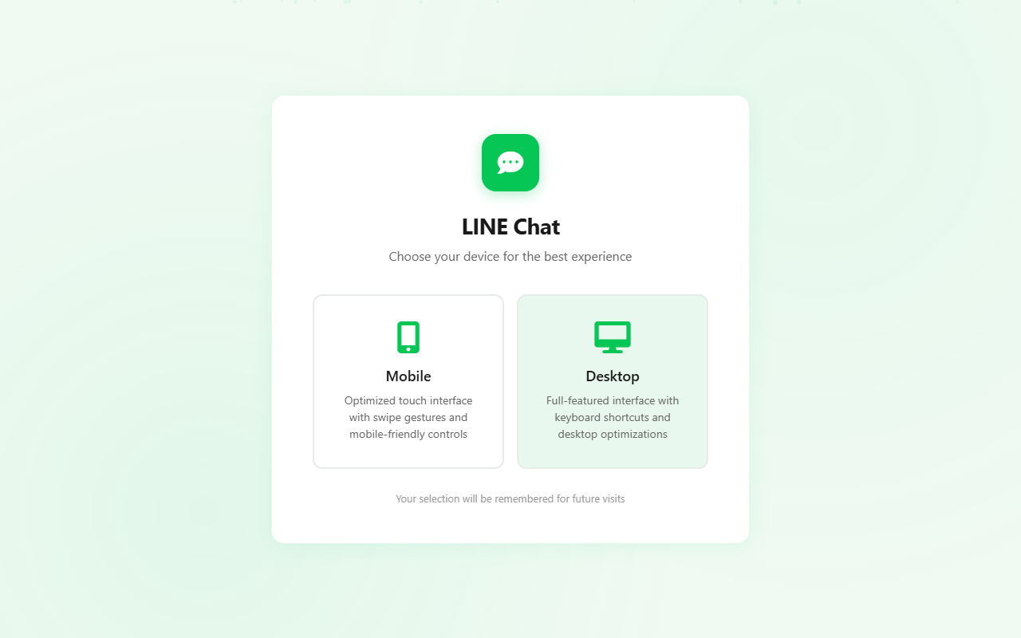
Figure 1 — Choose Desktop or Mobile

3. Create an account (Register)
- On the login page, click Create new account (or open Register).
- Enter a username (3–32 characters: letters, numbers, underscore).
- Enter a password (at least 6 characters).
- Confirm the password.
- Click Sign up.
After a successful registration you are logged in and taken to Chats.
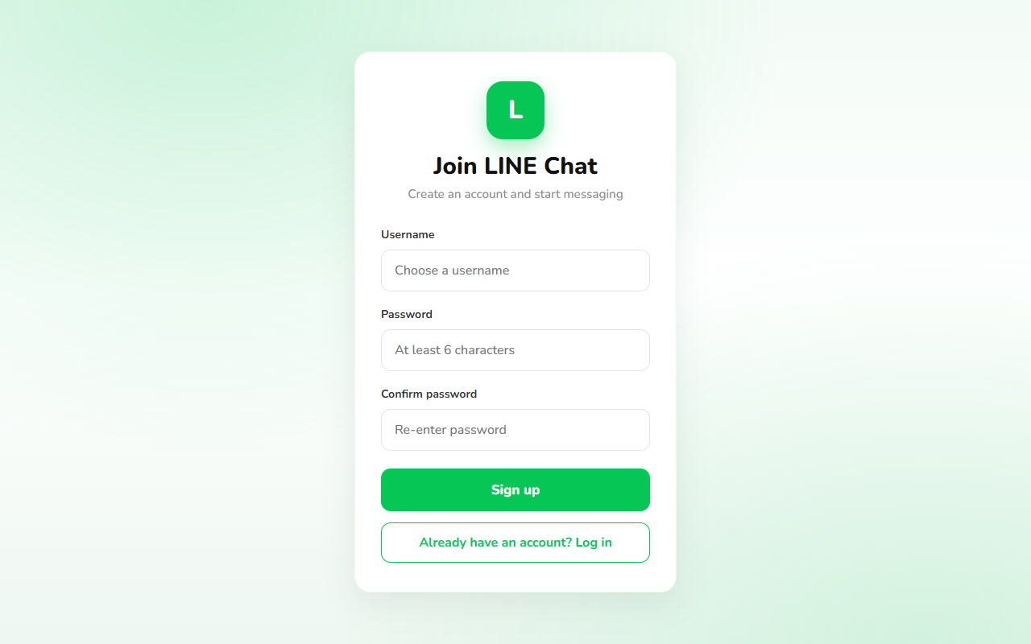
Figure 2 — Register page

4. Log in
- Open the Login page.
- Enter your username and password.
- Click Log in.
Use Change next to Desktop/Mobile mode if you want to switch device layout.
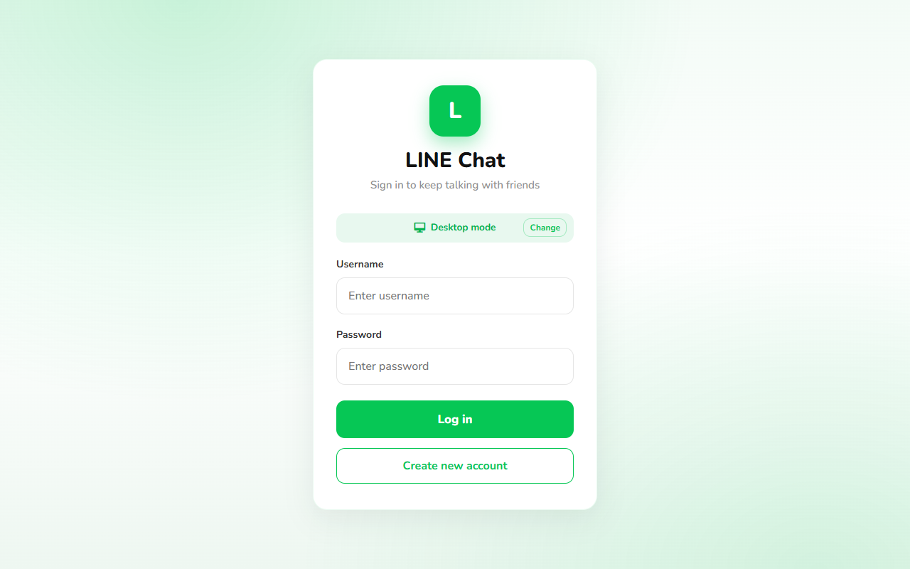
Figure 3 — Login page

5. Main navigation
After login, a green “L” rail appears on the left. Use it to move between sections:
- Friends — search users, send/accept friend requests
- Chats — private conversations
- Timeline — posts and forum activity
- Groups — group list and group chats
- Logout — sign out of your account
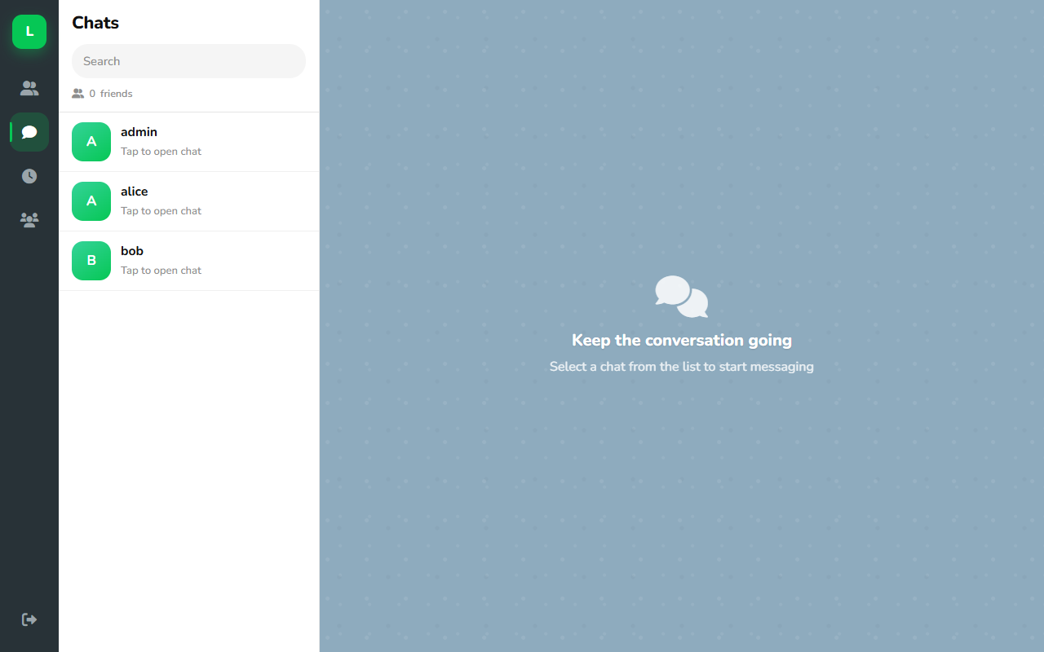
Figure 4 — Chats list and navigation rail

6. Friends
Open Friends from the left rail.
You can:
- Search for other users by username
- Send a friend request
- Accept or refuse incoming requests
- See your current friends list
You can only start a private chat with someone who is already your friend (accepted on both sides).
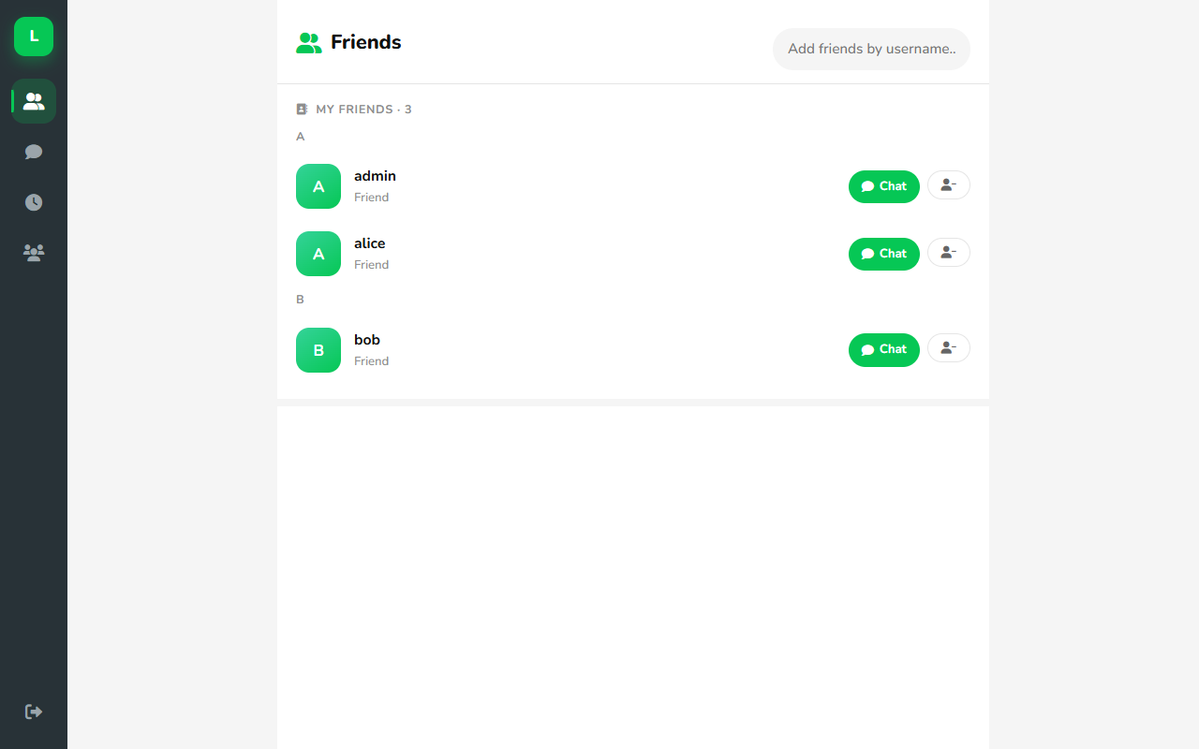
Figure 5 — Friends page

7. Private chat (1-to-1 messaging)
- Click Chats on the left rail.
- Select a friend from the chat list.
- Type your message in the box at the bottom.
- Press Enter or click the send button to send.
Useful controls in the chat composer:
- + — attachments / extra actions
- Emoji — insert emoji
- Message box — type text
- Mic / Send — send voice or text (send appears when typing)
Messages appear as bubbles (green for messages you send). The chat also supports reactions and related chat features depending on your build.
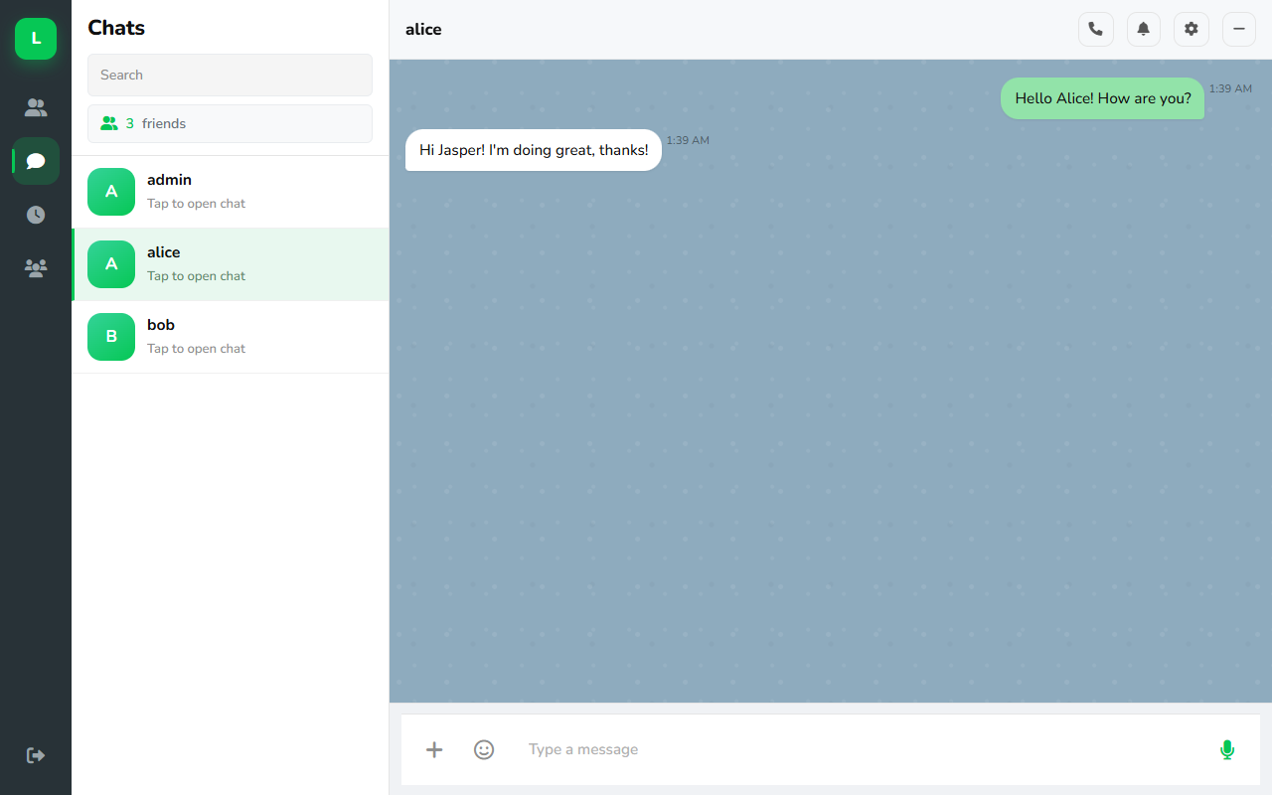
Figure 6 — Private chat with message input at the bottom

8. Voice calls
From an open private chat, click the phone icon in the chat header to start a voice call.
Requirements:
- Both users should be on each other’s chat page
- Allow microphone access when the browser asks
- Use HTTPS (your live site) or localhost
If the call does not connect, check mic permissions in the browser address bar and ask the other person to keep the chat page open.

9. Groups
Open Groups from the left rail.
Create a group:
- Enter a group name (and optional description).
- Select friends to add as members.
- Create the group.
Open a group to chat with all members at once.
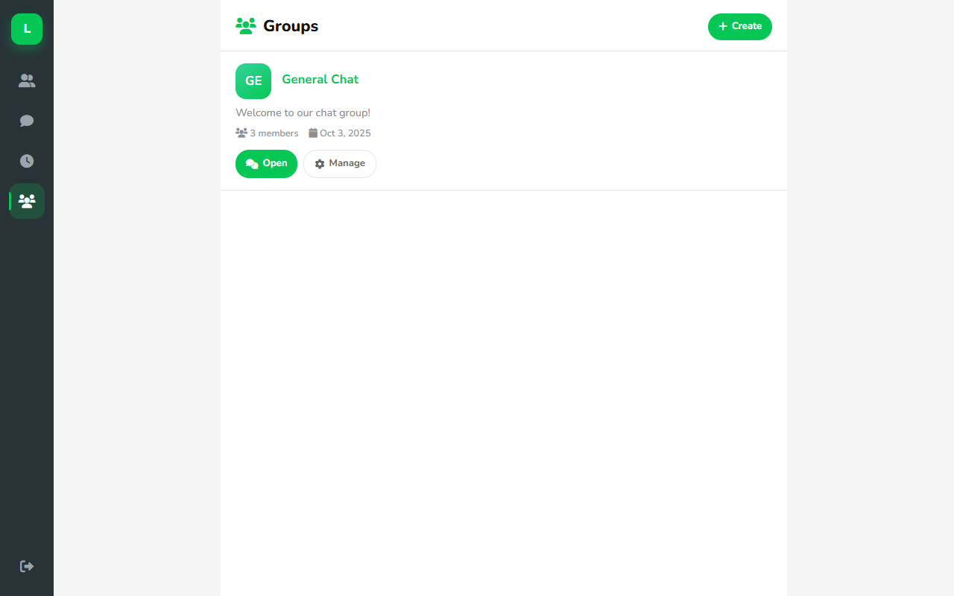
Figure 7 — Groups list
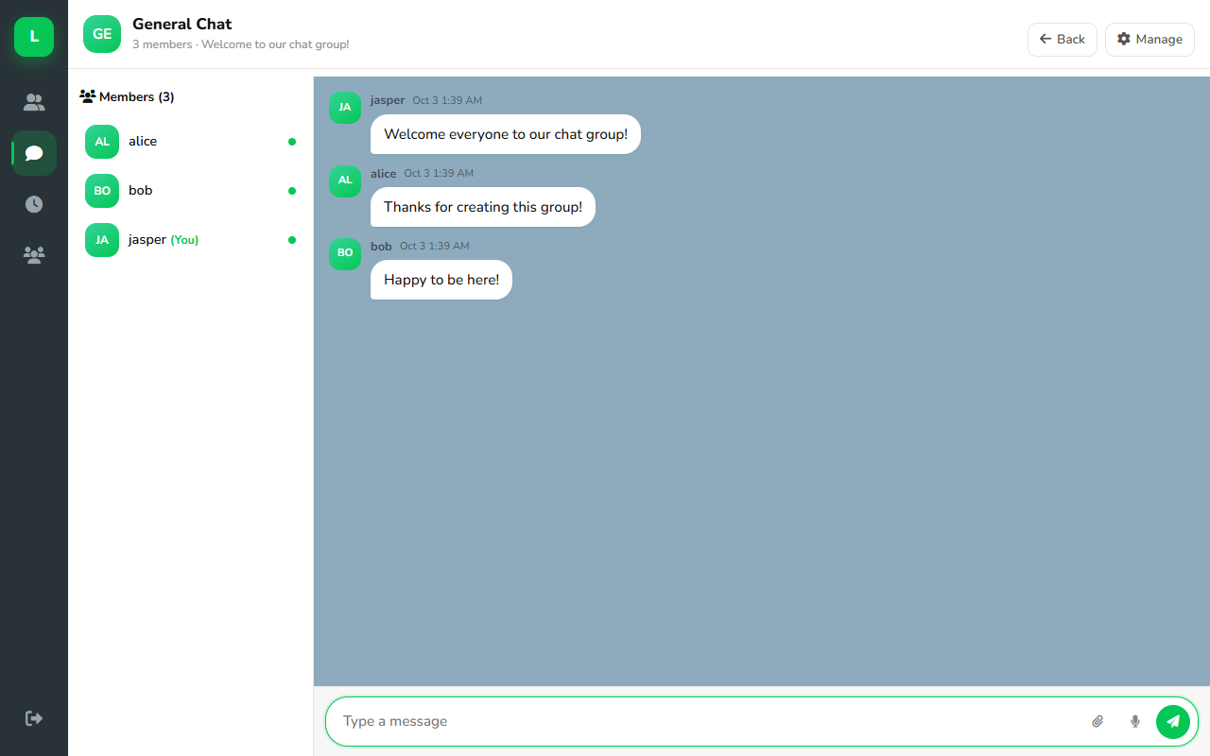
Figure 8 — Group chat
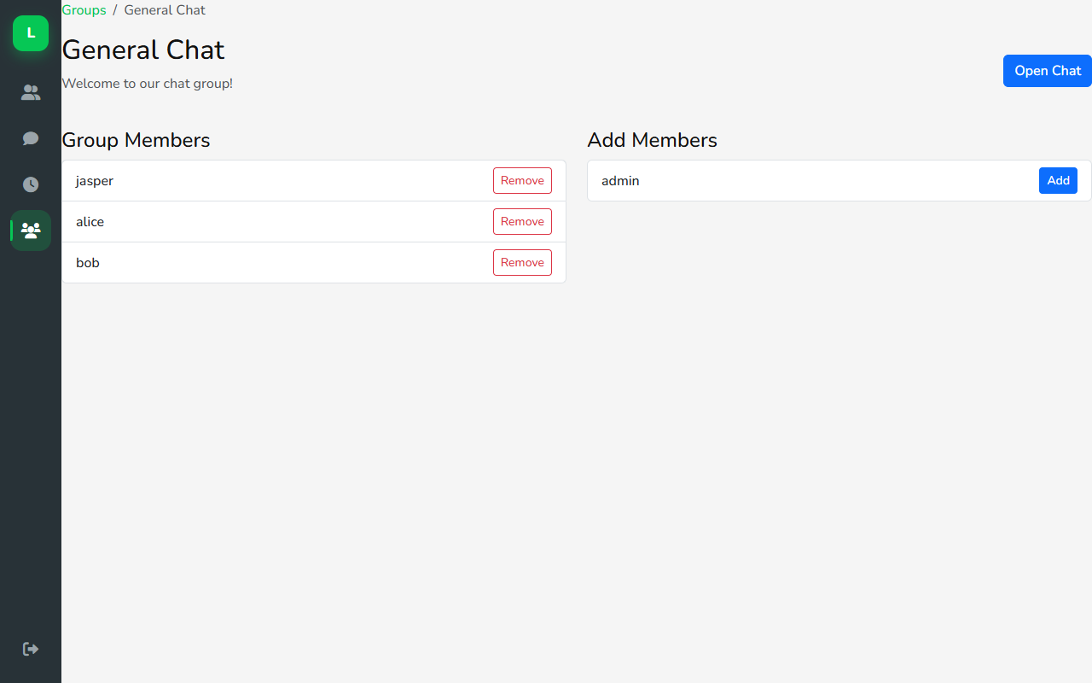
Figure 9 — Manage group members

10. Timeline & Forums
Timeline shows recent posts and social activity. Forums let you browse boards and topics.
- Timeline (main icon) — browse and create posts
- Forums — list of forum boards
- Forum posts — topics inside a board
- Forum post — read one topic and reply/interact
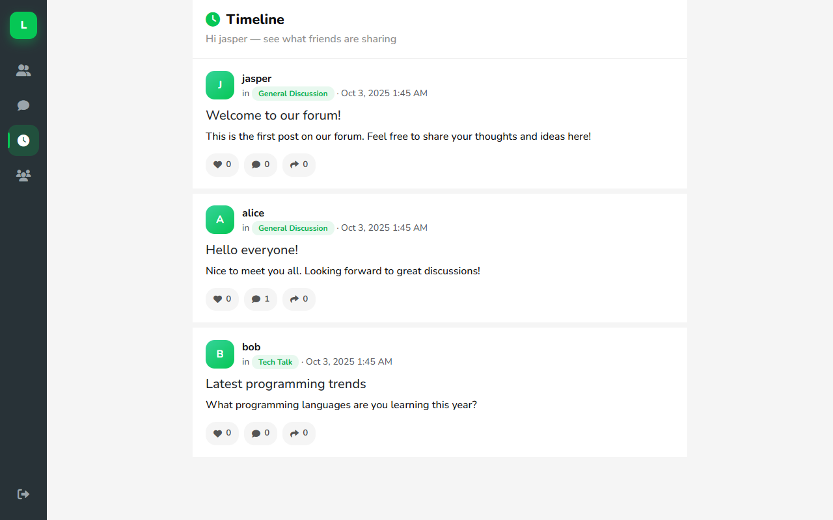
Figure 10 — Timeline
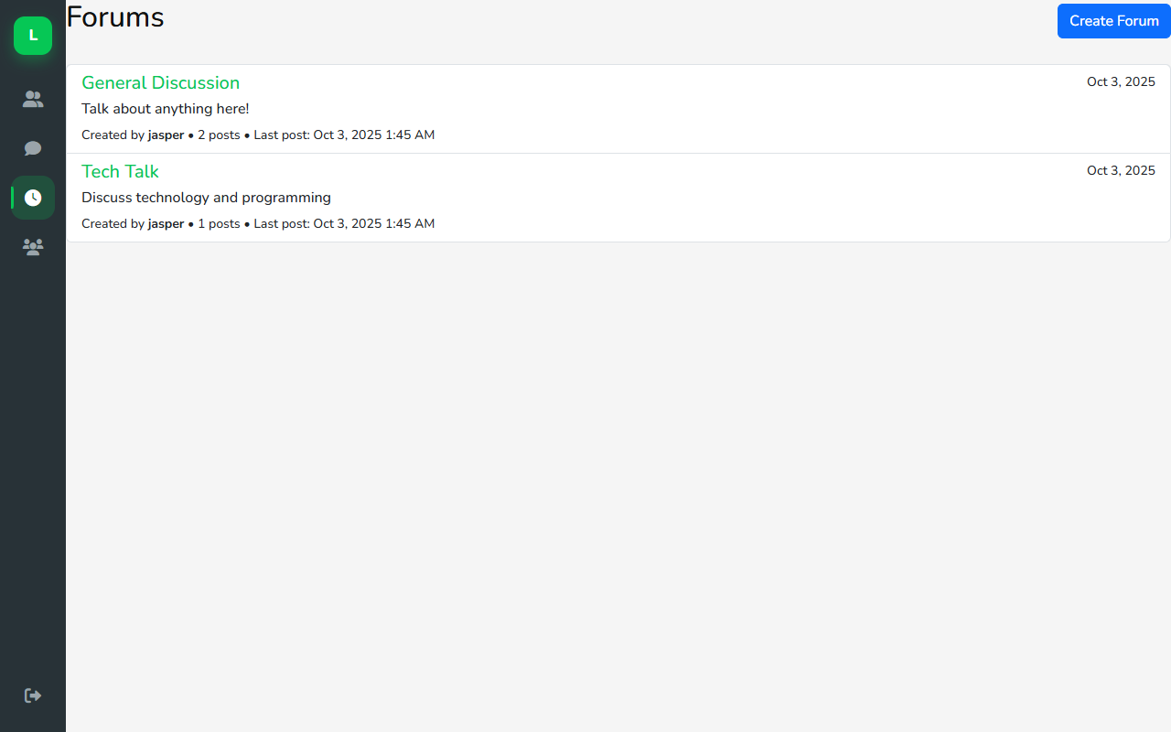
Figure 11 — Forums
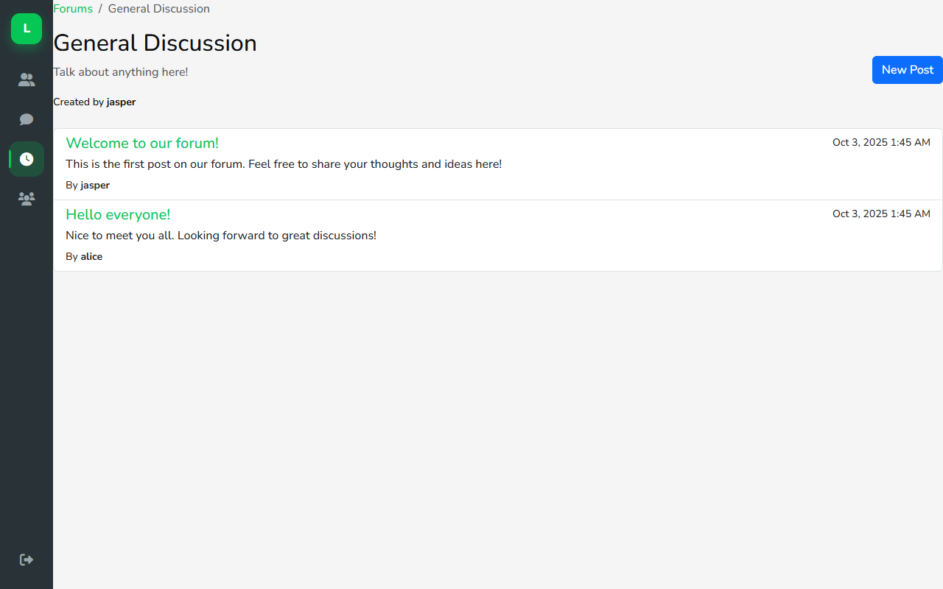
Figure 12 — Posts in a forum
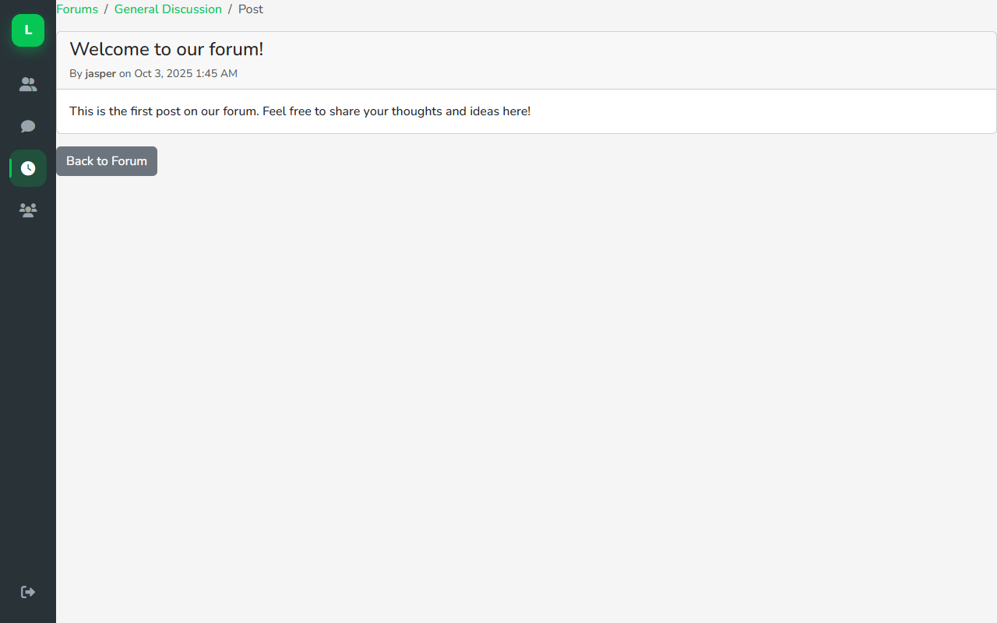
Figure 13 — Single forum post

11. Tips & troubleshooting
Common issues
- Cannot message someone — become friends first (send and accept the request).
- Page looks wrong on phone — return to device select and choose Mobile.
- Messages not updating — refresh the page; keep a stable internet connection.
- Voice call fails — allow microphone, stay on the chat page, use HTTPS.
- Forgot password — ask your admin to reset the account (self-reset may not be available).
Safety tips
- Do not share your password.
- Log out on shared computers.
- Be careful with links and files from people you do not know.

12. Quick reference
Task | Where to go
Open the app | https://leekimteck.kolejsynergy.com/Chatting/device_select.php
Choose layout | Device select page
Sign up | Register
Sign in | Login
Add friends | Friends
Send private message | Chats → select friend
Voice call | Private chat → phone icon
Group chat | Groups → open a group
Post / read topics | Timeline or Forums
Sign out | Logout on the left rail

End of User Manual — LINE Chat

