Jillian Nemec

December 22, 2020

Excel Homework – 1

Excel Challenge

1. Given the provided data, what are three conclusions we can draw about Kickstarter campaigns?

Many conclusions about Kickstarter campaigns given the provided data can be drawn. First, based on the Category analyzations, we can determine that film & video, music, and theater have the highest success rates. Next, we reviewed the sub-categories where we were able to determine that plays, a sub-category of theater, have the highest success rate overall. Finally, Kickstarter campaigns are most successful in May, and least successful in December.

1. What are some limitations of this dataset?

Some limitations of this dataset include the lack of geographical locations within the country, the category totals are inconsistent, the date ranges are very broad with inconsistent start and end dates. The “ask” is not clearly defined. Additionally, the success rate is determined based on whether the goal was achieved rather than the percentage of success.

1. What are some other possible tables and/or graphs that we could create?

Other tables and/or graphs that we could create include:

* + - Pivot to determine success based on year that you can filter by Country, Category, and Sub-Category
    - 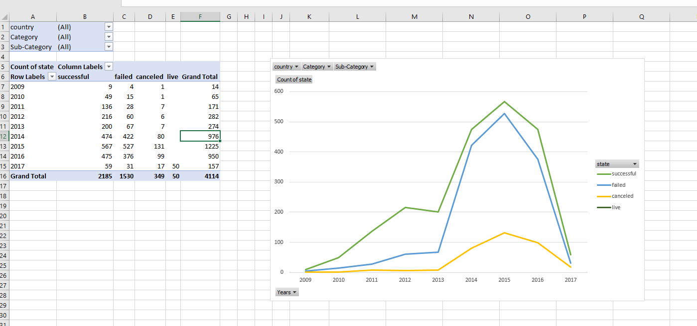
    - Category pivot that reviews the pledged total by year 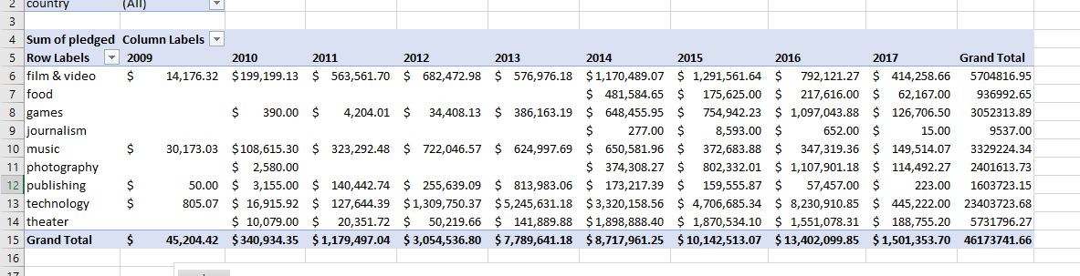
    - Pivot that reviews the % funded by category/year

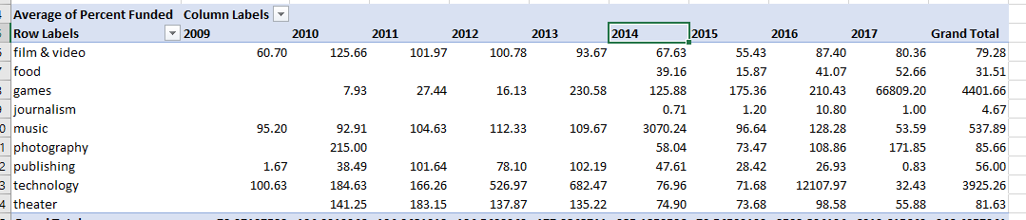

* + - Pivot that reviews the outcome of the % funded by year

