**14.1** For the depression data set described in Appendix A, perform a principal components analysis on the last seven variables DRINK–CHRONILL (Table 3.3). Interpret the results.

**Solution**

Title "PCA of last seven variables of Depression data set";

**proc** **princomp** data=depression out=depress_pca;

var DRINK HEALTH REG_DOC TREATED BEDDAYS ACUTE_ILLNESS CHRON_ILLNESS;

**run**;

**quit**;

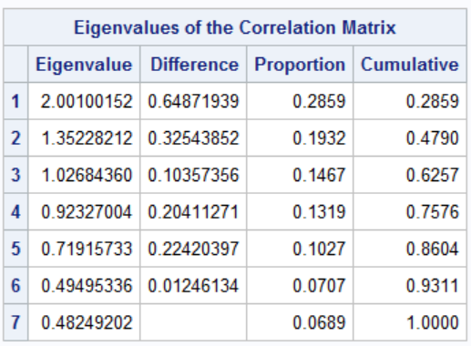

As can be seen from above result, Eigenvalues of first four components represents 75% of total variability.

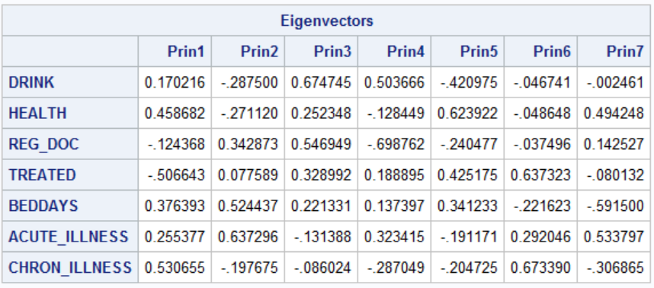

Prin1 = 0.170216*DRINK + 0.458682*HEALTH - 0.124368*REG_DOC - 0.506643*TREATED + 0.376393*BEDDAYS + 0.255377*ACUTE_ILLNESS + 0.530655*CHRON_ILLNESS

Similarly, we can write equation for other principal components.

**14.6** Using the family lung function data described in Appendix A define a new variable RATIO = FEV1/FVC for the fathers. What is the correlation between RATIO and FEV1? Between RATIO and FVC? Perform a principal components analysis on FEV1 and FVC, plotting the results. Perform a principal components analysis on FEV1, FVC, and RATIO. Discuss the results.

**Solution**

**data** Lung;

set "F:\SAS\Lung";

**run**;

**data** Lung_w_ratio;

set Lung;

Ratio_father = FEV1_father / FVC_father;

**run**;

**Correlation between RATIO and FEV1**

**proc** **corr** data=Lung_w_ratio;

var RATIO_father FEV1_father;

**run**;

**quit**;

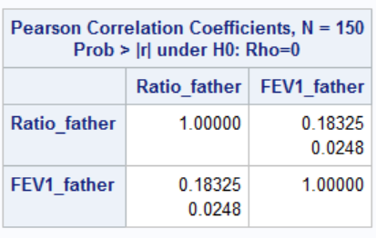

Correlation between Ratio_father and FEV1_father is 18%, which is significant. The ratio is positive which mean Ratio_father and FEV1_father is directly proportional to each other.

**Correlation between RATIO and FVC_father**

**proc** **corr** data=Lung_w_ratio;

var RATIO_father FVC_father;

**run**;

**quit**;

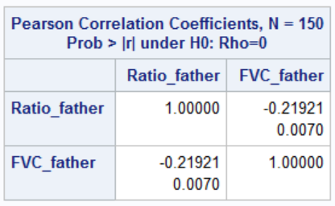

Correlation between Ratio_father and FVC_father is -21%, which is also significant. The ratio is negative because Ratio_father is inversely proportional to FVC_father.

**Principal components analysis on FEV1 and FVC**

Title "PCA of FEV1_father and FVC_father";

**proc** **princomp** data=Lung_w_ratio out=Lung_w_pca;

var FEV1_father FVC_father;

**run**;

**quit**;

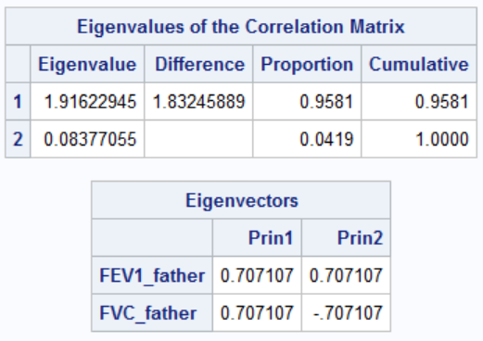

We can be see that 95 percent variability is achieved through first Principal Component.

Following is the computation of both Principal Component:

Prin1 = 0.707107*FEV1_father + 0.707107*FVC_father

Prin2 = 0.707107*FEV1_father – 0.707107*FVC_father

**Plotting the above result**

Title "Plot of Principal Components of FEV1_father and FVC_father";

**proc** **sgplot** data=Lung_w_pca;

scatter x = Prin1 y= Prin2 ;

ellipse x = Prin1 y= Prin2;

**quit**;

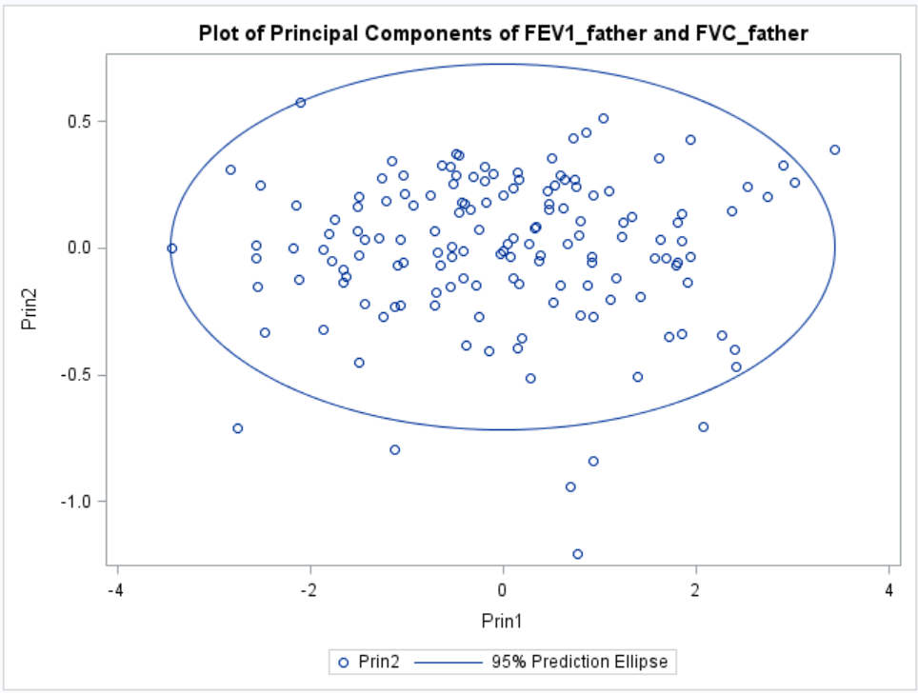

We can see from the above SG plot that a more variability is provided by Prin1 and less variability by Prin2.

**Principal components analysis on FEV1, FVC, and RATIO**

Title "PCA of FEV1_father, FVC_father and Ratio_father";

**proc** **princomp** data=Lung_w_ratio out=Lung_w_ratio_pca;

var FEV1_father FVC_father Ratio_father;

**run**;

**quit**;

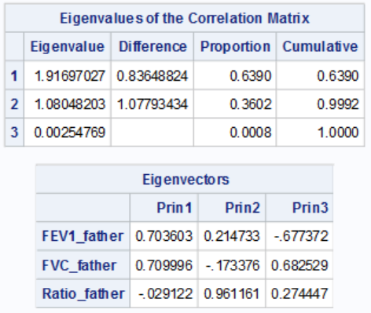

We can see above, 99% variability is provided by Principal Component 1 and 2.

Following is the computation of all the Principal Components:

Prin1 = 0.703603*FEV1_father + 0.709996*FVC_father – 0.029122*Ratio_father

Prin2 = 0.214733*FEV1_father – 0.173376*FVC_father + 0.961161*Ratio_father

Prin3 = -0.677372*FEV1_father + 0.682529*FVC_father + 0.274447*Ratio_father

**14.7** Using the family lung function data, perform a principal components analysis

on age, height, and weight for the oldest child.

**Solution**

Title "PCA of Age, Height and Weight of Oldest Child";

**proc** **princomp** data=Lung out=Lung_oldest_child_pca;

var Age_oldest_child Height_oldest_child Weight_oldest_child;

**run**;

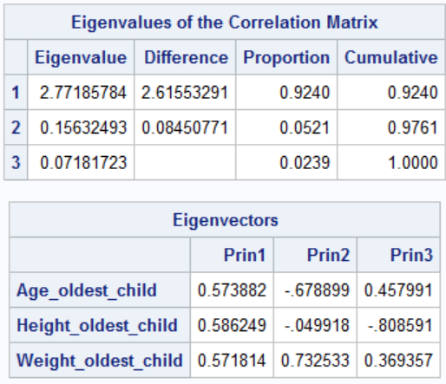

We can see from above result that 92% variability is achieved through Principal component 1 itself.

Following is the computation of all the Principal Components:

Prin1 = 0.583882*Age_oldest_child + 0.586249*Height_oldest_child + 0.571814*Weight_oldest_child

Prin2 = -0.678899*Age_oldest_child - 0.049918*Height_oldest_child + 0.732533*Weight_oldest_child

Prin3 = 0.457991*Age_oldest_child - 0.808591*Height_oldest_child + 0.369357*Weight_oldest_child