**Functional Specification Document**



Project- Tech Prometheon Website Development Phase-1

Version- Draft

**Created by- Sarang Mokashi**

Founder, Director

Tech Prometheon Internet Pvt. Ltd.

|  |  |
| --- | --- |
| Document Owner: | Tech Prometheon Internet Pvt. Ltd. |

Version History:

|  |  |  |  |
| --- | --- | --- | --- |
| Version | Date | Description | Author |
| Draft | 15-06-2017 | Website Functional Specifications-Draft | Sarang Mokashi |

Sign off:

|  |  |  |  |
| --- | --- | --- | --- |
| Approver | Role | Signed | Signed off/ Approval Date |
| Prasad Gulhane | Director, Tech Prometheon Internet Pvt. Ltd. |  |  |
| Jinesh Mehta | Developer |  |  |

1. **Overview**

This document is intended to specify and sign off the functional requirements for website of Tech Prometheon Internet Pvt. Ltd.

1. **Functional Specifications**

The website mainly contains company information contents, products, services, offerings, blogs, Contact us form, backend admin panel and setting up webmails. Detailed specifications with data, description and rules are discussed below:

* 1. **Tech Prometheon Header**

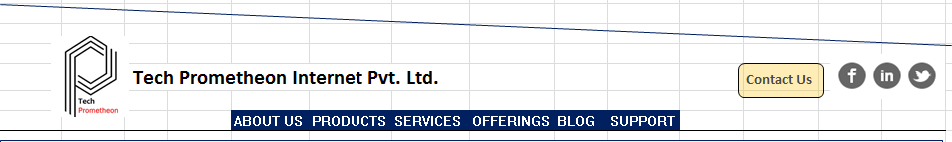

|  |  |  |
| --- | --- | --- |
| **Spec ID** | **Description** | **Rules (if any)** |
| Home-01 | Header with company logo, name, menu tab, connect icons, Contact us with slight transperant background. |  |
| Home-02 | Menu tab [PRODUCTS] when clicked displays the slide 'Product1' always |  |
| Home-03 | In long term in case of more products, different slides featuring products will be added as Product2, Product3 and gets displayed one after another |  |
| Home-04 | Menu tab [SERVICES] when clicked displays the slide 'Services'. There could be only one slide featuring all services with headings, featured icon of service and short description |  |
| Home-05 | Menu tab [Offerings] when clicked takes user to 'Knowledge Center' slide |  |
| Home-06 | Sequence of slides- Home, Product1, Services, Knowledge Center, Contact Us |  |
| Home-07 | Privacy policy page link and copyright appears at the footer |  |
| Home-08 | Know about us gets displayed on hovering cursor over [ABOUT US] tab and stays till cursor is on a slide | Look and feel of slide should match with homepage design |
| Home-09 | Dropdown for 'Know about us' can have text, images, icons |  |

* 1. **Products on Home page**

**Product1**

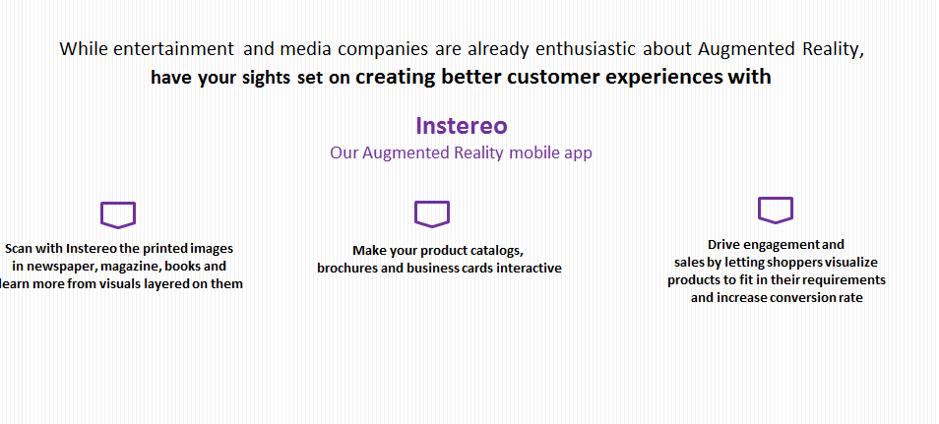

Note that above design is just for demo visualization

2.1.1 This Product1 slide provides links to download app from Google Play store and App Store.

2.1.2 Slide will feature the instereoAR logo, Product1_slide_image and link to explore product features

2.1.3 Product features, offered B2B/B2C solutions, pricing are taken on separate product1 page.

**(2.1.3 TBD in version 1.0)**

**Product2**

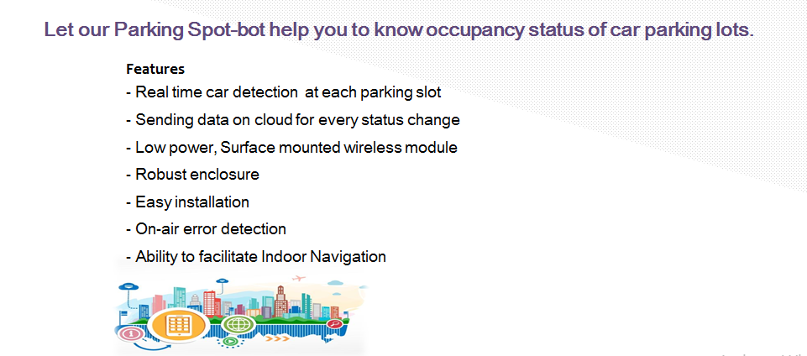

* + 1. Product2 slide would only have [Put Enquiry] button as of now which opens a form there itself that takes *email id, *Country, Contact, *Enquiry text field with 1000 char max and submit button (* is for mandatory fields)
    2. Submitted enquiries should go to [techprometheon@gmail.com](mailto:techprometheon@gmail.com) and [enquiry@techprometheon.com](mailto:enquiry@techprometheon.com) with subject- Enquiry for EasyParking Spot-bot
    3. Product2_slide_image to get available by v1.0
  1. **Services on Homepage**

Below Services should be featured in dedicated section on homepage ‘Services’ with suitable icons, look and feel:

|  |  |
| --- | --- |
| **Assurance Services** | Mobile and internet based business models are converging with big data, Artificial Intelligence (AI), Augmented Reality(AR) *etc.* and experiencing digital transformation. A small change in a device or process impacts connected downstream systems. This calls for maximum test coverage. We assure you right quality. Accelerate your time-to-market with us as your trusted testing partner. |
| **System Integration** | We design and deliver the best possible solutions that can be integrated with your existing designs or to meet your requirements. Having exprtise in embedded software, database, mobile app and game development, we are well equipped to bring required changes and integrate various modules together. Team has expertise in and offering system integration built around sensors, signal conditioning cards and modules like GSM, GPS, Bluetooth, Wi-Fi and many more. You specify the requirements and we offer highly reliable, cost effective solutions. |
| **IoT solutions for smart cities** | Create the added value to city services by storing and analysing the data of parking lots, public transport, security, lighting, electricity and water supply networks, waste management etc. to monitor and predict events for immediate problem solving |
| **Product Analytics** | Analyze how your customers use your products. Get insights based on data analysis to take smarter actions and improve your products with Machine Learning and AI techniques for predictive maintenance and management. |

* 1. **Offerings on Homepage**

This section on homepage is dedicatedly designed for Knowledge Center and Research Labs and design is expected to be like discussed below:



|  |  |  |
| --- | --- | --- |
| **Spec ID** | **Description** | **Rules (if any)** |
| KC-1 | This slide can have more than three columns (At a time only three are displayed) |  |
| KC-2 | Each column shows a particular training module information with Training module name in bold, two-three lines description, an image, I'm interested button, share icon as shown |  |
| KC-3 | If user hovers cursor over any column, that column gets acted with special effect as shown above. |  |
| KC-4 | Share icon and [I'm interested] button gets visible only when a column is hovered with cursor. |  |
| KC-5 | Share icon when clicked opens a pallet of icons of FB, Linkedin and Twitter where the link of particular google form can be shared on respective platform. Note that the Google form description appears on FB/Linkedin/Twitter post |  |
| KC-6 | When [I'm interested] button is clicked, user should be linked to respective google form. |  |
| KC-7 | Columns can move left-right when user clicks left-right buttons OR keeps moving like a slider with some time interval. |  |
| KC-8 | Functionality to add training modules (Title, description, image and link to google form) from backend admin panel |  |
| KC-9 | Training Modules   |  | | --- | | * **Internet of Things: Communication Technologies** | | * **Learn to architect your Smart IoT Device** | | * **Peripheral interfacings with Raspberry Pi** | | * **8051 Microcontrllers, Arduino platform and their interfacings** | | * **AWS IoT Platform** | | * **Programming in LabView** | | Given aside in Bold are Titles of Training modules. (Description, images and link to google form can be expected in v1.0)  *Till then dummy images can be used. |

* 1. **Support Tab**

On clicking [SUPPORT] on header, screen navigates to below look like section where links of FAQ pages are given:

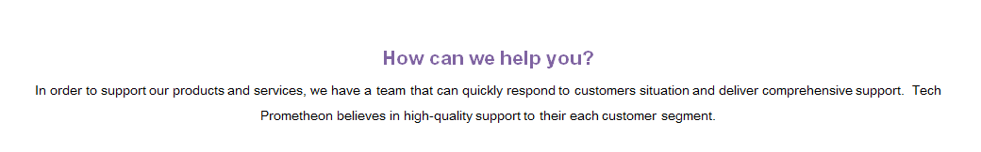

* + 1. For now we have two products out of which Product1 has dedicated page with featured business. FAQs link from homepage ‘How can we help you?’ section can direct user to Product1_FAQs page.
  1. **Blogs**

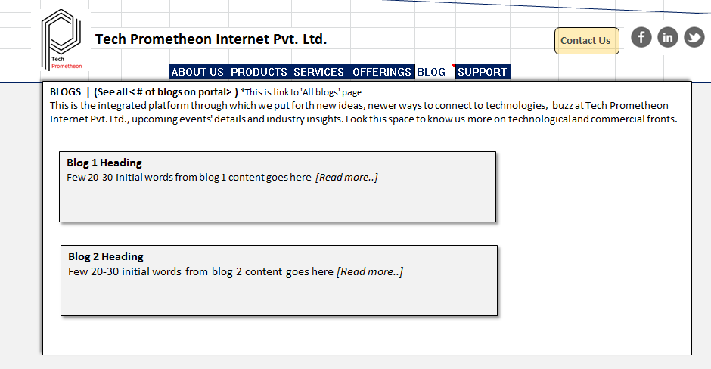

Note that above design is just for demo visualization

|  |  |  |
| --- | --- | --- |
| **Spec ID** | **Description** | **Rules (if any)** |
| Blog-1 | Blogs slide gets displayed on hovering cursor over BLOG tab and stays till cursor is on slide. User can click on available links on slide to navigate to other pages |  |
| Blog-2 | Dropdown slide from [BLOG] tab in header displays only two latest blogs with Read more link for each. |  |
| Blog-3 | On clicking Read more link of each blog, user gets navigated to respective blog page and complete blog contents (Cover image, title and written blog) | Date on which blog is posted can be shown just below title. (Low priority req) |
| Blog-4 | See All link at Blog slide opened by hovering [Blog] tab in header takes user to All blogs page where blogs are shown with pagination (Five latest blogs section at page 1) | Each blog section on this page is similar to blog section discussed in Blog-2 spec |
| Blog-5 | Blogs can only be published through backend (admin panel) | Check that the textbox on ‘post blog’ form at backend can take copy-pasted text and appears in matching font. Textbox should allow hyperlinks. |
| Blog-6 | Each blog should have share link near blog title. Any user can share blog link on FB/Linkedin/Quora |  |

* 1. **Contact US** 
     1. When user clicks [Contact US] button, ‘Get in Touch’ section appears with a form with mandatory fields (Name, Email ID, Message, Captcha) is displayed.
     2. On clicking the [Submit] button, mail is sent to [techprometheon@gmail.com](mailto:techprometheon@gmail.com) and [info@techprometheon.com](mailto:info@techprometheon.com) with subject- Contact us website notification

1. **Data and Images**
   1. **Home Image**



* + 1. This image should be displayed on home landing page. When user clicks the logo or name of company at the header, control navigates to this landing page.
    2. While doing scroll up/down on website, header stays on the screen.
  1. **Logo of Tech Prometheon**
  2. **Logo of instereoAR**
  3. **Privacy Policy Page Contents**

We believe it is important you know how we treat the information received from you on the internet.

In general, you can visit Tech Prometheon Internet Private Limited web portals without telling us who you are or revealing any information about yourself. Our Web servers collect the domain names, not the e-mail addresses, of visitors. This information is aggregated to measure the number of visits, average time spent on the site, pages viewed, etc. Tech Prometheon Internet Private Limited uses this information to measure the use of our site and to improve the contents. In addition, we may use third party services such as Google Analytics that collect, monitor and analyze this type of information in order to improve our Services' functionality. These third party service providers have their own privacy policies addressing how they use such information. Your accessing services signify your unconditional consent to allow the collection of your domain names.

There are times, however, when we may need information from you. When information is needed, we will try (but are not obligated) to let you know at the time of collection, how we will use the personal information. Usually, the personal information we collect is used only by us to respond to your enquiry or to provide you custom information about our offerings in support of your concerns.

Tech Prometheon Internet Pvt. Ltd. is sensitive to data privacy issues maintaining fairness and integrity in all operations. The contents on this website are for the business and reference purpose. Content in the blogs are well researched, filtered, reviewed before posting. If you are using any content from the website for reference, author should be acknowledged under suitable headings.

By accessing the website, you confirm your acceptance to privacy policy.

1. **Non-functional Requirements**
   1. Setting up below webmail accounts:

[info@techprometheon.com](mailto:info@techprometheon.com)

[enquiry@techprometheon.com](mailto:enquiry@techprometheon.com)

[instereo@techprometheon.com](mailto:instereo@techprometheon.com)

[prasad@techprometheon.com](mailto:prasad@techprometheon.com)

[sarang@techprometheon.com](mailto:sarang@techprometheon.com)

[abhishek@techprometheon.com](mailto:abhishek@techprometheon.com)

* 1. Google Analytics with admin user email id: [techprometheon@gmail.com](mailto:techprometheon@gmail.com)

1. **Points to be decided yet**
   1. Contents and page structure of Product1 (instereoAR) – High Priority (Spec ID- 2.1.3)
   2. Blog contents (Expecting to have this work done (in phase-2)
   3. Knowledge Center Training Modules’ image, description and Google form link
2. **Assumptions**

NA