Name:- Jinesh Nagori

Que 1.
Ans 1.
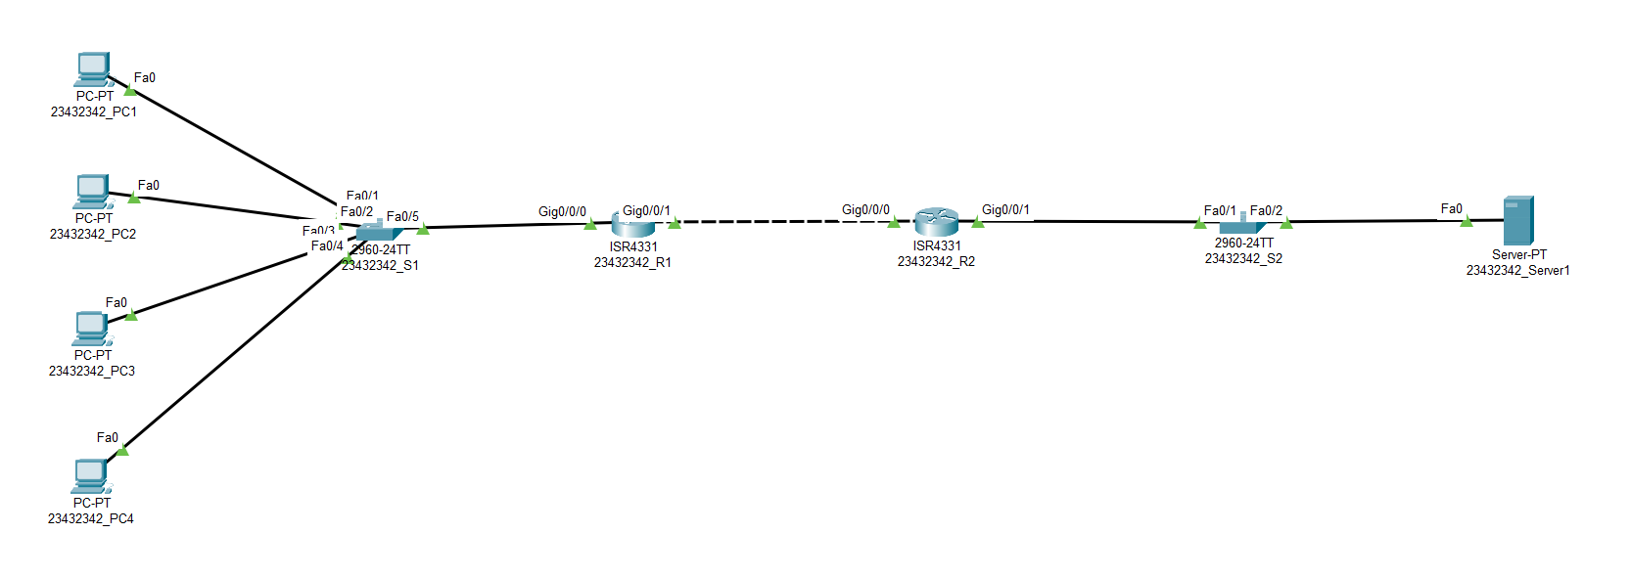

Ques 2. What is subnetting? Explain the types of Subnetting.
Ans 2. Subnetting is the practice of dividing a network into two or more smaller networks. It increases routing efficiency, enhances the security of the network and reduces the size of the broadcast domain.

Static Subnetting: Static subnetting means that all subnets in the subnetted network use the same subnet mask. This is simple to implement and easy to maintain, but it implies wasted address space for small networks. For example, a network of four hosts that uses a subnet mask of 255.255.255.0 wastes 250 IP addresses. It also makes the network more difficult to reorganize with a new subnet mask. All hosts and routers are required to support static subnetting.

Variable Length Subnetting: When variable length subnetting is used, the subnets that make up the network can use different subnet masks. A small subnet with only a few hosts needs a subnet mask that accommodates only these few hosts. A subnet with many hosts attached may need a different subnet mask to accommodate the large number of hosts.

Ques 3. Discuss the types of Dynamic routing, explain OSPF routing
And 3.
OSPF (Open Shortest Path First)
It is a very famous dynamic routing protocol that is being used in today’s world. OSPF is also an open protocol to ensure that any router or even server operating system can run this protocol. It selects the best route by making use of cost as its metric. It is also considered a complete-featured routing protocol, and also it can be complex; however, it can also scale to any size in the network.

EIGRP (Enhanced Interior Gateway Routing Protocol)
It is considered a proprietary protocol for Cisco. Just for your information, just the Cisco devices make use of EIGRP. It is a completed-featured protocol, just like OSPF. It has some amazing features, but until you make sure that you are going to have a Cisco network, the use of open protocol (OSPF) is recommended. EIGRP has replaced IGRP, which was its predecessor. The metric that is needed to select the best route through EIGRP is calculated using a formula that takes into account bandwidth, reliability, delay of the link, and load.

RIP (Routing Information Protocol)
RIP is considered an open-source protocol. Version 2 is the latest one that you should be using today since it provides VLSM, that is, Variable Length Subnet Mask support. It is the simplest and easiest protocol of routing to configure, although it also has got lesser features than OSPF.

BGP (Border Gateway Protocol)
BGP is considered the routing protocol of the Internet. It is also Exterior Gateway Protocol, that is, EGP which means that BGP is used by routers making decisions of routing on the Internet. If your home has a connection to the Internet, you don’t really need BGP or even need to run it. In case the router has got more than one dedicated connection, you might require running.

