Date: 12 December 2019
To,
HR Manager,
Rolling Plans Pvt.Ltd
Subject: Application for the post of Deputy Director.

Dear Sir/ Madam,
I am writing to apply for the post of Deputy Director as known from jobsnepal.com. I am enclosing a completed job application and my resume (C.V.).
The opportunity presented is very interesting and I believe that my experience and education will make me a very competitive candidate for this position. The position for the Deputy Director is a great interest to me. I believe that my strong track record of work will be the valued to me and Rolling Plans Pvt.Ltd. I also have experienced in learning and excelling every job I met.
Please see my resume for addition information on my experiences and education.
Thank you for your time and consideration. I look forward to speaking with you about this opportunity.

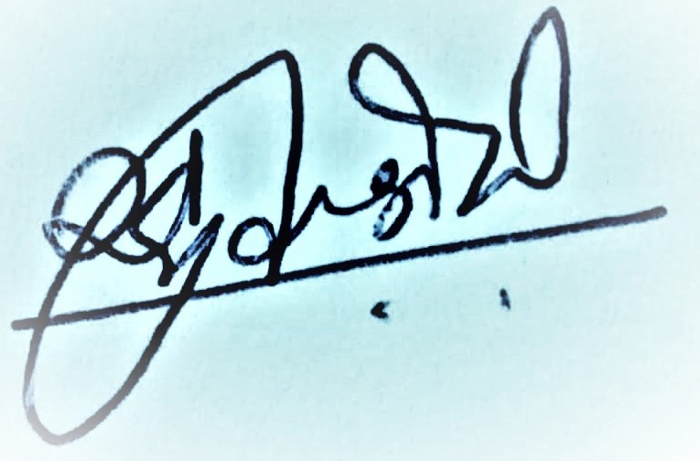

Sincerely,
Raju Shiwakoti
Mobile No: 9851032413/ 9815887322

