Upendra Raj Poudel 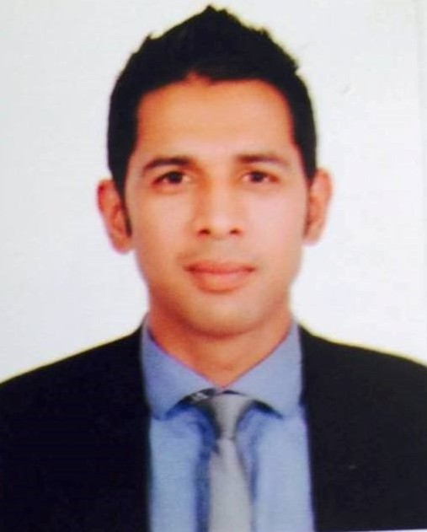
Present Address: Dubai, UAE
Nationality: Nepalese
DOB: 1981/03/18
Marital Status: Married
Passport Number: 07424477
Cell: +9715894784914

E-mail: upenpoudel9@gmail.com

Key Skills

Communication Good Standard of written and spoken English, Nepalese and Hindi gained from writing reports in various social organizations, media and international companies.

Team Work Friendly, team player and leader, encourages co-operation by sharing knowledge and humour.

Organisation Managed competing tasks and workload by focusing, planning ahead and prioritizing.

IT Skills Working knowledge of Microsoft Office Package including Word, Excel, PowerPoint, E-mail and the Internet.
Experience

January 2017- Till Date General Manager- CUin Holidays FZ LLC, United Arab Emirates
Plan and Directs the Operations and Departments, Establishes Financial and Services Standards of the Organization, Prepare Budgets, Monitor Expenses, Schedule and Supervise Staff and Recruitment, Relationship Development with Corporate Clients and Organizations, Market Research and Evaluation
August 2014- December 2016 Manager: Tours and Holiday Package – Adventure Leisure Tourism

Preparation of Holiday packages and itineraries, sales and marketing, networking and coordination with inbound and outbound tour operators, contracting with hotel and apartments, account management, business development, product development and promotions, assisting on daily operations, business proposal writings, replying the guest inquiries, writing contents for websites and blog, social media updates and promotions, networking and coordination with hotels and event organizers.

January 2012- August 2014 Business Development Manager - CUin Destination Guides Ltd, UK

Sales and marketing, product development and promotions, account development, developing holiday packages and itineraries, contracting with hotels and apartments, business development, handling daily operations, research, reporting, writing content for website, editing/proof reading, writing regular news stories and events reports, blog updates, networking and coordination with suppliers, tour operators, hotels and restaurants, analysis and evaluation.

October 2009- December 2011 Front Desk Agent – Sofitel T5 and Arora Hotel Heathrow, UK

Assist on guests check-in/check-out, guest services, assisted on hotel reservation, telephone handling, cash handling, assisted on meeting and events department, meeting rooms setup, assisted guests for local tours and excursions, assisted on various administrative work including filing, processing mail etc

July 2004- Sept 2009 Advocacy Officer - Child Welfare Scheme Nepal

Facilitated Child Journalism Group (Children’s Magazine and Radio
Program) and Western Regional Forum of Working Children, assisted administration in documentation, reporting and preparing proposals, organized various campaigns and rallies to raise the issue of street children/youth, assisted in organising various workshops/meeting to promote children issues and assisted managers to prepare reports, work plans and budget.

Education
October 2011- July 2012 Cardiff Metropolitan University, United Kingdom
Masters of Business Administration (MBA)
Key Subjects: Research Methods, Dissertation/Business Project

October 2009- July 2011 Guildhall College, United Kingdom (Edexcel BTEC Level 7)
Extended Diploma in Strategic Management and Leadership
Key Subjects: Strategic Management and Leadership Skills, Professional Development for Strategic Managers, Strategic Change Management, Strategic Human Resource Management, Strategic Marketing Management, Strategic Quality and Systems Management, Strategic Planning, Research Methods for Strategic Managers, Managing Financial Principles and Techniques and Project Development and Implementation.

2005- 2007 Tribhuvan University
Bachelor’s Degree in Education
Key Subjects: Curriculum and Evaluation, Foundation of Education, Health Science, Physical Education, Psychology, Population Study, and Administration Management.

1999- 2001 Tribhuvan University
Proficiency Certificate Level in Science and Technology
Key Subjects: Physics, Chemistry, Biology, English and Mathematics

1997-1998 National Higher Secondary School, Kaski, Pokhara
School Leaving Certificate (SLC)

Training

February 2014 Time Management Training- Griffith Education Consultant, Kathmandu Nepal

December 2014 Report and Proposal Writing Training- Griffith Education Consultant, Kathmandu, Nepal
,,

Hobbies/Interest

- Traveling and Writing Travel Blogs, Reading Books, Music, Social Work, Youth and Sport Development

References

- Billy Lyle- Managing Director, CUin Destination Guides Ltd, UK
E-mail: billy@cuinguides.com
Mobile: +4407985746666

- Nima Gurung- Program Coordinator, JYOTI Street Project, Nepal
E-mail: nima@jsp.org
Mobile: +9779856021343, +97761432087

