Dear Sir or Madam:

I am writing in regards to your search for a new staff at your organization. As the largest independent network in the market today, the company defines a great sense of energy and pride within the field; the type of environment I excel in. I believe that my combination of 16 years of professional experience (Sales, Marketing, Operation,Customer Relationship Management, Media Communication, HR & Admin) and Education has given me valuable insight and makes me a well-qualified candidate for the position.

I have had several experiences facilitating national & international Marketing, Operation& Sales Management, Corporate CommunicationManagement in Banks/FIs, FMCG Industry, Health & Pharmaceuticals Industry, Hospitality Industry, Social & Media Management, Financial services, Operation Management, Customer Service Managerial jobs, Business Development, Administrative & Management experiences and quickly developing rapport with clients as well as colleagues. My understanding of taking on key leadership skills has led me to be a proactive, solutions-minded individual with superior judgment and decision-making abilities.

As a result, it has greatly contributed to my valuable insight on the unique position your company holds among its broad worldwide audience.

I am currently Involved in the Company related to BFIs Industry where I am assigned to carry the works in Business Development & Sales in align to Insurance, Consumer Banking, Retail Market Development & Telcos relating Digital Financial Platform (BLB, Digital Banking, Digi Wallet, Mobile Banking, Contact less Payment) for BFIs, MFIs, Cooperatives, GoN and Business Houses. I am looking after the Operation &Market Coverage thorough out the Country involving Project Operation, Agent Network Management, Team distribution, M&E and overall business development.This involves establishing strong co-ordination and networking with Stakeholders, Governmental Entities, Banks, Financial Institutions, Educational Industry, Corporates, ISPs, DTHs, Educational Sectors, Hospitals & Pharmaceuticals, Airlines, Shops & Supermarkets to ensure effectiveness with Financial Literacy, Digital Payment System, brand sentiment, lead management, and integration with CRM systems for targeted and segmented initiatives that support sales. Aggressively collaborate with and train teams to best serve the objectives of the organization.

All the above major activities are not possible working jointly in Overseeing advertising, strategy, analytics and marketing with the topmost Advertising Company like Thompson Nepal in building the brand, market and sales. Thus, I have been working with this Media Agency since for last couple years.

My strong work ethic and positive energy level gives me the confidence that the synthesis of my education and work experience will enable me to make immediate and valuable contributions to your organization.

I appreciate the time you have taken to read this letter and to review the resume that follows. I look forward to further discussing with you, during a more extensive interview, the efficiency and effectiveness that I will bring to my work as a right candidate at your organization.

Thanking you.

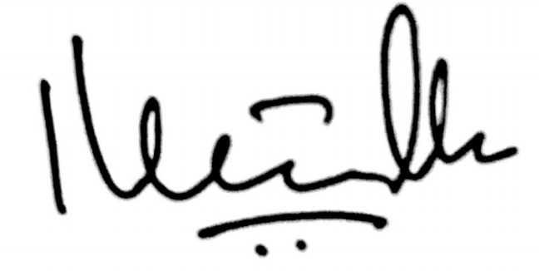

Dipen Maharjan