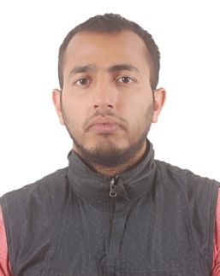 **Surya Prasad Poudyal**

Shantinagar-31,New Baneshwor

Kathmandu

+977- 9849812564

+977- 9803417349

+977- 9880535047

**Education And**

**Credentials:** Gramin Aadarsha Multiple Campus (TU) Kathmandu

**Master’s degree in Rural Development** 2014A.D Graduate

Ratna Rajya Laxmi Campus Kathmandu

**Bachelor’s program in Sociology and** 2009A.D Graduate

**Rural Development**

**Objective:** A challenging position as a teacher requiring a creative, resourceful team player with the proven ability to motivate students and create a stimulating classroom environment conducive to learning.

**Currently Working**

* : Working as a Sales Supervisor at Sarada group Pvt. Ltd (Alco Bev) since 2016.
* .Teaching as a lecturer at Glacier International college, New Baneshwor , Kathmandu.
* Teaching as a Marketing lecturer at CNAS College, Koteshwor, Kathmandu

**Past Experience:**

* Taught in New Ceres English Boarding School, Kathmandu.(2065-2070)
* Taught Sociology in Santwona College, New Baneshwor for 1 years.
* Peer Educator in” RHIYA” Project for 6 months.
* President of “Nawa Durga Redio Shrota Club” for 1 year at Jhapa
* Secretary of Nawa Durga Youth Club(District Level Club) for 1 year, Jhapa
* Owner of Stationary Shop for 4 years.
* Programme co-ordinator at “FAO Nepal” for 1 years.
* Health Worker of Hepatitis-B at Kunta Policlinic, Kathmandu, for 6 months.
* Worked as a market representative in Kantipur Publication for 3 months.

Contd.

**Trainings:**

* Volunteered in Filariasis eradicate Programme, Kathmandu.
* Foundation course of Computer from Presidential Abroad Academy.
* SPSS 21 programme from Om Educational Institute Pvt. Ltd.
* Anchoring Training from National Anchor Association Nepal.

**Skills:**

* Excellent interpersonal communication.
* Fluent in English, Nepali language.
* Leadership Skill
* Inspiring new staff
* Identifying students individualism and establishment of the comfortable, student focused two way communication that empower student to enjoy the learning process.
* Ability to communicate any idea in simple and clear way.

**Certification:**

* Credentialed teacher, Nepal

**References:**

1. **Ramesh Ghimire**

**Cell:9801012521**

Country Manager

Sharada Group ( SPG)

1. **Bishnu Sharma**

**9851080436**

Coordinator

Glacier International College

Shantinagar , Kathmandu