Newsfeed Module:

Steps:

A. Post Creation

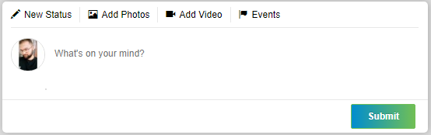

Tabs: NewStatus, Add Photos, Add Video, Events

Event Tab:

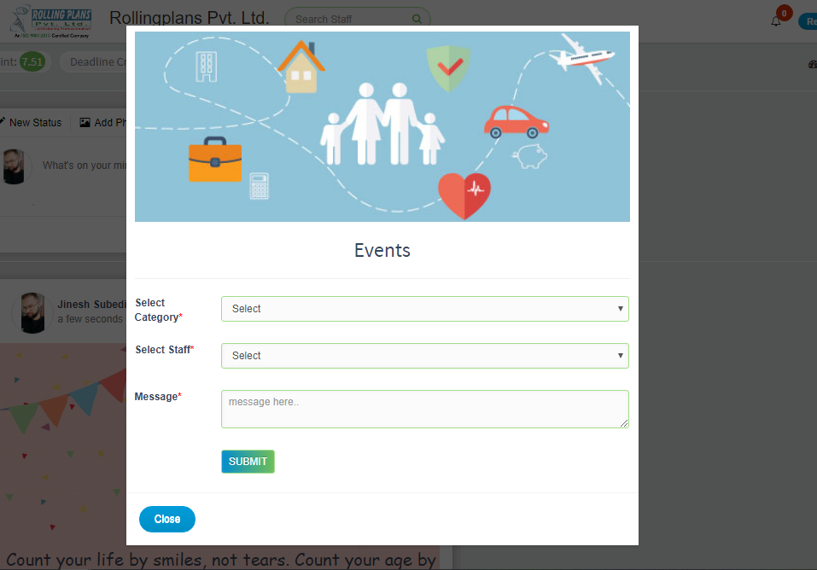

Category -> Birthday, Achievement, Travel, Anniversary

Staff -> current branch all staff

Message -> say anything, wish, quotes, etc.

(all are required)

After submit button post need to be:

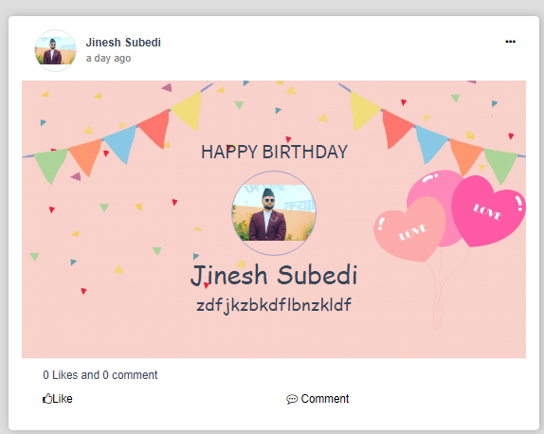

Wish, quote or anything

Staff name to whom you wish or priase

Category type default title

Video Tab:

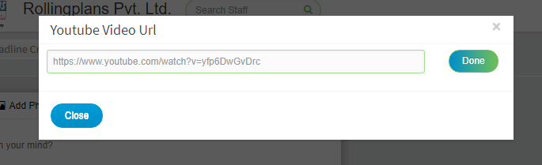

Allow user to input youtube video url.

After Done button clicked

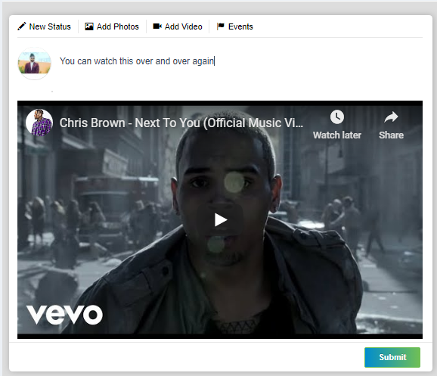

B. Like

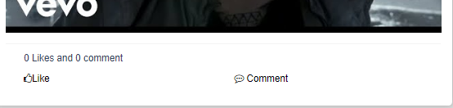

After click on like button, without refresh page it needs to be :

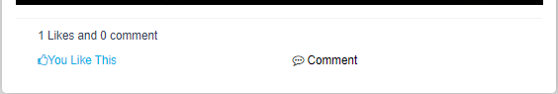

C. Comment

When click in comment ->

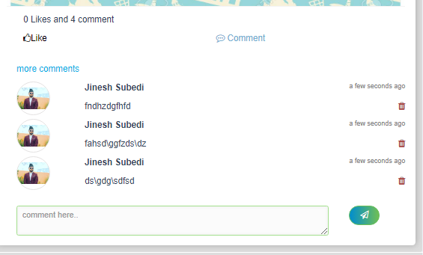

Button to submit comment.

More comment is for displaying more comments

Comment Creator can delete comment.