|  |  |  |  |  |
| --- | --- | --- | --- | --- |
|  |  | Request and Approval | Administrative Work  Travel Process | Expenses Report |
| Travel Request | Employee | Register Travel Request  Accept Travel Request  Approved Request  Send Decline Message  Changes/Edit Required  Yes  No  Approved Request  Travel Planner/Itinerary Submission  Estimate Expenses Details Submission  Review of Planner/itinerary  Review Expenses Details Submission  Register Booking/other Arrangement  Mode of Payment Arrangement  Travel Planner/Itinerary Submission |  |  |
| Supervisor |  | Changes/Edit Required |  |
| HR & Administration |  |  |  |

**Travel Request Form**

From: Employee To: Supervisor

From: Supervisor To: Employee

**Personnel Details**

Employee Name-

Department:-

Designation:-

**Travel Type:**

Tick

**Domestic**

Tick

**International**

**Travel Details**

**Tentative Destination from (Date Box) To (Date Box) Arrival Departure**

**Destination 1**

**Destination 2**

**Destination 3**

***Add Destination Button***

**Assignment of Travel (*Select the Options* )**

**One-day Assignment**

* **Assignment with the Client**
* **Assignment with the employee**
* **Field Assignment**
* **Business Development**
* **Client Meeting**
* **Conference**
* **Training**

**Multiple-day Assignment**

* **Assignment with the Client**
* **Assignment with the employee**
* **Field Assignment**
* **Business Development**
* **Client Meeting**
* **Conference**
* **Training**

**Brief Description of Purpose of Travel**

Description box:-

***Mode of Transport Road: Air:***

Tick

Tick

***Road Sub-Options:***

***Bike or Car***

***Self-Owned Vehicle***

***Company-Owned Vehicle***

Yes/No

Yes/No

***Rental Vehicle***

***Advance Required***

Yes/No

***Payment Mode***

***Tick Options***

1. ***Reimbursement Module***

***Sub-options***

1. ***Pre-paid 70%***
2. ***Post-Paid 30%***
3. ***Per Diem Reimbursement***

***Select your Positions Select your grade Per Diem Amount display***

Account Details (if the reimbursement or advance need to be done on another account)

Account Name:

Account Number:

Bank Name:

Cancel

Final Submit

Review with Edit option

Submit

**Estimation Expenses Details**

***Starting Date Ending Date***

***Destination from Destination To***

***Description Estimated Amount VAT Amount Other Taxes Net Total***

Net Amount

Insert %

Insert %

Insert Amount

1. ***Transportation (Ticket)***

Net Amount

Insert %

Insert %

Insert Amount

1. ***Accommodation (Lodging)***
2. ***Breakfast***

Net Amount

Insert %

Insert %

Insert Amount

Net Amount

1. ***Lunch***

Insert %

Insert %

Insert Amount

1. ***Dinner***

Net Amount

Insert %

Insert %

Insert Amount

1. ***Communication***

Net Amount

Net Amount

Insert %

Insert %

Insert Amount

1. ***Local Conveyance***

Insert %

Insert %

Insert Amount

1. ***Other***

Add Button

Gross Amount

***Total Gross Estimated Cost***

Cancel

Final Submit

Review with Edit option

Submit

***After the Approval of Supervisor & HR, a pop-up section of following line items will be pop-up:-***

***Travel Planner/Itinerary***

|  |  |  |  |  |  |
| --- | --- | --- | --- | --- | --- |
| ***Date*** | ***Travel*** | | ***Time*** | | ***Description*** |
| ***From*** | ***To*** | ***From*** | ***To*** |
|  |  |  |  |  |  |
|  |  |  |  |  |  |
|  |  |  |  |  |  |

***Add Button***

***Booking Details***

1. ***Ticket Booking (Select Options)***

***1.A. By Road-Vehicle Information (Selection Options***

**Self-Owned Vehicle**

Vehicle Number

**Company-Owned Vehicle**

Driver Number

Driver Name

Vehicle Number

**Rental Vehicle**

Vendor Name

Vehicle Number

Driver Number

Driver Name

Bus Number

***Bus***

***1.B..By Air-Flight Information***

Arrival city

Departure on

Flight Number

Airline Name

***Add button***

1. ***Hotel Booking Details***

Departure on

Arrival at

Hotel Number

District

Place Name

Hotel Name

***Add Button***

1. ***Attendance Booking***

***We can refer him/her to Generate Staff attendance page to submit his/her prior attendance during his/her travel.***

Cancel

Final Submit

Review with Edit option

Submit

***Request Travel Dashboard for the employee***

***Same report format for overall process from request to report submission***

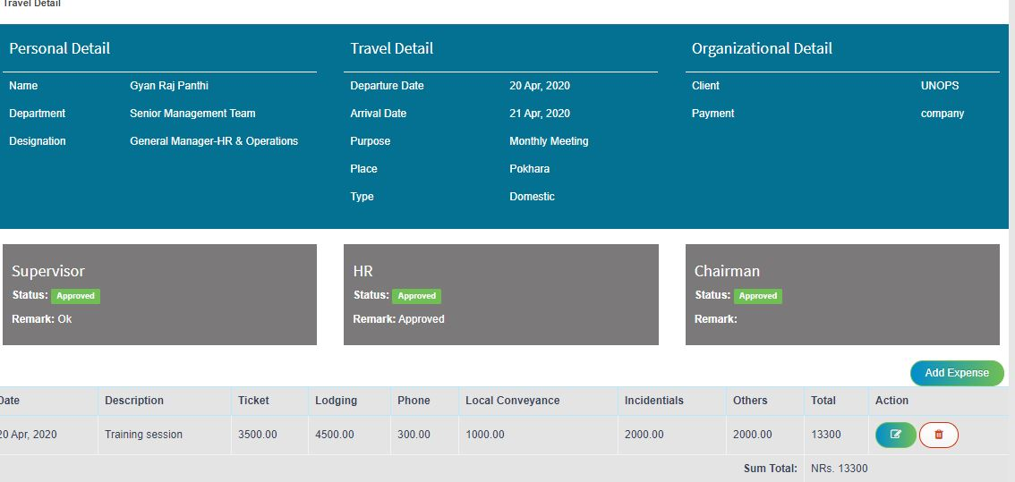

***Travel Request (Summary Dashboard)***

Date to

Date From

Name

***Search/ Sorting options***

***All Request***

|  |  |  |  |  |  |  |  |  |  |  |  |
| --- | --- | --- | --- | --- | --- | --- | --- | --- | --- | --- | --- |
| ***S.N*** | ***Unique travel Request ID or Number*** | ***Staff Name*** | ***Type*** | ***Date From*** | ***Date To*** | ***Assignment Type*** | ***Assignment Purpose*** | ***Supervisor***  ***(Accept/Decline)*** | ***HR***  ***(Accept/Decline)*** | ***Chairman***  ***(Accept/Decline)*** | ***Action***  ***Edit/View/Delete*** |

***Travel Request***

|  |  |  |  |  |  |  |  |  |  |  |
| --- | --- | --- | --- | --- | --- | --- | --- | --- | --- | --- |
| ***S.N*** | ***Unique travel Request ID or Number*** | ***Type*** | ***Date From*** | ***Date To*** | ***Assignment Type*** | ***Assignment Purpose*** | ***Supervisor***  ***(Accept/Decline)*** | ***HR***  ***(Accept/Decline)*** | ***Chairman***  ***(Accept/Decline)*** | ***Action***  ***Edit/View/Delete*** |

***Waiting Approval***

|  |  |  |  |  |  |  |  |  |  |
| --- | --- | --- | --- | --- | --- | --- | --- | --- | --- |
| ***S.N*** | ***Unique travel Request ID or Number*** | ***Staff Name*** | ***Type*** | ***Date From*** | ***Date To*** | ***Assignment Type*** | ***Assignment Purpose*** | ***HR***  ***(Accept/Decline)*** | ***Remark*** |

***Expenses Report Submission***

***Reminder Message through Pop-up & Email to the respective employee stating his/her pending travel expenses report.***

***Reminder Type: Daily basis after log-in (Pop-Up display on RA)***

***Reminder Message:***

***Dear Mr. /Ms. ………………..***

***Kindly request you to submit your final travel expenses details of Travel ID number Travel/RPPL/2020/01 by 25th April, 2020 attaching all the necessary documents. After your report submission, the process might take 7-10 working days for the final settlement.***

***Note: Your final settle amount will be deposited in your company account number.***

***Thank you,***

***Administration Department***

***RPPL***

***Expenses Details***

***Starting Date Ending Date***

***Destination from Destination To***

|  |  |  |  |  |  |  |  |
| --- | --- | --- | --- | --- | --- | --- | --- |
| ***S.N*** | ***Description*** | ***Bill No*** | ***Estimated Net Amount*** | ***Actual Expenses with VAT & Other Taxes*** | ***Difference in Amount*** | ***Remark*** | ***Attach file option for each items*** |
| ***1.*** | ***Transportation (Ticket)*** |  |  |  |  |  |  |
| ***2.*** | ***Accommodation (Lodging)*** |  |  |  |  |  |  |
|  | ***Lunch*** |  |  |  |  |  |  |
|  | ***Dinner*** |  |  |  |  |  |  |
|  | ***Communication*** |  |  |  |  |  |  |
|  | ***Other*** |  |  |  |  |  |  |

***Add option***

Cancel

Final Submit

Review with Edit option

Submit

***Settlement Status***

***Red-Pending Status***

***Yellow- On process***

***Green- Approved***