**INFORMATION ARCHITECTURE (PART A)**

#### A1 - Functionality & Microinteraction Needs

**Stakeholder Needs:**

* Pet Paradigm stakeholders need a website that:
* Simplifies navigation
* Offers essential pet care advice
* Enables users to contact the company for consultations
* Enhances brand recognition

**Audience Needs:**

* Users require:
* An easy-to-navigate site
* Straightforward content in plain language
* Content optimized for different device screen sizes

**Proposed micro-interactions:**

* Include visual and audio feedback on the navigation bar when hovering and clicking
* Provide text descriptions (alt text) for all images and buttons
* Enhance usability with the following interactions:
* Add a contact form with animation/feedback on submission success or failure
* Underline all links/hyperlinks
* Display company contact details (phone/email) at the top and bottom of each page
* Add social media sharing buttons and content download options

#### A2 - New Content

**Persona:** Fish Owners: Interested in freshwater and saltwater maintenance, often using handheld devices.

**New Content Description:**

* Detailed care and maintenance information for freshwater and saltwater fish
* Emphasis on using water tester kits and outlining chemical safety levels
* Guidance available via a "Pexpert" (pet expert) consultation
* Features:
  + "Fish" link in the navigation bar (1-2 clicks access)
  + Contact form under "Schedule an Appointment" for fish-specific consultations
  + Responsive design for mobile ease

#### A3 - Redevelop or Removal Existing Content

#### 1. Revamping the Homepage with Company Overview

#### Issue: Homepage lacks clear description of company and services

#### Solution: Add company description and summary of available information

#### 2. Responsiveness Redevelopment

#### Issue: Poor mobile adaptation

#### Solution: Implement full responsiveness across devices with advanced CSS and reorganized layout

#### 3. Navigation Bar Redesign & Bug Fixes

#### Issue: Broken links and incorrect tab highlights

#### Solution: Fix links, correct highlights, and reorganize navigation structure

#### 4. Adding "Top Pet Care Tips" Section

#### Issue: Dense content making key information hard to find

#### Solution: Add a "Top Pet Care Tips" section on each pet-specific page

#### 5. Adding a Footer and Useful Links

#### Issue: Lack of footer with essential links

#### Solution: Add footer with About Us, Contact, Privacy Policy, and Social Media links

#### A4 - Visual Sitemap

#### Section A5 - Stakeholder and Audience Needs

#### Stakeholder Needs:

#### Easy navigation

#### Content comprehension

#### Direct contact tool (form)

#### Improved brand recognition and SEO

#### Audience Needs:

#### Grouped and clear navigation

#### Content edited for clarity (based on US NARA guidelines)

#### Key recommendations summarized at the top of pages

#### Responsive design supporting all screen sizes

#### Clear hierarchy with important information easily accessible

#### Section A6 - Navigational Elements

**Primary Navigation Elements:**

* Navigation Bar (Home, About Us, Schedule an Appointment, Pet Information)
* Footer with quick access links
* Logo linking to Homepage

**Secondary Navigation:**

* Dropdown menu under "Pet Information"
* "Schedule an Appointment" form link
* "Top Pet Care Tips" list at top of pet pages

**Positional Awareness Strategies:**

* Color-highlighted current page in navigation
* Headings on pet information pages
* Page titles and subheadings for structure

**Navigational Elements: Meeting Stakeholder Needs:**

* Consistent navigation and branding across site
* Easy access to contact information

**Navigational Elements: Meeting Audience Needs:**

* Quick access to main pages
* Visual cues for navigation clarity
* Enhanced content comprehension and access

**PART B**

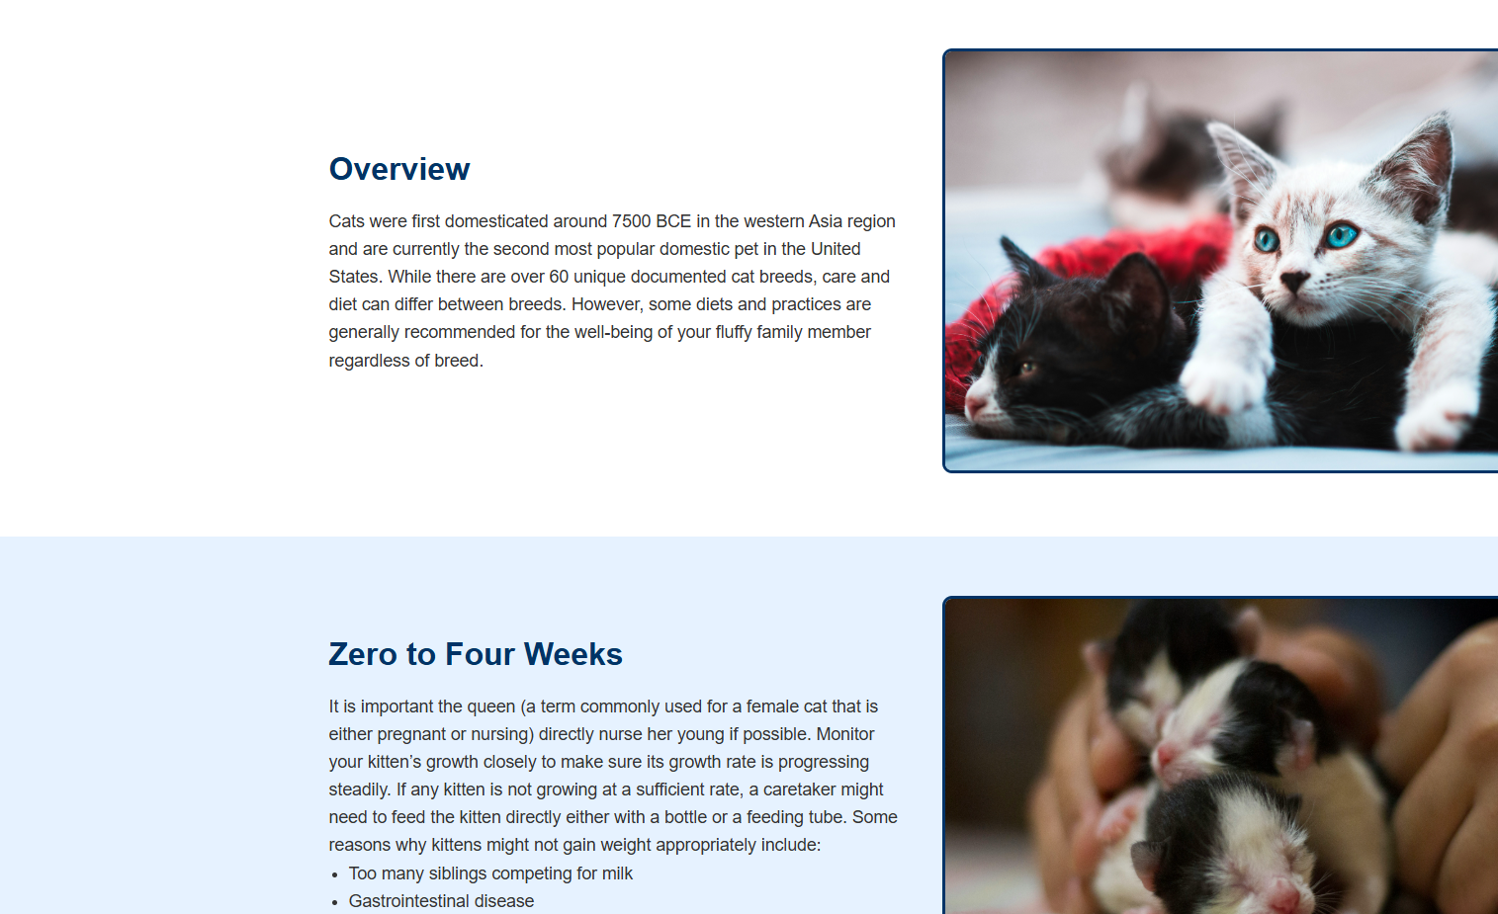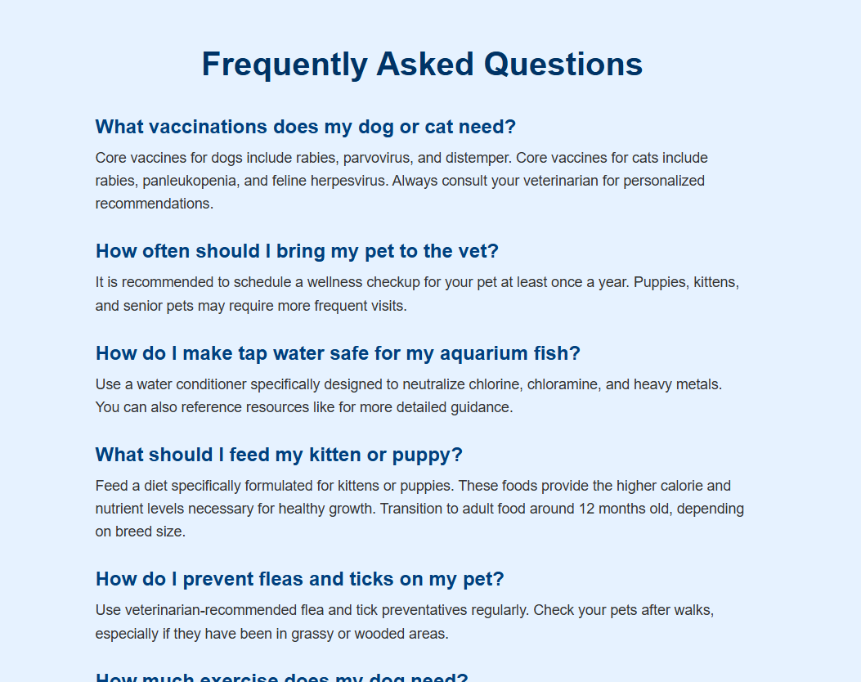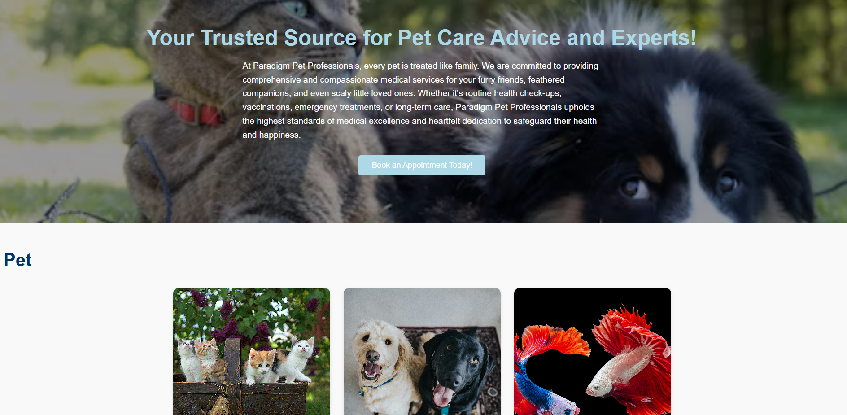

**Citations**

Apple Inc. (n.d.). Human interface guidelines. Apple Developer. Retrieved April 28, 2025, from https://developer.apple.com/design/human-interface-guidelines/

Elcock, A. (2018, September 13). 6 reasons why you should be prototyping more. Medium. Retrieved April 28, 2025, from https://medium.com/ux-prototyping/6-reasons-why-you-should-be-prototyping-more-6b7b2b15da77

Interaction Design Foundation. (n.d.). Wireframing. Interaction Design Foundation. Retrieved April 28, 2025, from https://www.interaction-design.org/literature/topics/wireframe

U.S. National Archives and Records Administration. (n.d.). Plain language: Improving communication from the federal government to the public. National Archives. Retrieved April 28, 2025, from https://www.archives.gov/open/plain-writing/

Unsplash. (n.d.). Beautiful free images and pictures. Unsplash. Retrieved April 28, 2025, from https://unsplash.com

Western Governors University. (n.d.). User interface design and development: Course material.

Google. (n.d.). Material design 3. Material Design. Retrieved April 28, 2025, from https://m3.material.io/