3.13 What is inheritance in object-oriented technology? Give an example.
Is-a relation is a relationship of inheritance. Inheritance is a relation between two classes: one called base class or superclass that defines the base type and the other called derived class or subclass that defines the derived type. The base class defines class members that are shared among all derived classes, while derived classes contain members that are specific to that particular class.
e.g. in the following example, cat is derived class, and animal is super class. cat has members of animal.

class animal
{
private:
std::String name;
int size;
};

class cat: public animal
{
public:
behavior(String condition);
};

3.14 What is the difference between an object and a class in OO technology?
software objects that share the select properties with their counterparts in the real world, so Objects in software represent the objects of the real world.
Classes are modules of the source code that define the properties of several objects.

3.15 Describe the role of polymorphism in object-oriented technology. Give an example.
Polymorphism is a construct of object-oriented technology that allows the use of a derived type in the place of the base type.

class robot
{
public:
virtual void sayName(){}
};

class Walle: public robot
{
public:
void makeSound() {std::cout<<”Wall-E”;}
};

class Eve: public robot
{
public:
void makeSound() {std::cout<<”Eve”;}
};

4.1 Draw a class diagram of a small banking system showing the associations between three classes: the bank, customer, and the account.

see SE_4_1.png
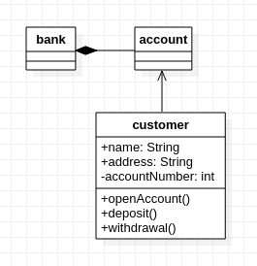
4.2 Draw a class diagram of a library lending books using the following classes: Librarian, Lending Session, Overdue Fine, Book Inventory, Book, Library, Checkout System, and Library Card.

see SE_4_2.png

Class library: class contain all other classes in library. It represent library as an object.

Class librarian: class contain information of librarian.

Class bookinventory: class contain list of all books and their location in library and also have functions to find certain books.

Class book: each class contain information of a book, including renting status, name, location and etc.

Class lendingsession: class represents reallife lending session as object, which contain information of all interfaces with customers.

Class checkoutsystem: checkoutsystem contain all payment functions and status of customers.

Class librarycard: the class represent librarycard as object in reallife. It contains all information of one customer the library need.

Class overduefine: It is the class record all overdue records of customers.
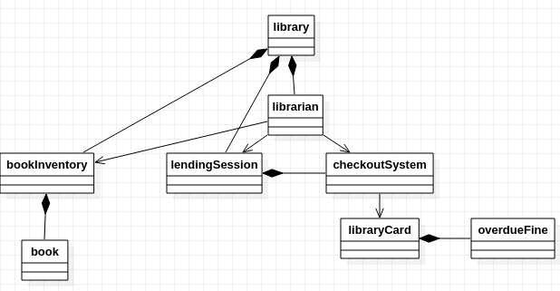

4.3 Draw an activity diagram of pumping gas and paying by credit card at the pump. Include at least five activities, such as “Select fuel grade” and at least two decisions, such as “Get receipt?”

See SE_4_2.jpg

4.5 Explain how a class dependency graph differs from a UML class diagram.
UML diagram has dependencies, aggregation, composition and associations relationships.
class dependency graph just has dependencies relationship

