Navigation of Mobile Robot
Jing Liang

Abstraction:
The project built a collision avoidance system using Q-learning for mobile robot especially Turtlebot. Open AI and Gym packages are used to provide interfaces among ROS (Robot Operating System), Gazebo simulator and Q-learning python scripts. The result of the project is making turtlebot navigate itself forward and at mean time avoid obstacles.

Introduction:
The collision avoidance is always a fundamental and big problem in motion planning area. There are many methods for the problem. With the computational ability of computers improving, reinforcement learning is becoming more and more popular in recent years, especially in auto driving area.
Reinforcement learning is one of control method. It is well used in sophisticated situation and hard-to-engineer behaviors. In reinforcement learning, agent is learning by interacting with environment to collect most reward. The categories of reinforcement learning includes Value based RL, policy based RL, and Actor Critic RL. In this project a model-free reinforcement algorihtm, Q-learning, is used.
Open AI gym is a useful tookit for reinforcemnet learning research. It provides a convenient interface among ROS, Gazebo and algorithms. The package separate the reinforcement learning system into several blocks inlcuding environment, robot and also reinforcement learning algorithm. The open ai gym package is used in the project, it cooperates with ROS to navigate turtlebot in Gazebo simulator.

Architecture:
As figure 1 shows, the project consists of three main software blocks: openai, ROS and Gazebo. Openai developed an environment, which interact with ROS system. The ROS system also communicate with Gazebo to get the simulation information.
OpenAI developed an environment and provides interface with algorithm. The openai package also in charge of communication with ROS system, which could generate simulation data to certain format used by algorihtm and also provide instructions which ROS system could use.
The ROS system is platform for communication of different terminals. In the project, it communicates with Gazebo simulator to track simulation result and also provide instructions to simulator, it also communicate with openai package to get reinforcement learning algorithm done.
The Gazebo simulator create a stable simulating environment for the project. In the project, there is a world file setting a maze, and there is also a turtlebot which has a hokuyo lidar on top. The simulator would simulate the movement of turtlebot and also provide relative environment information to ROS system.
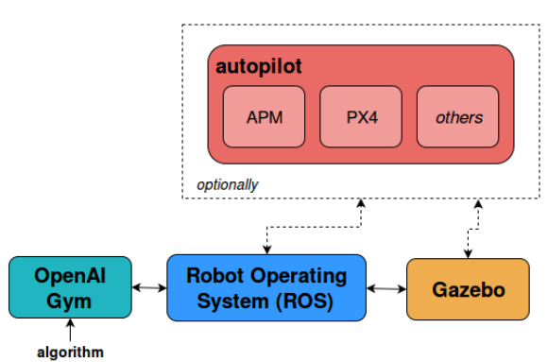
Figure 1 Architecture of the system
Q-Learning:
Q-learning in the project is a value-based reinforcement learning algorithm, and since it is also model-free algorithm, it could be used for different robots. Q-learning is used to generate optimal actions regarding to different state inputs.
Q-learning will update the value in each episode using the following function:
Q(st,at) is the Q value of current state which composed of current observation and action taken. Alpha is learning rate which decides in what rate the system is learning. R is the reward which generated by environment according to different policy. Q(st+1,at) is the value of next state, which makes the Q-learning consider future effect of each action.
There are several methods to map states to Q values. For complex environment or large number of states, neural networks is recommended, and for small number of state Q-table also works.
In the project, Q-table is used since the environment is simple and number of states is small.

Simulation:
Figure2 is the environment generated by Gazebo simulator. The environment is generated deliberately as a maze and the robot used in the project is turtlebot2, which has hokuyo lidar on top.

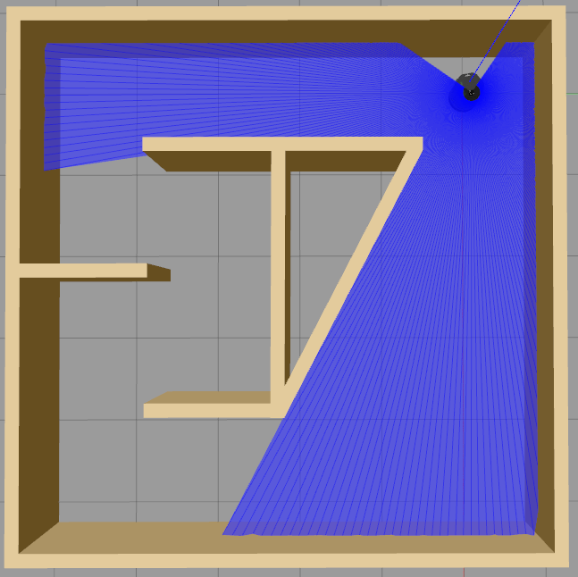
Figure 2. Simulation Environment

