The goal of risk analysis is not to minimize risk but to weigh risk against return properly.

Types of multi-factor model:

* Macroeconomic (observable economic variables, such as inflation and interest rates)
* Fundamental (observed security attributes such as dividend, industry membership)
* Statistical (derived from factor analysis of the covariance matrix of security returns)

Barra equity model are fundamental factor models, which outperform the others in terms of explanatory power.

1. Asset exposure to factors are specified or calculated
2. A cross sectional regression is performed to determine the returns to each factor over the relevant time period

**Exposures**: by observing patterns over time, common factors can be identified and exposures to these factors can be determined. These factors are based on market and fundamental data. The model’s profile of a security responds immediately to any change in the company’s structure or the market’s behaviour. Barra updates the security exposures of most fixed-income models on a daily basis and the security exposures of most equity models on a monthly basis, using the last trading day’s information to compute exposures for the coming month.

**Factor returns:** factor returns are pure measures of the factor’s actual performance net of any other effects. Since factor returns are nit readily observable, they must be estimated. Recall that asset exposures are computed at the end of each month. Using multiple-factor model framework and the observed asset returns over the next month, we can estimate factor returns over the month. This is done with a cross-sectional regression of asset returns over the month on the exposures of the assets to the factors.

For multiple-asset portfolio:

Estimating var-cov matrix of 1400 assets entails 980700 covariances and variances. A multiple factor model simplifies these calculations dramatically. This results from replacing individual asset profiles with categories defined by common characteristics (factors). For example, in the multiple horizon U.S. equity model, 68 factors capture the risk characteristics of equities. This reduces the number of covariance and variance calculations to 2346. Moreover, determining fewer parameters results in a smaller chance of finding spurious relationships.

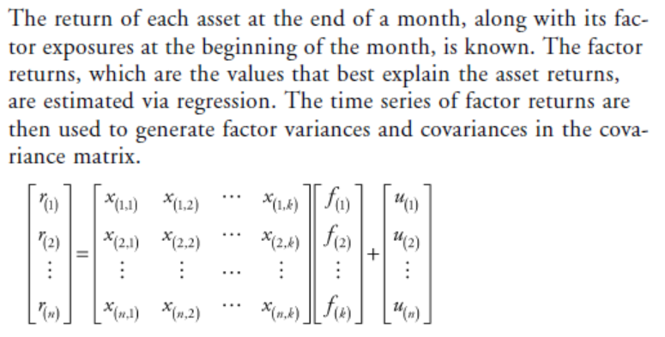

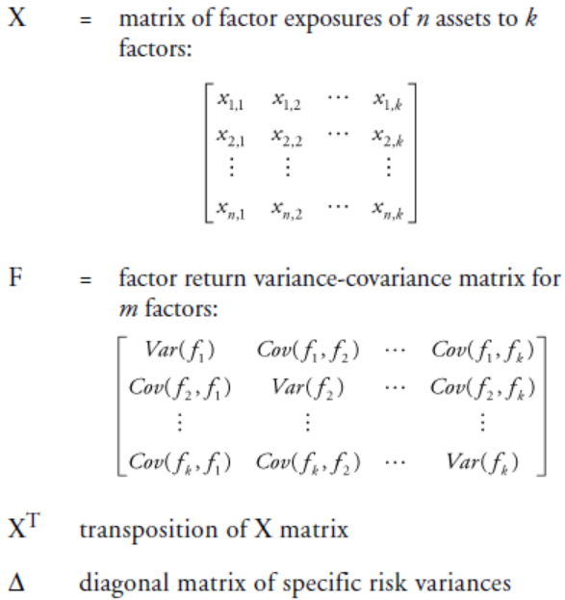

Final Risk Calculation: the covariance matrix is used in conjunction with a portfolio’s weight in each asset and the factor exposure of those assets to calculate portfolio risk.

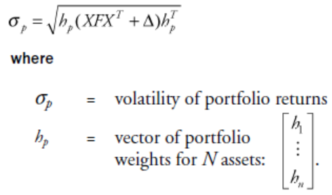

­**CAPM:**

**Historical beta and Predicted beta:**

**Historical beta** is calculated after the fact by running a regression (often over 60 months) on a stock’s excess returns against the market’s excess returns. There are two important problems with this simple historical approach:

* It does not recognize fundamental changes in the company’s operations. When the company’s risk characteristics changed significantly, historical beta would recognize this change only slowly, over time.
* It is influenced by events specific to the company that are unlikely to be repeated.

**Predicted beta** is derived from its risk model, is a forecast of a stock’s sensitivity to the market. It is derived from fundamental risk factors. In Barra model, these risk factors include attributes such as size, yield and volatility. Since they are re-estimated monthly, predicted beta reflects changes in the company’s underlying risk structure in a timely manner. Barra application uses predicted beta rather than historical beta as it is a better forecast of market sensitivity of an asset in a portfolio.

**Arbitrage Pricing Theory (APT)** asserts that security and portfolio expected returns are linearly related to the expected returns of an unknown number of systematic factors. The focus of APT is on forecasting returns.

In the mid-1970s, Barr Rosenberg pioneered a new class of risk models based on the idea that assets with similar characteristics should display similar returns. Multiple-factor models assert that many influences act on the volatility of an asset, and these influences are often common across many assets.

**Barra’s Equity Multi-factor Model**

It decompose asset returns into components due to common factors and a specific/idiosyncratic factor. The models capture the various components of risk and provide a multifaceted, quantitative measure of risk exposure. Together with specific risk, market membership, industries, and risk indices provide a comprehensive partition of risk.

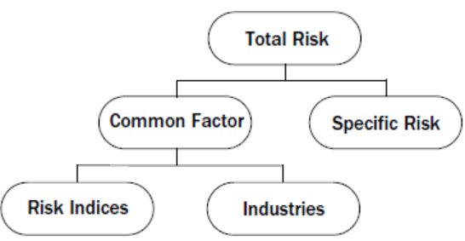

1. **Common Factors:**

Stocks with similar characteristics exhibit similar return behaviour. These shared characteristics, or common factors, are excellent predictors of future risk.

1. **Risk Indices**

Barra combines fundamental and market data to create risk indices that measure risk associated with common features of an asset. Common dimensions of style such as growth/value and smallcap/largecap can be described using risk indices. Each Barra equity risk model has a predefined set of risk indices.

1. **Industries**

An industry is a homogeneous collection of business endeavours. Each Barra equity risk model has a predefined set of industries and sector appropriate to its environment. Each security is classified into an appropriate industry as defined by its operations, although a number of models support multiple-industry classification for large conglomerates.

1. **Specific Risk**

Specific risk forecasting is a three-part process. We first estimate the average specific risk of all assets covered in a model, then the specific risk of each asset relative to the universe of assets. Finally, we combine the average and relative components and scale the product to adjust for average bias. The result is a specific risk forecast for each asset that is generally unbiased.

**Model Estimation Overview**

1. Acquire and clean data. Both market information and fundamental data are used. (Specific attention is paid to capital restructurings and other atypical events to provide for consistent cross-period comparisons)
2. Descriptors which best capture the risk characteristics of assets are selected. To determine which descriptors partition risk in the most effective and efficient way, the descriptors are tested for statistical significance. Useful descriptors often significantly explain cross-sectional returns.
3. Risk index formulation and assignment to securities involves collecting descriptors into their most meaningful combinations. A variety of techniques are used to evaluate different possibilities. (E.g. cluster analysis)
4. Along with risk index exposures, industry allocations are determined for each security. In most Barra models, a single industry exposure is assigned, but multiple exposures for conglomerates are calculated in a few models, including the U.S. and Japan models.
5. Next, through cross sectional regressions, we calculate factor returns to estimate covariances between factors, generating the covariance matrix used forecast risk. The factor covariances are computed for most models by exponentially weighting historical observations. This method places more weight on recent observations and allows the model to capture changes in risk in a timely fashion. We may further modify the matrix with either generalized auto-regressive conditional heteroskedasticity (GARCH) techniques or daily exponentially weighted index volatility (DEWIV) methods to make it more responsive to changing market conditions.
6. Specific returns are separated out at this stage of return estimation and specific risk is forecast. This is the portion of total risk that is related solely to a particular stock and cannot be accounted for by common factors. The greater an asset’s specific risk, the larger the proportion of return variation attributable to idiosyncratic, rather than common factors.
7. Lastly, the model undergoes final testing and updating. Risk forecasts are tested against alternative models. Tests compare ex ante forecast with ex post realizations of beta, specific risk, and active risk. New information from company fundamental reports and market data is incorporated, and the covariance matrix is recalculated. ­­

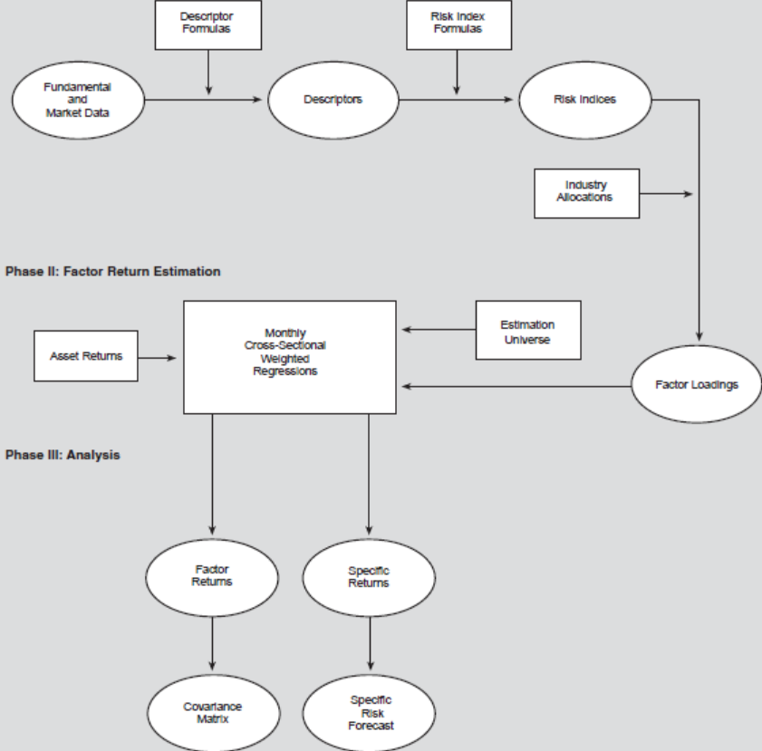

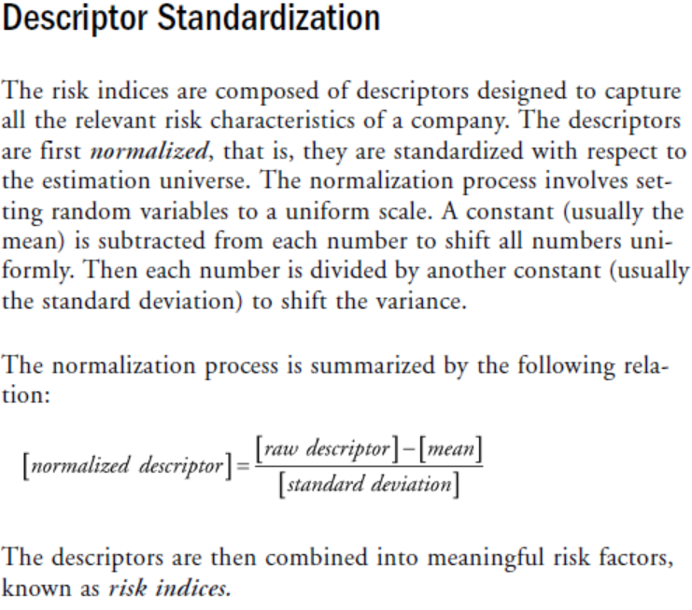

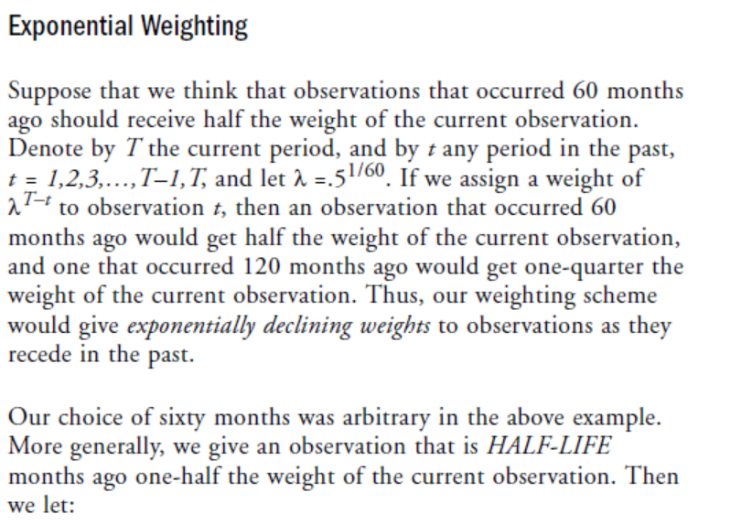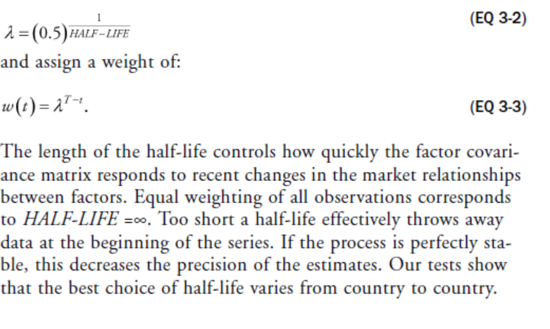

Hence, we use different values of half-life for different single-country models.

**DEWIV**

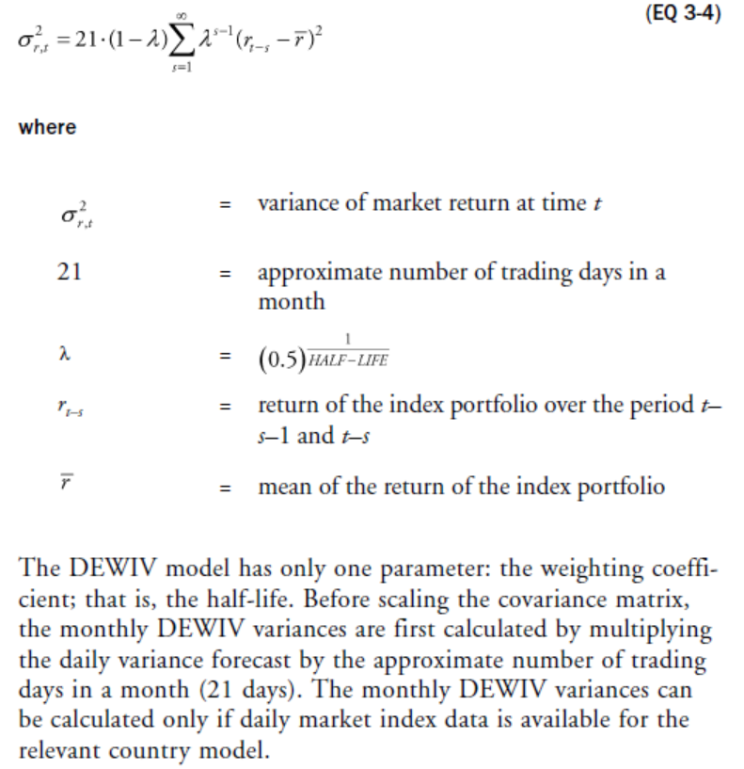

**GARCH**

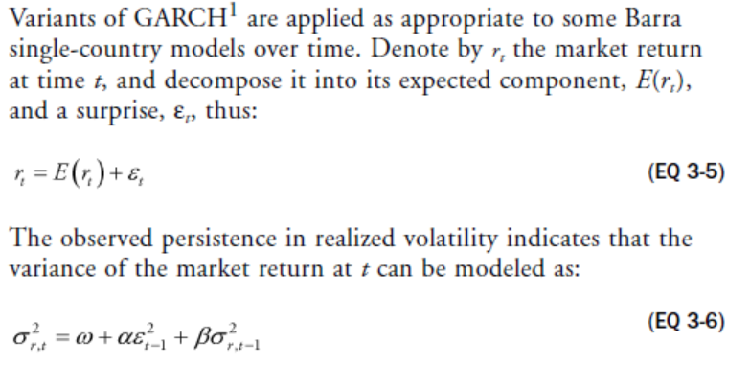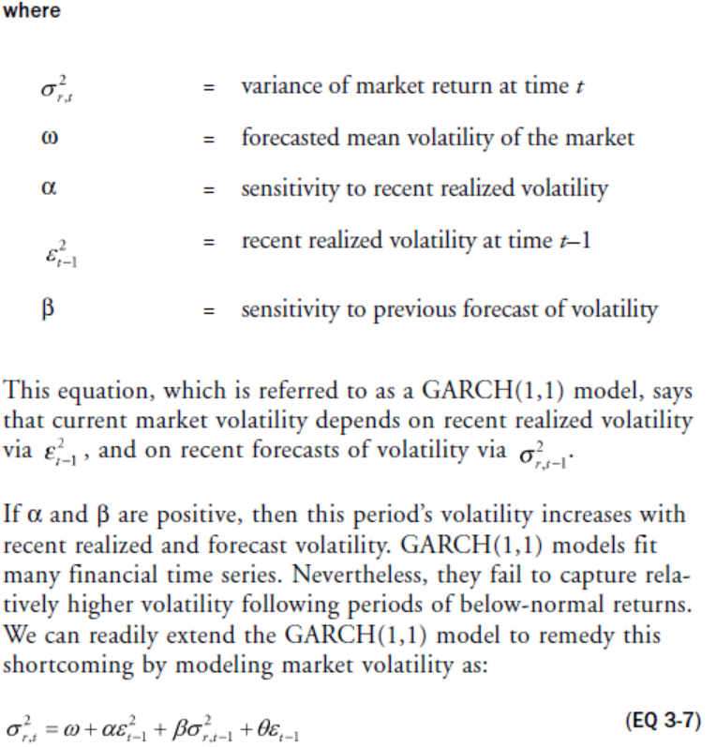

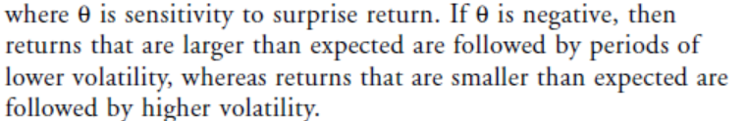

**Scaling**

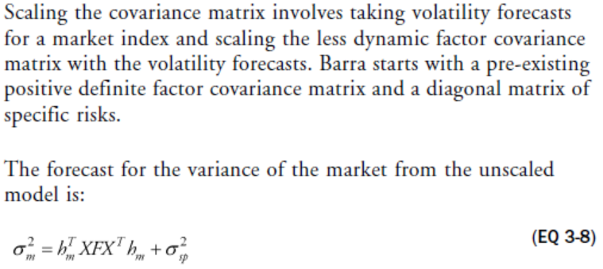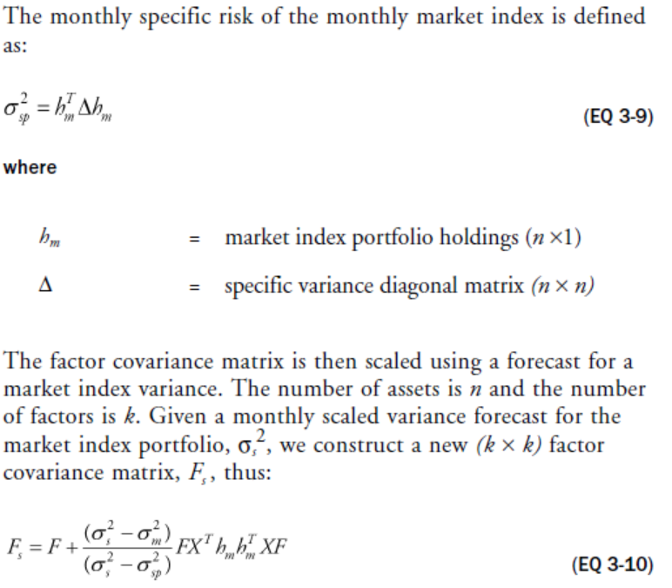

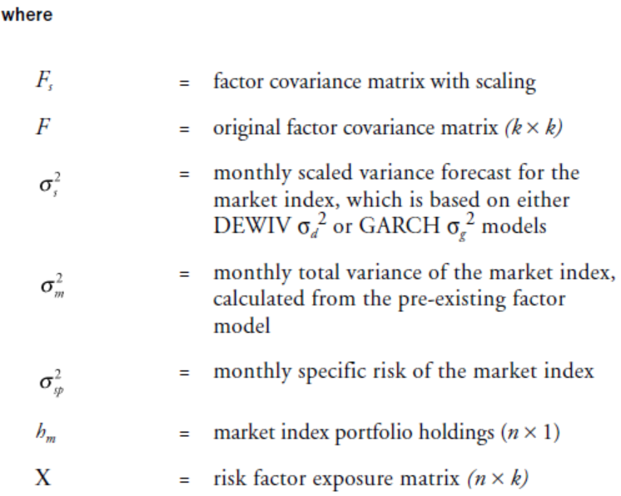

**Specific Risk Modelling**

