Usage of hate2wait
Terminology
Locations: the place user want to go, like swimming pool, restaurant, school, hospital, DMV...
Seats: each location has many seats, and each seat belongs to a specific location, the maximum number of seats in a location is the capacity of the location.
Users: registered user can book a seat in the locations.

I used Rubymine to do this project, sometimes I also use Textmate.

1. to see locations:
http://localhost:3000/locations or http://hate2wait.herokuapp.com/locations

2. to see seats
http://localhost:3000/seats or http://hate2wait.herokuapp.com/seats

3. to see users
http://localhost:3000/users or http://hate2wait.herokuapp.com/users

4. to see the connection between the location and the seat
a. in locations page, click the 'show', then in this page you book a seat with a name, then you can see the name appeared in the location page.
b. in seats page, you create a new seat with a name and a location id, then in that location page, you can see the seat you just created.

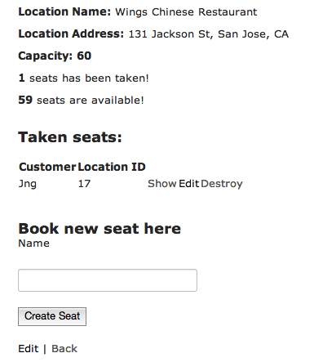

5. to see AJAX
Open 2 location show page, in one page you book a seat, after 5 seconds, you can see the seat list updated automatically in another location show page. PS: the 2 location pages belong to the same location.

6. to see RESTFUL API
On the home page, upright corner, click REST, you will see the data from outside website in the format: xml, jason and hash. (it may take several seconds)

7. about the test
I have written all the model test, static page tests, routing test and view test, they are all passed.

