Basic Installation
first, we need cygwin
http://www.cygwin.com/install.html
the installation process is pretty standard, just click next, the only thing you need change is
add the wget and mercurial package as shown in the following two figure
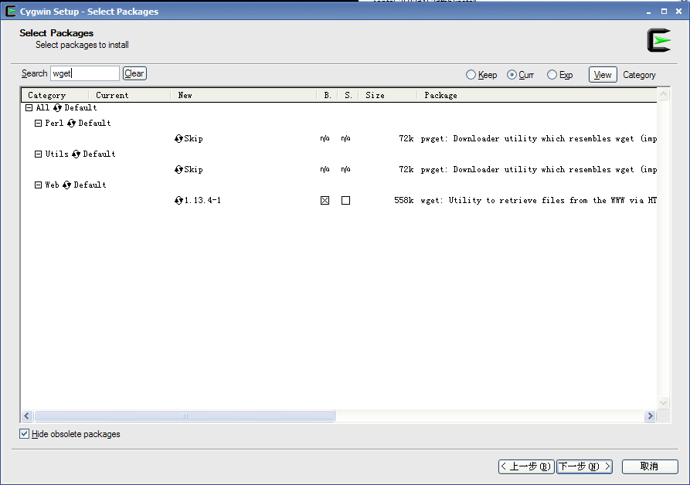
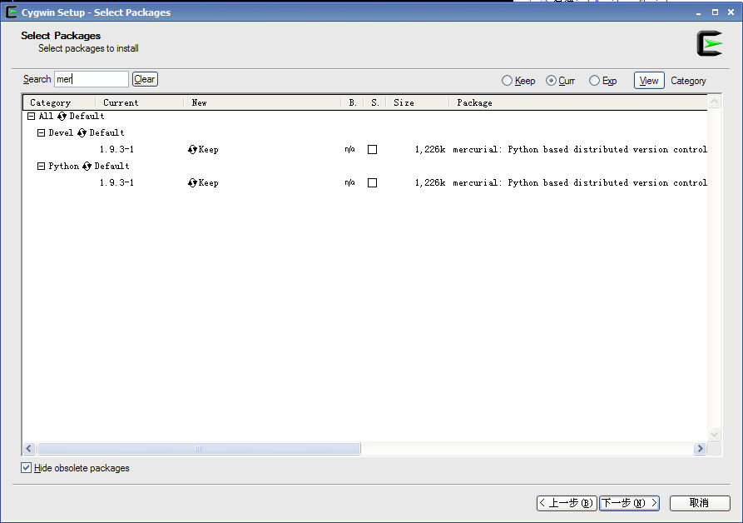

after click and open the cygwin command line window
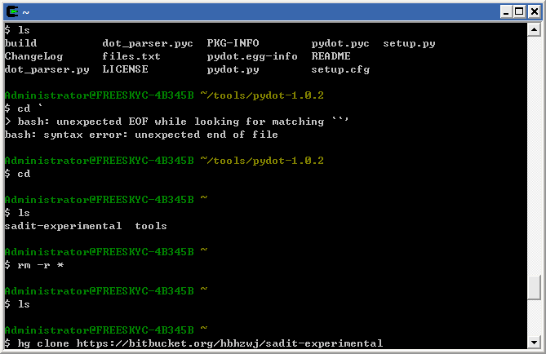

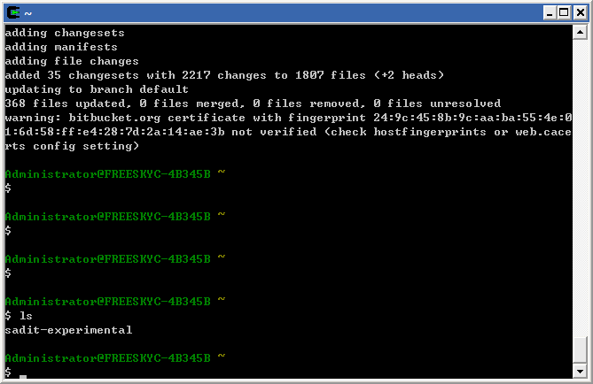

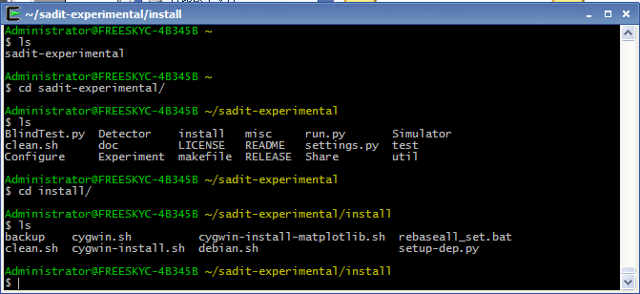
Then you are all set for basic installation. You can run the software by type
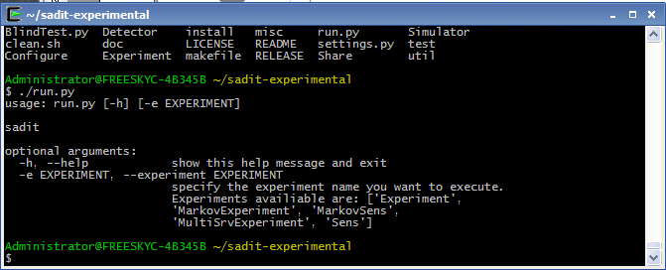

Basic installation is okay for most cases, but if you want get figures. You need install matplotlib.

Installation of Graphics
You need close all cygwin window
Then open a windows command line(not cygwin command line), navigate to \cygwin\bin
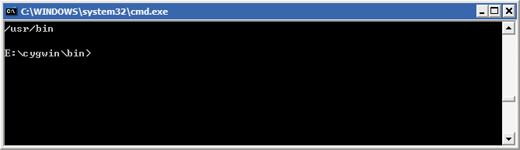
Type
>dash
You will enter dash command line
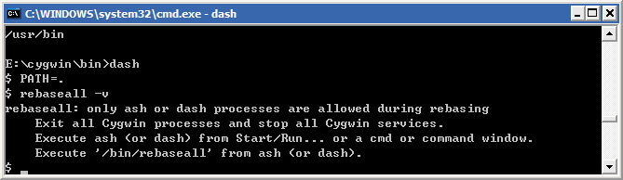
Type the command as in the previous figure, if there is any open cygwin window, the result will be like in the figure
If everything is okay, you will see splash screen
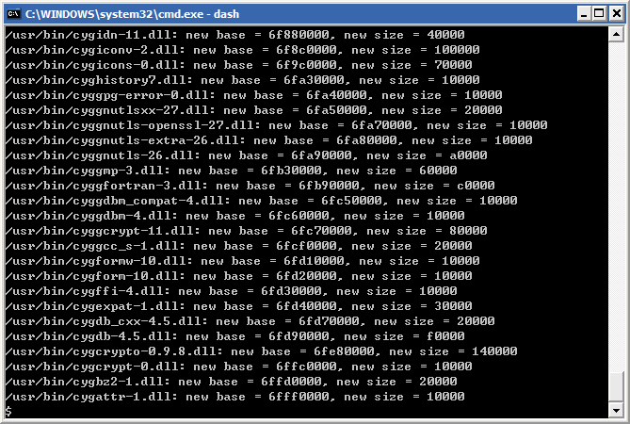

Just run the
$./cygwin-install-matplotlib.sh

A window x command line will pop out. You can run run.py in this window
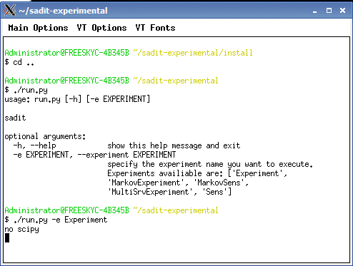
Finally you will get result like this
