Joseph Ingenito

5/10/19

Project

Part I

1)

(a)







(b)



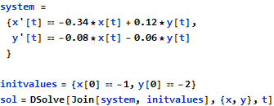



(c)



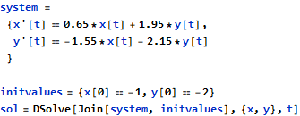

{{x -> Function[{t}, (-1. +

0. i) e^(-0.75 t) ((1. + 0. i) Cos[

1.03078 t] + (5.14176 + 3.1486*10^-17 i) Sin[1.03078 t])],

y -> Function[{t}, -2. e^(-0.75 t) (1. Cos[

1.03078 t] - (2.11006 + 5.50981*10^-17 i) Sin[1.03078 t])]}}

I couldn’t preserve Mathematica’s Formatting for this solution because the output is too long.

2)

For each system I made functions that also return the true solution found on Mathematica so making and editing the plots can be done easily.

(a)

function [t,x,y] = EulSystem_1(h, t0, x0, y0, tf)

k = 1;

t(k) = t0;

x(k) = x0;

y(k) = y0;

while((t(k) + h <= tf + 10^-10))

t(k+1) = t(k) + h;

x(k+1) = x(k) + h*(-0.5*x(k) + 0.6*y(k));

y(k+1) = y(k) + h*(-0.4*x(k) + 0.9*y(k));

k = k + 1;

end

end

function [t,x,y] = TrueSolution_1()

t = 0:0.1:4;

x = -exp(0.7.*t);

y = -2.*exp(0.7.*t);

end

(b)

function [t,x,y] = EulSystem_2(h, t0, x0, y0, tf)

k = 1;

t(k) = t0;

x(k) = x0;

y(k) = y0;

while((t(k) + h <= tf + 10^-10))

t(k+1) = t(k) + h;

x(k+1) = x(k) + h*(-0.34*x(k) + 0.12*y(k));

y(k+1) = y(k) + h*(-0.08*x(k) - 0.06*y(k));

k = k + 1;

end

end

function [t,x,y] = TrueSolution_2()

t = 0:0.1:4;

x = -exp(-0.1.*t);

y = -2.*exp(-0.1.*t);

end

(c)

function [t,x,y] = EulSystem_3(h, t0, x0, y0, tf)

k = 1;

t(k) = t0;

x(k) = x0;

y(k) = y0;

while((t(k) + h <= tf + 10^-10))

t(k+1) = t(k) + h;

x(k+1) = x(k) + h*(0.65*x(k) + 1.95*y(k));

y(k+1) = y(k) + h*(-1.55*x(k) - 2.15*y(k));

k = k + 1;

end

end

function [t,x,y] = TrueSolution_3()

t = 0:0.1:4;

x = -exp(-0.75.*t).*(cos(1.03078.*t) + 5.14176.*sin(1.03078.*t));

y = -2.*exp(-0.75.*t).*(cos(1.03078.*t)-2.11006.*sin(1.03078.*t));

end

3)

function CreateSubplots(t1,x1,y1,t2,x2,y2,tvec,xvec,yvec)

ax1 = subplot(4,2,1);

ax2 = subplot(4,2,2);

ax34 = subplot(4,2,[3,4]);

ax5 = subplot(4,2,5);

ax6 = subplot(4,2,6);

ax78 = subplot(4,2,[7,8]);

plot(ax1,t1,x1,"blue",tvec,xvec,"black")

title(ax1,"x(t) vs t with h=0.25")

xlabel(ax1,"t Axis")

ylabel(ax1,"x(t) Axis")

plot(ax2,t1,y1,"blue",tvec,yvec,"black")

title(ax2,"y(t) vs t with h=0.25")

xlabel(ax2,"t Axis")

ylabel(ax2,"y(t) Axis")

plot(ax34,x1,y1,"blue",xvec,yvec,"black")

title(ax34,"y(t) vs x(t) with h=0.25")

xlabel(ax34,"x(t) Axis")

ylabel(ax34,"y(t) Axis")

plot(ax5,t2,x2,"blue",tvec,xvec,"black")

title(ax5,"x(t) vs t with h=0.1")

xlabel(ax5,"t Axis")

ylabel(ax5,"x(t) Axis")

plot(ax6,t2,y2,"blue",tvec,yvec,"black")

title(ax6,"y(t) vs t with h=0.1")

xlabel(ax6,"t Axis")

ylabel(ax6,"y(t) Axis")

plot(ax78,x2,y2,"blue",xvec,yvec,"black")

title(ax78,"y(t) vs x(t) with h=0.1")

xlabel(ax78,"x(t) Axis")

ylabel(ax78,"y(t) Axis")

end

(a)

>> [t1,x1,y1] = EulSystem_1(0.25,0,-1,-2,4);

>> [t2,x2,y2] = EulSystem_1(0.1,0,-1,-2,4);

>> [tvec,xvec,yvec] = TrueSolution_1();

>> CreateSubplots(t1,x1,y1,t2,x2,y2,tvec,xvec,yvec);



Figure 1: Plots of the solutions to the first system with step sizes 0.25, and 0.1

(b)

>> [t1,x1,y1] = EulSystem_2(0.25,0,-1,-2,4);

>> [t2,x2,y2] = EulSystem_2(0.1,0,-1,-2,4);

>> [tvec,xvec,yvec] = TrueSolution_2();

>> CreateSubplots(t1,x1,y1,t2,x2,y2,tvec,xvec,yvec);



Figure 2: Plots of the solutions for the second system with step sizes 0.25, and 0.1

(c)

>> [t1,x1,y1] = EulSystem_3(0.25,0,-1,-2,4);

>> [t2,x2,y2] = EulSystem_3(0.1,0,-1,-2,4);

>> [tvec,xvec,yvec] = TrueSolution_3();

>> CreateSubplots(t1,x1,y1,t2,x2,y2,tvec,xvec,yvec);



Figure 3: Plots of the solutions for the third system with step sizes 0.25, and 0.1

4)

(a)

Using a step size of 0.25 deviated further from the true solution as x approaches 4 as expected, but as x gets arbitrarily close to 4 the estimated solution deviates too far from the true solution to give a meaningful result. With a step size of 0.1 the estimated solution is close enough to the true solution to give a meaningful approximation. Also the solution for y(t) is exactly 2 * x(t) so plotting y(t) vs x(t) actually produces a linear graph.

(b)

The approximated solutions with a step size of 0.25 and 0.1 were both almost identical to the true solution. For this system even a step size of only 0.25 is close enough to the true solution to give a meaningful approximation. Similar to the first system the solution for y(t) is exactly 2 * x(t) so plotting y(t) vs x(t) also produces a linear graph. This result can most likely be attributed to the initial conditions for x(t) and y(t) since x(0) = -1 and y(0) = -2, and since the solutions for these two systems don’t involve cosines or sines it can almost be expected for y(t) to be exactly double x(t).

(c)

The solutions for the third system involved cosines and sines, and it seems that for both a step size of 0.25 and 0.1 the inflection points seem to be the same for the estimated solution and the true solution. The end points of the interval also are both approximated close to the true solution for both step sizes. What differs between the two step sizes are the approximated portions of the curve in between the two inflection points, in which a step size of 0.1 is close enough to the true solution for a meaningful approximation.

5)

>> a1 = [-0.5 0.6; -0.4 0.9];

>> a2 = [-0.34 0.12; -0.08 -0.06];

>> a3 = [0.65 1.95; -1.55 -2.15];

>> eig(a1)

ans =

-0.3000

0.7000

>> eig(a2)

ans =

-0.3000

-0.1000

>> eig(a3)

ans =

-0.7500 + 1.0308i

-0.7500 - 1.0308i

Part II

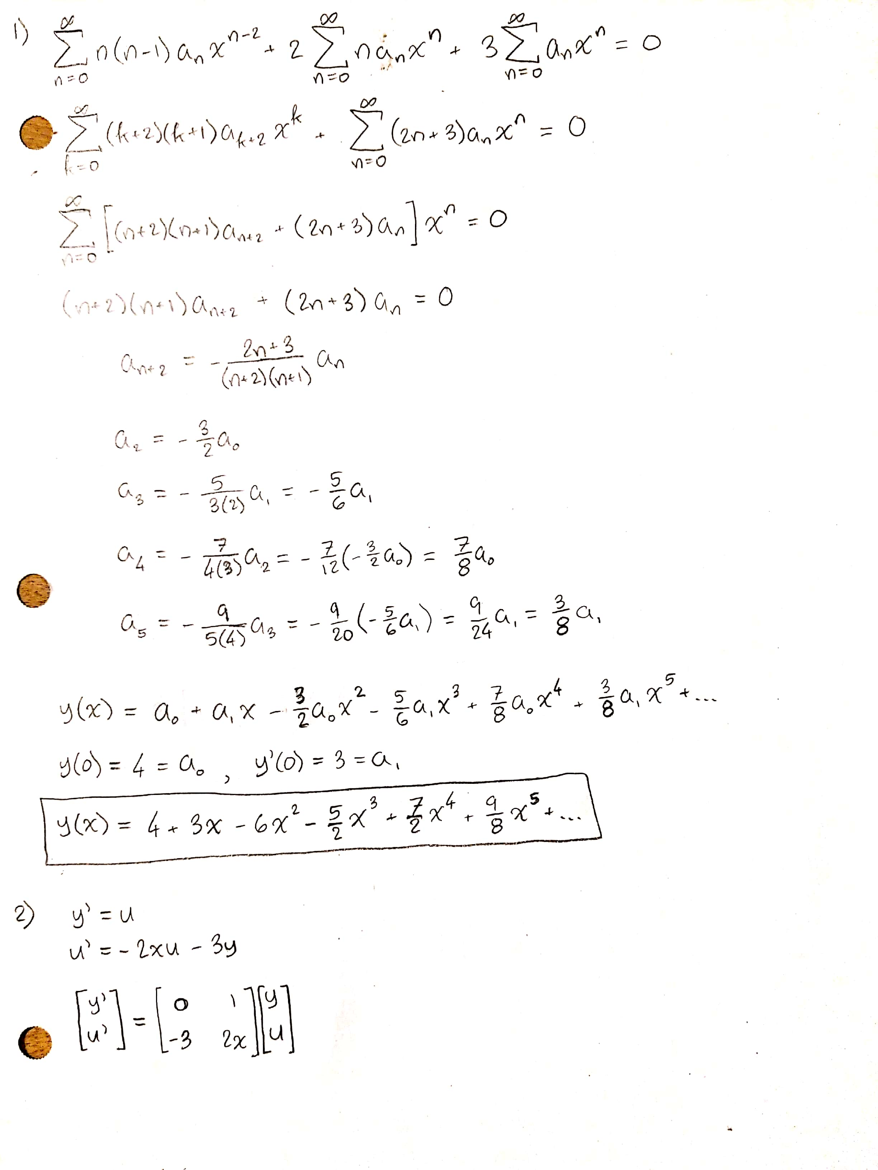

3)

function [x,u,y] = EulSystem_Part2(h, x0, y0, u0, xf)

k = 1;

x(k) = x0;

y(k) = y0;

u(k) = u0;

while((x(k) + h <= xf + 10^-10))

x(k+1) = x(k) + h;

y(k+1) = y(k) + h*u(k);

u(k+1) = u(k) + h*(-3*y(k) - 2*x(k)*u(k));

k = k + 1;

end

end

function [x,y] = SeriesSolution(y0, yprime0)

x = 0:0.1:2;

y = y0.*(1 - (3/2).*x.^2 + (7/8).*x.^4) + yprime0.*(x - (5/6).*x.^3 + (3/8).*x.^5);

end

function CreateSubplot(x1,y1,x2,y2,xseries,yseries)

ax1 = subplot(2,1,1);

ax2 = subplot(2,1,2);

plot(ax1,x1,y1,"blue",xseries,yseries,"black")

plot(ax2,x2,y2,"blue",xseries,yseries,"black")

title(ax1,"Plot of y(x) vs x with h=0.2")

title(ax2,"Plot of y(x) vs x with h=0.1")

xlabel(ax1,"x Axis")

xlabel(ax2,"x Axis")

ylabel(ax1,"y(x) Axis")

ylabel(ax2,"y(x) Axis")

end

4)

>> [x1,u1,y1] = EulSystem_Part2(0.2,0,4,3,2);

>> [x2,u2,y2] = EulSystem_Part2(0.1,0,4,3,2);

>> [xseries,yseries] = SeriesSolution(4,3);

>> CreateSubplot(x1,y1,x2,y2,xseries,yseries);



5)

The Euler’s Method approximation with a step size of 0.2 was closer to the approximated series solution than expected. With a step size of 0.1 the Euler’s Method approximation lines up almost exactly with the first 6 terms of the approximated series solution. If the ratio test is used to determine the interval of convergence from the recurrence relationship, the series seems to converge on , but the approximated series only seems to converge on . This can be contributed to the fact that only the first 6 terms were used from the series approximation.

Part III

Functions:

Used for quick referral to the data set.

function [t,x1,x2] = DataPoints()

t = [21.429 28.571 35.714 42.857 50 57.143 64.286 71.429 78.571 85.714 92.857 100];

x1 = [0.183 0.145 0.12 0.103 0.089 0.078 0.068 0.06 0.053 0.047 0.041 0.037];

x2 = [0.157 0.15 0.137 0.124 0.11 0.098 0.087 0.077 0.068 0.06 0.053 0.047];

end

Used to create al of the subplots for x1, x2, ln(x1), and ln(x2).

function CreateSubplots(t,x1,x2)

ax1 = subplot(2,2,1);

ax2 = subplot(2,2,2);

ax3 = subplot(2,2,3);

ax4 = subplot(2,2,4);

plot(ax1,t,x1);

plot(ax2,t,x2);

plot(ax3,t,log(x1));

plot(ax4,t,log(x2));

title(ax1,"Plot of x1(t)");

title(ax2,"Plot of x2(t)");

title(ax3,"Plot of ln(x1(t))");

title(ax4,"Plot of ln(x2(t))");

xlabel(ax1,"t Axis");

xlabel(ax2,"t Axis");

xlabel(ax3,"t Axis");

xlabel(ax4,"t Axis");

ylabel(ax1,"x1(t) Axis");

ylabel(ax2,"x2(t) Axis");

ylabel(ax3,"ln(x1(t)) Axis");

ylabel(ax4,"ln(x2(t)) Axis");

end

Used to both return the coefficients from the Polynomial of Least Squares, and also plot the polynomial.

function [p1,p2] = PolyFitDataSet(t,x1,x2,tmax)

tvec = 0:0.1:tmax;

p1 = polyfit(t,log(x1),1);

p2 = polyfit(t,log(x2),1);

y1 = polyval(p1,tvec);

y2 = polyval(p2,tvec);

ax1 = subplot(2,1,1);

ax2 = subplot(2,1,2);

plot(ax1,t,log(x1),'o',tvec,y1);

plot(ax2,t,log(x2),'o',tvec,y2);

title(ax1,"Least Squares Line for ln(x1(t))");

title(ax2,"Least Squares Line for ln(x2(t))");

ylabel(ax1,"ln(x1(t)) Axis");

ylabel(ax2,"ln(x2(t)) Axis");

xlabel(ax1,"t Axis");

xlabel(ax2,"t Axis");

end

Used to create the residual vector.

function[xr1,xr2] = ResidualPoints(t,x1,x2)

n = numel(t);

for k = 1:n

lim1 = 0.2495 * exp(-0.0178*t(k));

lim2 = 0.2495 * 0.9537 * exp(-0.0178*t(k));

xr1(k) = x1(k) - lim1;

xr2(k) = x2(k) - lim2;

end

end

Used for the same purpose as the previous PolyFit function but for the residual vectors.

function [p1,p2] = PolyFitResiduals(t,x1,x2,tmax)

tvec = 0:0.1:tmax;

p1 = polyfit(t,log(abs(x1)),1);

p2 = polyfit(t,log(abs(x2)),1);

y1 = polyval(p1,tvec);

y2 = polyval(p2,tvec);

ax1 = subplot(2,1,1);

ax2 = subplot(2,1,2);

plot(ax1,t,log(x1),'o',tvec,y1);

plot(ax2,t,log(x2),'o',tvec,y2);

title(ax1,"Residuals for x1(t)");

title(ax2,"Residuals for x2(t)");

ylabel(ax1,"x1 Residuals");

ylabel(ax2,"x2 Residuals");

xlabel(ax1,"t Axis");

xlabel(ax2,"t Axis");

end

function [t,x1,x2] = TrueSolution()

t = 0:0.1:100;

x1 = -1.40795.*exp(-0.0216.*t).*(exp(0.0037.*t)-1.44249.*exp(0.0179.*t));

x2 = -1.34756.*exp(-0.0216.*t).*(exp(0.0037.*t)-exp(0.0179.*t));

end

1)

2)

represents the rate of change of the concentration of the drug in the Central Compartment (Blood). The which represents the amount of the drug in the Tissue Compartment at rate c. The which represents the amount of drug in the Central Compartment at rate . Since the rate of change of concentrations are being modeled by , becomes negative.

represents the rate of change of the concentration of the drug in the Tissue Compartment. The which represents the amount of the drug in the Central Compartment at rate b. The which represents the amount of drug in the Tissue Compartment at rate c. Since the rate of change of concentrations are being modeled by , becomes negative.

3)

To show that the coefficient matrix has 2 distinct, real, and negative eigenvalues, we first show that the discriminant of the characteristic polynomial is positive which implies 2 distinct, real roots of the characteristic polynomial. Shown below is the characteristic polynomial of the coefficient matrix:

We now show that the discriminant of the characteristic polynomial is positive:

Since , the above inequality is true and the discriminant must be positive. Since the discriminant is positive, there are 2 distinct, real roots to the characteristic polynomial.

We now show that the 2 roots of the characteristic polynomial are negative by using relationship between the eigenvalues of a matrix and its trace, and determinant. We know that both eigenvalues must add to the trace of the matrix, and the must multiply to the determinant of the matrix.

Since and , the only possible signs for both eigenvalues are

4)

Since and are distinct eigenvectors of A, the concentrations of the drug in each compartment tend to 0 for large values of t.

5)

Since the eigenvalues satisfy ,

and so is transient

Which shows that

6)

For large values of t for which ,

Let denote the kth component of , and let denote the kth component of ,

Since we are trying to find the slope () of , let which follows that

To find the y – intercept () in terms of the defined parameters, substitute t=0 which gives:

Since is given by :

7)

At this point in time, the DataPoints function contains the entire set of data found on the excel sheet.

>> [t,x1,x2] = DataPoints();

>> CreateSubplots(t,x1,x2);



8)

>> [p1,p2] = PolyFitDataSet(t,x1,x2,100)

p1 =

-0.0252 -0.9956

p2 =

NaN -Inf

The first attempt fitting the data to a line could not even be done on the original data set for , shown below is the original plot:



From looking at the bottom subplot, all points for t < 20 have been removed from the data set, the result is shown on the next page.

>> [p1,p2] = PolyFitDataSet(t,x1,x2,100)

p1 =

-0.0197 -1.3882

p2 =

-0.0160 -1.4357



From arrays p1 and p2, we can formulate the equations of each line:

9)

It is shown above that , and since there are two lines the average of the two slopes are taken to find the first eigenvalue.

The relationship between and is shown above, from that we can find each parameter. Since any scalar multiple of an eigenvector is still an eigenvector, assuming one of the components of to be 1 is valid. This helps us because from that component can be found which then can be used to find the other component. Let

10)

Matlab is used to calculate the residual vector which can be used to find the parameters that correspond to using the same method for since . The same assumption that was used for will be used for since the same principle still applies.

>> [xr1,xr2] = ResidualPoints(t,x1,x2);

>> [p1,p2] = PolyFitResiduals(t,xr1,xr2,100)

p1 =

-0.0069 -4.2592

p2 =

-0.0006 -4.6551

The result is shown on the next page, the approximation for the residuals is significantly worse than the previous approximations since we are now compounding estimations.



From the MatLab results, the equations can now be formulated:

The same methods that were used to find and the corresponding parameters will now be repeated for :

11)

The coefficient matrix A through use of Diagonalization which is done on paper below, shown first is the code used in MatLab for the calculations:

>> p = [1 1.5036; 0.9537 1]

p =

1.0000 1.5036

0.9537 1.0000

>> e = [-0.0178 0; 0 -0.0038]

e =

-0.0178 0

0 -0.0038

>> a = p*e*inv(p)

a =

0.0285 -0.0485

0.0308 -0.0501

On the next page is the portion done by hand.

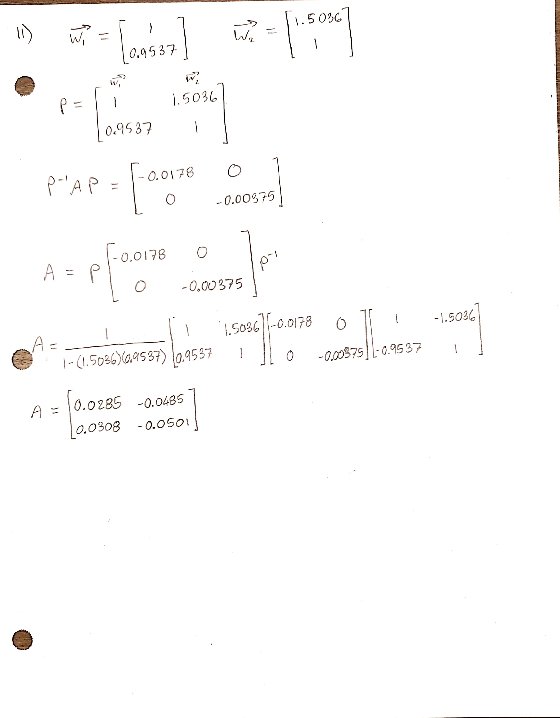

From the results of finding A, the rates a,b,c can now be determined. Since c appears twice in A but the approximations yielded two different values, the average of the two values are taken to find c:

12)

system =

{x'[t]==0.0285*x[t]-0.0485*y[t],

y'[t]==0.0308*x[t]-0.0501*y[t]

}

initvalues={x[0]==0.623,y[0]==0}

sol=DSolve[Join[system,initvalues],{x,y},t]

{{x -> Function[{t}, -1.40795 E^(-0.0216 t) (1. E^(0.00368031 t) -

1.44249 E^(0.0179197 t))],

y -> Function[{t}, -1.34756 E^(-0.0216 t) (1. E^(0.00368031 t) -

1. E^(0.0179197 t))]}}

13)

>> t = [0 7.143 14.286 21.429 28.571 35.714 42.857 50 57.143 64.286 71.429 78.571 85.714 92.857 100];

>> x1 = [0.623 0.374 0.249 0.183 0.145 0.12 0.103 0.089 0.078 0.068 0.06 0.053 0.047 0.041 0.037];

>> x2 = [0 0.113 0.151 0.157 0.15 0.137 0.124 0.11 0.098 0.087 0.077 0.068 0.06 0.053 0.047];

>> [tvec,x1vec,x2vec] = TrueSolution();

>> ax1 = subplot(2,1,1);

>> ax2 = subplot(2,1,2);

>> plot(ax1,t,x1,'o',tvec,x1vec)

>> plot(ax2,t,x2,'o',tvec,x2vec)

>> title(ax1,"True Solution of x1(t)")

>> title(ax2,"True Solution of x2(t)")

>> xlabel(ax1,"t Axis")

>> xlabel(ax2,"t Axis")

>> ylabel(ax1,"x1(t) Axis")

>> ylabel(ax2,"x2(t) Axis")



14)

The solution that I found was poorly approximated. This can be due to numerous factors, but the most probable are either when the residual vector was calculated, or when determining the coefficient matrix based off the eigenvectors/eigenvalues. If time were not a factor I would’ve been able to track down the errors since the mentioned areas were the most rushed due to time.