Statistical Analysis:

Assumption 1

There are no extreme outliers in the distribution of dependent variable,

as assessed by visual inspection of boxplot

Assumption 2

The independent variable has two related groups (Horizontal and Fixation)

Assumption 3

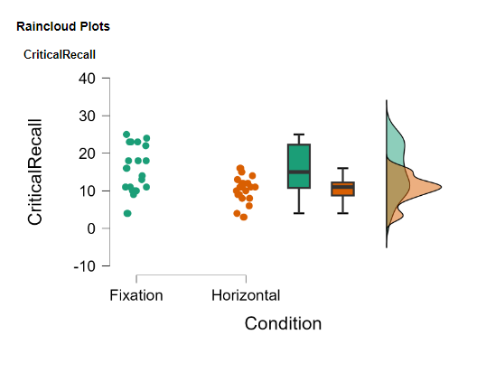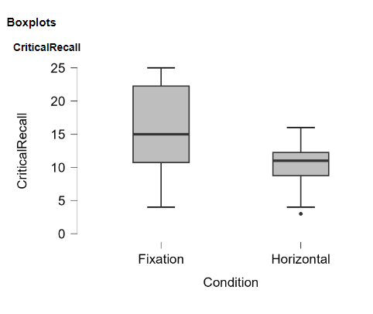

Assumption 4

1. Normality test:

- Level condition: Shapiro-Wilk test (p-value = 0.164) indicates that the data are normally distributed.

- Fixed condition: The Shapiro-Wilk test (p-value = 0.079) also indicates a normal distribution.

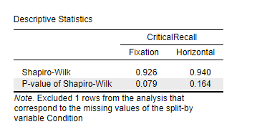

Assumption 5

Independent samples T test:

- t-test (t = 3.233, p-value = 0.002) showed a statistically significant difference between the two groups. Given that the p-value is less than 0.05, we reject the null hypothesis that there is no difference in "critical recall" between the "level" and "fixed" conditions.

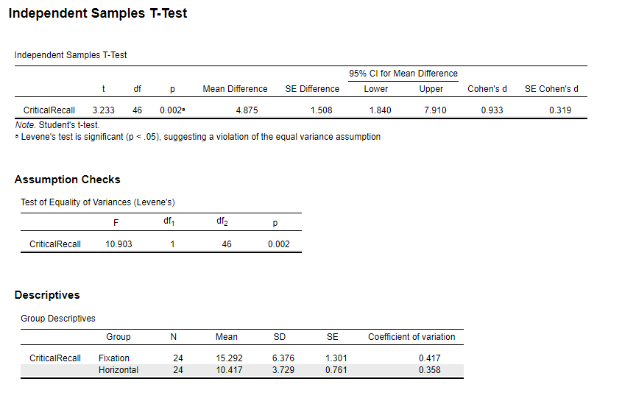

- Levene's test (p-value = 0.002) shows that the variances of the two groups are not equal, which violates one of the t-test assumptions.

GITGUB LINK: