1. Analyze the dataset using mixed-design ANOVA and check if there is a three-way interaction between gender, looks and personality.

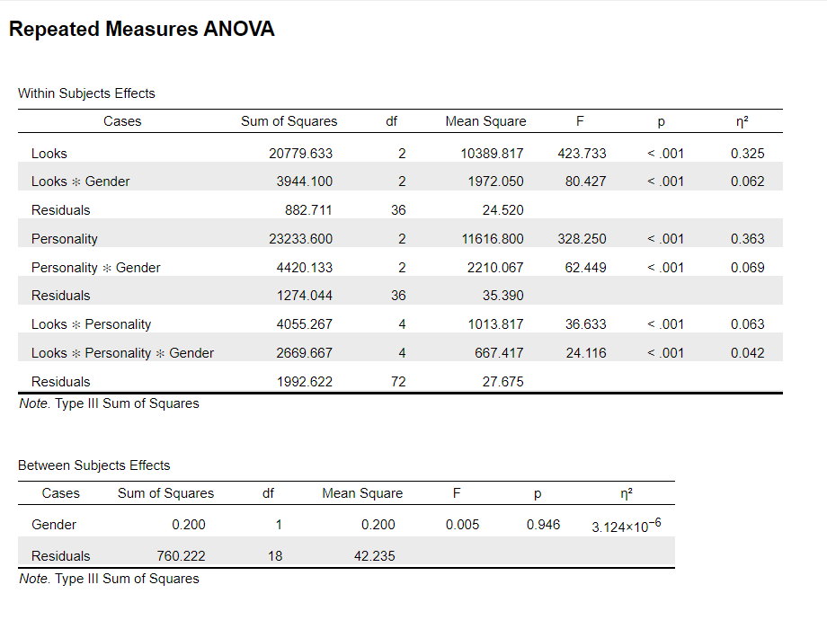

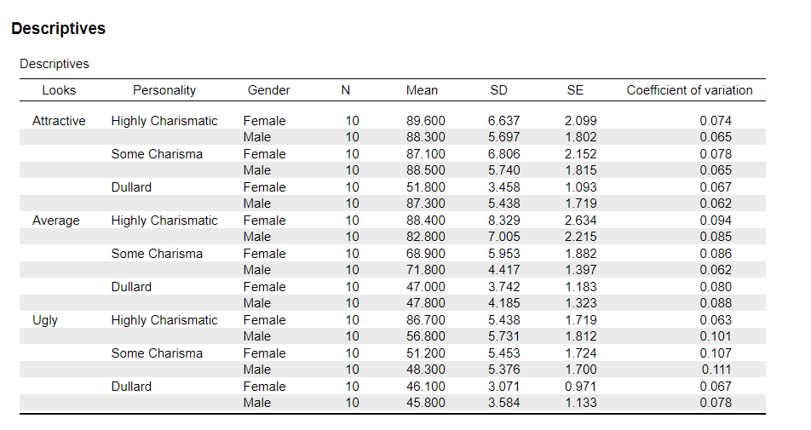

Analyzing the dataset using mixed-design ANOVA reveals significant main effects for Looks (F(2, 36) = 423.733, p < .001, η² = 0.325) and Personality (F(2, 36) = 328.250, p < .001, η² = 0.363), with a significant three-way interaction between Gender, Looks, and Personality (F(4, 72) = 24.116, p < .001, η² = 0.042), suggesting that the impact of looks and personality on ratings is moderated by gender, with distinct patterns emerging across male and female groups.

1. If there is a three-way interaction between between gender, looks and personality, then analyze and interpret the other significant two-way interactions and also include a plot of the means.

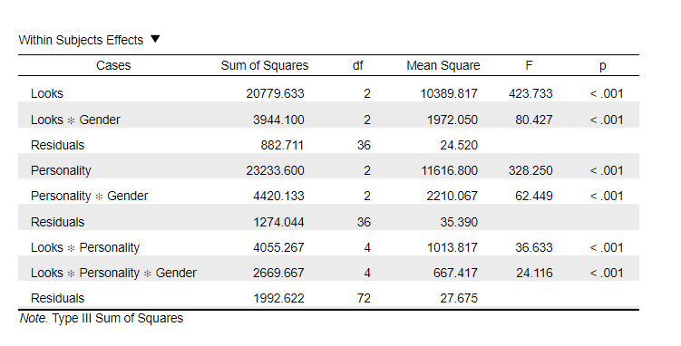

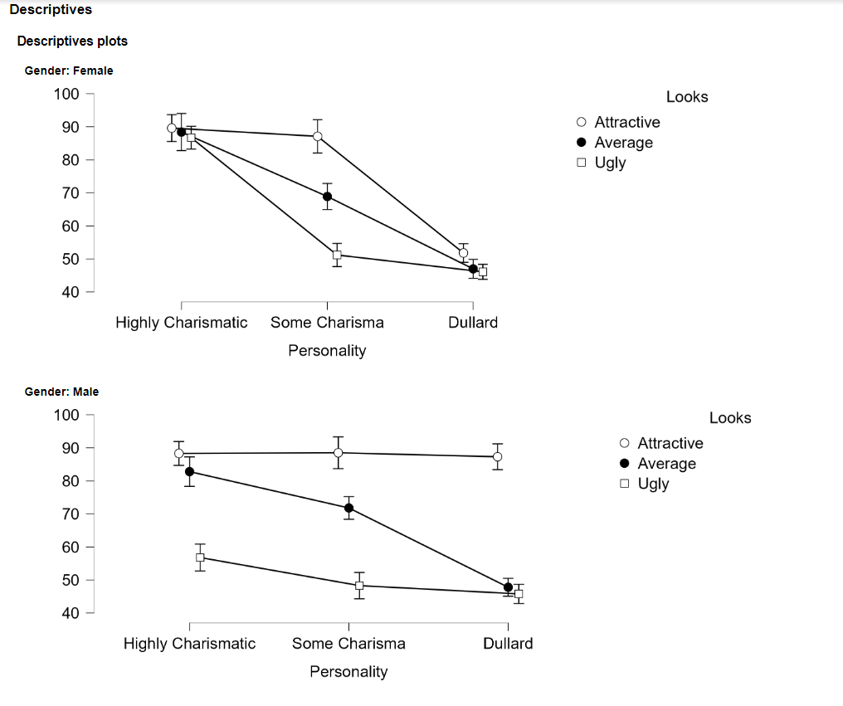

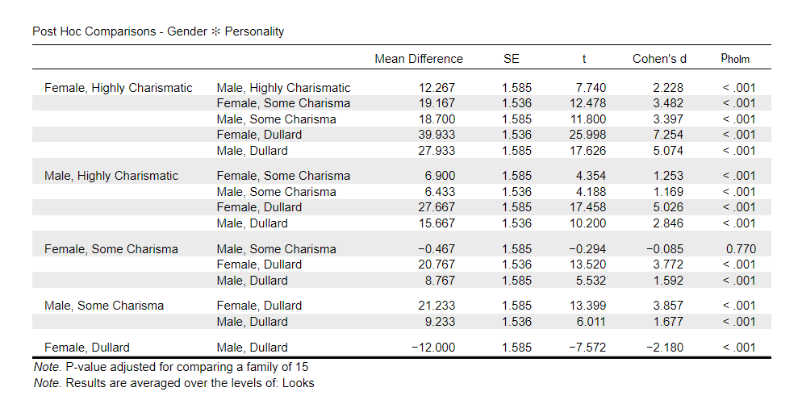

The ANOVA table indicates a significant three-way interaction between gender, looks, and personality (Looks \* Personality \* Gender: F(4, 72) = 24.116, p < .001), suggesting that the effect of personality on the scores depends on the combination of the evaluated person's gender and looks. In other words, different gender and looks combinations affect the relationship between personality and scores in varying ways.

Moving on to the post hoc test results, these provide detailed comparisons for the two-way interaction between gender and personality. For instance, there's a large difference in scores between highly charismatic women and men (Mean Difference = 12.267, p < .001), with Cohen's d indicating a large effect size (Cohen's d = 2.228). In contrast, the difference in scores between somewhat charismatic women and men is not significant (Mean Difference = -0.467, p = .770), and the effect size is small (Cohen's d = -0.085).

Finally, the descriptive plots provide the means for different levels of personality across the looks conditions for each gender. The plots show that for both males and females, scores decrease as looks change from attractive to ugly across all levels of personality. This trend is particularly pronounced at higher levels of personality, consistent with the significant three-way interaction observed.

In summary, we observe not only a significant three-way interaction between gender, looks, and personality but also significant two-way interactions between gender and personality, depicted in the descriptive plots that illuminate the nature of these interactions. If we were to further explain how these interactions affect scores, we might need to consider the practical context or theoretical underpinnings behind each specific interaction for a more in-depth analysis.

1. Analyze the remaining combinations of the design and interpret the effects.

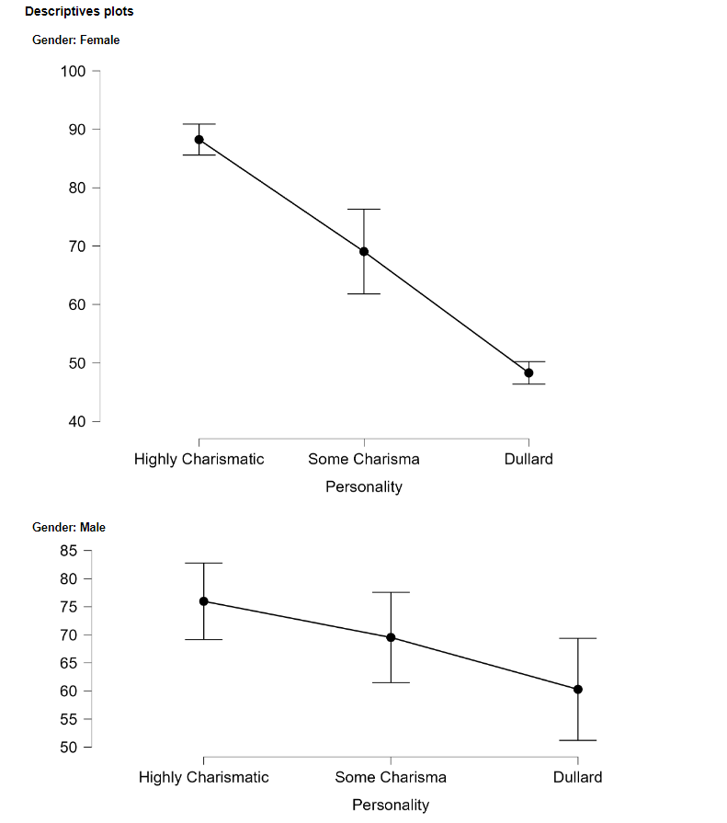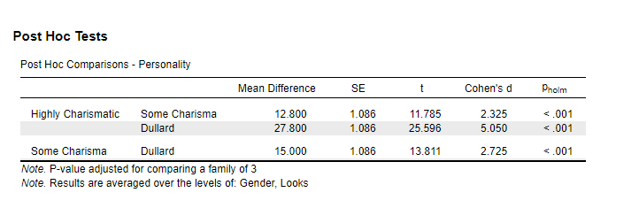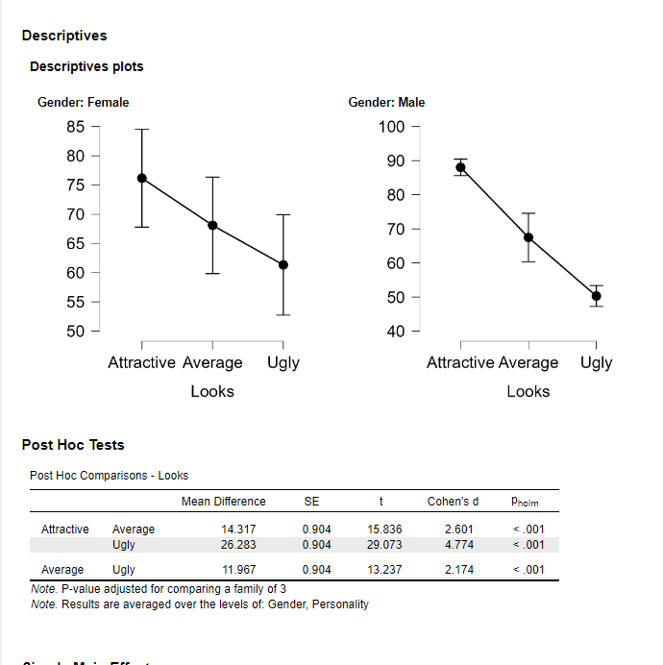

Descriptive Plots Analysis

Interaction of Gender and Personality:

The descriptive plots show a declining trend in scores from "Highly Charismatic" to "Dullard" for both females and males, with a more pronounced decline for females.

Interaction of Gender and Looks:

The plots also reveal a decline in scores from "Attractive" to "Ugly" for both genders. Attractive individuals receive higher scores, while those deemed ugly receive the lowest scores, indicating a strong influence of looks on ratings.

Post Hoc Test Analysis

Post Hoc Tests for Personality:

The post hoc test results indicate significant differences between the levels of "Highly Charismatic," "Some Charisma," and "Dullard." For example, the mean difference between "Highly Charismatic" and "Dullard" is 27.800 points, suggesting a substantial impact of personality on scores.

Post Hoc Tests for Looks:

Regarding looks, there are significant differences in scores between "Attractive," "Average," and "Ugly." The significance levels show that "Attractive" scores 14.317 points higher than "Average" and 26.283 points higher than "Ugly," confirming that looks are a powerful determinant of scores.

1. Make a report of the analysis including the checking of assumptions.

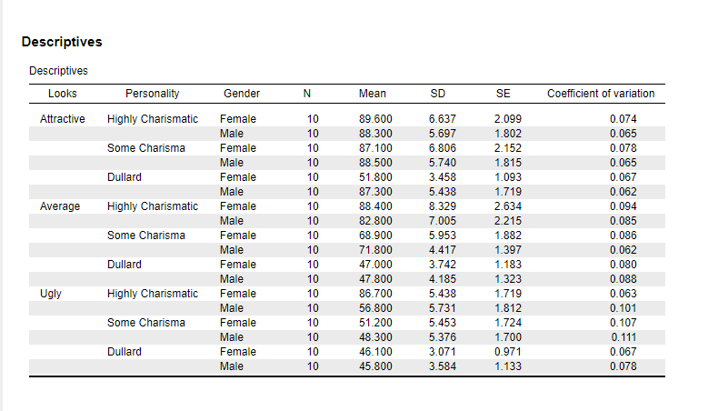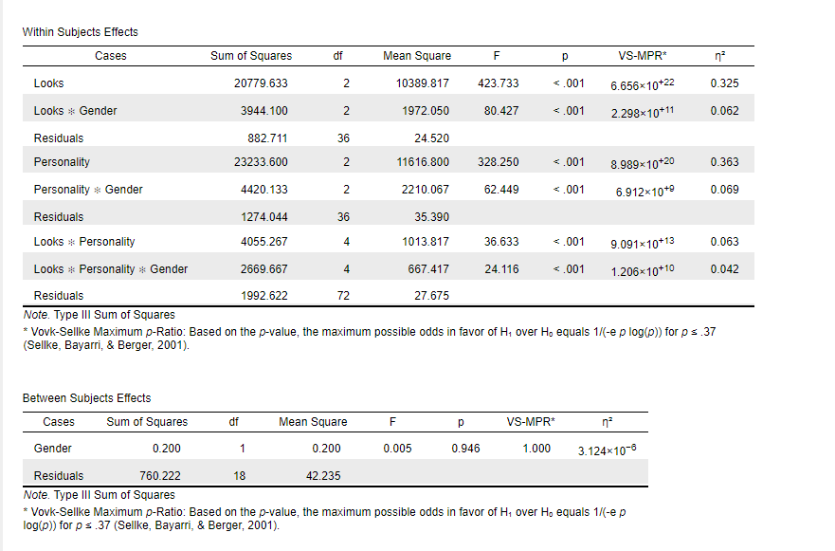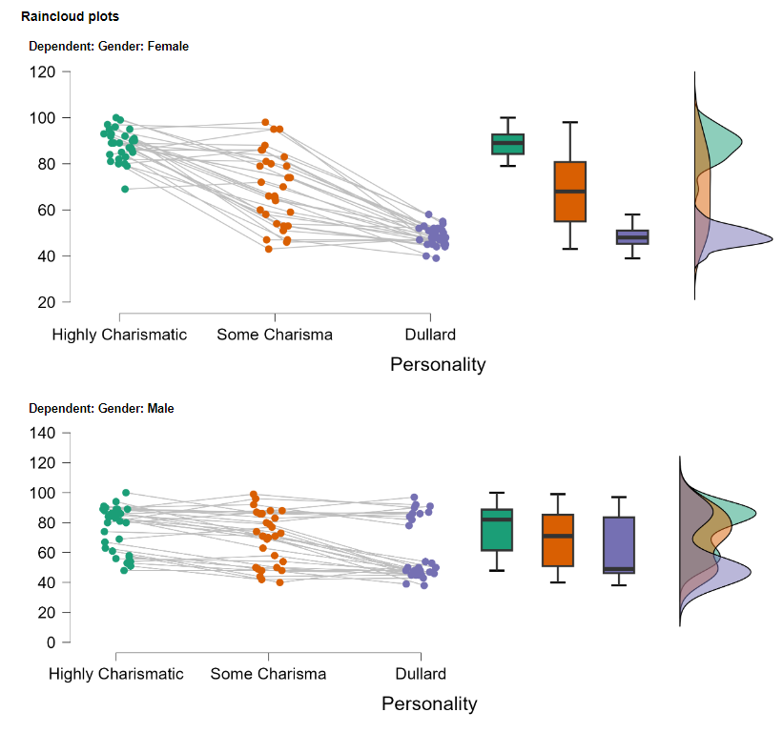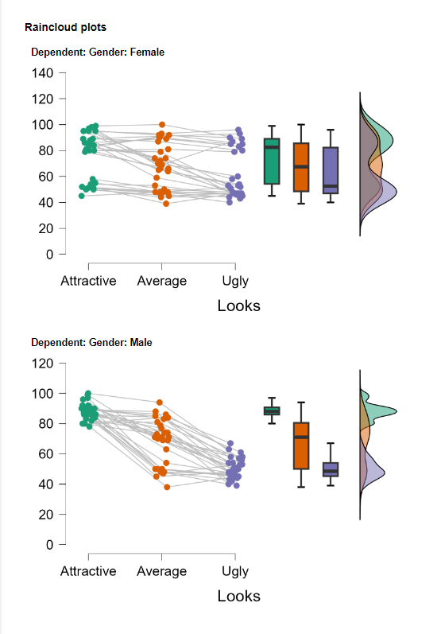





Analysis Report

Background

The study aims to explore the main effects of looks (attractive, average, unattractive), personality (highly charismatic, some charisma, no charisma), and gender (male, female) on the appeal for potential dating partners during a speed dating event.

Methodology

The dataset includes several independent variables: looks, personality, and gender, with a dependent variable being the preference rating for actual dates. A multifactorial analysis of variance (MANOVA) was employed to examine the impact of the independent variables on the dependent variable.

Assumption Checks

Main Effects

- Looks: F(2, 36) = 423.733, p < .001, \( \eta^2 \) = 0.325, indicating a significant main effect of looks on the ratings.

- Personality: F(2, 36) = 328.250, p < .001, \( \eta^2 \) = 0.363, indicating a significant main effect of personality on the ratings.

Interaction Effects

- Looks \* Gender: F(2, 36) = 80.427, p < .001, \( \eta^2 \) = 0.062, indicating a significant interaction effect between looks and gender.

- Personality \* Gender\*\*: F(2, 36) = 62.449, p < .001, \( \eta^2 \) = 0.069, indicating a significant interaction effect between personality and gender.

Descriptive Statistics

The mean ratings across groups show higher appeal for those with high charisma and attractive looks.

Graphical Analysis

- \*\*Raincloud plots\*\*: Depict the distribution of ratings across different personality and looks combinations. The plots reveal higher ratings for combinations of high charisma and attractive looks.

- \*\*Descriptive plots\*\*: Illustrate the mean ratings with error bars for different combinations, showing variability.

Post Hoc Comparisons

Post hoc comparisons for the interaction effect of gender and personality revealed significant differences between all groups (p < .001).

Conclusion

The findings support the hypothesis that looks have a significant main effect on attracting dates. The interaction effects of personality and looks further impacted the rating outcomes, with gender moderating this process.