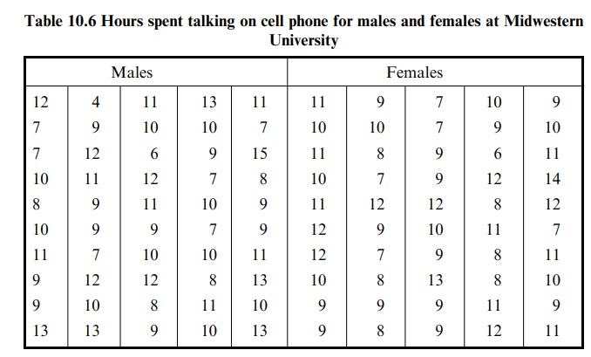

Questions:

1. **Formulate and present the rationale for a hypothesis test that the researcher could use to compare the mean time spent on cell phones by male and female college students per week.**

**Hypothesis Test Rationale:**

Choice of Test: An independent samples t-test is chosen because there are two separate groups – male and female students – whose mean phone usage times are being compared, and each group's data are assumed to be independent of the other's.

**Hypotheses:**

- Null Hypothesis (H0): μ1 - μ2 = 0 (The mean time spent on cell phones is equal for both male and female students).

- Alternative Hypothesis (H1): μ1 - μ2 ≠ 0 (There is a difference in the mean time spent on cell phones between male and female students).

**Assumptions:**

- Independence: The cell phone usage time for one student is independent of that for another, satisfying the independence assumption necessary for a t-test.

- Normality: The Central Limit Theorem suggests that the means of samples from a population will be normally distributed, especially when sample sizes are large (n ≥ 30), which is the case here.

- Equality of Variances: Levene's test for equality of variances is used to verify that the assumption of homogeneity of variance is not violated. In this case, the p-value for Levene's test (0.346) is greater than the significance level (0.05), indicating that the variances are equal.

**Test Statistic**

- A t-statistic is calculated to determine the difference between the two means relative to the spread or variability of their scores. The calculated t-value is 0.304, with 98 degrees of freedom.

Results and Conclusion:

- With a p-value of 0.762, the test fails to reject the null hypothesis, indicating that there is no significant difference in mean cell phone usage time between male and female students at the university level.

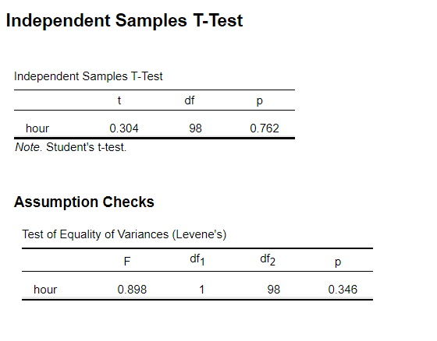

1. **Analyze the data to provide the hypothesis testing conclusion. What is the p-value for your test? What is your recommendation for the researcher?**

**The p-value of the test: In the independent samples t-test, the p-value is 0.762.**

**In conclusion:**

Because the p-value is much larger than the usual significance level (for example, α = 0.05), we do not have enough evidence to reject the null hypothesis.

This means that based on the sample data, we cannot conclude that there is a statistically significant difference in the average time spent on mobile phones per week among male and female college students.

**Researchers recommend:**

Data Interpretation: Carefully interpret the meaning of the data and avoid over-interpreting the results. Even if no significant differences are found, this may provide valuable insights into the behavioral patterns of the target population.

Sample size: Consider whether a larger sample size is needed to increase the statistical power of the study, especially if the expected effect size is small.

Effect size: Reporting an effect size (such as Cohen's d), even if the result is not significant, can help understand the actual size of the difference.

Additional variables: Consider whether there are other potential variables that may affect the results, such as students' grade level, major, or the specific purpose for which they use their phones.

Follow-up research: If this study is preliminary, it is recommended that follow-up research be conducted to explore other factors that may influence cell phone use time.

Data collection: Ensure there are no biases in the data collection process, such as selection bias or reporting bias, which could affect the accuracy of the results.

1. **Provide descriptive statistical summaries of the data for each gender category.**

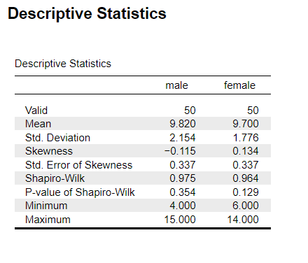

From the data provided, the average weekly cell phone usage time is very similar between male and female college students, with males at 9.82 hours and females at 9.70 hours. The standard deviations are also similar, indicating that the variability in the distribution of phone usage time is similar across genders. Additionally, the skewness for both groups is close to zero, indicating near-symmetric distributions.

The Shapiro-Wilk test results for normality suggest that there is no significant deviation from a normal distribution for both gender categories (since p-values are greater than 0.05). This further supports the decision to use an independent samples t-test, which assumes normality of the data.

The minimum and maximum values show the range of weekly phone usage time, with males ranging from 4 to 15 hours and females from 6 to 14 hours. These values provide us with the extremes of the distribution of phone usage times, but given that the means are very close, we can conclude that there is no significant difference in cell phone usage time between male and female students based on the sample.

1. **What is the 95% confidence interval for the population mean of each gender category, and what is the 95% confidence interval for the difference between the means of the two populations?**

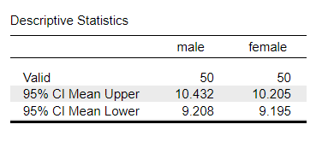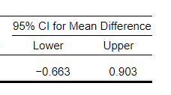

For male students, the 95% confidence interval for the mean ranges from 9.208 to 10.432 hours.

For female students, the 95% confidence interval for the mean ranges from 9.195 to 10.205 hours.

The 95% CI for Mean Difference ranges from 0.663 to 0.903, which means we are 95% confident that the true mean difference between the groups falls within this range.

1. **Do you see a need for larger sample sizes and more testing with the time spent on cell phones? Discuss.**

While the current study does not suggest a significant difference in the time spent on cell phones between male and female students, a larger sample size and continued testing could provide a more definitive answer and might be warranted if cell phone usage is linked to critical outcomes like academic performance, mental health, or other areas of concern. If the study aims to inform policy or interventions, ensuring the results are robust and applicable to the broader population would be particularly important.

1. **Make a report including the testing of the assumptions for two independent samples t-test.**

**Statistical Analysis Report**

**Introduction**

This report presents the findings of a statistical analysis conducted to compare the mean time spent on cell phones by male and female students at Midwestern University. The objective was to determine if there is a significant difference in the average hours per week male and female students spend talking on their cell phones.

**Methodology**

Participants

A total of 100 students from Midwestern University participated in the study, with an even split of 50 male and 50 female students.

Procedure

Participants reported the number of hours they spent talking on their cell phones per week. The data was collected through a survey and compiled for analysis.

Statistical Analysis

An Independent Samples T-Test was performed to compare the means of the two groups. The test assumptions include:

- The dependent variable, hours spent on cell phones, is approximately normally distributed.

- The variances of the two groups are assumed to be equal.

- The two samples are independent of one another.

The null hypothesis (H0) states that there is no difference in mean cell phone usage between male and female students (μ1 = μ2). The alternative hypothesis (H1) states that there is a difference (μ1 ≠ μ2).

**Results**

**Descriptive Statistics**



The 95% confidence interval for the mean hours spent on cell phones is [9.208, 10.432] for male students and [9.195, 10.205] for female students.

**Hypothesis Test Results**



The t-test yielded a t-value of 0.304 with 98 degrees of freedom. The p-value was 0.762, which is above the conventional alpha level of 0.05. The 95% confidence interval for the difference in means includes zero, ranging from -0.663 to 0.903 hours.

**Discussion**

The analysis did not provide sufficient evidence to reject the null hypothesis. The p-value indicates a high probability that any observed difference in mean cell phone usage between males and females could be due to random sampling error. The confidence intervals for the mean of each group overlap significantly, further suggesting that any difference in cell phone usage is not statistically significant.

**Conclusion**

Based on the Independent Samples T-Test, there is no statistical evidence to suggest a difference in the average time spent on cell phones between male and female students at Midwestern University. The data supports the null hypothesis of equal means between the two gender groups.