**Analysis of the Impact of Visual Stimuli on Rat Exploration Behavior**

***JingHuaYang***

***BSAM-DS***

***2023-12-14***

***Github link:*** [jingexe/SA-2 (github.com)](https://github.com/jingexe/SA-2)

**Abstract:**

This study examines the influence of different 2-dimensional visual stimuli on the spontaneous exploration behavior of rats. A one-way ANOVA was conducted to compare the effects of three types of visual stimuli—shapes, patterns, and pictures—on the time rats spent exploring an experimental chamber. The results indicate significant differences in exploration time across stimuli types.

**Methods:**

**Participants:**

Thirty-six rats were selected and randomly assigned to one of three treatment conditions.

**Procedure:**

Rats were released into an experimental chamber containing one of three types of visual stimuli—shapes, patterns, or pictures. The duration of exploration within the chamber was recorded in seconds.

**Data Analysis**

* A one-way Analysis of Variance (ANOVA) was conducted to compare the exploration time between the three treatment conditions (shapes, patterns, pictures).
* Assumption checks for ANOVA were performed, including normality of residuals and homogeneity of variances.
* Post-hoc Tukey's Honestly Significant Difference (HSD) tests were conducted to identify specific group differences.

**Results:**

**Descriptive Statistics**

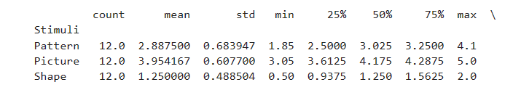

The exploration behavior of rats was quantified by measuring the time they spent interacting with various visual stimuli: shapes, patterns, and pictures. The mean exploration times observed for shapes, patterns, and pictures were 1.250 seconds, 2.888 seconds, and 3.954 seconds, respectively, indicating a trend towards increased engagement with more complex visual stimuli.

**One-Way ANOVA**

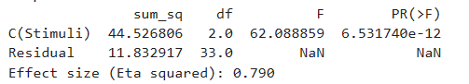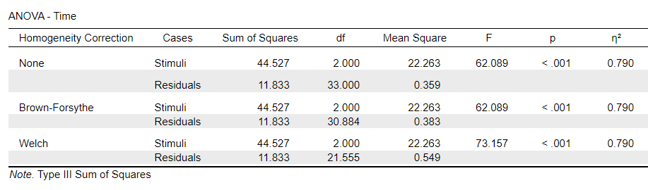

The one-way ANOVA conducted on the mean exploration times for the three types of stimuli showed a significant effect of the type of visual stimulus on exploration time, F(2, 33) = 62.089, p < .001, with a very large effect size (η² = 0.790). This suggests that the nature of the visual stimulus plays a crucial role in the exploration behavior of rats.

**Post-hoc Tukey's HSD**

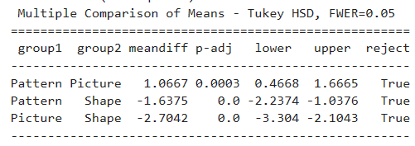

Further analysis using Tukey's HSD post-hoc test revealed significant differences between all pairs of stimuli (p < .001), with pictures resulting in the longest exploration times, followed by patterns, and then shapes. This pattern of results underscores the importance of stimulus complexity in exploration behavior.

**Assumption Checks:**

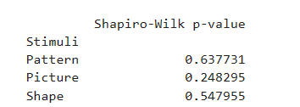

The Shapiro-Wilk tests for normality across each type of stimulus were not significant (p > .05), confirming that the exploration times were normally distributed, which is a critical assumption for ANOVA. The Q-Q plot of standardized residuals affirmed this normality, as the data points closely followed the theoretical line, suggesting that the variance in our data is consistent with statistical expectations.

**Normality of Residuals**

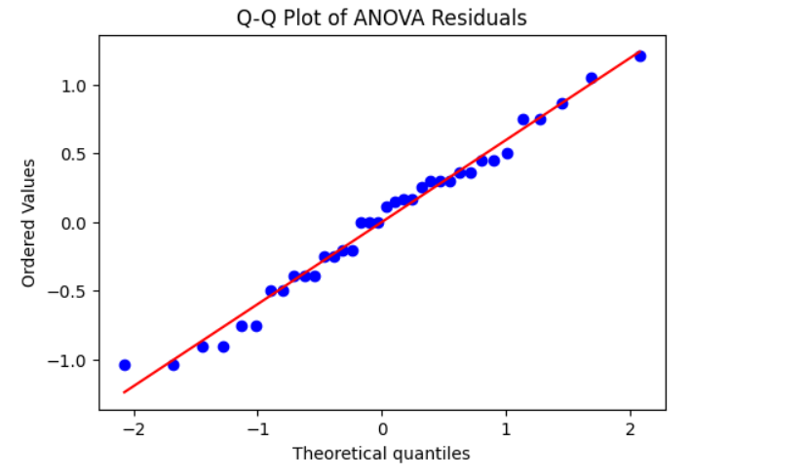

The Q-Q plot of standardized residuals also indicated normality, with data points closely aligning with the theoretical line.

**Homogeneity of Variances**



Levene's test for equality of variances was also non-significant (F(2, 33) = 0.774, p = .469), indicating that the assumption of homogeneity of variances was met. This suggests that the variability in exploration times was similar across the different types of visual stimuli.

**Discussion:**

The findings demonstrate that visual stimuli type significantly affects exploration behavior in rats, with pictures prompting the longest exploration time. These results suggest that the complexity or familiarity of visual stimuli may influence spontaneous exploration.

**Conclusion:**

The type of visual stimuli has a significant impact on the exploration behavior of rats. Future research could explore the underlying mechanisms of this effect and its implications for understanding sensory processing and behavior in rodents.

