**The Effect of Engine Oil Type on Car Mileage: A Repeated-Measures ANOVA Study**

***JingHuaYang***

***BSAM-DS***

***2023-12-14***

***Github link:*** [jingexe/SA-2 (github.com)](https://github.com/jingexe/SA-2)

**Abstract:**

This study investigated whether different types of engine oils lead to variations in car mileage. A repeated-measures ANOVA was employed to analyze the mileage of five cars using four different engine oils. The analysis did not reveal a significant effect of engine oil type on car mileage.

**Method:**

**Participants**

Five cars were used in the study.

**Procedure**

Each car's mileage was measured using four different types of engine oils.

**Design**

A repeated-measures design was used, with engine oil type as the within-subject factor.

**Statistical Analysis:**

**Code Execution:**

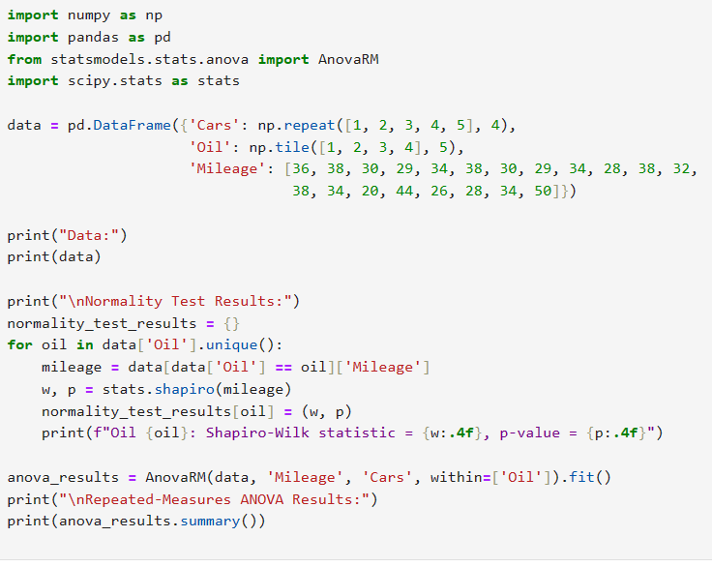

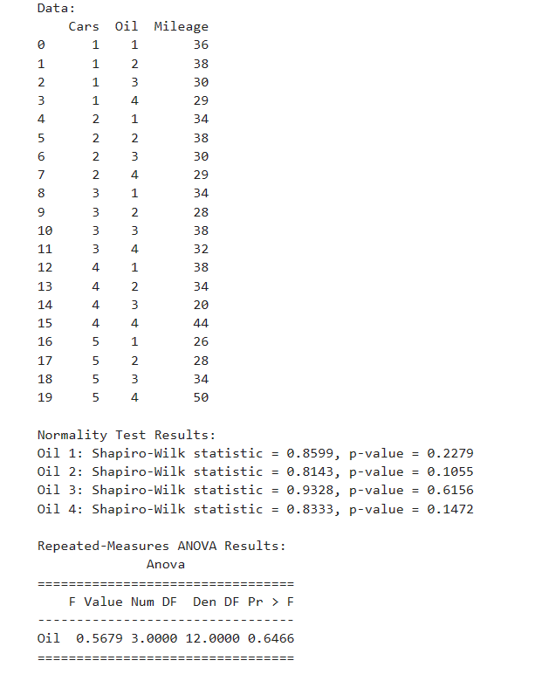

**Normality Check:** Shapiro-Wilk tests were performed to assess normality for each engine oil type. Results indicated that the mileage distributions for each oil type did not significantly deviate from normality (Oil 1: p = 0.228, Oil 2: p = 0.105, Oil 3: p = 0.616, Oil 4: p = 0.147).

(Shapiro-Wilk Test)

Oil 1: Shapiro-Wilk statistic = 0.860, p-value = 0.228

Oil 2: Shapiro-Wilk statistic = 0.814, p-value = 0.105

Oil 3: Shapiro-Wilk statistic = 0.933, p-value = 0.616

Oil 4: Shapiro-Wilk statistic = 0.833, p-value = 0.147

**Repeated-Measures ANOVA:** The analysis was conducted using the AnovaRM function from the statsmodels library in Python.

**Results:**

**Assumptions**

Normality was confirmed for each engine oil type (Oil 1: p = 0.228, Oil 2: p = 0.105, Oil 3: p = 0.616, Oil 4: p = 0.147).

**ANOVA**

A non-significant effect of engine oil type on car mileage was found, F(3, 12) = 0.5679, p = 0.6466.

**Discussion:**

The findings from the repeated-measures ANOVA revealed no statistically significant difference in the mileage of cars when using different types of engine oils (F(3, 12) = 0.5679, p = 0.6466). This suggests that the type of engine oil used does not significantly affect car mileage under the conditions tested. It is important to consider the limitations of this study, such as the small sample size and specific engine oil types used. Further research with a larger and more varied sample could provide more generalized conclusions.

**Conclusion:**

This study contributes to the understanding of how different engine oils might impact car performance, specifically mileage. However, within the context of this study, no significant effect was observed, indicating that other factors might play a more substantial role in determining car mileage.