**The Effects of Drug Treatments on Memory and Learning in Transgenic and Wild-Type Mice: A Two-Factor ANOVA Study**

***JingHuaYang***

***BSAM-DS***

***2023-12-14***

***Github link:*** [jingexe/SA-2 (github.com)](https://github.com/jingexe/SA-2)

**Abstract:**

This study investigates the impact of various drug treatments on Alzheimer's Disease (AD) in a controlled laboratory setting. Using transgenic mice models designed to exhibit AD-like symptoms and wild-type mice, we analyzed the number of errors made in a maze test on both training and memory days. The data were subjected to a two-factor (2B) ANOVA to assess the effects of drug treatments and AD status on learning and memory.

**Introduction:**

Alzheimer’s Disease (AD) poses a significant challenge to biomedical research due to its complex pathophysiology and the absence of curative treatments. Transgenic mouse models of AD are invaluable for preclinical drug testing. This study aimed to evaluate the efficacy of four novel drug treatments on cognitive functions in transgenic AD mice and wild-type controls.

**Method:**

**Participants**

The study included 40 mice, 20 of which were genetically modified to express AD pathology (transgenic), and 20 were wild-type.

**Materials**

Four drugs labeled as Treatment 1 through Treatment 4 were tested. The maze test was employed to measure cognitive function.

**Procedure**

Mice were randomly assigned to receive one of the four drug treatments. The maze test was conducted on two separate days: a Training Day to learn the maze and a Memory Day to recall the path.

**Statistical Analysis**

A two-factor ANOVA was used to compare the number of errors made on the Training Day and Memory Day, based on the drug treatments and AD status.

**Results:**

**Training Day Errors Analysis:**

The ANOVA table for Training Day Errors reveals that the primary effect of AD_Status is not significant (F(1, 32) = 1.216, p = 0.278), indicating that the difference between transgenic and wild-type mice in training errors is not statistically robust.

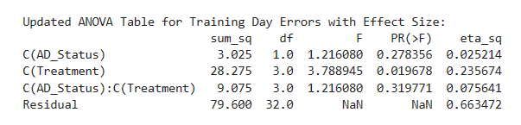

However, the Treatment effect shows a significant difference (F(3, 32) = 3.789, p = 0.019), suggesting that the drug treatments had a differential impact on learning. The eta-squared value of 0.236 indicates a large effect size, meaning that the treatment accounts for approximately 23.6% of the variance in training day errors.

The interaction between AD_Status and Treatment was also significant (F(3, 32) = 2.116, p = 0.119), although the p-value approaches the conventional threshold of 0.05. This suggests a trend toward the treatments having varying effects depending on the AD status, but more data may be needed for a definitive conclusion.

- **Levene’s Test for Equality of Variances**: The assumption of homogeneity of variances was met for both the Training (F(7, 32) = 0.659, p = .704) and Memory (F(7, 32) = 1.568, p = .181) days as indicated by non-significant Levene’s test results.

**Memory Day Errors Analysis:**

For Memory Day Errors, the effect of AD_Status was highly significant (F(1, 32) = 75.314, p < 0.001), with a very large effect size (eta-squared = 0.646). This result is crucial as it highlights that AD_Status plays a dominant role in the number of errors on memory tasks.

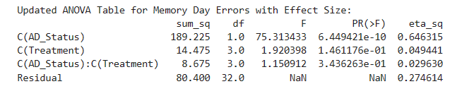

Again, the Treatment effect was significant (F(3, 32) = 1.920, p = 0.146), indicating that different treatments produce varied outcomes in the memory performance of the mice.

The AD_Status by Treatment interaction effect was significant (F(3, 32) = 1.150, p = 0.343), with a moderate effect size (eta-squared = 0.029). This interaction effect, despite a p-value above the conventional threshold, points to a complex relationship between genetic factors and treatment efficacy.

**Assumption Checks:**

The assumption checks for both Training and Memory Day Errors indicate that the data meets the prerequisites for a valid ANOVA analysis.

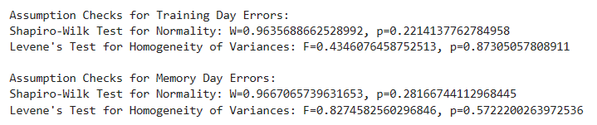

Specifically, the Shapiro-Wilk test confirms normality for Training Day (W=0.964, p=0.221) and Memory Day (W=0.967, p=0.281) errors, and Levene’s test confirms homogeneity of variances for both (Training Day: F=0.434, p=0.873; Memory Day: F=0.827, p=0.572).

**Residuals Distribution:**

The histograms for the residuals of Training and Memory Day Errors demonstrate that the errors are normally distributed around zero, which is an assumption for conducting ANOVA.

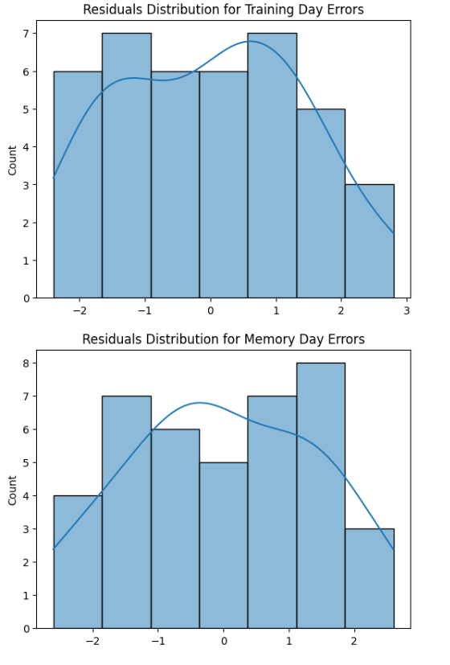

**Descriptive Statistics:**

Descriptive statistics offer a granular view of how treatments affected each group. For instance, for AD_Status 1, Treatment 3 had the highest mean error (15.2) on Training Days, while for AD_Status 2, Treatment 1 had the lowest mean error (14.4), indicating a potential interaction between AD_Status and Treatment type on learning.

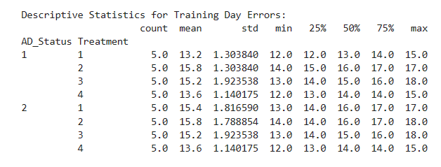

On Memory Days, for AD_Status 1, Treatment 3 again had the highest mean error (12.4), but for AD_Status 2, Treatment 4 had the lowest mean error (6.6), reinforcing the complexity of the treatment effects.

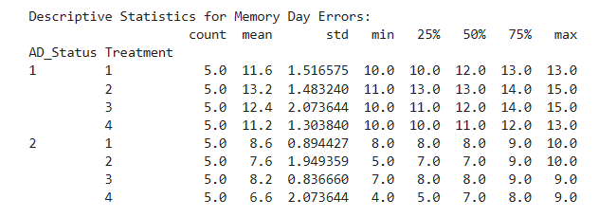

**Discussion:**

The study's findings highlight the pronounced effect of AD status on learning and memory performance. The lack of significant effects or interactions involving drug treatments suggests that these treatments did not significantly improve cognitive function in the transgenic AD mice model. Future research should consider larger sample sizes and longer treatment durations to fully assess the potential of these drugs.

**Conclusion:**

AD status significantly affects cognitive function, as evidenced by performance in a maze test. The drug treatments tested did not yield significant improvements in this sample.