## Trident3 QSPI serial flash programming

# Requirement

DS-5

DS-5 Debugger software v5.10 or later

Broadcom supplied DS-5 Jython script: program_sflash_td3.py

Tiny program: sfw.bin

The binary file to be programmed into the serial flash, e.g PCIe Gen3 Firmware binary

# Instructions to program the serial flash

* 1. Connect DS-5 to the target

Please follow instructions in Appendix A to setup a connection and connect to the target

* 1. Execute the Broadcom supplied DS-5 script ‘program_sflash_td3.py’

There are two ways to run this script.

* + 1. Using command line to run this script

DS-5 eclipse command format:

source program_sflash_td3.py <binary file to be programmed> sfw.bin

Example:

source C:\program_sflash_td3.py C:\pcieg3fw.bin C:\sfw.bin

Please see the below figures, please input the command in the command window shown in RED color, and click ‘submit’.

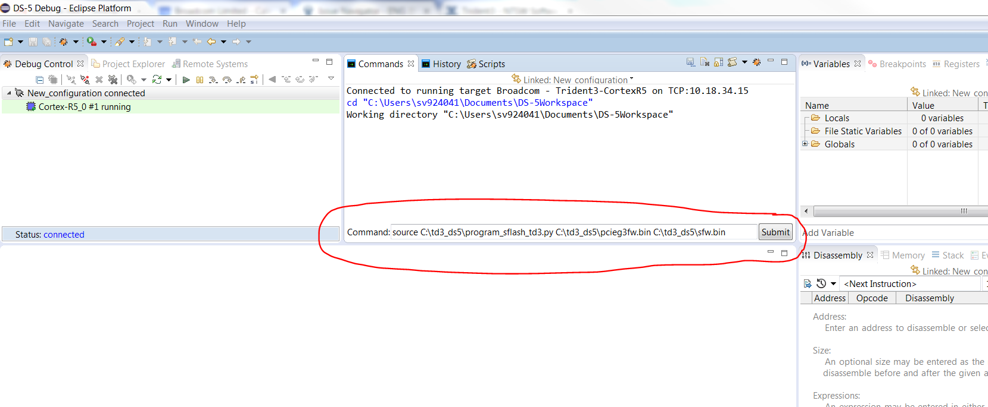

Command window should show output log like this:

source C:\td3_ds5\program_sflash_td3.py C:\td3_ds5\pcieg3fw.bin C:\td3_ds5\sfw.bin

--Start of script--

Size of C:\td3_ds5\pcieg3fw.bin is 24232 bytes.

Execution stopped in SVC mode at 0x1C0007C4

0x1C0007C4 B {pc} ; 0x1c0007c4

Force to stop debugger

Memory table entry number 8 created

Initialize spi controller...

Initialize spi controller done!

Sflash erasing......

1 sectors need to be erased

wait_for_complete reg_addr = 0x18021220, mask=0x1, value=0x1

wait_for_complete reg_addr = 0x18021220, mask=0x1, value=0x1

polling status register

wait_for_complete reg_addr = 0x18021220, mask=0x1, value=0x1

wait_for_complete reg_addr = 0x18021220, mask=0x1, value=0x1

wait_for_complete reg_addr = 0x18021220, mask=0x1, value=0x1

polling flag status register

wait_for_complete reg_addr = 0x18021220, mask=0x1, value=0x1

1th secotr erased......done!

Erase done!

restore C:\td3_ds5\sfw.bin binary 0x2000400

Restoring Binary file C:\td3_ds5\sfw.bin into memory

Restoring section 0x00000000 to 0x000002F3 into memory 0x02000400 to 0x020006F3

block_num = 0

C:\td3_ds5\pcieg3fw.bin

write block 0 len 24232

Restoring Binary file C:\Users\sv924041\Documents\DS-5Workspace\__TEMP.bin into memory

Restoring section 0x00000000 to 0x00005EA7 into memory 0x02001000 to 0x02006EA7

Execution stopped in SVC mode at breakpoint 1: 0x0200053C

0x0200053C BL {pc}+0xc ; 0x2000548

Deleted temporary breakpoint: 1

>>>>> Block 0, size 24232, write done!

--End of script--

* + 1. Using DS-5 script tool to run this script
* Step-1

Click ‘Scripts’ tab, and click ‘Import script…’ button, then click on “Import a DS or Jython Script”. Please see the below figure:

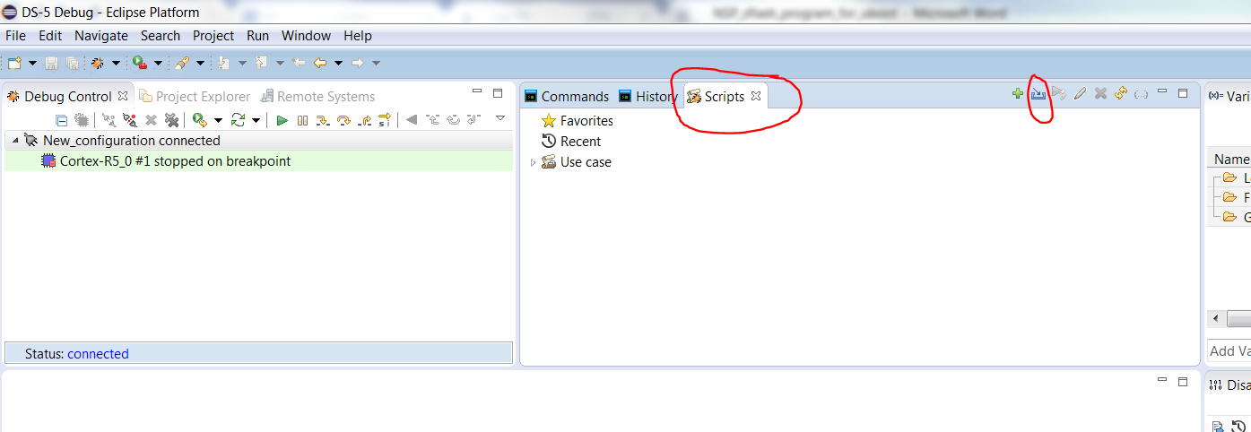

* Step-2

In the pop-up windows, you can select the script. See below:

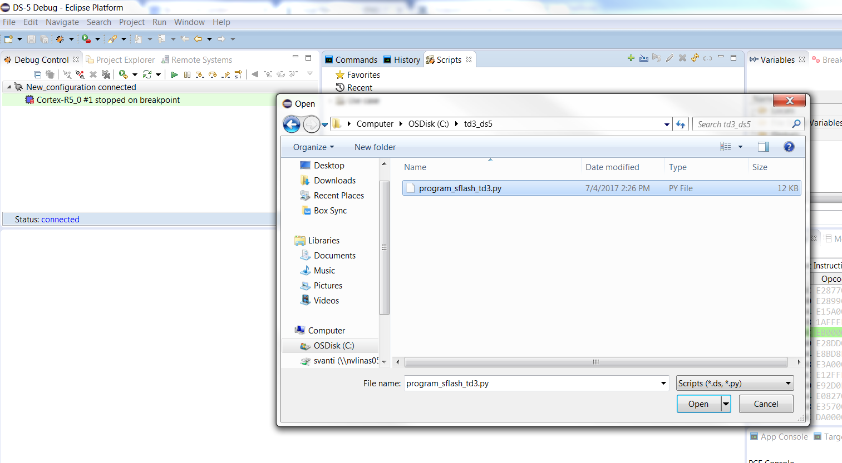

* Step-3

Click ‘Script parameters’ button, and input two parameters in the pop-up windows, See the below.

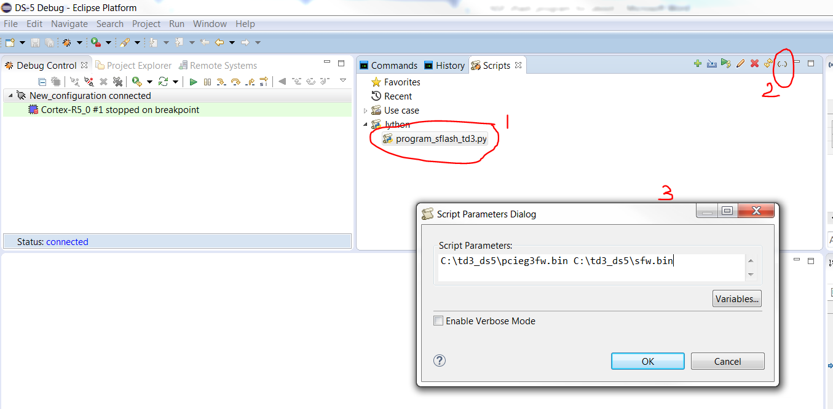

* Step-4

Double click the Jython script file, ‘binary file’ will be programmed into the serial flash.

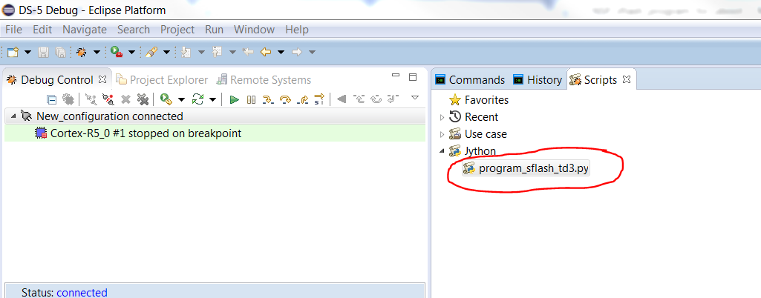

**Notes:**

This script is for Trident3 platform with *Micron MT25QL256ABA8E or N25Q256A13E* flash devices only. For any other flash devices, flash parameters in python script should be modified accordingly.

How to verify if FW is programmed?

Stop the Cortex-R5_0, then click on memory window, input address 0x1C002000 (QSPI flash offset 0x2000) which should show magic number 0x50434549 (ASCII equivalent of “PCIE”)

# Appendix A. Instructions to create DS-5 debugging connection

For DS-5 v5.26 or later, follow the instructions at <https://developer.arm.com/docs/dui0446/latest/platform-configuration/creating-a-platform-configuration>

For DS-5 versions v5.25 or earlier, follow the instructions at the following link, or follow the example below

<https://developer.arm.com/products/software-development-tools/debug-probes-and-adapters/dstream/docs/dui0498/latest/getting-started-with-the-debug-hardware-configuration-utilities>

Example for DS-5 v5.25

* create New Device Profile from beginning

Machine generated alternative text: ARM DS-5
ARM DS-5 License Management Gui
DS-5 Command Prompt
? DS-5 Online Documentation
Eclipse for DS-5
e
?
Examples Index
Release Notes
Debug Hardware
Debug Hardware Config Ip
. Debug Hardware Configuration
? Debug Hardware Update
Documentation

On the “Debug Hardware Config” popup, select the DStream debugger connected to your target, and make sure the Ethernet address matches with that of DStream. You can see Ethernet address of the Dstream on the back of Dstream device, or clock on identify button with each entry selected to see which entry is making Dstream to flash

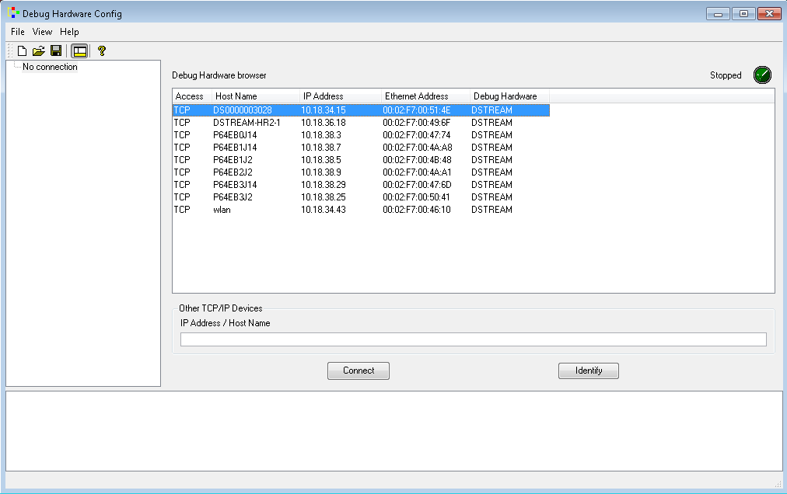

* Click connect
* On te next Window, click on “Auto Configure” button

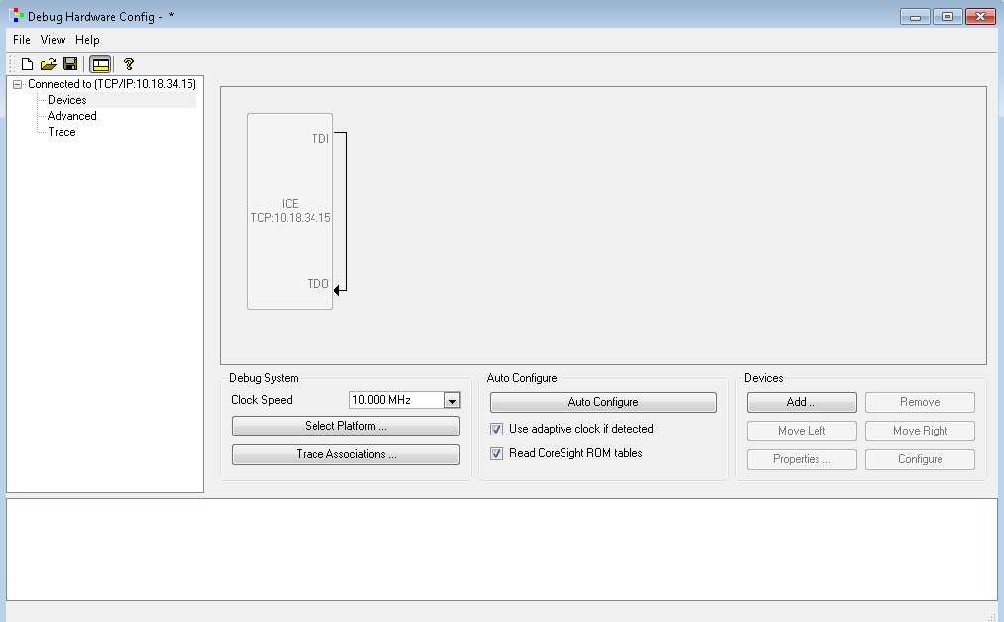

* Debug Hardware Config window should show Cortex-R5_0/1 along with other DAP devices

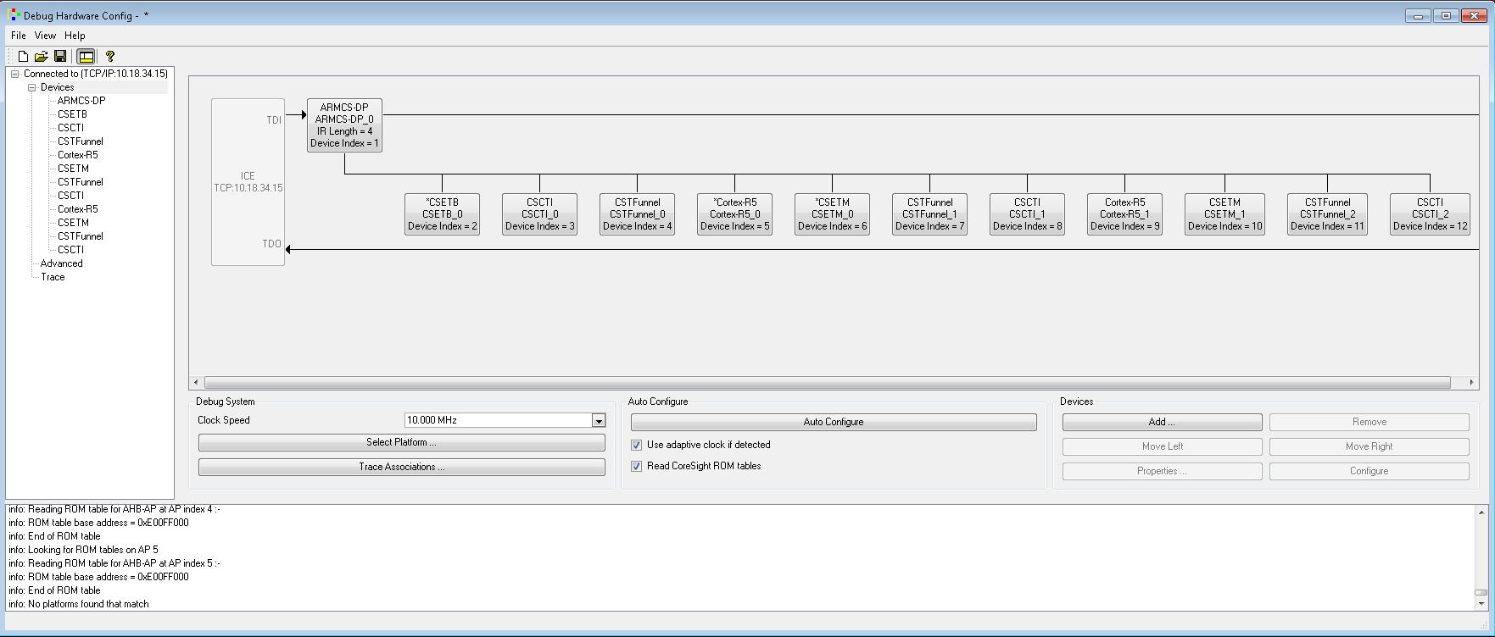

* Save this configuration as "c:\target.rvc"
* Select Start > All Programs > ARM DS-5 >DS-5 Command Prompt
* On the command prompt
* cdbimporter -c C:\DS-5\sw\debugger\configdb c:\target.rvc

Press ‘Enter’

Press ‘Enter’

Input ‘Broadcom’ and press ‘Enter’

Input ‘Trident3_Cortex-R5’ and press ‘Enter’

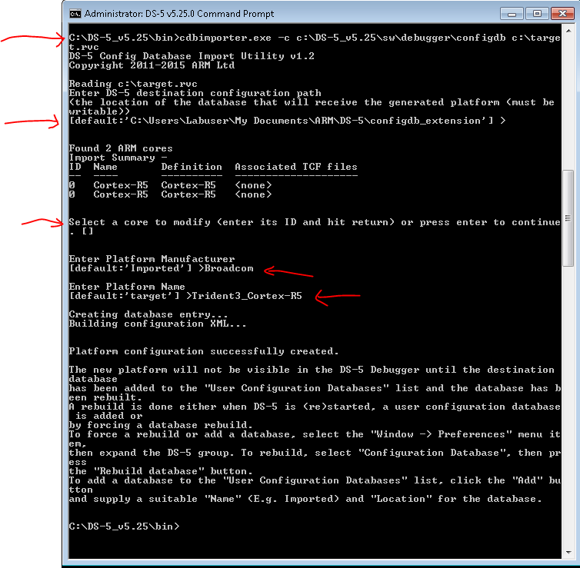

* Rebuild Target base

Enter DS-5, Menu "Window->Preference -> DS-5 -> TargetDatabase", Add the profile

directory and click on Rebuild, Apply and OK.

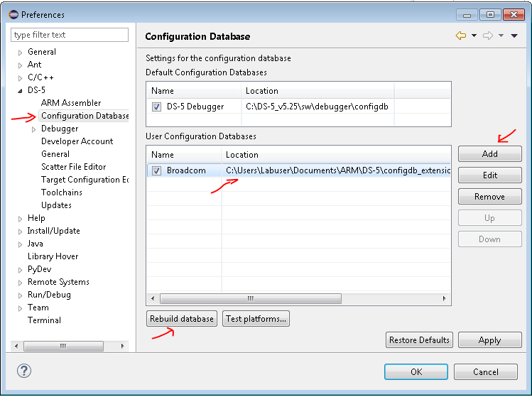

* Connect to target
* Click on DS-5 🡪 Run 🡪 Debug configurations…
* Select DS-5 Debugger, and right click it to create a new target profile, change name in the “Name:” input on the right pane and apply.
* On Connection pane, Select Broadcom->Trident3_Cortex-R5->Bare Metal Debug -> Cortex-R5_0

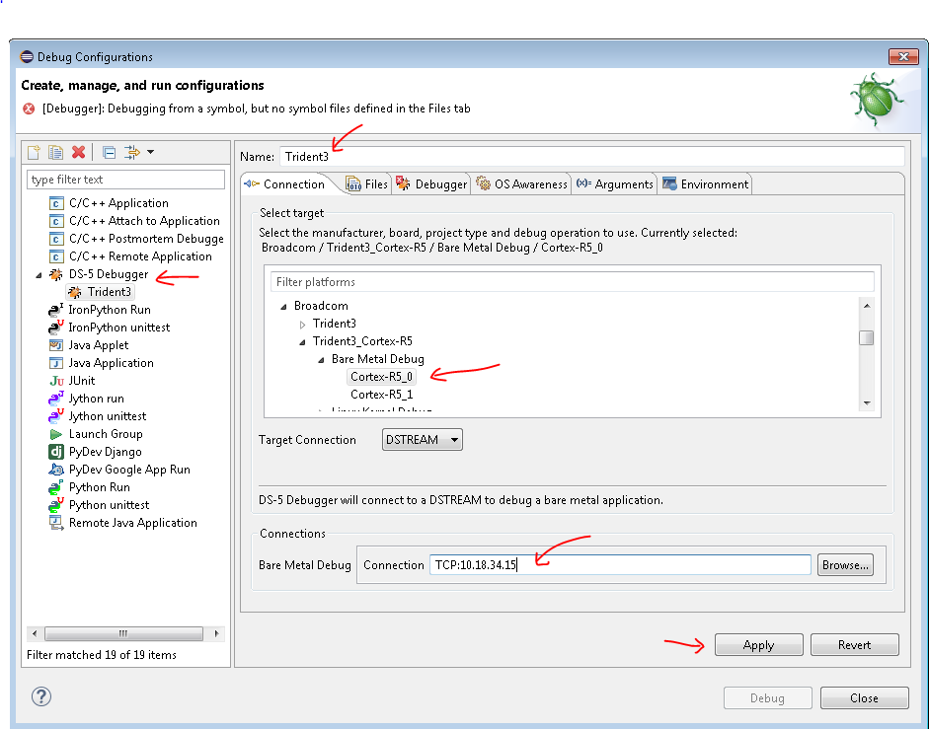

* For “Bare Metal Debug: Connection, provide IP address of Dstream
* Select the ‘Debugger’ tab, and select ‘Connect only’

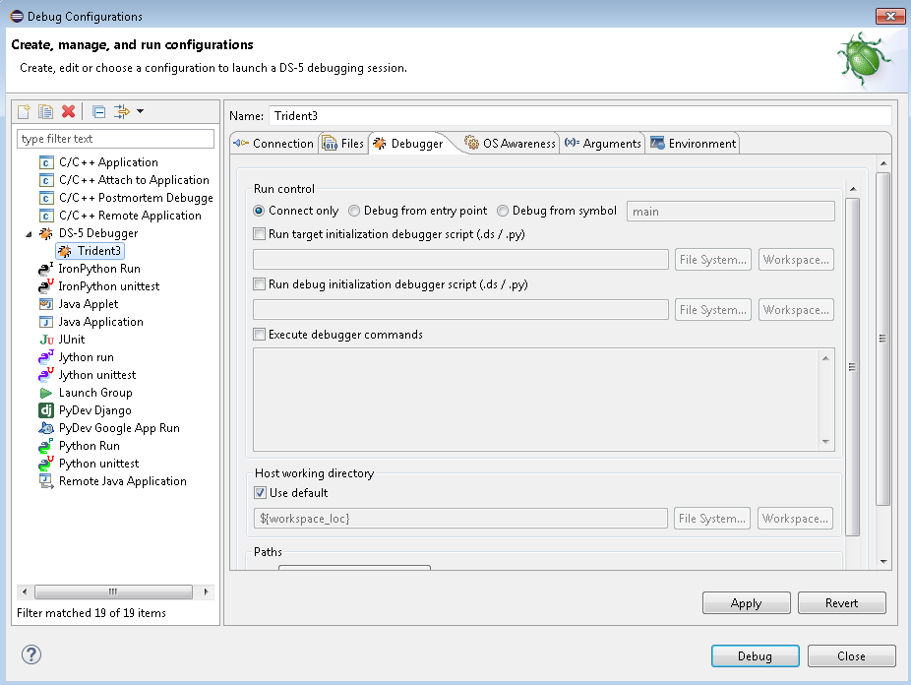

* Click “Apply”
* Click ‘Debug’ button to connect to the target
* Debugger would connect and shows target status

