Back-end
In back-end, I used java and MVC(Module, view, control) to contribute back-end,The name of project is item,there are four layer involved, bean, dao, service,servlet.
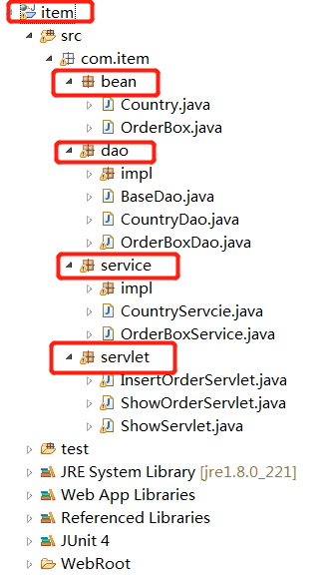

Database:
Configuration of Database, In BaseDao class,
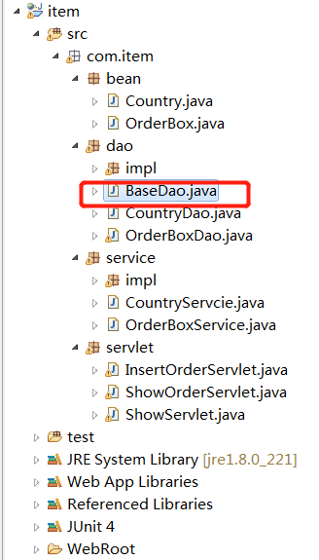
In this class, you need connect in your local database.
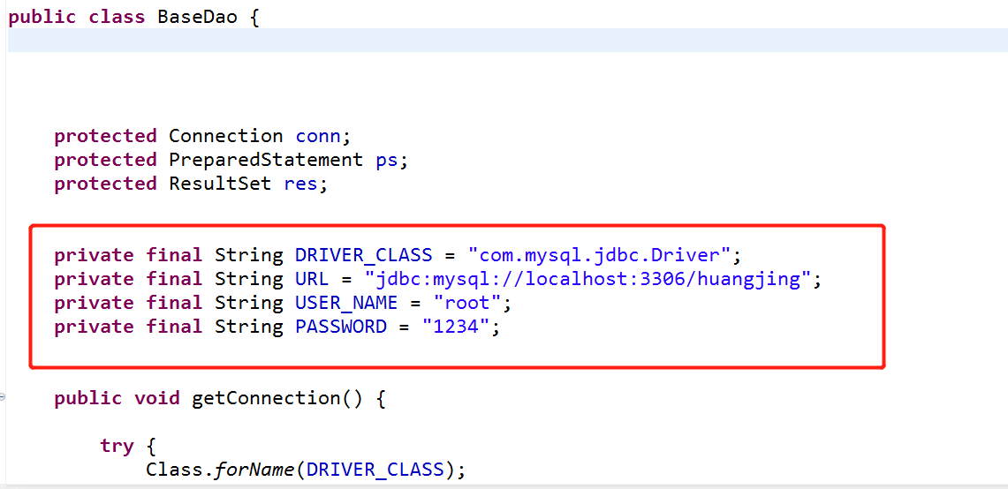

Configuration of service,
In my project, i have run two service in local computer, one is for react ,and other is for back-end, use different port number is necessary, i have configure the port number in the back-end side
