# PW-pipeline

PathWay pipeline using GWAS summary statistics, named analogously after FM-pipepline I have implemented.

## INTRODUCTION

Pathway analysis becomes an important element in GWAS. Broadly, it involves SNP annotation, such as Variant Effect Predictor (VEP), gene analysis such as VEGAS2, and gene set analysis. Visualisation of a particular region has been facilitated with LocusZoom, while network(s) from pathway analysis via [gephi](https://gephi.org/) or [Cytoscape](http://www.cytoscape.org/), which uses genes and a collection of edges, directed or undirected, to build a network. Aspects to consider include part or all databases, individual level genotype data vs GWAS summary statistics, computing speed, with and without tissue enrichment.

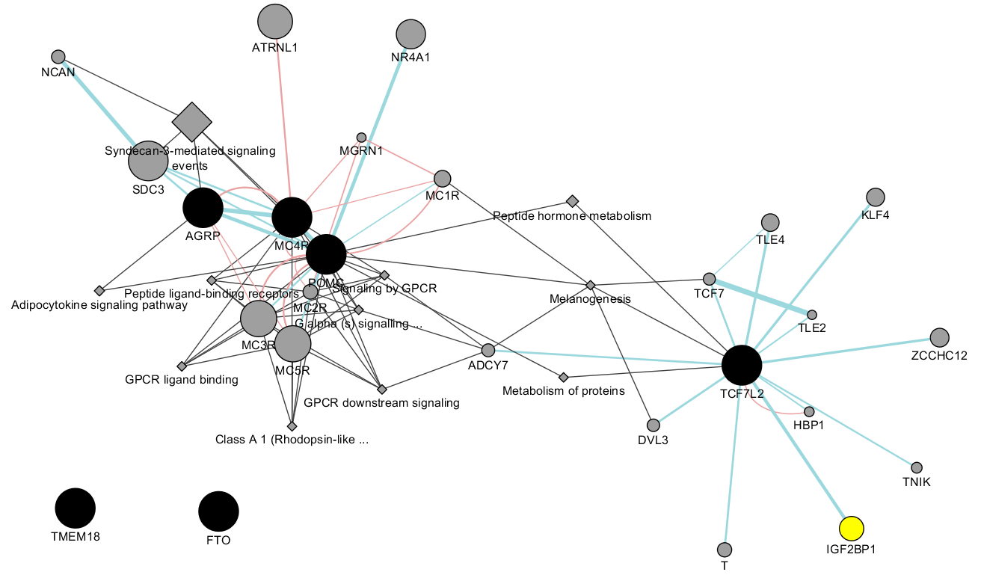

diagram from CytoScape/GeneMANIA

## INSTALLATION

This pipeline involves several software for pathway analysis using GWAS summary statistics, as shown below,

|  |  |  |
| --- | --- | --- |
| **Full name** | **Abbreviation** | **Reference** |
| Meta-Analysis Gene-set Enrichment of variaNT Associations | MAGENTA | Segre, et al. (2010) |
| Multi-marker Analysis of GenoMic Annotation | MAGMA | de Leeuw, et al. (2015) |
| PAthway SCoring ALgorithm | PASCAL | Lamparter, et al. (2016) |
| Data-Driven Expression Prioritized Integration for Complex Traits | DEPICT | Pers, et al.(2015) |

The full functionality of the pipeline requires availability of individual software for pathway analysis, which should fulfil their requirements, e.g., [Matlab](https://www.mathworks.com/products/matlab.html) for MAGENTA, PLINK. It is useful to install [xpdf](https://www.xpdfreader.com/) or [ImageMagick](https://www.imagemagick.org/) to produce Excel workbook. By default [Sun grid engine](https://en.wikipedia.org/wiki/Oracle_Grid_Engine) is used but this can be any other mechanism such as [GNU parallel](https://www.gnu.org/software/parallel/) [note with its --env to pass environment variables]. As usual, [R](https://www.r-project.org/) is required.

The pipeline itself can be installed from GitHub in the usual way.

## USAGE

The pipeline requires users to specify both software and database to be used. It is possible that a given database can be used for several software when appropriate.

The syntax is

bash pwp.sh <input file>

### Input

The input will be GWAS summary statistics [described here](https://github.com/jinghuazhao/SUMSTATS) **in that order without the header**,

### Output

The output will be available from individual directories named after the software you choose, and optionally in case all software are used the output can also be an Excel workbook containing combined results.

In case of DEPICT database, it is possible to call [netowrk_plot.py](files/network_plot.py) to generate network diagram and perform cluster analysis.

## EXAMPLE

The two inputs can be prepared [here](https://github.com/jinghuazhao/SUMSTATS).

We use bmi.txt

pwp.sh bmi.txt

We now use ST4,

pwp.sh ST4 &

## FEATURES

The pipeline puts together analyses involving several software using a unified input format and customises databases across software, with the ability to collect results from them and add features such as FDRs and graphics with possibility for additional analyses. The other aspect is that software such as MAGENTA and PASCAL could take long time while MAGENTA would normally require a copy for a particular user and run interactively which would vie for resources with other interactive sessions. The pipeline enables them run on noninteractive clusters.

Several flags are notable:

* collection_only. If setting to 1, it only collects all available software outputs to form a final Excel file.
* mp. If setting to 1 it will regenerate multiple precision P and -log10(P) values from z, which is necessary when |z| is very large and P=0, -log10(P)=infinity.
* MAGENTA
* min_gs_size. By default, the mininum number of genes contained in a pathway is five rather than 10 in order to be consistent with other software and this can be changed to 10 via min_gs_size in the script if you intend to use the same threshold.
* max_gs_size. By default, the maximum number of genes contained in a pathway is 2000 but this can be changed as above.
* DEPICT
* number_of_threads. Number of threads used by the Java binary.
* p_threshold. This is to accommodate the suggestion that DEPICT is run twice, for P<=5 x 10-8 and P<=10-5, respectively.
* nr_repititions. This sets the number of random sampling (200) for calculated FDR.
* cutoff_type. This takes value of fdr or pvalue for network plot.
* pvalue_cutoff. This sets pvalue cutoff for cutoff_type=pvalue for network plot.

Moreover, potential downstream analysis such as clustering significant pathways and network of pathways is illustrated with [network.sh](files/network.sh), which performs affinity propagation and k-means clustering as well as generates .csv and .sif formats to be used by software gephi and Cytoscape.

Individual software are briefly described as follows.

1. **MAGENTA**. Segre, et al. (2010) describes how it works:

* DNA variants, e.g. single-nucleotide polymorphisms (SNPs), are mapped onto genes.
* each gene is assigned a gene association score that is a function of its regional SNP association p-values.
* confounding effects on gene association scores are identified and corrected for, without requiring genotype data (enabling use of meta-analyses or other types of GWA studies where only variant association statistics are available).
* a Gene Set Enrichment Analysis (GSEA)-like statistical test is applied to predefined biologically relevant gene sets to determine whether any of the gene sets are enriched for highly ranked gene association scores compared to randomly sampled gene sets of identical size from the genome.``

It maps SNPs to genes taking 110 Kb upstream and 40 Kb downstream of each gene as extended boundaries to include regulatory regions. Each gene is then assigned a genetic set (GS) score, which is the P-value of the most significant SNP within the gene’s extended boundaries, corrected for potential confounding factors of physical and genetic properties of genes through a step-wise multiple linear regression.

1. **MAGMA**. It consists of three steps: annotation (--annotate), gene analysis-SNP p values (--pval --gene-annot), and gene-set analysis (--gene-results --set-annot).

The gene-set analysis is divided into two parts.

* a gene analysis is performed to quantify the degree of association each gene has with the phenotype. In addition the correlations between genes are estimated. These correlations reflect the LD between genes, and are needed in order to compensate for the dependencies between genes during the gene-set analysis.
* the gene p-values and gene correlation matrix are then used to perform the actual gene-set analysis.

1. **PASCAL**. Gene scores are obtained by aggregating SNP p-values from a GWAS meta-analysis while correcting for LD using a reference population via the max and sum of chi-squared statistics based on the most significant SNP and the average association signal across the region, respectively. Gene sets are based on external databases for reported pathways by combining the scores of genes that belong to the same pathways. Pathway enrichment of high-scoring (potentially fused) genes is evaluated using parameter-free procedures (chi-square or empirical score), avoiding any p-value cut-off inherent to standard binary enrichment tests.
2. **DEPICT**. It is a computational framework for gene prioritization, GSEA and tissue/cell type enrichment analysis. The GSEA is perfomed by testing whether genes in GWAS-associated loci are enriched for reconstituted versions of known molecular pathways (jointly referred to as reconstituted gene sets). The reconstitution is accomplished by identifying genes that are co-regulated with other genes in a given gene set based on a panel of 77,840 gene expression microarrays. Genes that are found to be transcriptionally co-regulated with genes from the original gene set are added to the gene set, which results in the reconstitution. DEPICT also facilitates tissue and cell type enrichment analyses by testing whether the genes in associated regions are highly expressed in any of the 209 MeSH annotations for 37,427 microarrays on the Affymetrix U133 Plus 2.0 Array platform.

The p.adjust function in R/stats can be used to obtain FDRs and count the number of pathways reaching FDR<=0.05. It implements the so-called Benjamini-Hochberg (BH) procedure, which attempts to control for expected proportion of false discoveries among the rejected hypotheses (i.e., those with p values below 0.05) and most powerful for independent tests. The BH procedure for an m number of tests (pathways) achieves false discovery rate at level α by finding the largest number k such that p values is no greater than (k/m)α, and declares only those below this threshold as being significant, https://en.wikipedia.org/wiki/False_discovery_rate.

## DATABASES

Several databases can be supplied to MAGENTA, MAGMA and PASCAL while by default DEPICT uses its own database. The following table helps to choose specific software and database combinations,

|  |  |  |  |  |
| --- | --- | --- | --- | --- |
| Database | MAGENTA | MAGMA | PASCAL | DEPICT |
| MAGENTA | x | x | x |
| MSigDB/c2 | x | x | x |
| MSigDB | x | x | x |
| DEPICT |  |  |  | x |
| DEPICT* | x | x | x | x |

* The common database to all software is derived from [a database from DEPICT website](https://data.broadinstitute.org/mpg/depict/depict_download/reconstituted_genesets/GPL570-GPL96-GPL1261-GPL1355TermGeneZScores-MGI_MF_CC_RT_IW_BP_KEGG_z_z.txt.gz).

Except DEPICT, MAGENTA database, all or part (c2) of pathways in Molecular Signatures Database (MSigDB) can also be used. An entry in MAGENTA database contains a database ID, a pathway ID, followed by a list of Entrez gene IDs. Although MSigDB has an additional column after the pathway ID indicating URLs of the pathway, it would be ignored by MAGMA for instance since these URLs do not match any Entrez gene IDs thus has no effect on the results. This feature facilitates use of software considerably. Comparative as well as individual results including figures are kept in Excel workbooks called mmp.xlsx, depict.xlsx and xlsx.xlsx, respectively.

Additional details about these databases are described here.

1. **MAGENTA**. There are six databases (.db) with a total of 10,327 entries were distributed with the MATLAB implementation:

|  |  |
| --- | --- |
| Name | Entries |
| GO_terms_BioProc_MolFunc | 9,433 |
| Ingenuity_pathways | 92 |
| KEGG_pathways | 168 |
| PANTHER_BioProc | 241 |
| PANTHER_MolFunc | 252 |
| PANTHER_pathways | 141 |

Only 2,529 contain 10 or more genes were used by MAGENTA by default, leading to Bonferroni threshold 0.05/2529=1.977066e-05 when only this subset is used.

1. **MSigDB** (http://software.broadinstitute.org/gsea/msigdb/collections.jsp). The MSigDB v6.0 is divided into 8 major collections and several sub-collections on 17,779 gene sets, c2 containing 4,731 curated gene sets (from various sources such as online pathway databases, the biomedical literature, and knowledge of domain experts. MSigDB/BIOCARTA_KEGG_REACTOME came as default to PASCAL and MSigDB v4.0 is distributed with PASCAL.

|  |  |  |
| --- | --- | --- |
| Name | Entries | Bonferroni threshold |
| c2.all.v6.0.entrez.gmt | 4,731 | 1.056859015007398e-05 |
| msigBIOCARTA_KEGG_REACTOME.gmt | 1,077 | 4.642525533890436e-05 |
| msigdb.v4.0.entrez.gmt | 10,295 | 4.85672656629431e-06 |
| msigdb.v6.0.entrez.gmt | 17,779 | 2.81230665391754e--06 |

1. **DEPICT**. Some of the entries are described in the following table,

|  |  |
| --- | --- |
| Gene database | Entries |
| Protein molecular pathways | 5,984 |
| Phenotypic gene sets | 2,473 |
| Reactome database pathways | 737 |
| KEGG pathways and gene ontology terms | 184 |

The protein molecular pathways were deribed from 169,810 high-confidence experimentally derived protein-protein interactions, the phenotypic gene sets were from from 211,882 gene-phenotype pairs from the mouse genetics initiative and 5,083 gene ontology terms.

An additional note relates to the DEPICT database: while it is appropriate for comparison, many entries are named after the ENSEMBL GENEID, e.g., ENSG00000000419, linking a reconstituted geneset containing C20orf11 (3.2), TOMM22 (3.1), CSDA (2.3), C5orf47 (2.2), EIF4EBP1 (2.2), NCK1 (2.2), ZNF337 (2.2), GORASP2 (2.1), KDELR3 (2.1), SNX17 (2.1), FAM208B (2.0), ENSG00000243155 (1.9), ENSG00000227195 (1.9), GDI2 (1.9), INHBB (1.8), OCIAD1 (1.7), SMU1 (1.7), ENTPD6 (1.6), LRRC41 (1.6), EIF2B4 (1.6), IRAK3 (1.5), SUMF2 (1.4), CCDC117 (1.4), POMGNT1 (1.3), NANP (1.3), SLC17A9 (1.3), TMEM14B (1.3), CRLS1 (1.2), APTX (1.2), SBNO1 (1.2), MPV17 (1.2), EXD1 (1.2), DNAJB14 (1.2), CALCR (1.2), GSPT1 (1.1), ENSG00000228389 (1.1), METAP1D (1.0), MYCBP (1.0), RSL1D1 (0.9), IFT172 (0.9), SLC25A12 (0.9), C11orf46 (0.9), PIWIL1 (0.9), ABHD12 (0.9), EIF3M (0.8), CBY1 (0.8), SLCO4A1 (0.8), ODF1(0.8), SUV420H2 (0.8), TNFRSF17 (0.7) with value in the bracket being the z-score in the original DEPICT database, so extra work is required to work out the gene SYMBOL in pathways. This can be done via R/ensembldb as follows,

library(EnsDb.Hsapiens.v86)  
chrall <- select(EnsDb.Hsapiens.v86, keys=paste(1:22), keytype="SEQNAME")  
chrall_table <- subset(chr22[selcol],!duplicated(chr22[selcol]))  
write.table(chrall_table,file="GS.txt",quote=FALSE,row.names=FALSE,col.names=FALSE)

So ENSG00000000419 corresponds to DPM1, ENSG00000243155 to RP11-46A10.5 but ENSG00000228389 does not correspond to any symbol. In general, a gene symbol may be mapped to more than one GENEID.

As for Gene Ontology and Mammalian Phenotype Ontology this could be done similarly,

library(GO.db)  
x <- as.list(GOTERM)  
golist <- c("GO:0000002","GO:0000018")  
x[golist]  
  
library(rols)  
mplist <- c("MP:0000003","MP:0000005")  
for(i in mplist) print(term("MP",i))

A pre-prepared table is also available as [id_descrip.txt.gz](files/id_descrip.txt.gz) which will be complementary to these.

## ACKNOWLEDGEMENTS

The work drives from comparison of software performances using our own GWAS data. The practicality of a common DEPICT database to all software here was due to PASCAL developer(s). At the end of our implementation it came to our attention that similar effort has been made, e.g., [DEPICT-pipeline](https://github.com/RebeccaFine/DEPICT-pipeline) and other adaptations.

## RELATED LINKS

* [BioGRID](https://thebiogrid.org/): an interaction repository with data compiled through comprehensive curation efforts.
* [Osprey](https://osprey.thebiogrid.org/): Network Visualization System.
* [GeneMANIA](http://genemania.org/): Imports interaction networks from public databases from a list of genes with their annotations and putative functions.
* [VisANT](http://visant.bu.edu/): Visual analyses of metabolic networks in cells and ecosystems.

## SOFTWARE AND REFERENCES

[DEPICT](https://data.broadinstitute.org/mpg/depict/) ([GitHub](https://github.com/perslab/depict))

Pers TH et al.(2015) Biological interpretation of genome-wide association studies using predicted gene functions. Nat Commun. 6:5890. doi: 10.1038/ncomms6890.

[MAGENTA](https://software.broadinstitute.org/mpg/magenta/)

Segre AV, et al (2010). Common Inherited Variation in Mitochondrial Genes Is Not Enriched for Associations with Type 2 Diabetes or Related Glycemic Traits. PLoS Genet. 12;6(8). pii: e1001058. doi: 10.1371/journal.pgen.1001058

[MAGMA](http://ctg.cncr.nl/software/magma)

de Leeuw C, et al. (2015) MAGMA: Generalized Gene-Set Analysis of GWAS Data. PLoS Comput Biol. 11(4): e1004219. doi: 10.1371/journal.pcbi.1004219

[PASCAL](http://www2.unil.ch/cbg/images/3/3d/PASCAL.zip) ([GitHub](https://github.com/dlampart/Pascal))

Lamparter D, et al. (2016) Fast and Rigorous Computation of Gene and Pathway Scores from SNP-Based Summary Statistics. PLoS Comput Biol. 2016 Jan 25;12(1):e1004714. doi: 10.1371/journal.pcbi.1004714