Search Test Lab Report

Names: Jingjing Liao

**1. Linear Search**

We know from class that the theoretical time complexity of linear search over *unordered lists* is:

|  |  |  |
| --- | --- | --- |
| **Best Case** | **Worst Case** | **Average Case** |
| *1* | *N* | *N/2* |

**Q1:** Increasing the number of trials and the value of N

1. Run experiments with an increasing value of N (from 1000 to 10,000). Does increasing N affect how many trials you have to run to get accurate results? Explain.

Yes, the more the number input, the more trials should be to get accurate results

Because the range to pick the key becomes larger, we need more trials to make sure the result is correct

1. Write down the number of trials that seem to have worked well for N=10,000.

|  |
| --- |
| **Number of Trials** |
| 1000 |

**Q2:** Linear Search Time Complexity Plot (Unordered List)

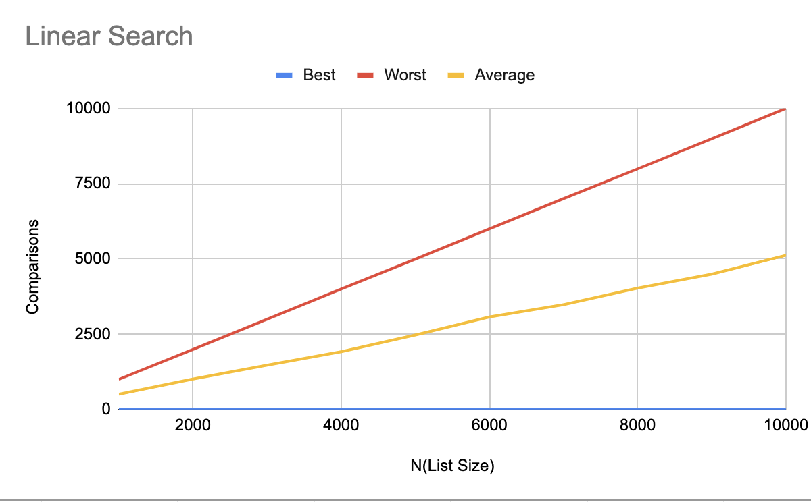

**Q3:** Does the order of the data in the list affect the number of comparisons? In the table below, guess the time complexity of Linear Search on an *Ordered List.*

|  |  |  |
| --- | --- | --- |
| **Best Case** | **Worst Case** | **Average Case** |
| 1 | N | N/2 |

Linear Search Time Complexity Plot (Ordered List)

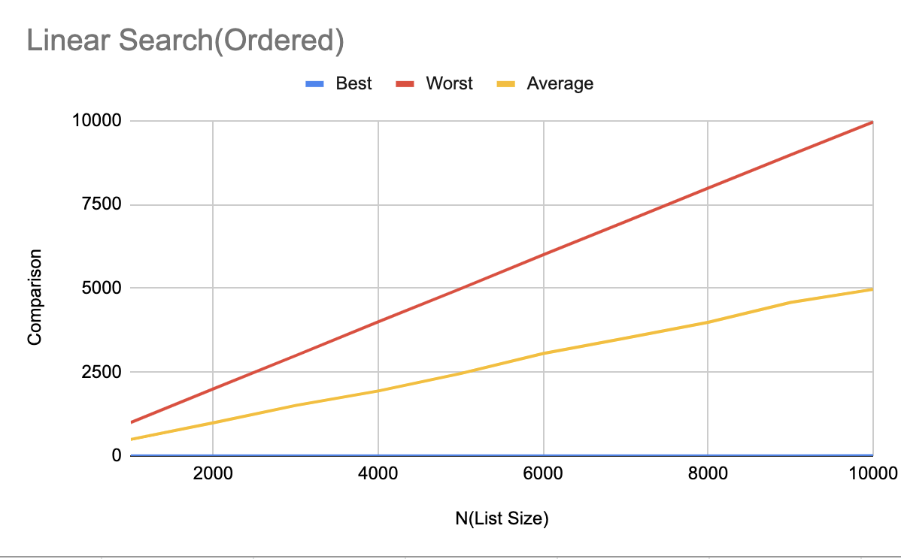

**Conclusion:**

Whether it is ordered or unordered list has the same time complexity for linear search algorithm

**2. Binary Search**

We know from class that the theoretical time complexity of binary search over *ordered lists* are:

|  |  |  |
| --- | --- | --- |
| **Best Case** | **Worst Case** | **Average Case** |
| *1* | $$\log_{2}{N}$$ | $$\log_{2}{N}$$ |

**Q4:** Binary Search Time Complexity Plot

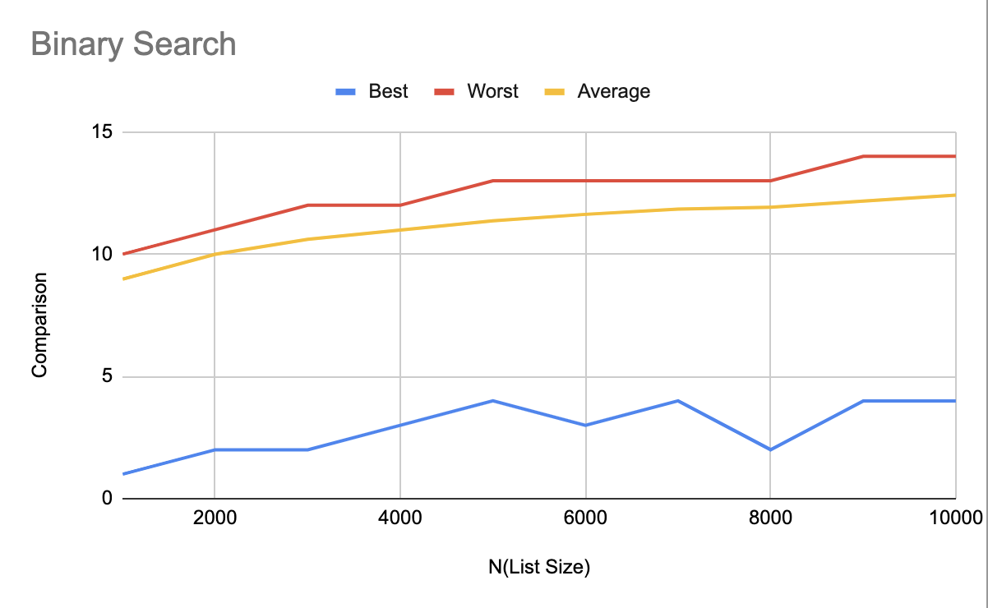

**Conclusion:** What do your results tell you about the average-case complexity of Binary Search?

The average case and the worst case is near to each other

**3. Median**

Q5: We hypothesize that the time complexity of find_median is:

|  |  |  |
| --- | --- | --- |
| **Best Case** | **Worst Case** | **Average Case** |
| N | $$N^{2}$$ | $$N^{2}/2$$ |

**Justification:**

1. Best case scenario:

*Happens when the first element is the median one*

1. Best case scenario:

*Happens when the last element in the list is the median one*

1. Average case scenario: *mid element in the list is the median one*

Find_median Time Complexity Plot

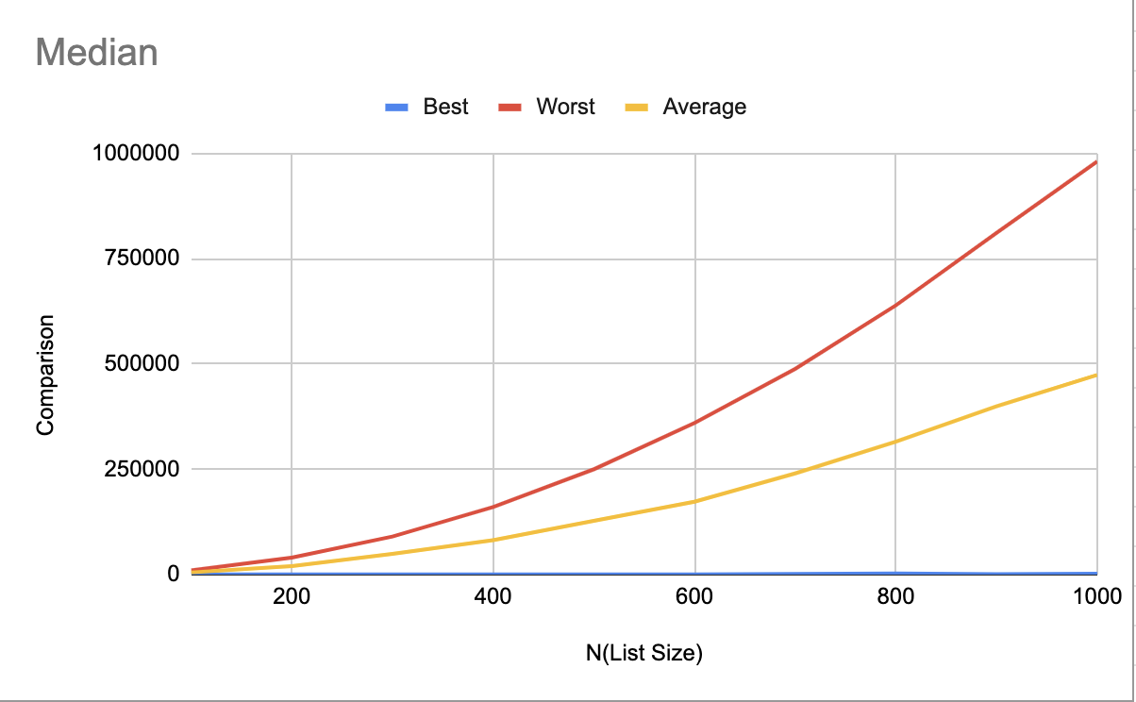

**Conclusion:** Did your results support your hypothesis? If not, why not, and how does it change your original hypothesis?

My result support my hypothesis