RefLookUp: Managing Citations for Biosketches
Use RefLookUp to easily verify your publications and easily import them into MyNCBI for your NIH Biosketch.

1. Export References
Export your selected references from Google Scholar (or another manager) as a .bib or .csv file.
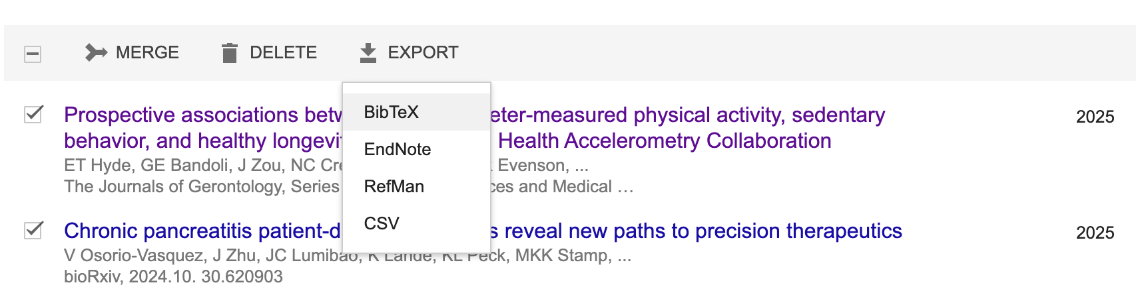

2. Verify in RefLookUp
Go to the RefLookUp Web App:
https://reflookup.streamlit.app/
browse, or drag and drop your exported file into the upload field, and click Search References.
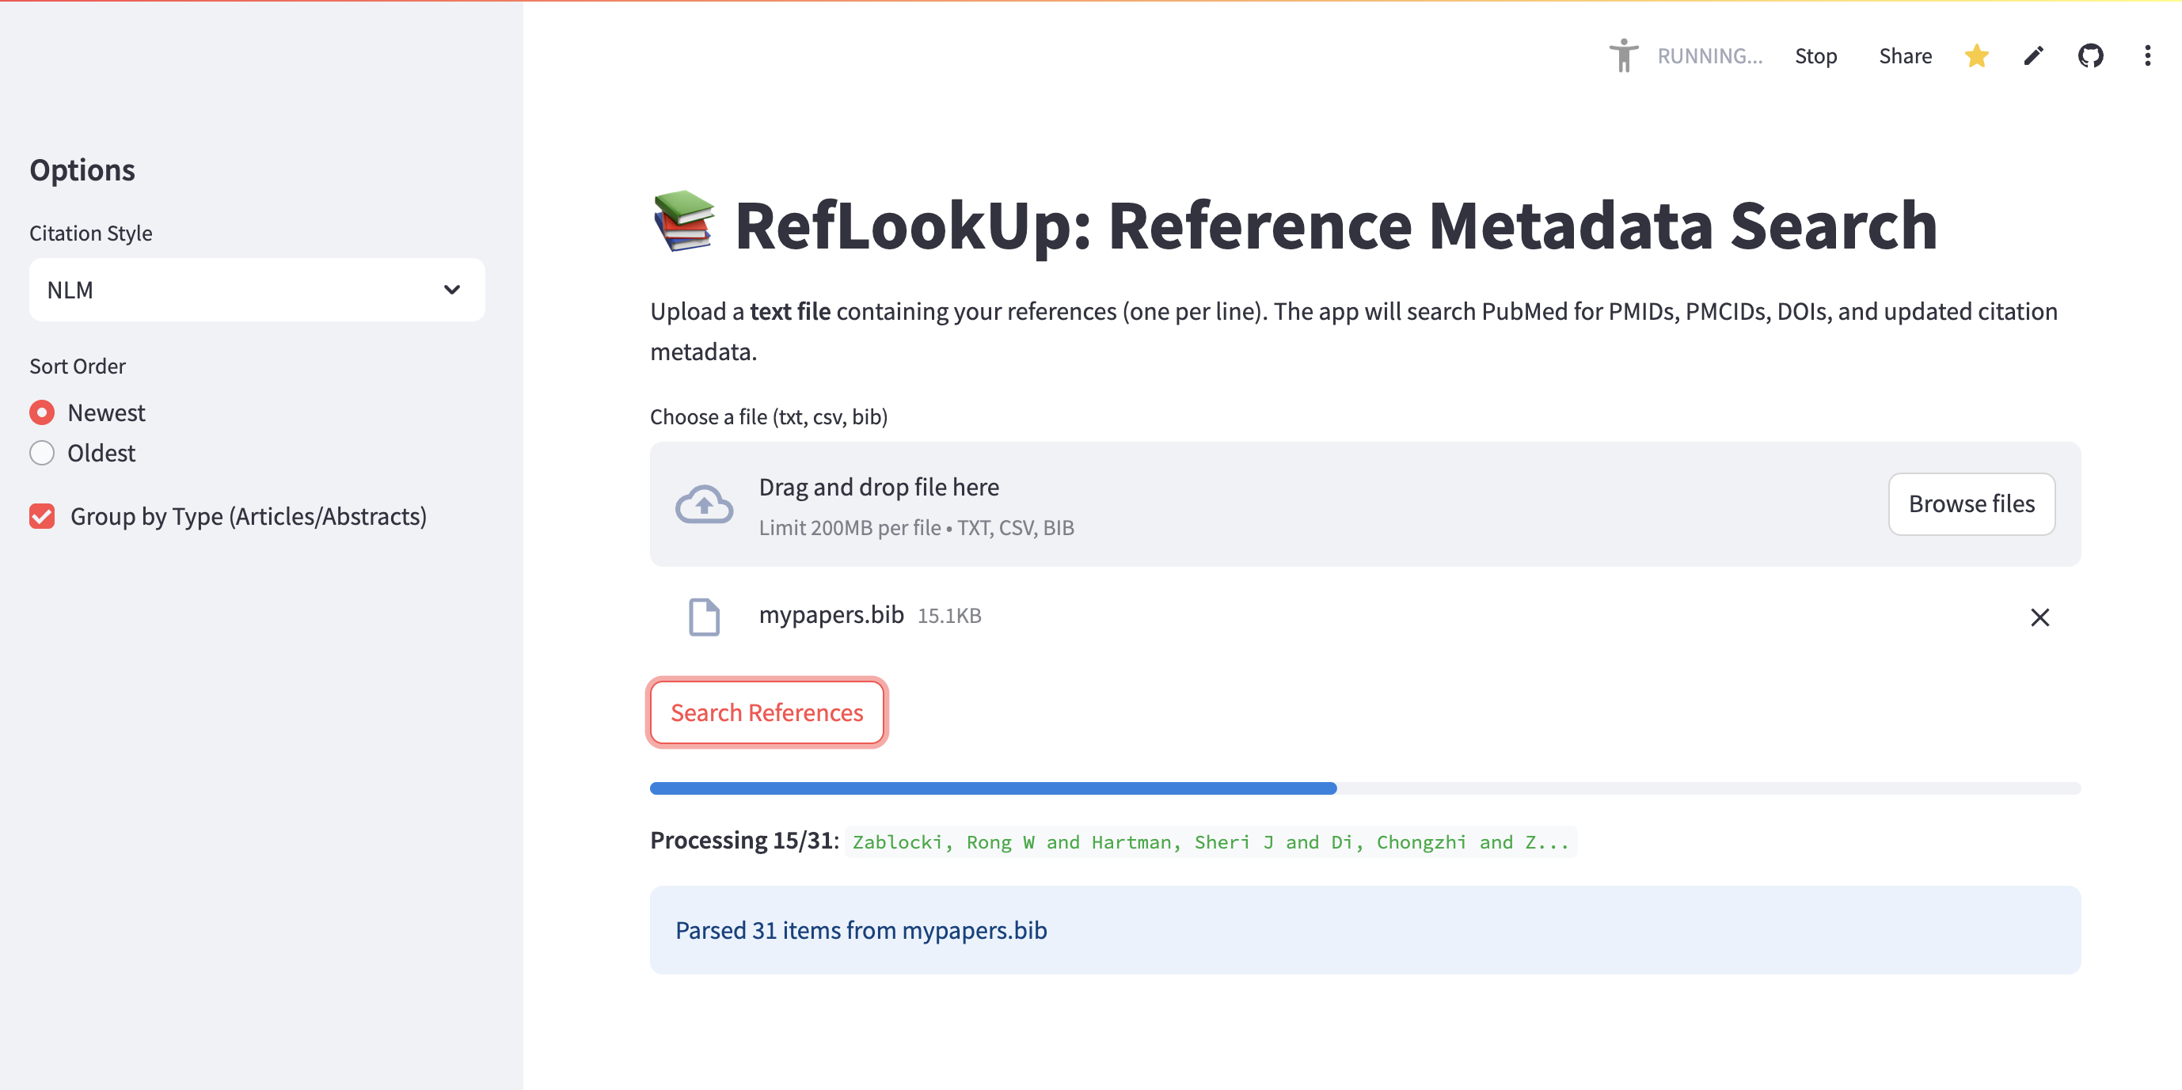

Once finished, look for the RIS download button. This format is specifically designed for citation managers on myNCBI.
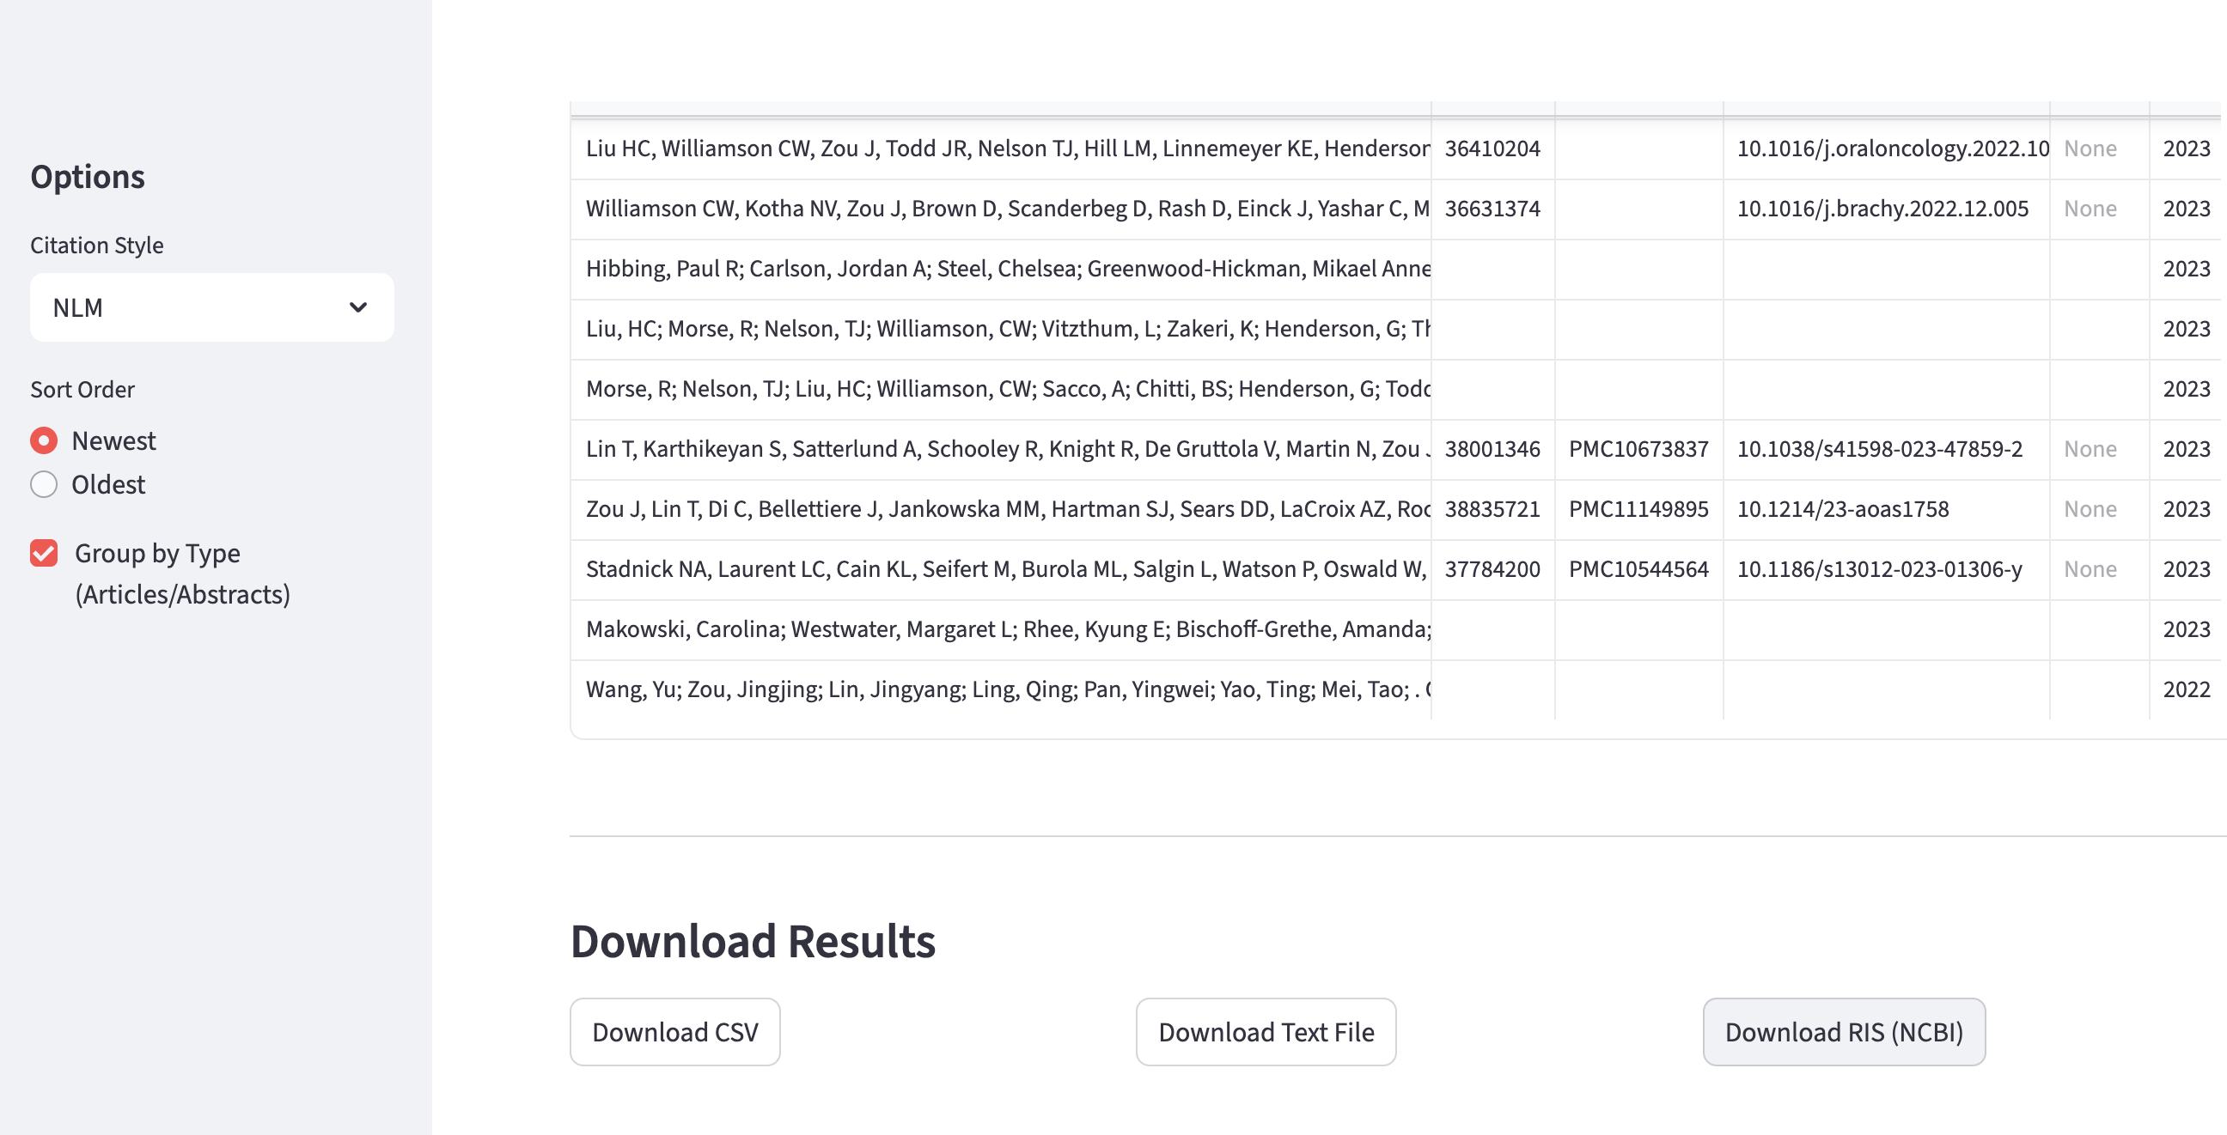

3. Import to MyNCBI
Go to your MyNCBI Bibliography. Click "Manage My Bibliography" -> "Add Citations" -> "From a file". Upload the .ris file you just downloaded.
