**My test file**

# 1111

Do you just want OCR server, or see the working example of this package? Yes, there is already-made server application, which is seriously easy to deploy!

👉 <https://github.com/otiai10/ocrserver>

[LINK](https://yourbasic.org/golang/trim-whitespace-from-string/)

----------------------------------------------------

|  |  |
| --- | --- |
| 11 | Aa |
| 22 | Bb |
| 33 | Cc |

----------------------------------------------------

# 2222

**核心的patch代码和算号代码并不是我写的，本项目1.9版本中的破解方案来自这位大佬 @googleweb ，**

**2nd page**

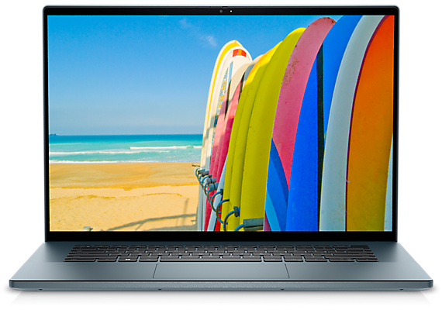

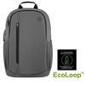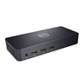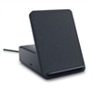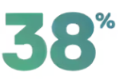

**Version ?**

**3rd Page**

## **使用 os.Stat() 获取 file 文件信息**

### ["yield"关键字有什么作用？](https://qa.1r1g.com/sf/ask/16223721/)

打开BurpLoaderKeygen.jar即可自动启动BurpSuite，不显示注册机窗口，但会在后台自动检测Burp更新，当检测到更新时将显示注册机，你可以勾选Ignore Update 来禁止检测更新，启动Burp后注册机直接退出