# Config for obfuscar xml

## Add config file

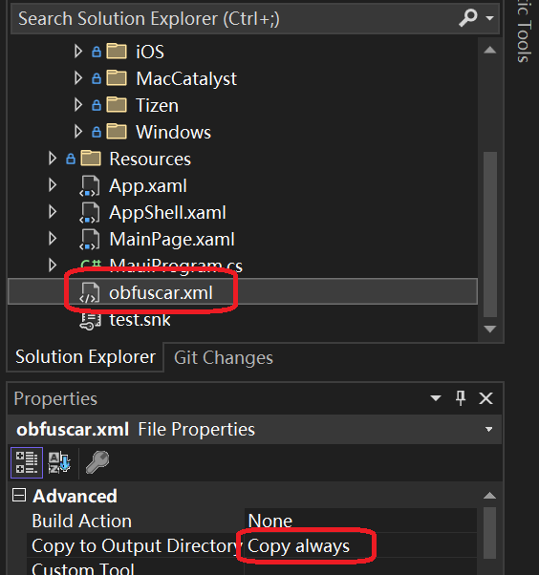

Property of the file obfuscar.xml should be set to Copy always,

or the compile error will be occurred.

## Config

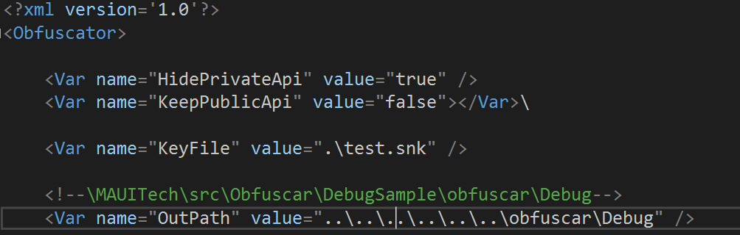

The OutPath here means that where the obfuscated DLL file will be produced to, the path of this sample code is:

\MAUITech\src\Obfuscar\DebugSample\obfuscar\Debug

# Config for csproj

## MSBuild’s event

[Extend the build process - MSBuild | Microsoft Learn](https://learn.microsoft.com/en-us/visualstudio/msbuild/how-to-extend-the-visual-studio-build-process?view=vs-2022#example-aftertargets-and-beforetargets)

We should follow the example to use the “AfterTargets” instead of using “AfterRebuild” directly.



## Config execute command

WorkingDirectory is the path which obfuscar process the obfuscate work, here is the exe's path



## Copy command

SourceFiles is the obfuscated file's path

DestinationFolder is exe's path

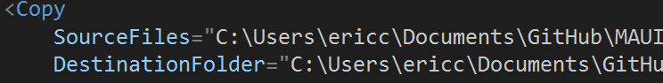

# Config for snk file

# Find the exception information

## Replicate the exception

### Obfuscar xml:



### csproj:



### Runtime exception:

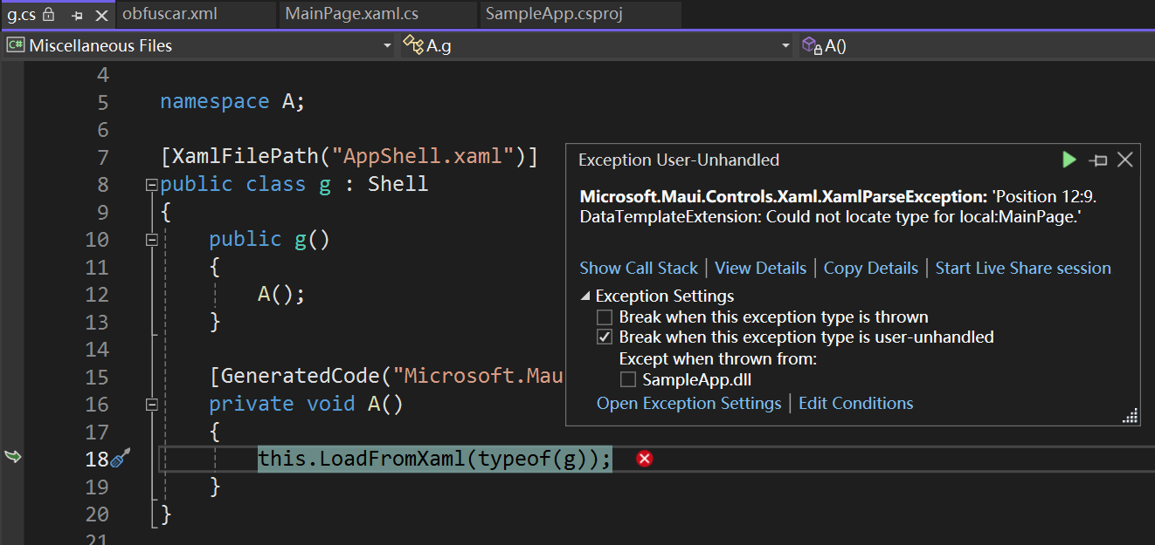

### Exception Analysis

#### 1)Could not locate type exception:

DataTemplateExtension: Could not locate type for local:MainPage.

#### Root cause

Check the dll:

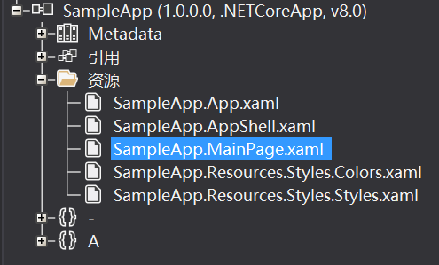

In debug mode, the xaml file is not compiled to IL, so the name “MainPage” will pass to the code as parameter, so the exception throw.

[XAML compilation - .NET MAUI | Microsoft Learn](https://learn.microsoft.com/en-us/dotnet/maui/xaml/xamlc?view=net-maui-8.0#enable-xaml-compilation):

XAML compilation is enabled by default in .NET MAUI apps. For apps built using the debug configuration, XAML compilation provides compile-time validation of XAML, but does not convert the XAML to IL in the assembly. Instead, XAML files are included as embedded resources in the app package, and evaluated at runtime. For apps built using the release configuration, XAML compilation provides compile-time validation of XAML, and converts the XAML to IL that's written to the assembly. However, XAML compilation behavior can be overridden in both configurations with the XamlCompilationAttribute class.

#### Fix this exception

Skip MainPage for obfuscate:



#### 2)No method with correct signature exception:

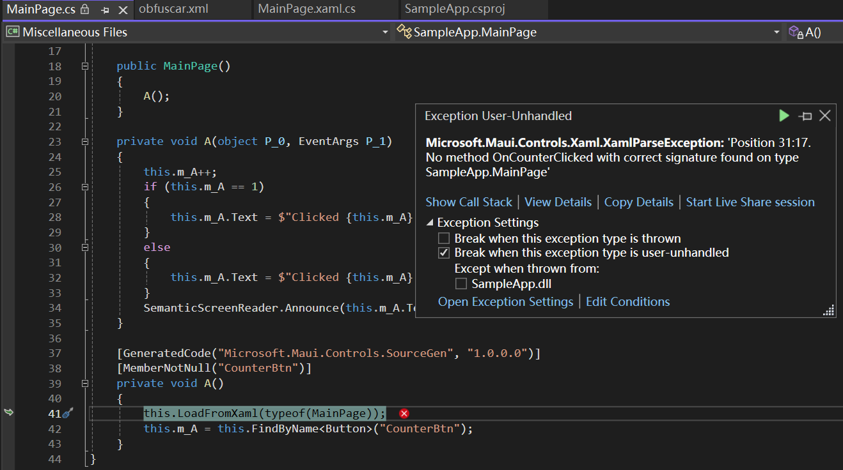

#### Root cause

Because of xaml still using the event name “OnCounterClicked”, but c# code was obfuscated

#### Fix this exception

Add the exclude obfuscation attribute above the callback method of the event



#### 3)No any info from exception:

No any exception information from runtime

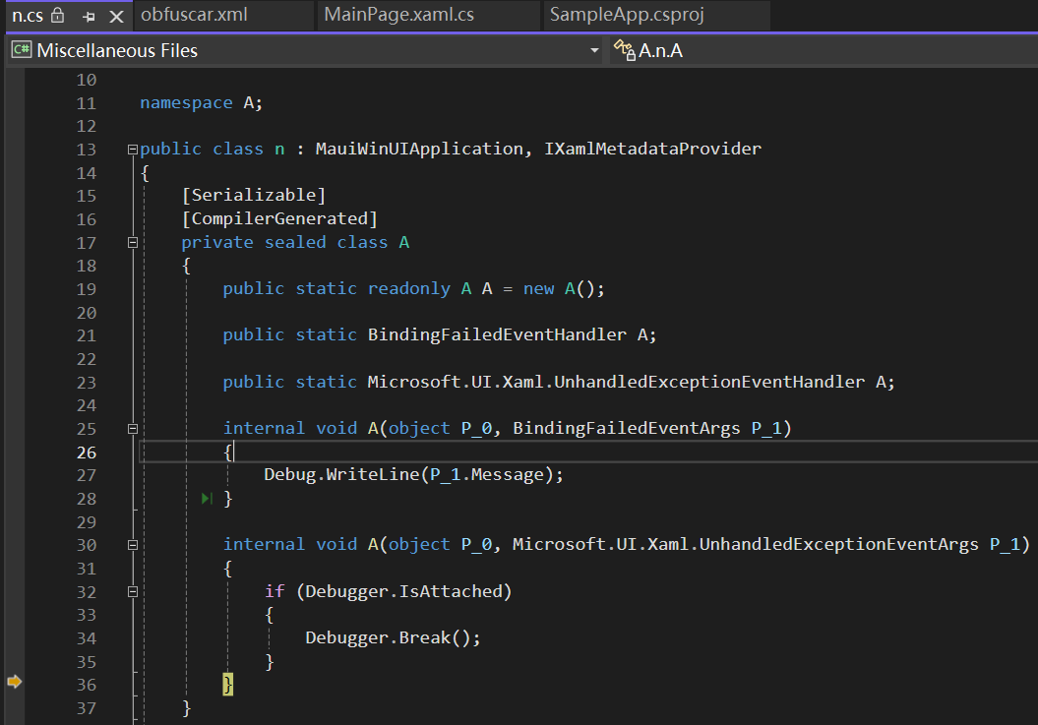

#### Root cause

Not sure

#### Fix this exception:

Clean the solution and delete the bin folder and obj folder.