# **Supplementary Information**

## **Supplementary Tables**

Supplementary Table 1 Summary statistics

|  |  |  |  |  |  |
| --- | --- | --- | --- | --- | --- |
| Variable | Obs. | Mean | Std. dev. | Min. | Max. |
| Heatwave | 803,746 | 0.094 | 0.292 | 0 | 1 |
| Outages per county | 803,746 | 2.463 | 1.410 | 0 | 104 |
| Outage length (hours) | 803,746 | 6.448 | 15.888 | 0 | 3,138 |
| Distance-weighted daily temperature(°C) | 803,746 | 24.815 | 3.504 | 11.204 | 32.329 |
| Distance-weighted visibility (miles) | 803,746 | 10.126 | 1.767 | 2.510 | 17.915 |
| Distance-weighted wind speed (m/s) | 803,746 | 2.432 | 0.460 | 0.607 | 9.055 |
| Distance-weighted precipitation (inch/day) | 803,746 | 0.208 | 0.187 | 0.001 | 7.626 |
| Distance-weighted relative humidity | 803,746 | 76.772 | 6.853 | 33.891 | 97.636 |
| Economic loss from natural hazards (100 million yuan) | 803,746 | 186.434 | 168.882 | 1.7 | 602.6 |
| Wildfire | 803,746 | 47.176 | 41.851 | 2 | 206 |
| Holiday dummy | 803,746 | 0.095 | 0.293 | 0 | 1 |

Notes: The summary statistics of outages refer to the average daily outages per county, which is the total of events across all locations. Distance-weighted variables are calculated as a weighted average using the inverse distance weighting approach, which aligns the data from meteorological stations with the county centroid based on their latitudes and longitudes.

Supplementary Table 2 Impacts of heatwaves on residential power outages

|  |  |  |
| --- | --- | --- |
|  | Outage Occurrence | Outage length |
| Heatwave | 0.040*** | 0.083*** |
|  | (0.005) | (0.011) |
| 2019.year | 0.000 | 0.000 |
|  | (.) | (.) |
| 2020.year | 0.016* | 0.086*** |
|  | (0.010) | (0.020) |
| 2021.year | 0.066*** | 0.177*** |
|  | (0.011) | (0.023) |
| 5.month | 0.000 | 0.000 |
|  | (.) | (.) |
| 6.month | 0.117*** | 0.302*** |
|  | (0.010) | (0.025) |
| 7.month | -0.011 | -0.028 |
|  | (0.008) | (0.021) |
| 8.month | -0.030*** | -0.072*** |
|  | (0.008) | (0.023) |
| 9.month | 0.043*** | 0.116*** |
|  | (0.006) | (0.015) |
| 10.month | 0.080*** | 0.219*** |
|  | (0.008) | (0.021) |
| Weekend dummy | -0.134*** | -0.321*** |
|  | (0.006) | (0.015) |
| Distance-weighted visibility | -0.001 | -0.007** |
|  | (0.001) | (0.003) |
| Distance-weighted wind speed (m/s) | 0.021*** | 0.049*** |
|  | (0.003) | (0.007) |
| Distance-weighted precipitation (inch/day) | 0.047*** | 0.087*** |
|  | (0.010) | (0.024) |
| Distance-weighted relative humidity | 0.002*** | 0.005*** |
|  | (0.000) | (0.001) |
| Economic loss from natural hazards (in 100 million yuan) | 0.069*** | 0.168*** |
|  | (0.022) | (0.044) |
| Wildfire dummy | 0.002* | 0.006** |
|  | (0.001) | (0.003) |
| Holiday dummy | -0.231*** | -0.613*** |
|  | (0.010) | (0.023) |
| _cons | -12.743*** | -30.946*** |
|  | (4.004) | (8.019) |
| N | 803746 | 803746 |
| R2 | 0.067 | 0.062 |

Notes: Month-fixed effects control for temporal variation using a set of indicators for month. County-by-year fixed effects control for the county-specific unobserved factors. Clustered at the city gives cluster-robust standard errors that reflect the clustering of data in a city. The dependent variable is the log of residential outages. Standard errors in the parentheses are clustered at the county level. *p<0.10, **p<0.05, *** p<0.01.

Supplementary Table 3 Power outage interruption costs and values of VoLL (the Value of Lost Load)

|  |  |  |  |
| --- | --- | --- | --- |
| Country | Year | VoLL | Reference |
| Germany | 2007 | 15.7 €/kWh | (Praktiknjo et al., 2011) |
| Republic of Ireland | 2008 | 12.9 €/kWh | (Leahy and Tol, 2011) |
| Cyprus | 2009 | 6.5 €/kWh | Zachariadis, T., & Poullikkas, A. (2012). |
| Austria | 2011 | 17.1 €/kWh | ([Reichl et al., 2013](https://www.sciencedirect.com/science/article/pii/S1040619024000216#bib78)) |
| US | 2012 | $2.3/kWh | ([London Economics International LLC, 2013](https://www.sciencedirect.com/science/article/pii/S1040619024000216#bib56)) |
| *Notes: It also includes VoLL for Austria, New Zealand; Australia, Republic of Ireland* | | | |
| Netherlands | 2013 | 15.8 €/kWh | ([Shivakumara et al., 2017](https://www.sciencedirect.com/science/article/pii/S1040619024000216#bib84)) |
| US |  |  |  |
| *Notes: It also includes VoLL for 28 countries in the European Union* | | | |
| China | 2017 | 4.8–12.1 yuan/kWh | ([Chen et al., 2021](https://www.sciencedirect.com/science/article/pii/S1040619024000216#bib18)) |
| US | 2018 | $1.7–2.3 /kW | (Baik et al., 2020) |

Notes: Power outage interruption costs, or the Value of Lost Load (VoLL), represent the average cost to consumers per unit of unserved electricity due to outages. This encompasses both direct costs, such as spoiled food and lost productivity, and indirect costs, including inconvenience and potential health risks. This table includes only studies published after 2010. The most common methodologies employed are survey methods (i.e., willingness to pay (WTP) and willingness to accept (WTA)) and macroeconomic approaches. The mean and standard deviation of these costs were calculated after adjusting for inflation to the year 2020, and then converting to yuan.

Supplementary Table 4 Projected residential outages under climate scenarios

|  |  |  |  |  |
| --- | --- | --- | --- | --- |
|  |  | 2030 | 2050 | 2090 |
| RCP2.6 | Average heatwave frequency | 0.145 | 0.142 | 0.122 |
|  | Increase in outage occurrence | 12.5% | 12.0% | 8.8% |
|  | Economic losses (billion yuan) | 9.7 | 3.2 | 3.1 |
| RCP4.5 | Average heatwave frequency | 0.100 | 0.113 | 0.177 |
|  | Increase in outage occurrence | 5.2% | 7.4% | 17.6% |
|  | Economic losses (billion yuan) | 1.3 | 1.9 | 4.5 |
| RCP8.5 | Average heatwave frequency | 0.120 | 0.194 | 0.324 |
|  | Increase in outage occurrence | 8.4% | 20.3% | 41.2% |
|  | Economic losses (billion yuan) | 2.2 | 5.2 | 10.6 |

Supplementary Table 5 Marginal cost of grid reliability improvement

|  |  |  |  |
| --- | --- | --- | --- |
| Country | Methods | Marginal cost | Reference |
| Pakistan | Econometrics method | 0.023 Rupees per minute per customer (2018) | (Mirza and Mushtaq, 2022) |
| China | Distance function approach | 59.66 to 74.65 yuan/per min per customer (2012–2018) | (Yuan et al., 2021) |
| China | Distance function approach | $1.67 per household* h (2017) | (Chen et al., 2021) |
| France | Distance function approach | 10.7€ shadow price of quality (2003–2005) | (Coelli et al., 2013) |
| UK | Econometrics method | 30.7 pence per minute per customer (1995–2003) | (Jamasb et al., 2012) |

Notes: We obtained the reported values in the literature, deflated them to 2020, and then transferred them to yuan. The mean is 16.2 yuan per minute per customer with a standard deviation of 33.2 yuan. The annual costs of upgrading a county’s grid are calculated by multiplying the marginal cost per minute per customer by the number of customers and the average unserved electricity for the county.

Supplementary Table 6 Impact of heatwaves and grid reliability on residential outages

|  |  |  |  |  |
| --- | --- | --- | --- | --- |
|  | Low-reliability regions | | High-reliability regions | |
|  | Outage occurrence | Outage length | Outage occurrence | Outage length |
| Heatwave | 0.055*** | 0.109*** | 0.029*** | 0.061*** |
|  | (0.004) | (0.009) | (0.003) | (0.008) |
| Month fixed effects | Yes | Yes | Yes | Yes |
| County-by-year fixed effects | Yes | Yes | Yes | Yes |
| Climate extreme covariates | Yes | Yes | Yes | Yes |
| County-by-year fixed effects | Yes | Yes | Yes | Yes |
| N | 404,260 | 404,260 | 399,486 | 399,486 |

Notes: The dependent variable is the log of residential outages. Standard errors in the parentheses are clustered at the county level. *p<0.10, **p<0.05, *** p<0.01.

Supplementary Table 7 Impact of heatwaves on residential outages in different regions

|  |  |  |  |  |
| --- | --- | --- | --- | --- |
|  | Regions with high fossil generation | | Regions with high renewable generation | |
|  | Outage occurrence | Outage length | Outage occurrence | Outage length |
| Heatwave | 0.033*** | 0.072*** | 0.082*** | 0.143*** |
|  | (0.002) | (0.006) | (0.007) | (0.016) |
| County-by-year fixed effects | Yes | Yes | Yes | Yes |
| Month fixed effects | Yes | Yes | Yes | Yes |
| Weather covariates | Yes | Yes | Yes | Yes |
| Climate extreme covariates | Yes | Yes | Yes | Yes |
| N | 618,718 | 618,718 | 185,028 | 185,028 |

Notes: The dependent variable is the log of residential outages. Regions with high renewable generation (wind, solar, and hydroelectric) refer to the top five provinces, namely, Sichuan, Yunnan, Hubei, Inner Mongolia, and Guizhou provinces. Standard errors in the parentheses are clustered at the county level. *p<0.10, **p<0.05, *** p<0.01.

Supplementary Table 8 Impacts of heatwaves on residential peak-hour power outages in cities of different industrial production levels

|  |  |  |  |  |  |  |
| --- | --- | --- | --- | --- | --- | --- |
|  | Light-industry cities | | Middle-industry cities | | Heavy-industry cities | |
| Outage occurrence | Outage length | Outage occurrence | Outage length | Outage occurrence | Outage length |
| Heatwave | 0.020*** | 0.034*** | 0.030*** | 0.058*** | 0.035*** | 0.076*** |
|  | (0.003) | (0.008) | (0.003) | (0.009) | (0.004) | (0.009) |
| County-by-year fixed effects | Yes | Yes | Yes | Yes | Yes | Yes |
| Month fixed effects | Yes | Yes | Yes | Yes | Yes | Yes |
| Weather covariates | Yes | Yes | Yes | Yes | Yes | Yes |
| Climate extreme covariates | Yes | Yes | Yes | Yes | Yes | Yes |

Notes: Month-fixed effects control for temporal variation using a set of indicators for months. County-by-year fixed effects control for the county-specific unobserved factors across different years. Clustered at the city gives cluster-robust standard errors that reflect the clustering of data in a city. The cities are divided into three equal groups based on their percentage of secondary industry production to total gross production (China City Statistical Yearbook, 2020–2022). The dependent variable is the log of residential outages. Standard errors in the parentheses are clustered at the county level. *p<0.10, **p<0.05, *** p<0.01.

Supplementary Table 9 Impact of heatwaves on the number of household outages

|  |  |  |
| --- | --- | --- |
|  | Outage occurrence | |
| Heatwave | 0.015*** | 0.015*** |
|  | (0.005) | (0.005) |
| County fixed effects | Yes | No |
| Year fixed effects | Yes | No |
| Month fixed effects | Yes | Yes |
| Weather covariates | Yes | Yes |
| Climate extreme covariates | Yes | Yes |
| County-by-year fixed effects | No | Yes |
| N | 25,251 | 25,251 |

Notes: The dependent variable is the log of residential outages in a thousand households. *p<0.10, **p<0.05, *** p<0.01. Standard errors in the parentheses are clustered at the county level.

Supplementary Table 10 Impacts of heatwaves on residential power outages

|  |  |  |  |  |
| --- | --- | --- | --- | --- |
|  | Outage Occurrence | Outage length | Outage Occurrence | Outage length |
| Heatwave | 0.039*** | 0.079*** |  |  |
|  | (0.002) | (0.006) |  |  |
| Lag of heatwave |  |  | 0.040*** | 0.087*** |
|  |  |  | (0.002) | (0.006) |
| County-by-year fixed effects | Yes | Yes | Yes | Yes |
| Month fixed effects | Yes | Yes | Yes | Yes |
| Weather covariates | Yes | Yes | Yes | Yes |
| *Excluding relative humidity* | Yes | Yes | No | No |
| Climate extreme covariates | Yes | Yes | Yes | Yes |
| N | 803,746 | 803,746 | 801,024 | 801,024 |

Notes: The dependent variable is the log of residential outages. Standard errors in the parentheses are clustered at the county level. *p<0.10, **p<0.05, *** p<0.01.

Supplementary Table 11 Average SAIDI and SAIFI in China

|  |  |  |  |  |
| --- | --- | --- | --- | --- |
|  | 2018 | 2019 | 2020 | 2021 |
| Average SAIDI | 15.26 | 13.72 | 11.87 | 11.26 |
| *Urban* | 4.72 | 4.50 | 4.82 | 4.89 |
| *Rural* | 18.95 | 17.03 | 14.51 | 14.06 |
| Average SAIFI | 3.18 | 2.99 | 2.69 | 2.77 |
| *Urban* | 1.23 | 1.08 | 1.17 | 1.24 |
| *Rural* | 3.99 | 3.67 | 3.25 | 3.45 |

Supplementary Table 12 Impacts of heatwaves on residential power outages

|  |  |  |
| --- | --- | --- |
|  | (1) | (2) |
|  | SAIDI | SAIDI |
| Heatwave | 0.00109 | 0.000187 |
|  | (0.00301) | (0.00326) |
| 2020.year | 0.0348 | 0.00854 |
|  | (0.0338) | (0.0626) |
| 2021.year | 0.229*** | 0.156** |
|  | (0.0461) | (0.0698) |
| City fixed effects | Yes | Yes |
| Year fixed effects | Yes | Yes |
| Weather covariates | Yes | Yes |
| Climate extreme covariates | No | Yes |
| Constant | 2.308*** | 5.569** |
|  | (0.100) | (2.509) |
| Observations | 803 | 803 |
| R-squared | 0.121 | 0.134 |
| No. of cities | 274 | 274 |

Notes: The dependent variable is the logarithm of the annual SAIDI. Standard errors in parentheses are clustered at the city level. *p<0.10, **p<0.05, *** p<0.01. The city-level SAIDI is replaced by utility-level reported data when missing. The reason for the difference in regression coefficients and their statistical significance might be that aggregated SADI data at the city-year level fails to capture some micro-level patterns than analyses at the county-daily level. Thus, it hides some data variation at a more granular level due to aggregation bias (Garrett, 2003).

## **Supplementary Figures**

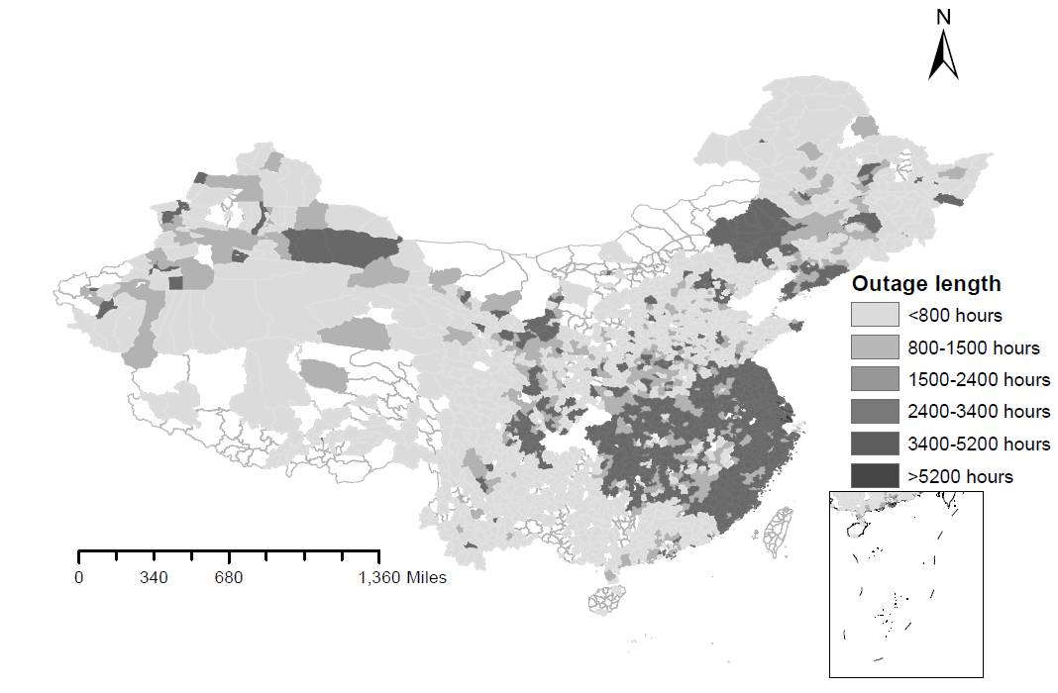

Supplementary Fig. 1 Duration (in hours) of residential outages during 2019-2021 in China

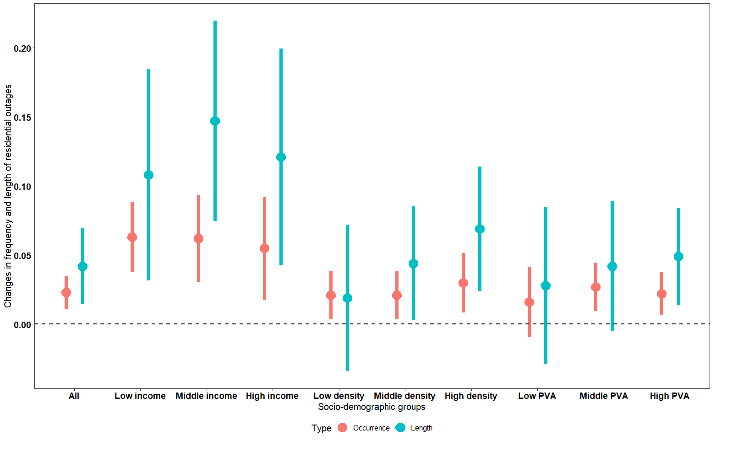

Supplementary Fig. 2 Heterogeneous impacts of heatwaves on power outages by different socio-demographic factors at the city level

## **Supplementary Notes**

### **Supplementary Note 1**

We acknowledge the great contribution made by other approaches and are fully aware of the excellent works under the physics-informed approach (e.g., Wang et al., 2021; Lin and Xi, 2023; Sheng et al., 2023). However, our econometrics analysis has the following advantages. (1) Our method can disentangle the effect of heatwaves on power outages, which is very challenging, if feasible, for engineering models. The factors causing outages are very complex and diverse, many of which are not solely related to physical systems. The econometrics analysis isolates the effect of heatwaves from all other influencing factors. It considers not only the physical process but also accounts for the influences from diverse non-physical factors such as human preventative and adaptive behaviors. (2) Our analyses are conducted at a very granular county level. Given that not all data at the county level are available for engineering modeling (such as transformer and distribution substation data at the county level), it is almost infeasible to model the power outages at the local level currently. The empirical estimation from econometric analyses could also have the potential to be fed into systems engineering and simulation studies. Given that there is no study to disentangle the impact of heatwaves on power outages yet, we take advantage of the historical data and address such a gap.

Therefore, the modeling approach to study outages should include coupled models such as the weather model, distribution network model, and response model, which can be an important area for future research. Also note that although systematic modeling is feasible, accumulative errors with inappropriate assumptions at all stages threaten to undermine accuracy.

### **Supplementary Note 2**

The projected future heatwave frequency is estimated based on the escalation of temperature. The heatwave and high-temperature threshold are defined the same way in the main text (i.e., the 99 percentile). The projected temperatures in a city in different scenarios are projected according to temperature changes from the CCSM. New heatwave frequency is thus the heatwave days divided by all days in a year. The increases in heatwave-induced outages in different future scenarios are estimated based on the scaling of the heatwave-induced outages in Table 1. We assume for each county, the average impacts estimated in our main text still hold, which is one more heatwave leads to a 3.9% increase in outages. nationally (around 3000 counties), as the total heatwave occurrences across all counties increase by a certain percentage, we assume the national outages will increase proportionally. The economic losses caused by more outages are estimated the same way the back-of-the-envelope analysis in the section “Heatwave-induced outages”.

## **Future demand and supply projections**

***Demand***

Our analysis focuses on the relative changes in temperature-responsive cooling demand induced by heatwaves (Supplementary Table 13). The electricity demand increment is calculated as ${∆D}_{i,d}$ = ${D_base}_{i,d}×β_{i,d}×{∆t}_{i,d}$.There are three critical parameters in the estimation: (1) the base consumption ${D_base}_{i,d}$; (2) the sensitivity of demand changes to heating $β_{i,d}$, which is the percentage increment of demand relative to ${D_base}_{i,d}$ per degree; (3) the temperature changes ${∆t}_{i,d}$. The temperature response parameters $β_{i,d}$ are sourced from existing studies including empirical temperature-response curves (Li et al., 2019; Cong et al., 2022; Liu et al., 2023). They are assumed to be 3% per °C for non-hot (Northern) regions, and 5% per °C for hot (Southern) regions when the temperature is 22–25°C. For temperatures above 25°C, the sensitivity increases to 8% per °C for non-hot regions and 10% per °C for hot regions. The base level of annual electricity consumption, ${D_base}_{i,d}$, is obtained from the China City Statistical Yearbook (NBS, 2021). We then disaggregate annual consumption to the daily level, factoring in daily variability representative of the load for provinces where the cities are located (NDRC, 2019). ${∆t}_{i,d}$ is based on the projected temperature from the Community Climate System Model (CCSM). The annual increase in cooling demand across China represents the sum of daily increases in electricity consumption due to temperature rises for all locations.

Supplementary Table 13 Increase in annual electricity demand due to increased high-temperature extremes

|  |  |  |  |
| --- | --- | --- | --- |
|  | 2030 | 2050 | 2090 |
| RCP2.6 | 0.56 trillion kWh | 0.51 trillion kWh | 0.58 trillion kWh |
| RCP4.5 | 0.45 trillion kWh | 0.53 trillion kWh | 0.74 trillion kWh |
| RCP8.5 | 0.50 trillion kWh | 0.68 trillion kWh | 1.22 trillion kWh |

***Supply***

The future supply is projected in a similar fashion. We focus on the vulnerability of different energy sources of electricity generation to high temperatures during heatwaves. The electricity supply decrement for province *i* at day *d* is ${∆S}_{i,d}$ = $\sum_{j}^{n}{{S_base}_{i,j,d}×γ_{j,d}×{∆t}_{i,d}}$. There are three critical parameters: (1) the projected base supply ${S_base}_{i,j,d}$ for province *i* for energy source *j* at day *d*; (2) the vulnerability of different energy sources to high temperatures $γ_{j,d}$, which indicates the percentage decrease of supply relative to ${S_base}_{i,j,d}$ per degree; (3) the temperature changes ${∆t}_{i,d}$. $γ_{j,d}$, which quantifies how susceptible each energy type, is derived from existing literature that discusses the electrical and thermal performance characteristics of different technologies (Supplementary Table 14). ${∆t}_{i,d}$ is the same as the former. The base supply $S_base$ is estimated through the following steps. (1) National supply prediction by fuel type: using the GCAM model, we predict national supply by fuel type under three SSP-RCP scenarios. The total supply in 2030, 2050, and 2090 is estimated as 12.00, 16.30, and 12.05 trillion kWh. (2) Disaggregation to provincial levels. National supply is disaggregated into provincial levels based on the provincial energy mix from (Zhuo et al., 2022); (3) Daily disaggregation at the provincial level. For each province, its supply at the annual level is further disaggregated into the daily level by imposing the intra-annual variation. The daily wind and solar variation are based on the daily potentials from (Fan et al., 2023). Daily variability of nuclear, coal, natural gas, and hydro generation is obtained from public reports and government releases (CBS, 2021; CAEA, 2021).

The decrement in generation is displayed in Supplementary Table 15. We find that high-temperature extremes reduce the average generation by 2.3–3.7% for RCP 2.6, 4.5 and 8.5 in 2030, 4.5–8.3% by 2050, and 2.7–12.1% by 2090 (the percentage is calculated as the decrement in generation due to vulnerability to high temperature divided by GCAM predicted supply). This is consistent with existing studies, which show that the electricity losses are 4.4–19% in the mid-term (e.g., Van Vliet et al., 2012; Zhang et al., 2021)

Supplementary Table 14 Parameters on the vulnerability of electricity generation to high temperatures

|  |  |  |  |
| --- | --- | --- | --- |
| Type | Parameters | Explanation | References |
| Coal | 0.1% /°C | One degree increase in temperature leads to an efficiency reduction of 0.09% for coal-fired power plants | (Zhang et al., 2021) |
| Each degree increase in temperature reduces the efficiency of thermal electric plants by 0.12-0.45% | (Henry and Pratson, 2016) |
| Natural gas | 0.1%/°C | Natural gas combustion turbines have an efficiency loss of 0.1%°C above ideal operating conditions; | (Dumas and Cunliff, 2019) |
| Temperature increase reduces average generating capacity by 2-3% for RCP 4.5-8.5 by the 2060s | (Zhang et al., 2017) |
| Hydro | 3.0% | Hydropower potential will change by -2.2 to -5.4% for 2020–2050 and 2070–2099, respectively | (Liu et al., 2016) |
| Nuclear | 0.3%/°C below 30°C; 1.1%/°C above 30°C | One degree increase in the coolant temperature causes a decrease in power output and efficiency of 0.39% and 0.16%, respectively, in a nuclear power plant | (Dumas and Cunliff, 2019) |
| One degree increase for ambient temperatures between -7°C and 20°C reduces output by 0.3–0.4%; output decreases by 0.96–1.10% per degree over 20°C | (Dumas and Cunliff, 2019) |
| Load reduction reaches 11.8% if river temperature increases by 5 degrees | (Förster and Lilliestam, 2010) |
| Solar PV | 0.7%/°C | High temperatures lead to a drop in the maximum capacity and conversion efficiency of 0.66%/°C and 0.08%/°C, respectively | (Dumas and Cunliff, 2019) |
| Electricity conversion efficiency decreases by about 3–6‰ per degree | (Ji et al., 2007); |
| Per degree increase in the cell temperature leads to an efficiency loss between 0.4% and 0.5% | (Cavadini and Cook, 2021) |
| Wind | 0.1% | Annual wind power generation decreases by around 0.1% of their average production due to climate change | (Huang et al., 2020) |
| Wind generation potential will decrease (3–4%) under RCP 4.5 and RCP8.5 | (Gao et al., 2019) |

Supplementary Table 15 Increase in annual electricity supply

|  |  |  |  |
| --- | --- | --- | --- |
|  | 2030 | 2050 | 2090 |
| RCP2.6 | 0.38 trillion kWh | 0.73 trillion kWh | 0.32 trillion kWh |
| RCP4.5 | 0.28 trillion kWh | 1.09 trillion kWh | 0.64 trillion kWh |
| RCP8.5 | 0.45 trillion kWh | 1.36 trillion kWh | 1.46 trillion kWh |

***Supply-demand mismatch (power shortage)***

Finally, we integrate the projected demand with the projected supply to assess the supply-demand mismatch or power shortage rate. This rate is calculated at the province-day level, aligning with the granularity of the projected demand data. Consequently, city-level supply projections are aggregated to the province level to facilitate this analysis. The national outage rate is estimated using the following equation:

${Out}_{i,d}=\left\{\begin{aligned}1 if {ED}_{i,d}>{ES}_{i,d} \\ 0 otherwise\end{aligned}\right.$ (A1)

${PS}^{N}=\frac{\sum_{1}^{N}{{Out}_{id}}}{Nd}$ (A2)

Where the dummy variable ${Out}_{i,d}$ indicates whether demand exceeds supply in province *i* on day *d*. ${ED}_{i,d}$ denotes the demand and ${ES}_{i,d}$ is the supply. ${PS}^{N}$ represents the national power shortage rate, which is calculated as the ratio of cumulative days during which demand exceeds supply across all provinces and days. *Nd* represents the total number of observations, which is the product of the number of provinces and the number of days observed for each province.

The results in Supplementary Table 16 show that power outage rates generally hover around 10%. A comparison with Table 5 reveals similarities in some scenarios but differences in others. This variance stems from the fact that power shortage rates only assess the imbalance between supply and demand, without considering failed distribution, substation, and local transformers.

Supplementary Table 16 Power shortage rate

|  |  |  |  |
| --- | --- | --- | --- |
|  | 2030 | 2050 | 2090 |
| RCP2.6 | 7.66% | 8.55% | 7.47% |
| RCP4.5 | 7.33% | 9.03% | 8.45% |
| RCP8.5 | 8.03% | 9.98% | 11.5% |

We have calculated the additional power plant capacity required to address potential demand surges during heatwaves. This estimation is based on our previous calculations of electricity demand. The national capacity $∆C$ is estimated by $∆C=\sum_{g}{\max_{d}{D_{g,d}}{×∂}_{g}}$, where $D_{g,d}$ represents the daily electricity demand for region *g.* Considering that regions are typically interconnected and the supply network operates at a regional level, we have included eight regions as outlined by Fan et al. (2023). The term $\max_{d}{D_{g,d}}$ represents the peak of demand across all days for each region. The factor $∂_{g}$ is the proportion of single highest peak-hour demand relative to the total daily demand, calculated based on the daily demand profiles reported by the NDRC (2019). $∆C$ hen represents the cumulative peak-hour demand across all regions. As shown in Supplementary Table 17, to mitigate the impacts of heatwaves, it is estimated that between 220 and 620 power plants, each with a capacity of 1000 MW per hour, need to be constructed (in reality, the type of energy sources and storage capacity should also be considered). These additional plants would primarily function as peaking power plants, operational only during periods of high demand (Gu et al., 2016). Note this high demand could also be met by increasing the utilization rate of existing power plants, especially since China’s current capacity is underutilized, operating below 50% (Ritchie, 2023). Coal power plants, in particular, could serve as peaking power plants in China, meeting reliability requirements by ramping up and down more efficiently. Furthermore, high demand might also be addressed through storage technologies or end-user services, potentially obviating the need for additional power sector infrastructure (Chen et al., 2021).

Supplementary Table 17 Additional capacity needed due to increased temperature

|  |  |  |  |
| --- | --- | --- | --- |
|  | 2030 | 2050 | 2090 |
| RCP2.6 | 0.22 billion kW | 0.21 billion kW | 0.25 billion kW |
| RCP4.5 | 1.27 billion kW | 2.73 billion kW | 2.22 billion kW |
| RCP8.5 | 2.90 billion kW | 2.89 billion kW | 6.20 billion kW |

Note: An increased peak demand of 0.22 billion kW indicates around 220 additional power plants with 1000 MW needed to be built by 2030.

Besides, we are fully aware that our projection of future supply and demand is a simplified attempt in our efforts to assess power outages during heatwaves. Many valuable published studies, although not focusing on power outages as we do, have examined energy consumption and supply under climate change. Interested readers are directed to these papers listed in Supplementary Table 18.

Supplementary Table 18 Examples of studies on future energy projections

|  |  |
| --- | --- |
|  | References |
| Change in energy demand impacted by climate change/high temperature | e.g., Yalew et al., 2020; Zhang et al., 2022 |
| Change in energy supply impacted by climate change/high temperature | e.g., Gernaat et al., 2021; Zhang et al., 2021; Zhuo et al., 2022; |
| Supply-demand match/ power shortage | e.g., Liu et al., 2023; Fan et al., 2023 |

## **Future electricity sector scenarios**

We explore how the potential changes in the electricity sector may impact heatwave-induced power outages by constructing electricity sector scenarios. We construct the following scenarios: (1) the Reference Scenarios, where the current energy mix remains unchanged; (2) the Impacted Generation Scenario, where electricity generation from fossil and non-fossil sources is impacted differently by climate change; (3) the Battery Storage Deployment Scenarios, where battery technology mitigates the variability of renewable generation in the electricity grid, in addition to the impacts outlined in scenario (2). Note that these scenarios are highly stylized and are intended solely to explore comparative changes in the electricity sector. Altogether, we have developed four scenarios: Reference, Impacted Generation, Low Energy Storage, and High Energy Storage.

Supplementary Table 19 Stylized future electricity sector scenarios

|  |  |  |
| --- | --- | --- |
| Scenarios | 2030 | 2050 |
| Reference | No change (same as 2020) | No change (same as 2020) |
| Impacted Generation | Generation from both fossil and renewable sources (increase by 50%) is compromised by climate change | Generation from both fossil and renewable sources (increase by 100%) is compromised by climate change |
| Energy Storage | Battery storage deployment increases by 50% (Low), by 100% (High) | |

The Reference scenario adopts the temperature projection in RCP2.6. In the Impacted Generation scenario, it is assumed that renewable energy, projected to increase by 50% in 2030 and 100% in 2050, will be impacted by climate change. The impact factors are listed in Supplementary Table 14. In the Energy Storage scenario, we assume that the low and high energy storage scenarios correspond to 50% (50% storage) and 20% (100% storage) of renewable generation being affected by climate change, respectively. It is important to highlight that a reduction in generation does not necessarily translate into increased outages. This is because system dispatching and demand response can mitigate some of the negative impacts, although these factors are not fully incorporated into our simplified model. As such, our estimates should be considered as upper bounds on the potential effects.

Our results (Supplementary Fig. 3) indicate that increased renewable energy generation (Impacted Generation Scenario) contributes to a higher probability of power disruptions, increasing by 0.62% in 2030 and by 0.79% in 2050. Conversely, the deployment of additional energy storage (High Energy Storage Scenario) facilitates greater integration of renewable energy and enhances the overall system reliability. Here, the projected increase in the likelihood of power disruptions is modest, at 0.16% in 2030 and 0.17% in 2050. These results align with existing research which indicates that as more renewable generation is incorporated into the grid, power reliability and stability may be increasingly compromised by extreme weather conditions (Schmietendorf et al., 2015; Abdin et al., 2019; Liu et al., 2023).

Supplementary Fig. 3 Impacts of future energy system on the probability of power outages in four scenarios

## **Projections using alternative downscaled climate data**

We also applied available downscaled data from NASA’s Earth Exchange Global Daily Downscaled Projections (NEX-GDDP) (Thrasher et al., 2022; NASA, 2024). We accessed the NEX-GDDP-CMIP6 data and obtained daily average temperature data at a higher resolution (0.25 degrees). The results under RCP2.6 and RCP4.5 align with previous findings, while those for RCP5.8 are substantially higher, likely due to the underestimation of extreme events at lower resolutions.

Supplementary Table 20 Projected outages under climate scenarios

|  |  |  |  |  |
| --- | --- | --- | --- | --- |
|  |  | 2030 | 2050 | 2090 |
| **RCP2.6** | Average heatwave frequency | 0.14 | 0.179 | 0.207 |
|  | Increase in outage occurrence | 13.9% | 21.3% | 26.6% |
|  | Economic losses (billion yuan) | 26.0 | 33.3 | 38.5 |
| **RCP4.5** | Average heatwave frequency | 0.137 | 0.186 | 0.246 |
|  | Increase in outage occurrence | 13.3% | 22.6% | 34.0% |
|  | Economic losses (billion yuan) | 25.5 | 34.6 | 45.8 |
| **RCP8.5** | Average heatwave frequency | 0.648 | 0.654 | 0.664 |
|  | Increase in outage occurrence | 110.4% | 111.5% | 113.4% |
|  | Economic losses (billion yuan) | 120.5 | 121.7 | 123.5 |

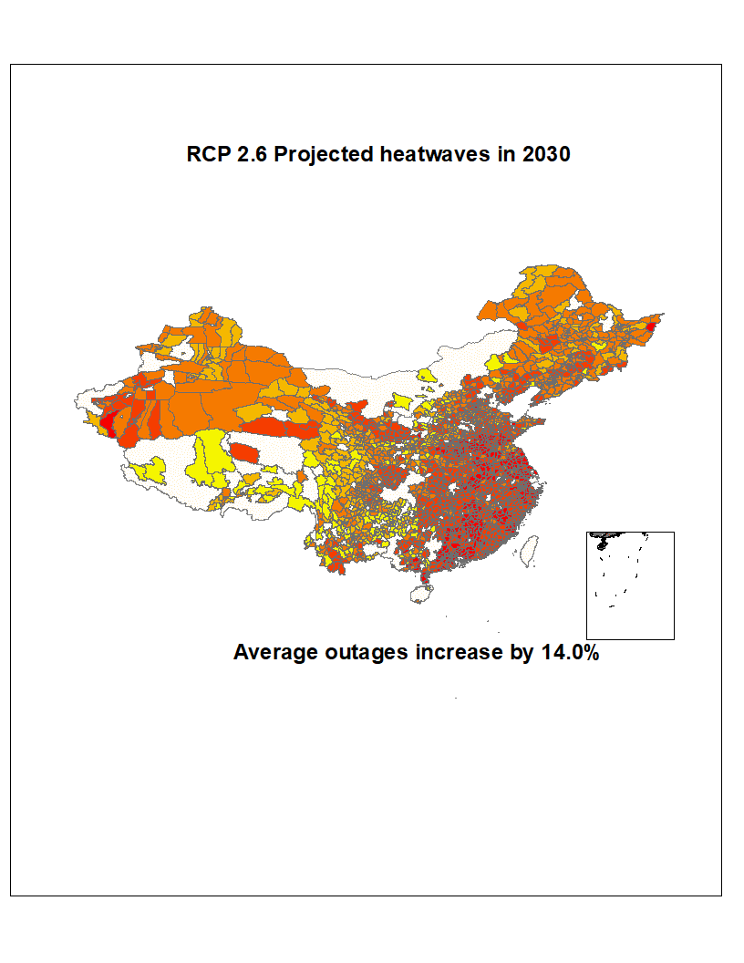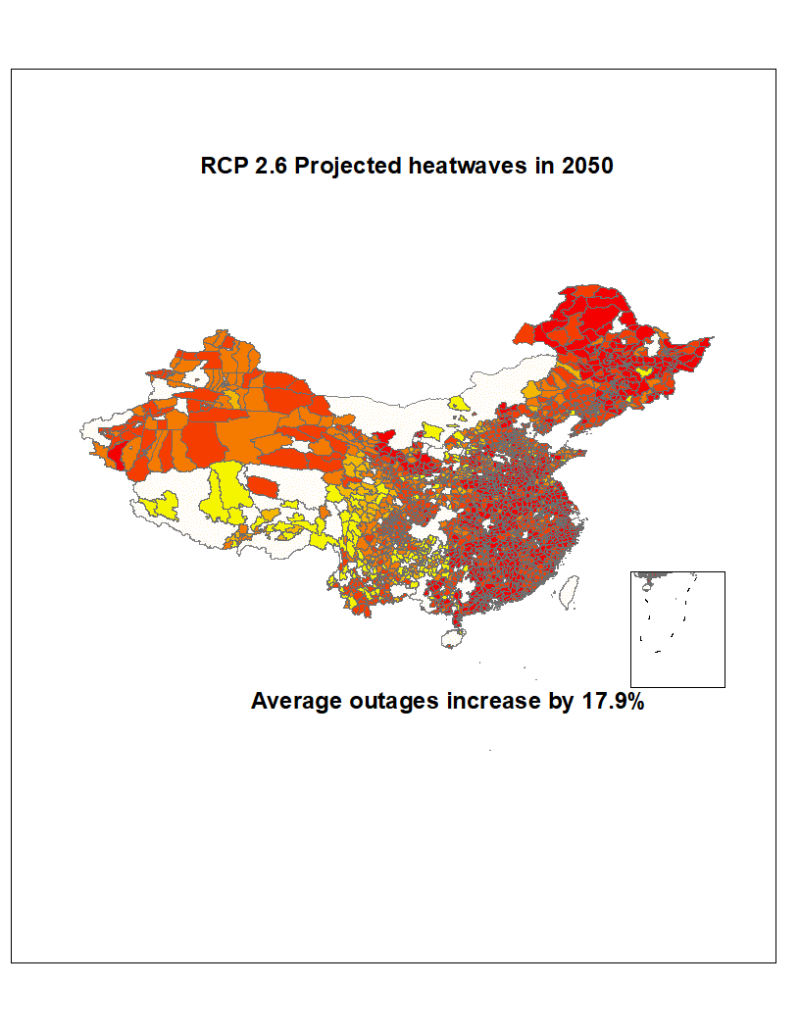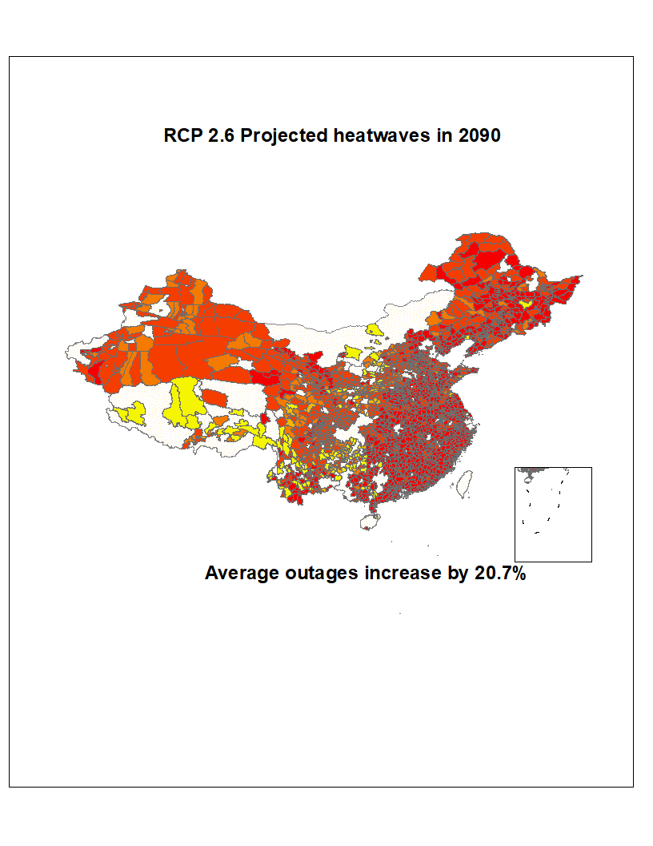

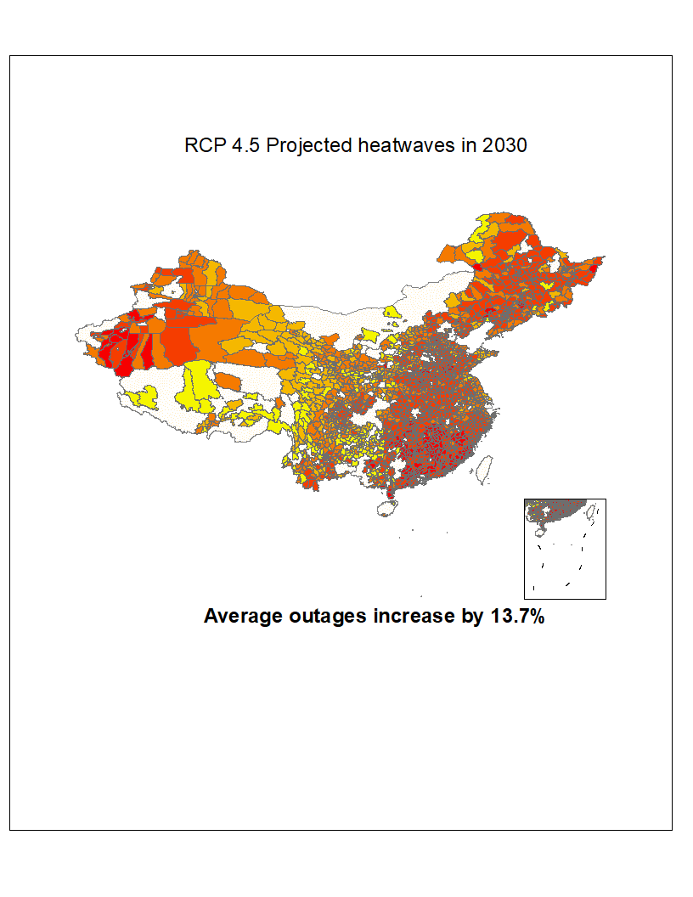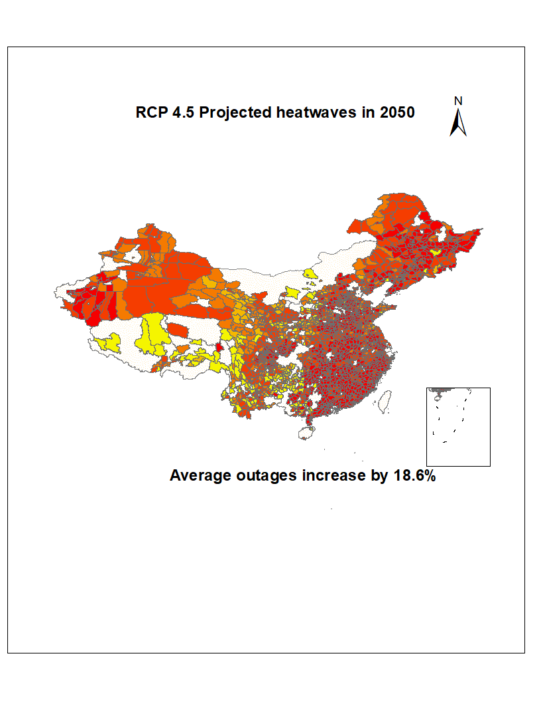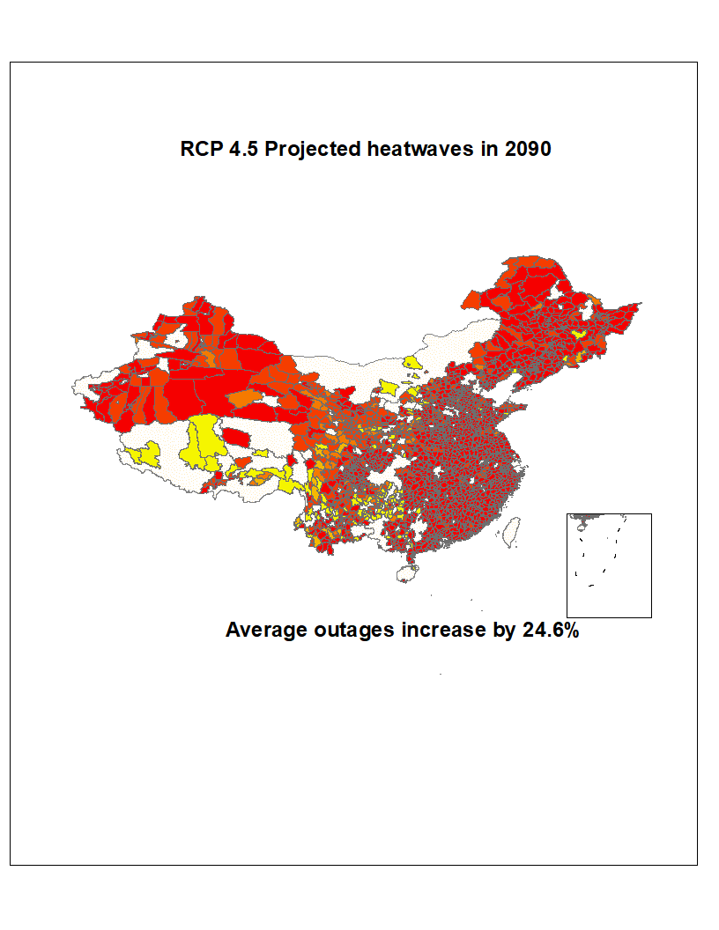

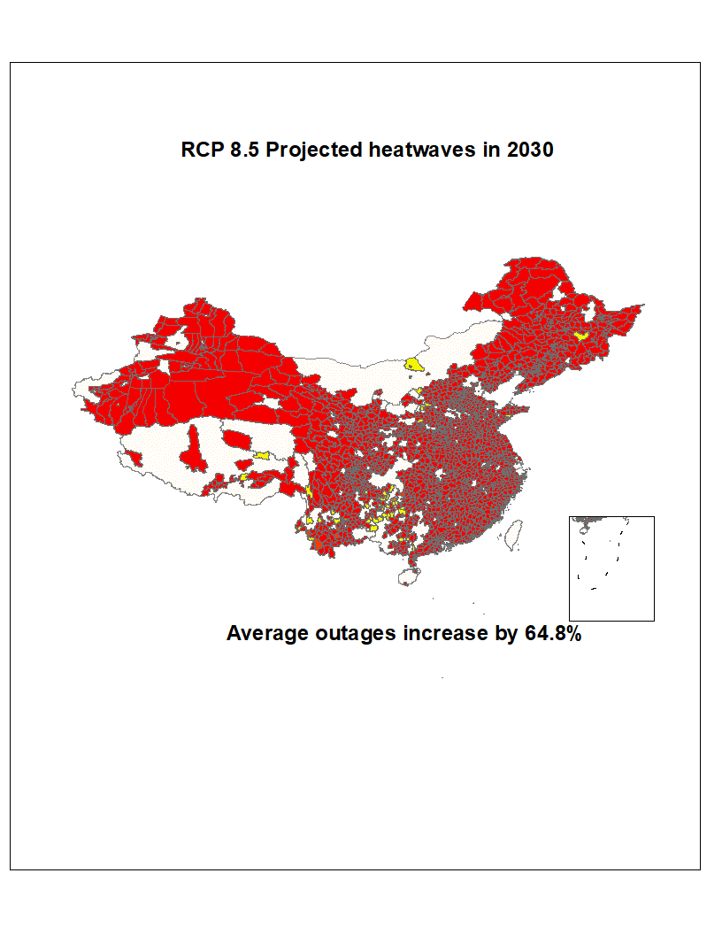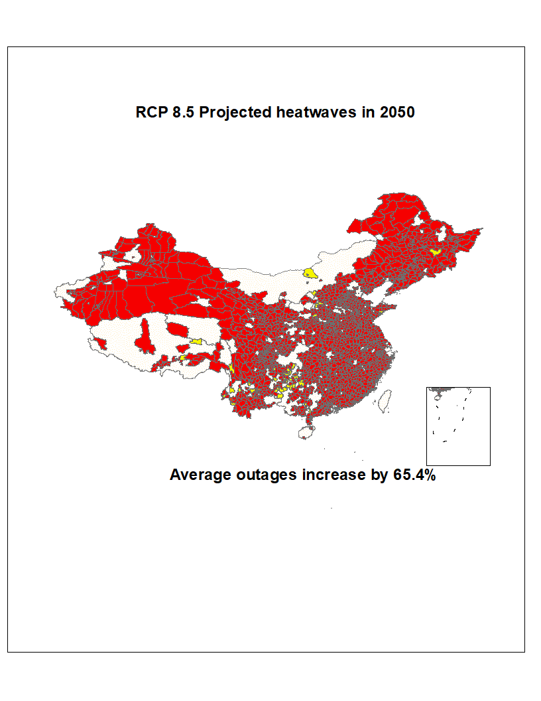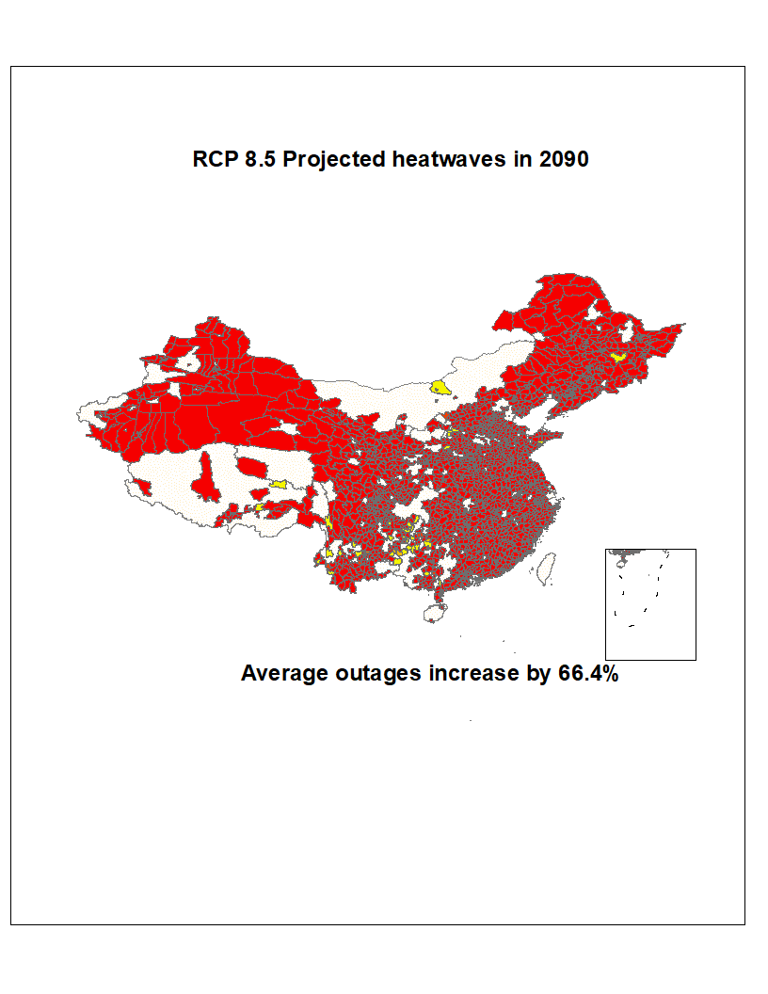

Supplementary Fig. 4 Distribution of heatwaves in scenarios of RCP2.6, RCP4.5, and RCP8.5 using NEX-GDDP-CMIP6 data

## **Failure rates for electric components**

Reports indicate that in 2020, the failure rate for overhead lines was 10.35 per 100 km/year, 4.06 per 100 km/year for cable lines, 0.28 per 100 units/year for transformers, and 0.34 per 100 units/year for circuit breakers (CEA, 2020). The failure indicators for 13 types of electric components are summarized in the following table (Supplementary Table 21) (CEA, 2020). In 2021, the failure rate for overhead lines was 9.84 per 100 km/year, 3.96 per 100 km/year for cable lines, 0.40 per 100 units/year for transformers, and 0.50 per 100 units/year for circuit breakers (CEA, 2021). In 2022, these rates decreased significantly: 3.85 per 100 km/year for overhead lines, 1.43 per 100 km/year for cable lines, 0.17 per 100 units/year for transformers, and 0.15 per 100 units/year for circuit breakers (CEA, 2022).

We also examined the correlation between heatwaves and failures of specific electric components. The correlation coefficient between the national average temperature and cable line faults is 0.39, 0.79 for transformers, and 0.99 for circuit breakers. This suggests that heatwaves increase the failure rates of electric components, leading to power outages. As detailed nationwide data on component failures is not yet available, the above correlation analysis is preliminary.

Supplementary Table 21 Reliability indicator of electric components for transmission lines at 220 kV and above in China (2020)

|  |  |  |  |  |  |  |  |
| --- | --- | --- | --- | --- | --- | --- | --- |
| Facility Type | Facility/ Line Length (km) | Forced Outage Rate (%) | Availability (%) | Unplanned Outage Occurrences | Unplanned Outage Duration | Planned Outage Occurrences | Planned Outage Duration |
| Overhead Line | 8387.6 | 0.046 | 99.466 | 436 | 0.17 | 4698 | 44.029 |
| Transformer | 21696.0 | 0.197 | 99.63 | 76 | 0.342 | 5099 | 31.715 |
| Coupling Capacitor | 7139.0 | 0.013 | 99.989 | 1 | 0.0 | 96 | 0.937 |
| Wave Trap | 12173.0 | 0.015 | 99.982 | 2 | 0.002 | 192 | 1.382 |
| Cable Line | 72.8 | 0.029 | 99.970 | 3 | 0.025 | 81 | 2.59 |
| Reactor | 4520.0 | 0.406 | 99.761 | 20 | 0.69 | 533 | 20.007 |
| Circuit Breaker | 52460.0 | 0.174 | 99.839 | 122 | 0.042 | 7623 | 13.957 |
| Current Transformer | 150409.0 | 0.008 | 99.948 | 40 | 0.011 | 7965 | 4.511 |
| Combined Apparatus | 9616.0 | 0.024 | 99.955 | 88 | 0.014 | 10206 | 3.552 |
| Busbar | 14240.0 | 0.148 | 99.947 | 22 | 0.384 | 816 | 4.211 |
| Voltage Transformer | 98443.0 | 0.016 | 99.945 | 21 | 0.002 | 5707 | 4.803 |
| Disconnector Switch | 185111.0 | 0.007 | 99.965 | 32 | 0.002 | 6001 | 3.078 |
| Surge Arrester | 167085.0 | 0.012 | 99.953 | 26 | 0.003 | 6939 | 4.145 |

Note: Total Facility/Line Length (km): for overhead lines and cable lines, the unit is per 100 kilometers; for other equipment, the unit is in sets or sections. Planned Outage Duration (times): for overhead lines, the unit is hours per 100 kilometers per year; for other equipment, the unit is hours per unit (sets, sections) per year.

## **Appendix references**

Abdin, I. F., Fang, Y. P., & Zio, E. (2019). A modeling and optimization framework for power systems design with operational flexibility and resilience against extreme heat waves and drought events. *Renewable and Sustainable Energy Reviews*, *112*, 706-719.

Bureau of Statistics. *China City Statistical Yearbook* 2011. China Statistics Press, 2011.

Cavadini, G. B., & Cook, L. M. (2021). Green and cool roof choices integrated into rooftop solar energy modelling. *Applied Energy*, *296*, 117082. https://doi.org/10.1016/j.apenergy.2021.117082

CEP-Editorial Board of the China Electric Power Yearbook. China electric power yearbook 2021. China Electric Power Press, Beijing (2013)

Chen, H., Chen, X., Niu, J., Xiang, M., He, W., & Küfeoğlu, S. (2021). Estimating the marginal cost of reducing power outage durations in China: A parametric distance function approach. *Energy Policy*, *155*, 112366.

China Atomic Energy Authority (CAEA). National nuclear power operation status from January to December 2020. https://www.caea.gov.cn/

China Bureau of Statistics (CBS). "Energy production situation in December 2020" <https://www.stats.gov.cn/sj/zxfb/202302/t20230203_1900969.html>

China Electricity Administration (CEA). National Electricity Reliability Annual Report. 2020. http://prpq.nea.gov.cn/uploads/file1/20230308/640801ab6e248.pdf

China Electricity Council (CEA). National Electricity Reliability Annual Report. 2021. http://prpq.nea.gov.cn/uploads/file1/20230308/640801ab6e248.pdf

China Electricity Council (CEA). National Electricity Reliability Annual Report. 2022. http://prpq.nea.gov.cn/uploads/file1/20231018/652f331bc7aed.pdf

Cong, S., Nock, D., Qiu, Y. L., & Xing, B. (2022). Unveiling hidden energy poverty using the energy equity gap. *Nature Communications*, *13*(1), 1-12. https://doi.org/10.1038/s41467-022-30146-5

Deroubaix, A., Labuhn, I., Camredon, M., Gaubert, B., Monerie, P. A., Popp, M., ... & Siour, G. (2021). Large uncertainties in trends of energy demand for heating and cooling under climate change. *Nature communications*, *12*(1), 5197.

Ding, N., Duan, J., Xue, S., Zeng, M., & Shen, J. (2015). Overall review of peaking power in China: Status quo, barriers and solutions. *Renewable and Sustainable Energy Reviews*, *42*, 503-516. https://doi.org/10.1016/j.rser.2014.10.041

Dumas, M., Kc, B., & Cunliff, C. I. (2019). *Extreme weather and climate vulnerabilities of the electric grid: A summary of environmental sensitivity quantification methods* (No. ORNL/TM-2019/1252). Oak Ridge National Lab.(ORNL), Oak Ridge, TN (United States).

Förster, H., & Lilliestam, J. (2010). Modeling thermoelectric power generation in view of climate change. *Regional Environmental Change*, *10*, 327-338.

Gao, Y., Ma, S., & Wang, T. (2019). The impact of climate change on wind power abundance and variability in China. *Energy*, *189*, 116215. https://doi.org/10.1016/j.energy.2019.116215

Garrett, T. A. (2003). Aggregated versus disaggregated data in regression analysis: implications for inference. *Economics Letters*, *81*(1), 61-65.

Gernaat, D. E., de Boer, H. S., Daioglou, V., Yalew, S. G., Müller, C., & van Vuuren, D. P. (2021). Climate change impacts on renewable energy supply. *Nature Climate Change*, *11*(2), 119-125.

Gu, Y., Xu, J., Chen, D., Wang, Z., & Li, Q. (2016). Overall review of peak shaving for coal-fired power units in China. *Renewable and Sustainable Energy Reviews*, *54*, 723-731. https://doi.org/10.1016/j.rser.2015.10.052

Henry, C. L., & Pratson, L. F. (2016). Effects of environmental temperature change on the efficiency of coal-and natural gas-fired power plants. *Environmental science & technology*, *50*(17), 9764-9772.

Huang, J., Jones, B., Thatcher, M., & Landsberg, J. (2020). Temperature impacts on utility-scale solar photovoltaic and wind power generation output over Australia under RCP 8.5. *Journal of Renewable and Sustainable Energy*, *12*(4).

Ji, J., Lu, J., Chow, T., He, W., & Pei, G. (2007). A sensitivity study of a hybrid photovoltaic/thermal water-heating system with natural circulation. *Applied Energy*, *84*(2), 222-237. https://doi.org/10.1016/j.apenergy.2006.04.009

Lin, N., & Xi, D. (2023). Likelihood of back-to-back tropical cyclone hazards is increasing. *Nature Climate Change*, *13*(3).

Liu, L., He, G., Wu, M., Liu, G., Zhang, H., Chen, Y., ... & Li, S. (2023). Climate change impacts on planned supply–demand match in global wind and solar energy systems. *Nature Energy*, *8*(8), 870-880.

Liu, L., Hejazi, M., Li, H., Forman, B., & Zhang, X. (2017). Vulnerability of US thermoelectric power generation to climate change when incorporating state-level environmental regulations. *Nature Energy*, *2*(8), 1-5.

Liu, X., Tang, Q., Voisin, N., & Cui, H. (2016). Projected impacts of climate change on hydropower potential in China. *Hydrology and Earth System Sciences*, *20*(8), 3343-3359.

NASA Earth Exchange Global Daily Downscaled Projections (NEX-GDDP-CMIP6) was accessed on 10-20-2024 from https://registry.opendata.aws/nex-gddp-cmip6.

National Bureau of Statistics (NBS). China City Statistical Yearbook 2021. China Statistics Press.

National Development and Reform Commission. Typical power load curves in each provincial power system. in Chinese, https://www.ndrc.gov.cn/xxgk/zcfb/tz/201912/P020191230336066090861.pdf (2019).

Pavanello, F., De Cian, E., Davide, M., Mistry, M., Cruz, T., Bezerra, P., ... & Lucena, A. F. (2021). Air-conditioning and the adaptation cooling deficit in emerging economies. *Nature communications*, *12*(1), 6460.

Ritchie, H. (2023). China is building more coal plants but might burn less coal. Sustainability by Number. https://www.sustainabilitybynumbers.com/p/china-coal-plants.

Schmietendorf, K., Peinke, J., & Kamps, O. (2017). The impact of turbulent renewable energy production on power grid stability and quality. *The European Physical Journal B*, *90*, 1-6.

Sheng, M., Reiner, M., Sun, K., & Hong, T. (2023). Assessing thermal resilience of an assisted living facility during heat waves and cold snaps with power outages. *Building and Environment*, *230*, 110001.

[Stanway](https://www.reuters.com/authors/david-stanway/), D. 2024-2-22. China 2023 coal power approvals rose, putting climate targets at risk. <https://www.reuters.com/sustainability/climate-energy/china-2023-coal-power-approvals-rose-putting-climate-targets-risk-2024-02-22/>

Thrasher, B., Wang, W., Michaelis, A., Melton, F., Lee, T., & Nemani, R. (2022). NASA global daily downscaled projections, CMIP6. *Scientific data*, *9*(1), 262.

Van Ruijven, B. J., De Cian, E., & Sue Wing, I. (2019). Amplification of future energy demand growth due to climate change. *Nature communications*, *10*(1), 2762.

Van Vliet, M. T., Yearsley, J. R., Ludwig, F., Vögele, S., Lettenmaier, D. P., & Kabat, P. (2012). Vulnerability of US and European electricity supply to climate change. *Nature Climate Change*, *2*(9), 676-681.

Wang, Z., Hong, T., & Li, H. (2021). Informing the planning of rotating power outages in heat waves through data analytics of connected smart thermostats for residential buildings. *Environmental Research Letters, 16(7),* 074003.

Yalew, S. G., van Vliet, M. T., Gernaat, D. E., Ludwig, F., Miara, A., Park, C., ... & Van Vuuren, D. P. (2020). Impacts of climate change on energy systems in global and regional scenarios. *Nature Energy*, *5*(10), 794-802.

Yang Y. 2023-07-11. "Extreme High Temperatures Continue, Electricity Usage Hits Record! Energy SOEs Brace for Summer ‘Big Bake’. https://www.thepaper.cn/newsDetail_forward_23634654

Zhang, H., Da, Y., Zhang, X., & Fan, J. L. (2021). The impacts of climate change on coal-fired power plants: Evidence from China. *Energy & Environmental Science*, *14*(9), 4890-4902

Zhuo, Z., Du, E., Zhang, N., Nielsen, C. P., Lu, X., Xiao, J., Wu, J., & Kang, C. (2022). Cost increase in the electricity supply to achieve carbon neutrality in China. *Nature Communications*, *13*(1), 1-13. https://doi.org/10.1038/s41467-022-30747-0