一、安装anaconda

1.访问网址：<https://www.anaconda.com/products/individual>

2.下载

3.按步骤安装

二、安装pytorch

1.访问网址：<https://pytorch.org/get-started/locally/>

页面截图如下：

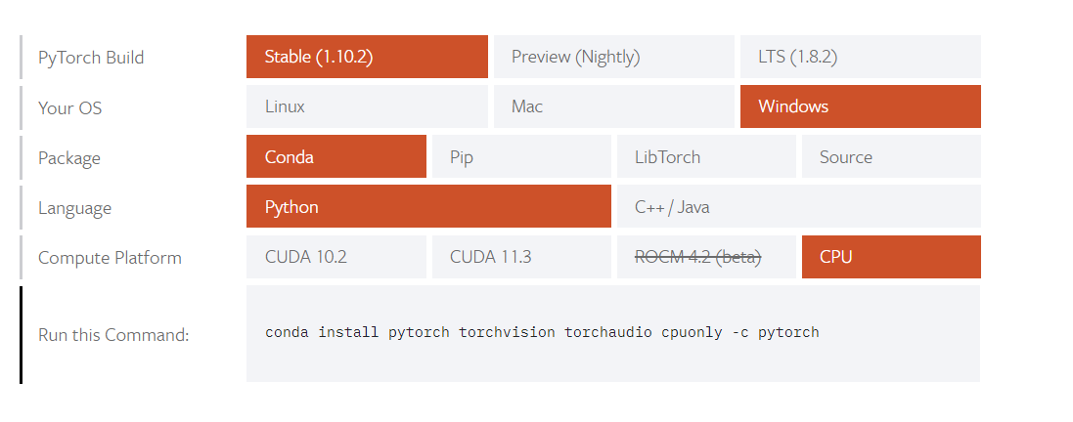

2.打开Anaconda的命令窗口，依次输入以下命令

1）Pytorch安装

conda install pytorch torchvision torchaudio cpuonly -c pytorch

2）安装包

conda install cmake pyyaml typing scikit-image matplotlib pandas pillow tqdm

pip install moviepy torchsummary attrdict keyring opencv-python

3）测试

在命令行输入python，然后输入import torch。

import torch

3.添加conda的下载源(可以做也可以不做)

conda config --add channels https://mirrors.tuna.tsinghua.edu.cn/anaconda/pkgs/free

conda config --add channels <https://mirrors.tuna.tsinghua.edu.cn/anaconda/pkgs/main>

conda config --add channels <https://mirrors.tuna.tsinghua.edu.cn/anaconda/cloud/>pytorch

删除conda的下载源

conda config --remove channels https://mirrors.tuna.tsinghua.edu.cn/anaconda/pkgs/free

conda config --remove channels <https://mirrors.tuna.tsinghua.edu.cn/anaconda/pkgs/main>

conda config --remove channels <https://mirrors.tuna.tsinghua.edu.cn/anaconda/cloud/>pytorch

4.可选安装

方案一：安装tensorboard

conda install tensorboard

conda install –channel <https://conda.ananconda.org/anaconda> tensorflow==2.2.0

或

conda install tensorflow

方案二：安装visdom

conda install visdom

或者

conda install –c conda-forge visdom