The Effects of Different Hormonal Contraceptives on the Risk of HIV Acquisition in Sexually Active HIV Uninfected Women

Abstract

In order to assess the effect of different hormonal contraceptives on the risk of HIV acquisition in sexually active HIV uninfected Zambian women, a randomized clinical trial was conducted in Zambia, with 3000 subjects enrolled. The results show that among three contraceptives (DMPA, Jadelle and IUD), IUD group has the highest HIV rate. In addition, among all the factors that have been collected, marital status is highly associated with HIV infection.

# Introduction

In order to assess the effect of different hormonal contraceptives on the risk of HIV acquisition in sexually active HIV uninfected Zambian women, a randomized clinical trial was conducted in Zambia, enrolled 3000 women ages 18-35 years who are seeking highly effective contraceptives. Upon enrollment into the study 3000 women were randomized to one of three study arms: (i) DMPA, i.e., Depo-Provera, (ii) Jadelle, i.e., Norplant II, or (iii) or an intra-uterine device (IUD). After randomization women were followed for up to 48 months, with visits to the trial’s clinic approximately every three to six months to receive an HIV test.

## Research Questions

AIM1: Assess differences in the rate of HIV infection between the three arms of the study.

AIM2: Identify risk factors for HIV infection.

## Data

For each subject, there are at most 12 visits including baseline. For each visit, self-reported sexual behavior from last visit has been gathered. In addition, baseline risk factors collected for HIV include CD4 T cell counts at baseline, age, marital status and number of times that woman had given birth previously. Survival time is calculated based on date of last visit and baseline visit.

### **Data issues**

There is a 25 year old woman (ID=1995) that has given birth to 21 children, that is treated as a data error and set to missing in the analysis dataset. Same approach has been used for a subject who has marital status neither 1 nor 0.

# Methods

Descriptive statistics have been generated for the baseline characteristics and listed in the appendix part.

## Primary Research Question

Chi-square test of association will be used as an exploratory analysis to assess the differences in the rate of HIV infection. Unadjusted hazard ratio for HIV among three treatment arms would be shown, together with the Kaplan Meier curve.

## Secondary Research Question

Cox proportional hazard model is used to examine the risk factors for HIV. The corresponding adjusted hazard ratio will also be provided.

# Results

## Primary Research Question

### Chi-square Test for Association

Table 3‑1 HIV Status by the end of the study versus ARM

|  |  |  |  |
| --- | --- | --- | --- |
| Arm | HIV Status by the end of the study | | |
| Frequency(Row Pct) | HIV Negative | HIV Positive | Total |
| DMPA | 954 (96.17) | 38 (3.83) | 992 |
| IUD | 944 (92.37) | 78 (7.63) | 1022 |
| Jadelle | 947 (96.04) | 39 (3.96) | 986 |
| Total | 2845 | 155 | 3000 |

The test Statistics from Chi-square test of association is 19.2384, yielding the p-value of <.0001. The null hypothesis that there is no association between HIV and three different types of contraceptive methods is rejected. From the table above, we could tell that IUD arm has the highest HIV infection rate (7.63%), DMPA arm has marginally lower HIV infection rate compared to Jadelle.

Due to the necessity to adjust for time to event data and censoring, the primary research question will also be answered by using survival analysis techniques.

### Kaplan Meier Curve

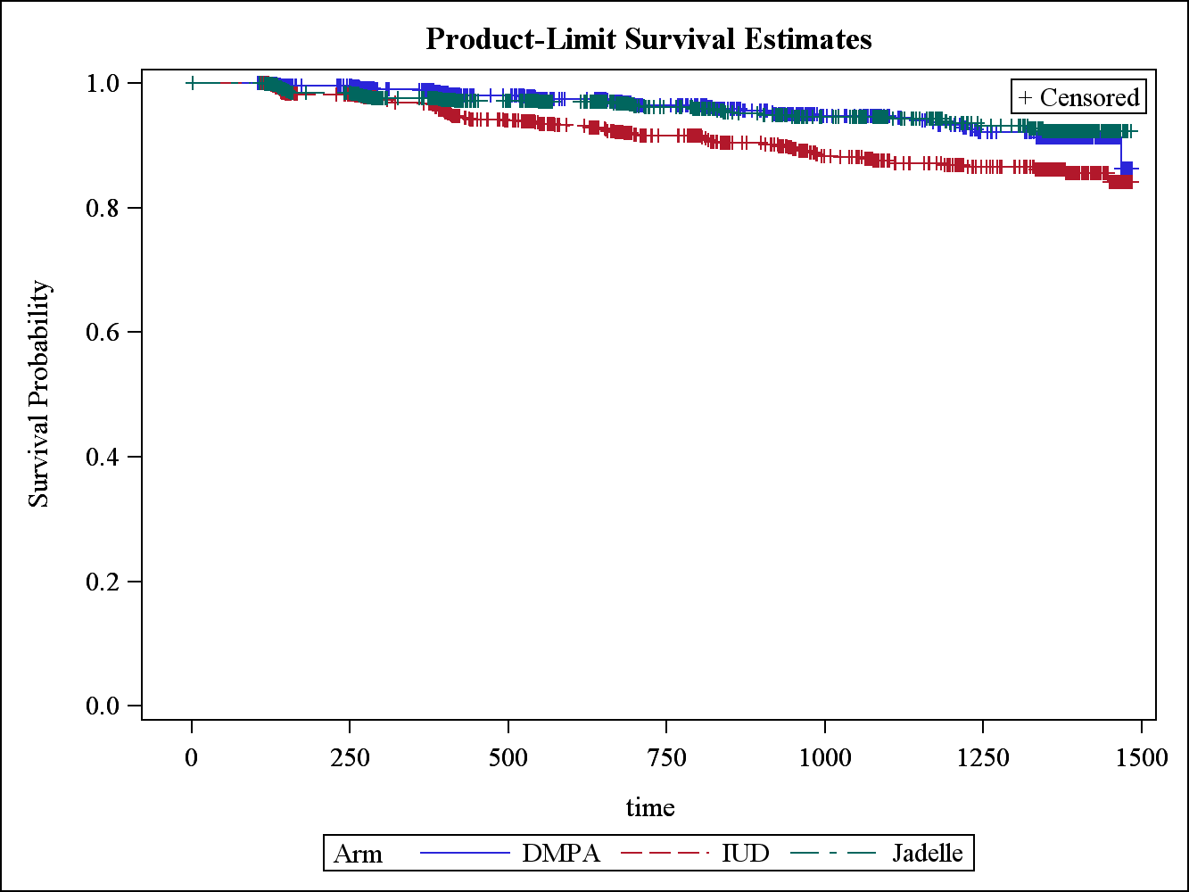

Figure 3‑1 Kaplan Meier Curve for Three Contraceptive Arms

From the Kaplan Meier curve, when judging by eyes, we could see that the survival probability of subjects using IUD differs from the other two contraceptive treatments. And the survival probability for DMPA and Jadelle do not seem to be different from each other.

### Unadjusted Hazard Ratio for three Arms

### Table 3‑2 Unadjusted Hazard Ratio between Different Arms

|  |  |  |  |
| --- | --- | --- | --- |
| Description | Point Estimate | 95% Wald Confidence Limits | |
| DMPA vs IUD | 0.505 | 0.342 | 0.744 |
| DMPA vs Jadelle | 0.995 | 0.636 | 1.555 |
| IUD vs Jadelle | 1.971 | 1.342 | 2.894 |

From Table **3**‑**2** Unadjusted Hazard Ratio between Different Arms, we have following findings:

1. The hazard ratio of getting HIV for DMPA vs IUD is 0.505, the confidence interval does not include 1, and the difference is statistically significance.
2. The corresponding hazard ratio for DMPA versus is Jadelle is 0.995, the confidence interval does not include 1, which means the differences between DMPA and Jadelle is not statistically significant but DMPA does slight better than Jadelle.
3. The comparison between IUD and Jadelle is also statistically significant. The point estimate of the hazard ratio for IUD versus Jadelle is 1.971, which means the hazard of getting HIV when using IUD is 1.97 times the hazard of using Jadelle.

In general, DMPA does as good as Jadelle, both of them do a better job compared to IUD.

## Secondary Research Question

The candidate model from stepwise model selection includes Arm, baseline CD4, baseline marital status. Also, condom use is another factor of interest, although it has not been selected into the model. Therefore, manually compare AIC and -2 LOG L:

|  |  |  |
| --- | --- | --- |
| Model | AIC | -2 LOG L |
| Arm + CD4 + married | 1728.360 | 1720.360 |
| Arm + CD4 + married+ condom | 1728.114 | 1718.114 |

After comparing two models, we found that even including condom use in the model, the -2Log L does not change much, therefore we choose to use the most parsimonious model, that is, use treatment ARM, baseline CD4 counts and baseline marital status to do the prediction.

### Linearity Assumption

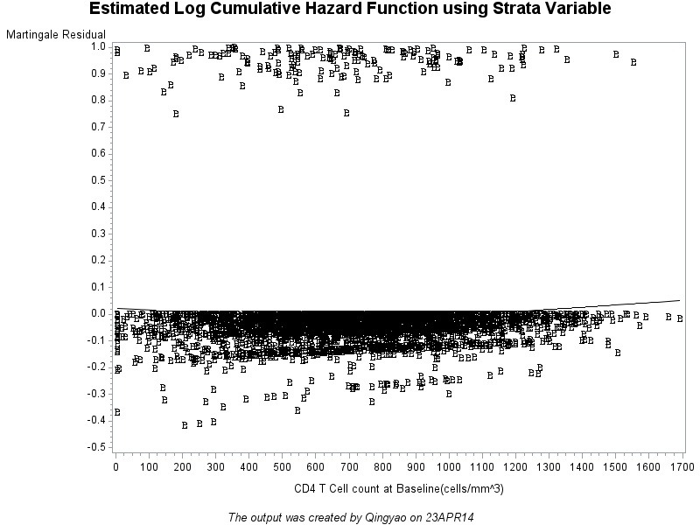

Figure 3‑2 Martingale Residual versus Baseline CD4 Cell Counts

From the martingale residual versus CD4 counts plot, we conclude that the linear assumption holds.

### Proportional Hazard Assumption

Neither CD4 nor marital status interacts with time. Also, the log cumulative hazard function based on strata variable is parallel within each arm. Therefore, proportional hazard assumption holds.

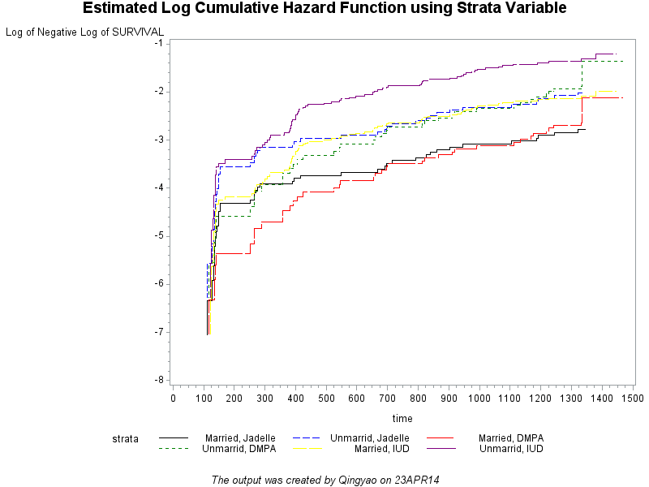

### Parameter Estimates

Table 3‑3 Regression Parameter Estimate

|  |  |  |  |  |  |  |
| --- | --- | --- | --- | --- | --- | --- |
| Parameter | Parameter  Estimate | Standard  Error | Pr > ChiSq | Hazard  Ratio | 95% Hazard Ratio Confidence Limits | |
| Arm DMPA | -0.0035 | 0.2280 | 0.9878 | 0.9970 | 0.6370 | 1.5580 |
| Arm IUD | 0.7104 | 0.1963 | 0.0003 | 2.0350 | 1.3850 | 2.9900 |
| CD4 T Cell count at Baseline(cells/mm^3) | -0.0004 | 0.0003 | 0.1285 | 1.0000 | 0.9990 | 1.0000 |
| Marital Status at Baseline Married | -0.7642 | 0.1647 | <.0001 | 0.4660 | 0.3370 | 0.6430 |

Baseline marital status and contraceptive arms are associated with HIV. Findings:

1. Married women are less likely to be infected compared to unmarried ones controlling baseline CD4 and contraceptive methods. The hazard for a married woman to be infected by HIV is 53% the hazard for her unmarried counterpart.
2. For the treatment arms, when compared to Jadelle, DMPA does slightly a better job in terms of hazard to be infected by HIV, although the difference is not statistically significant. The hazard associated with IUD is twice the hazard of Jadelle.

### Odds Ratio Estimate

Table 3‑4 Adjusted Odds Ratio Estimate

|  |  |  |  |
| --- | --- | --- | --- |
| Description | Point Estimate | 95% Wald Confidence Limits | |
| Arm DMPA vs IUD | 0.49 | 0.332 | 0.722 |
| Arm DMPA vs Jadelle | 0.997 | 0.637 | 1.558 |
| Arm IUD vs Jadelle | 2.035 | 1.385 | 2.99 |

The result does not change much from the unadjusted odds ratio. Again, among the three contraceptive arms, IUD has the highest HIV infection hazard. And DMPA does as good as Jadelle.

# Discussion

The limitation includes that the exact time of HIV could not be defined, the interval censoring was not dealt with specifically. There are two reasons for not taking care of interval censoring: 1. HIV has long incubation time, and it is not a frequent disease, and the time interval is relatively short. 2. The procedure in SAS that works for interval censoring does not account time-dependent covariates. Therefore, the PHREG procedure has been chosen because of its capacity to accommodate time dependent variables.

In addition, for some factors like sexual contacts and condom use, even if they are not statistically significant, their value might have clinical meanings. Most of the time, physicians’ professional suggestion should be taken into consideration regardless of whether certain variable is statistically significant.

# Appendix

## Baseline Table

Table 5‑1 Descriptive Statistics for Baseline Characteristics

|  |  |  |  |  |  |
| --- | --- | --- | --- | --- | --- |
| Baseline Characteristics | N | Mean | Std Dev | Min | Max |
| CD4 T Cell count (cells/mm^3) | 3000 | 705.3 | 291.51 | 5 | 1691 |
| Age | 3000 | 26.5 | 3.86 | 18 | 35 |
| Number of Times that woman had given birth previously | 2999 | 1.5 | 1.24 | 0 | 7 |

Table 5‑2 Baseline Marital Status versus Contraceptive Arms

|  |  |  |  |  |
| --- | --- | --- | --- | --- |
| (Marital Status at Baseline) | Arm | | | |
| Frequency (Col Pct) | DMPA | IUD | Jadelle | Total |
| Otherwise | 260 (26.21) | 248 (24.27) | 252 (25.58) | 760 |
| Married | 732 (73.79) | 774 (75.73) | 733 (74.42) | 2239 |
| Total | 992 | 1022 | 985 | 2999 |

## Derived Variable:

Time =lastvisit-visitdate1+1

## Cox Proportional Hazard model

Stepwise selection has been used to determine the final model with entry criterion 0.25 and stay criterion 0.15. Condom and sexual contacts were treated as time-dependent covariates in the full model.