Results

Nan Zhang

July 27, 2015

# The tables for priliminary paper. How to generate the table, see the [web page] (<http://www.tablesgenerator.com/markdown_tables>)

## Table 1

|  |  |  |  |  |  |  |  |  |  |  |
| --- | --- | --- | --- | --- | --- | --- | --- | --- | --- | --- |
| Table1. Steatosis zone 1,3 and demographic, anthropometric, laboratory values for children with NAFLD |  |  |  |  |  |  |  |  |  |  |
|  | Total(N=390) | Zone1(N=146) | Zone3(N=244) | P-value |  |  |  |  |  |  |
| Demographic |  |  |  |  |  |  |  |  |  |  |
| Age at enrollment(meanas.d.),years | 13.3a0.14 | 10.8a0.18 | 14.7a0.14 | <0.0001 |  |  |  |  |  |  |
| Gender, n(%) |  |  |  |  |  |  |  |  |  |  |
| Boy | 273(70.2) | 111(75.9) | 163(66.8) | 0.059 |  |  |  |  |  |  |
| Girl | 116(29.8) | 35(24.1) | 81(33.2) |  |  |  |  |  |  |  |
| Hispanic,n(%) |  |  |  |  |  |  |  |  |  |  |
| Yes | 248(64.1) | 108(75.0) | 140(57.6) | 0.0008 |  |  |  |  |  |  |
| No | 139(35.9) | 37(25.0) | 103(42.4) |  |  |  |  |  |  |  |
| Anthropometric |  |  |  |  |  |  |  |  |  |  |
| BMI(meanas.d.,kg/m2) | 32.7a0.33 | 29.6a0.45 | 34.5a0.42 | <0.0001 |  |  |  |  |  |  |
| Z-score(meanas.d.) | 2.25a0.11 | 2.22a0.03 | 2.26a0.02 | 0.438 |  |  |  |  |  |  |
| Laboratory values(meanas.d.) |  |  |  |  |  |  |  |  |  |  |
| ALT, U/T | 85.7a3.15 | 87.2a5.27 | 84.8a3.94 | 0.659 |  |  |  |  |  |  |
| Triglycerides,mg/DL | 149.5a3.15 | 124.9a5.36 | 164.2a6.63 | 0.0001 |  |  |  |  |  |  |
| Cholesterol LDL,mg/DL | 100.1a1.5 | 99.3a2.16 | 100.6a2.04 | 0.9014 |  |  |  |  |  |  |
| Cholesterol total,mg/DL | 167.9a1.88 | 164.3a2.49 | 170.2a2.59 | 0.2048 |  |  |  |  |  |  |

* Two subjects missing Hispanic. One in Zone1, one in Zone3.
* One subject missing Alt in Zone1.
* Three subjects missing Triglycerides. One in Zone1, two in Zone3.
* Five subjects missing cholesterol LDL. One in Zone1, four in Zone3.
* Three subjects missing cholesterol Total. One in Zone1, two in Zone3.
* Demographic and anthropometric continuous parameters using T-test, category parameter using Chi-square test.
* Laboratory continuous parameters using wilcoxon Rank test.

## Table2

|  |  |  |  |  |
| --- | --- | --- | --- | --- |
| Table2. Histological characteristics foe children with NAFLD IN in steatosis zone1,3 |  |  |  |  |
|  | Total(N=389) | Zone1(N=145) | Zone3(N=244) | P-value |
| Steatosis,n(%) |  |  |  |  |
| 1 | 127(32.6) | 50(34.5) | 77(31.6) | 0.7076 |
| 2 | 149(38.3) | 53(36.6) | 96(39.3) |  |
| 3 | 113(29.0) | 42(28.9) | 71(29.1) |  |
| Portal inflammation,n(%) |  |  |  |  |
| 0 | 45(11.5) | 5(3.5) | 40(16.4) | <0.0001 |
| 1 | 284(73.0) | 104(71.7) | 180(73.8) |  |
| 2 | 60(15.4) | 36(24.8) | 24(9.8) |  |
| Lobular inflammation,n(%) |  |  |  |  |
| 0 | 1(10.3) | 1(0.7) | 0(0.0) | 0.6988 |
| 1 | 225(57.8) | 80(55.2) | 145(59.4) |  |
| 2 | 139(35.7) | 57(39.3) | 82(33.6) |  |
| 3 | 24(6.2) | 7(4.8) | 17(7.0) |  |
| Fibrosis,n(%) |  |  |  |  |
| 0 | 147(37.8) | 27(18.6) | 120(49.1) | <0.0001 |
| 1a | 32(8.2) | 2(1.4) | 30(12.3) |  |
| 1b | 22(5.7) | 1(0.7) | 21(8.6) |  |
| 1c | 115(29.6) | 91(62.8) | 24(9.8) |  |
| 2 | 43(11.1) | 5(3.5) | 38(15.6) |  |
| 3 | 30(7.7) | 19(13.1) | 11(4.5) |  |
| steatosis-NASH |  |  |  |  |
| 0 | 121(31.1) | 21(14.5) | 100(40.9) | <0.0001 |
| 1a | 61(15.7) | 0(0.0) | 61(25.0) |  |
| 1b | 124(31.9) | 115(79.3) | 9(3.7) |  |
| 2 | 83(21.3) | 9(6.2) | 74(30.3) |  |

* All parameters using Mantel-Haenszel Chi-Square Test

## Table3

|  |  |  |  |  |
| --- | --- | --- | --- | --- |
| Table3. Demographic, anthropometric, laboratory values for children with NAFLD in steatosis zone 3 |  |  |  |  |
|  | Total(N=75) | Fibrosis_1a_1b(N=51) | Fibrosis_1c(N=24) | P-value |
| Demographic |  |  |  |  |
| Age (meanas.d.),years | 15.2a0.26 | 15.7a0.25 | 14.2a0.55 | 0.0142 |
| Gender, n(%) |  |  |  |  |
| Boy | 50(66.7) | 36(70.6) | 14(58.3) | 0.2936 |
| Girl | 25(33.3) | 15(29.4) | 10(41.7) |  |
| Hispanic,n(%) |  |  |  |  |
| Yes | 36(48.6) | 23(46.0) | 13(54.2) | 0.5106 |
| No | 38(51.4) | 27(54.0) | 11(45.8) |  |
| Anthropometric |  |  |  |  |
| BMI(meanas.d.,kg/m2) | 35.1a0.75 | 35.0a0.89 | 35.4a1.40 | 0.8395 |
| Z-score(meanas.d.) | 2.3a0.05 | 2.3a0.06 | 2.4a0.09 | 0.2238 |
| Laboratory values(meanas.d.) |  |  |  |  |
| ALT, U/T | 83.6a6.43 | 96.6a8.38 | 56.0a6.54 | <0.0001 |
| Histological characteristic |  |  |  |  |
| Steatosis,n(%) |  |  |  |  |
| 1 | 20(26.7) | 10(19.6) | 10(41.7) | 0.0778 |
| 2 | 34(45.3) | 25(49.0) | 9(37.5) |  |
| 3 | 21(28.0) | 16(31.4) | 5(20.8) |  |
| Portal inflammation,n(%) |  |  |  |  |
| 0 | 13(17.3) | 11(21.6) | 2(8.3) | 0.0112 |
| 1 | 56(74.7) | 39(76.5) | 17(70.8) |  |
| 2 | 6(8.0) | 1(1.9) | 5(20.9) |  |
| Lobular inflammation,n(%) |  |  |  |  |
| 1 | 42(56.0) | 26(50.9) | 16(66.7) | 0.1712 |
| 2 | 29(38.7) | 21(41.2) | 8(33.3) |  |
| 3 | 4(5.3) | 4(7.8) | 0(0.0) |  |
| steatosis-NASH |  |  |  |  |
| 0 | 16(21.3) | 1(1.9) | 15(62.5) | <0.0001 |
| 1a | 25(33.3) | 22(43.1) | 3(12.5) |  |
| 1b | 4(5.3) | 0(0.0) | 4(16.7) |  |
| 2 | 30(40.0) | 28(54.9) | 2(8.3) |  |

* One subject missing Hispanic in fibrosis_1a_1b
* Demographic and anthropometric continuous parameters using T-test, category parameter using Chi-square test.
* Laboratory continuous parameters using wilcoxon Rank test.
* All parameters using Mantel-Haenszel Chi-Square Test

# The plots of table1, continuous variables are ploted in boxplots, categorical variables are plots in bar plots.

* Histogram for Age in Zone1 and Zone3 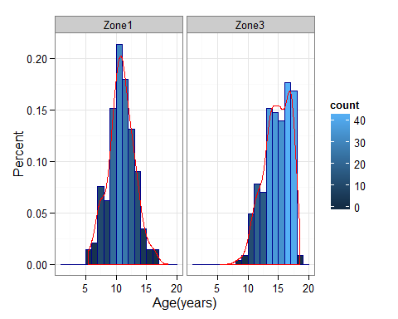
* Count for Sex of children in zone1,3 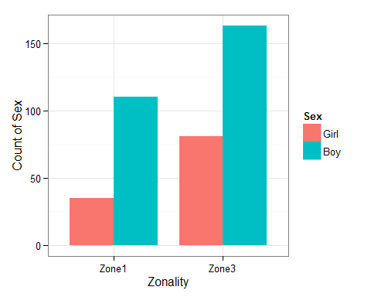
* Count for Hispanic of children in zone1,3 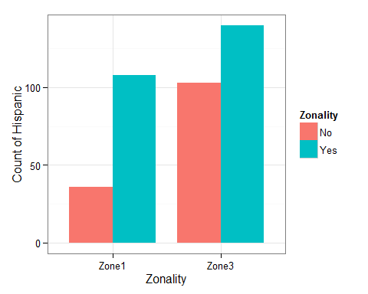
* Average BMI of children in zone1,3 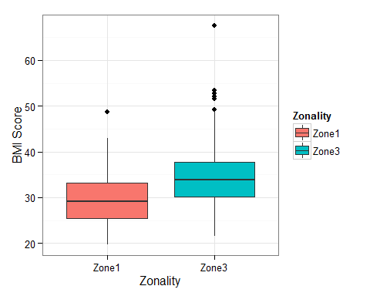
* Average BMIZ of children in zone1,3 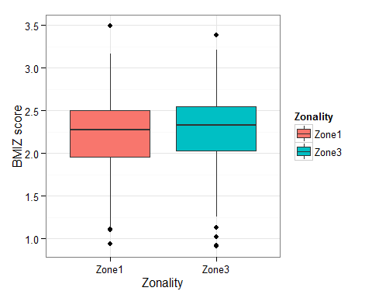
* Average Alt density of children in zone1,3 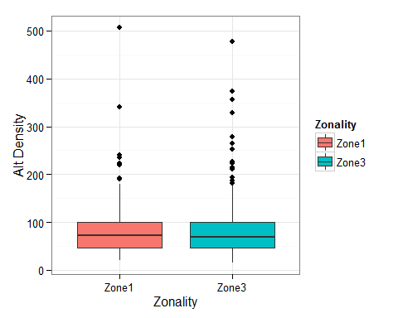
* Average Trig density of children in zone1,3 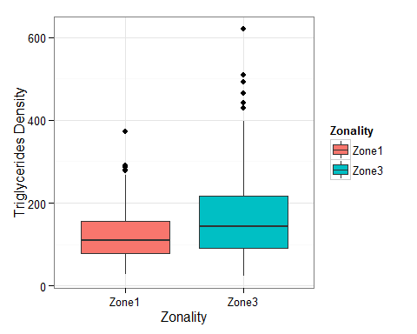
* Average LDL density of children in zone1,3 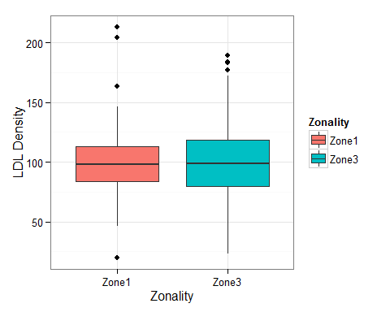
* Average Density of Cholesterol total of children in zone1,3 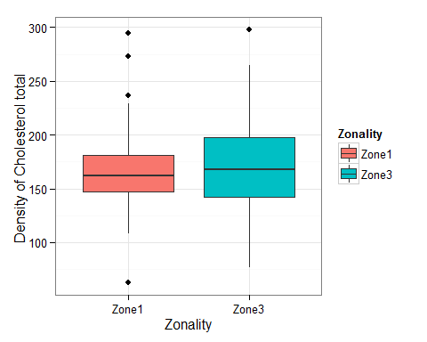

# The plots for table2. All categorical variables are plotting in bar plot.

* Count for steatosis of children in zone1,3 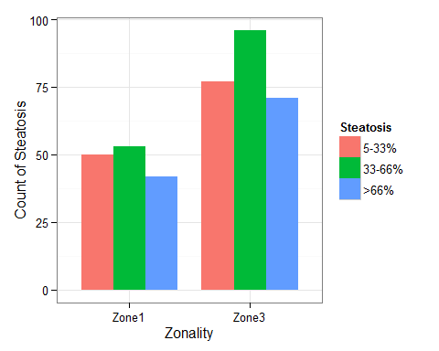
* Count for portal of children in zone1,3 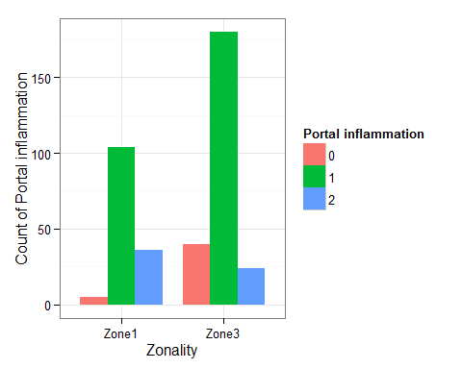
* Count for lobinfl of children in zone1,3 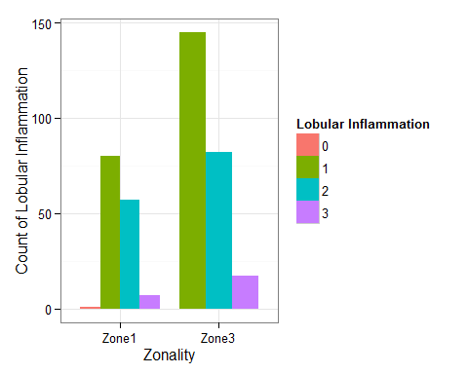
* Count for fibrosis of children in zone1,3 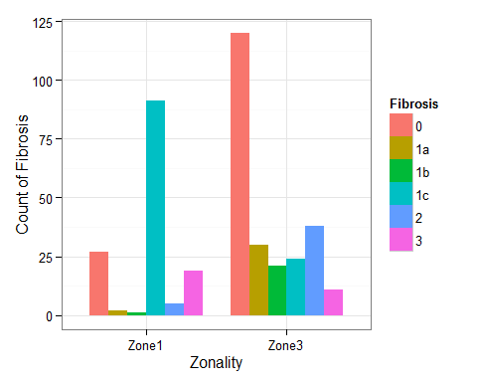
* Count for steatodx of children in zone1,3 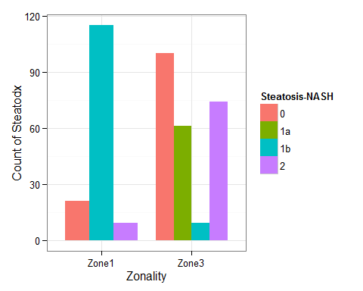

# The plots of table3, continuous variables are ploted in boxplots, categorical variables are plots in bar plots.

* Histogram for Age of Fibrosis_1a_1b vs Fibrosis_1c in Zone3 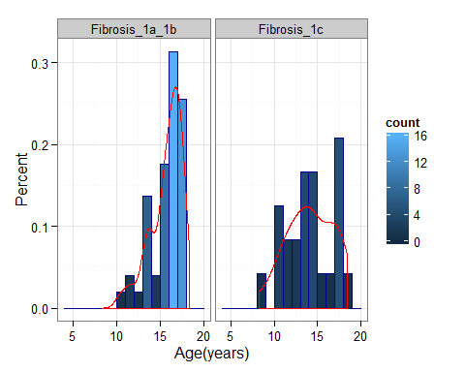
* Count for Children's Sex in Subfibs 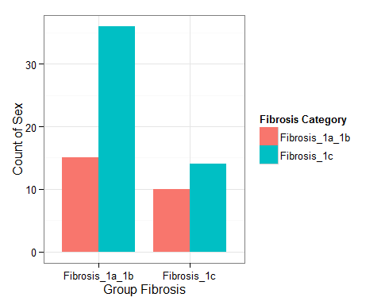
* Count for Children's Ethnicity in Subfibs 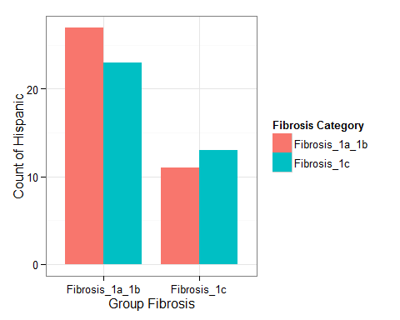
* Average BMI of Children in Subfibs 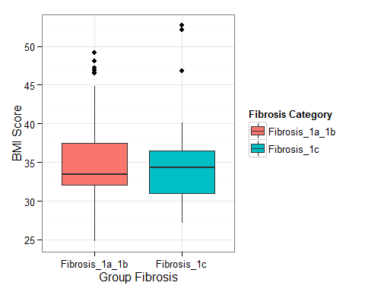
* Average BMIZ of Children in Subfibs 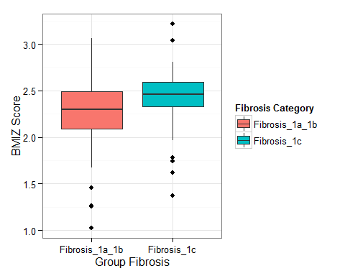
* Average Alt of Children in Subfibs 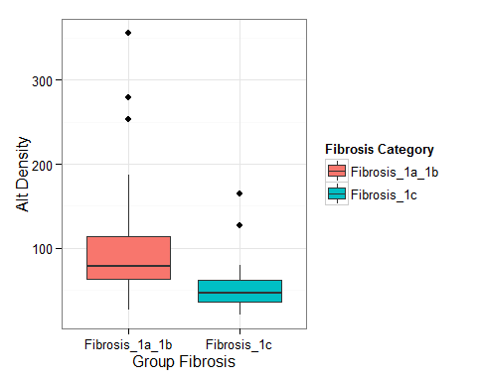
* Count for Steatosis of Children in Subfibs 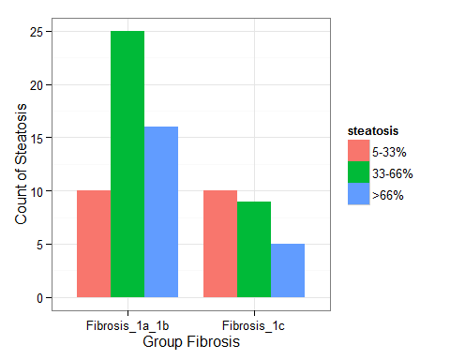
* Count for Portal of Children in Subfibs 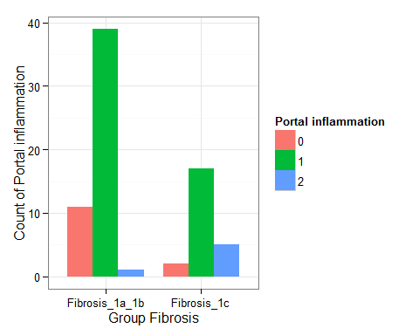
* Count for Lobinfl of Children in Subfibs 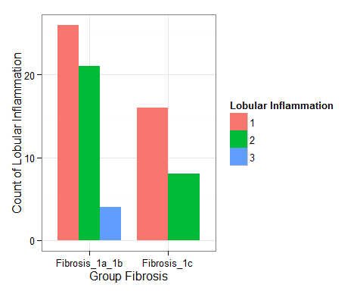
* Count for Steatodx of Children in Subfibs 