SUPPLEMENTARY INFORMATION

Native-grid analysis of apparent profile W50 under 248-nm UV and 976-nm NIR writing
This Supplementary Note reports a secondary sensitivity analysis of apparent X-direction half-maximum width derived from one registered UV/NIR image pair. The analysis quantifies image-derived profiles; intrinsic linewidth, optical-system resolution, and minimum bit pitch require complementary measurements.

Supplementary Methods

Analysis objective and status
The analysis compared the apparent lateral confinement of patterns written under 248-nm UV and 976-nm NIR conditions. A locked recomputation package stored the five transects, image hashes, coordinate transformations, measurement channel, profile parameters, validity threshold, and summary definition. Here, locked denotes parameters fixed during the reported recomputation, not preregistration. The stored transect positions were used unchanged for the W50 and UV/NIR-ratio calculations.
This sensitivity analysis uses a high-resolution NIR input, the CIE Lab a* channel, and five stored transects. The resulting values characterize the selected image source, signal channel, and ROI design. Table S4 compares them with the primary archived Figure S14 result.

Image inputs and analytical roles
Quantitative profiles were sampled from the native UV TIFF and the supplied high-resolution NIR JPEG, labelled as unsharpened. The registered 976-nm NIR TIFF served only for display and localization. The workflow used the retained quantitative inputs without added sharpening, deconvolution, or super-resolution. RUN_MANIFEST.json records the retained-file inventory, and M4_recompute_manifest.json records SHA-256 hashes for the quantitative UV image, quantitative NIR image, and stored transect configuration used in the M4 recomputation.
Table S1. Image inputs and analytical roles
Input | File format | Dimensions (px) | Analytical role | Quantitative use
248-nm UV | TIFF, RGBA to RGB | 314 x 390 | Native UV signal | Yes
976-nm NIR high resolution | JPEG, RGB; sRGB | 4096 x 3000 | Native NIR signal | Yes
976-nm NIR registered | TIFF, RGBA | 285 x 355 | Display and ROI localization | No
The UV and NIR quantitative inputs have different sampling and file-format histories, defining the scope of the image-pair comparison.

Coordinate transforms and native-grid sampling
Transect geometry was defined on a 285 × 355-pixel common reference grid. The upstream registration analysis estimated the mapping from image structure before width measurement and used subpixel correlation, scale-invariant features, and robust outlier rejection for validation [1–3]. The locked recomputation applies the stored transforms to all reported measurements.
The UV mapping used resize scales of 0.9076433 in X and 0.9102564 in Y, a 1.5000° rotation, and shifts of −3.25 pixels in X and +1.30 pixels in Y. The high-resolution NIR mapping used an isotropic similarity scale of 8.426995 high-resolution pixels per reference pixel, a 0.085970° rotation, and translations of 1087.3136 and 6.2309 high-resolution pixels.
Profile coordinates were generated in the common reference system, mapped to the corresponding native UV or high-resolution NIR image, and sampled by first-order interpolation. The high-resolution NIR image was not downsampled before profile extraction. Because no micrometre-per-pixel calibration was available, widths are reported as common-reference-grid apparent pixels.

Signal channel and fixed transects
The tagged high-resolution NIR JPEG was interpreted as sRGB, whereas the untagged UV TIFF was treated as sRGB after conversion from RGBA to RGB. RGB values were converted to CIE 1976 L*a*b* coordinates, and the a* opponent-colour channel was fixed for the reported recomputation [4]. Five technical transects with normal directions within 15° of the reference-grid X axis (X01–X05) were imported from M4_5X_ROIs.csv. They were nested within four parent spatial ROIs, with X04 and X05 sharing parent ROI M0_004 (Table S2).
Table S2. Stored transect geometry on the common reference grid
Transect | ROI ID | Parent ROI | Center X | Center Y | Normal angle (deg) | Upstream tangent shift (px)
X01 | M4_002 | M0_001 | 23.000 | 213.000 | 176.879 | 0
X02 | M4_005 | M0_002 | 71.000 | 231.000 | 168.827 | 0
X03 | M4_008 | M0_003 | 221.000 | 238.000 | 8.244 | 0
X04 | M4_010 | M0_004 | 76.136 | 233.065 | 6.525 | -10
X05 | M4_011 | M0_004 | 75.000 | 243.000 | 6.525 | 0
Angles and coordinates are defined in the common reference coordinate system. Normal angle is measured from the +X axis with +Y directed downward; increasing angle is therefore clockwise on the displayed image, and positive profile distance follows (cos θ, sin θ). The final centre coordinates were used directly in recomputation. Upstream tangent shift records displacement of the candidate centre during transect construction and is not the ±5-pixel parallel-profile offset used below.

Profile extraction
At each transect, 11 parallel profiles were sampled normal to the local ridge at tangent offsets of −5 to +5 reference pixels in 1-pixel increments. Each profile extended from −22 to +22 reference pixels and was sampled at 0.20-reference-pixel intervals (221 samples). The 11 profiles were averaged pointwise before filtering and half-maximum analysis. Figure S9 shows all five transect-profile pairs used for the primary apparent-W50 measurements.
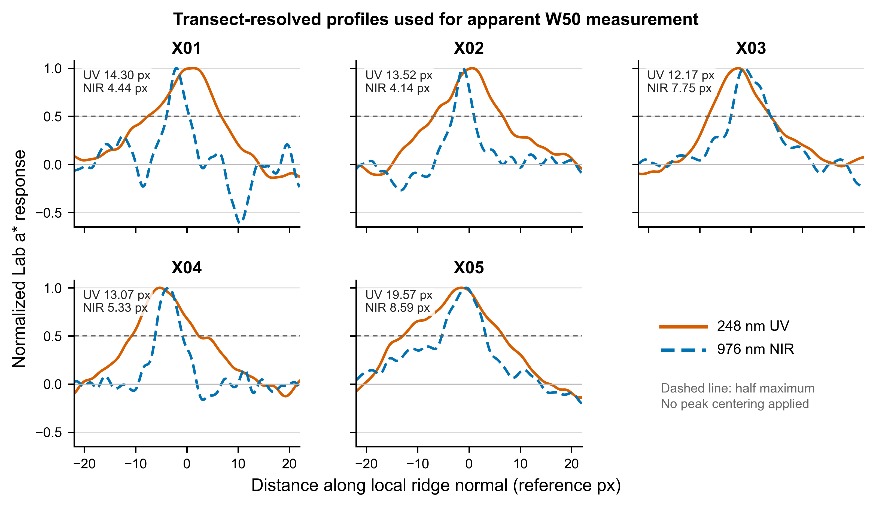
Figure S9. Transect-resolved profiles used for apparent-W50 measurement. UV (solid orange) and NIR (dashed blue) profiles are shown for the five fixed transects. The dashed horizontal line marks half maximum. No peak centring was applied.

Background, smoothing, validity, and W50
Background samples were taken from the outer 18% at each end of the unsmoothed mean profile. The local baseline B was their median. Background noise was defined as the larger of the sample standard deviation and 1.4826 times the median absolute deviation. A one-dimensional Gaussian filter with σ = 0.75 reference pixel was then applied to the mean profile for crossing detection.
The peak P was the maximum of the filtered profile within |r| ≤ 9.24 reference pixels. A condition-by-transect measurement was valid only when P − B was positive, the peak-to-noise ratio (PNR) was at least 3, and finite half-maximum crossings were present on both sides of the peak.
The filtered profile was normalized to the local baseline and central peak. On each side, a cumulative monotonic envelope was formed from the profile periphery toward the peak to suppress noise-induced recrossings. The first 0.5 crossing on each side was obtained by linear interpolation between adjacent samples. Apparent W50 was the absolute distance between the two crossings [5]. Figure S10 gives the representative X04 extraction.
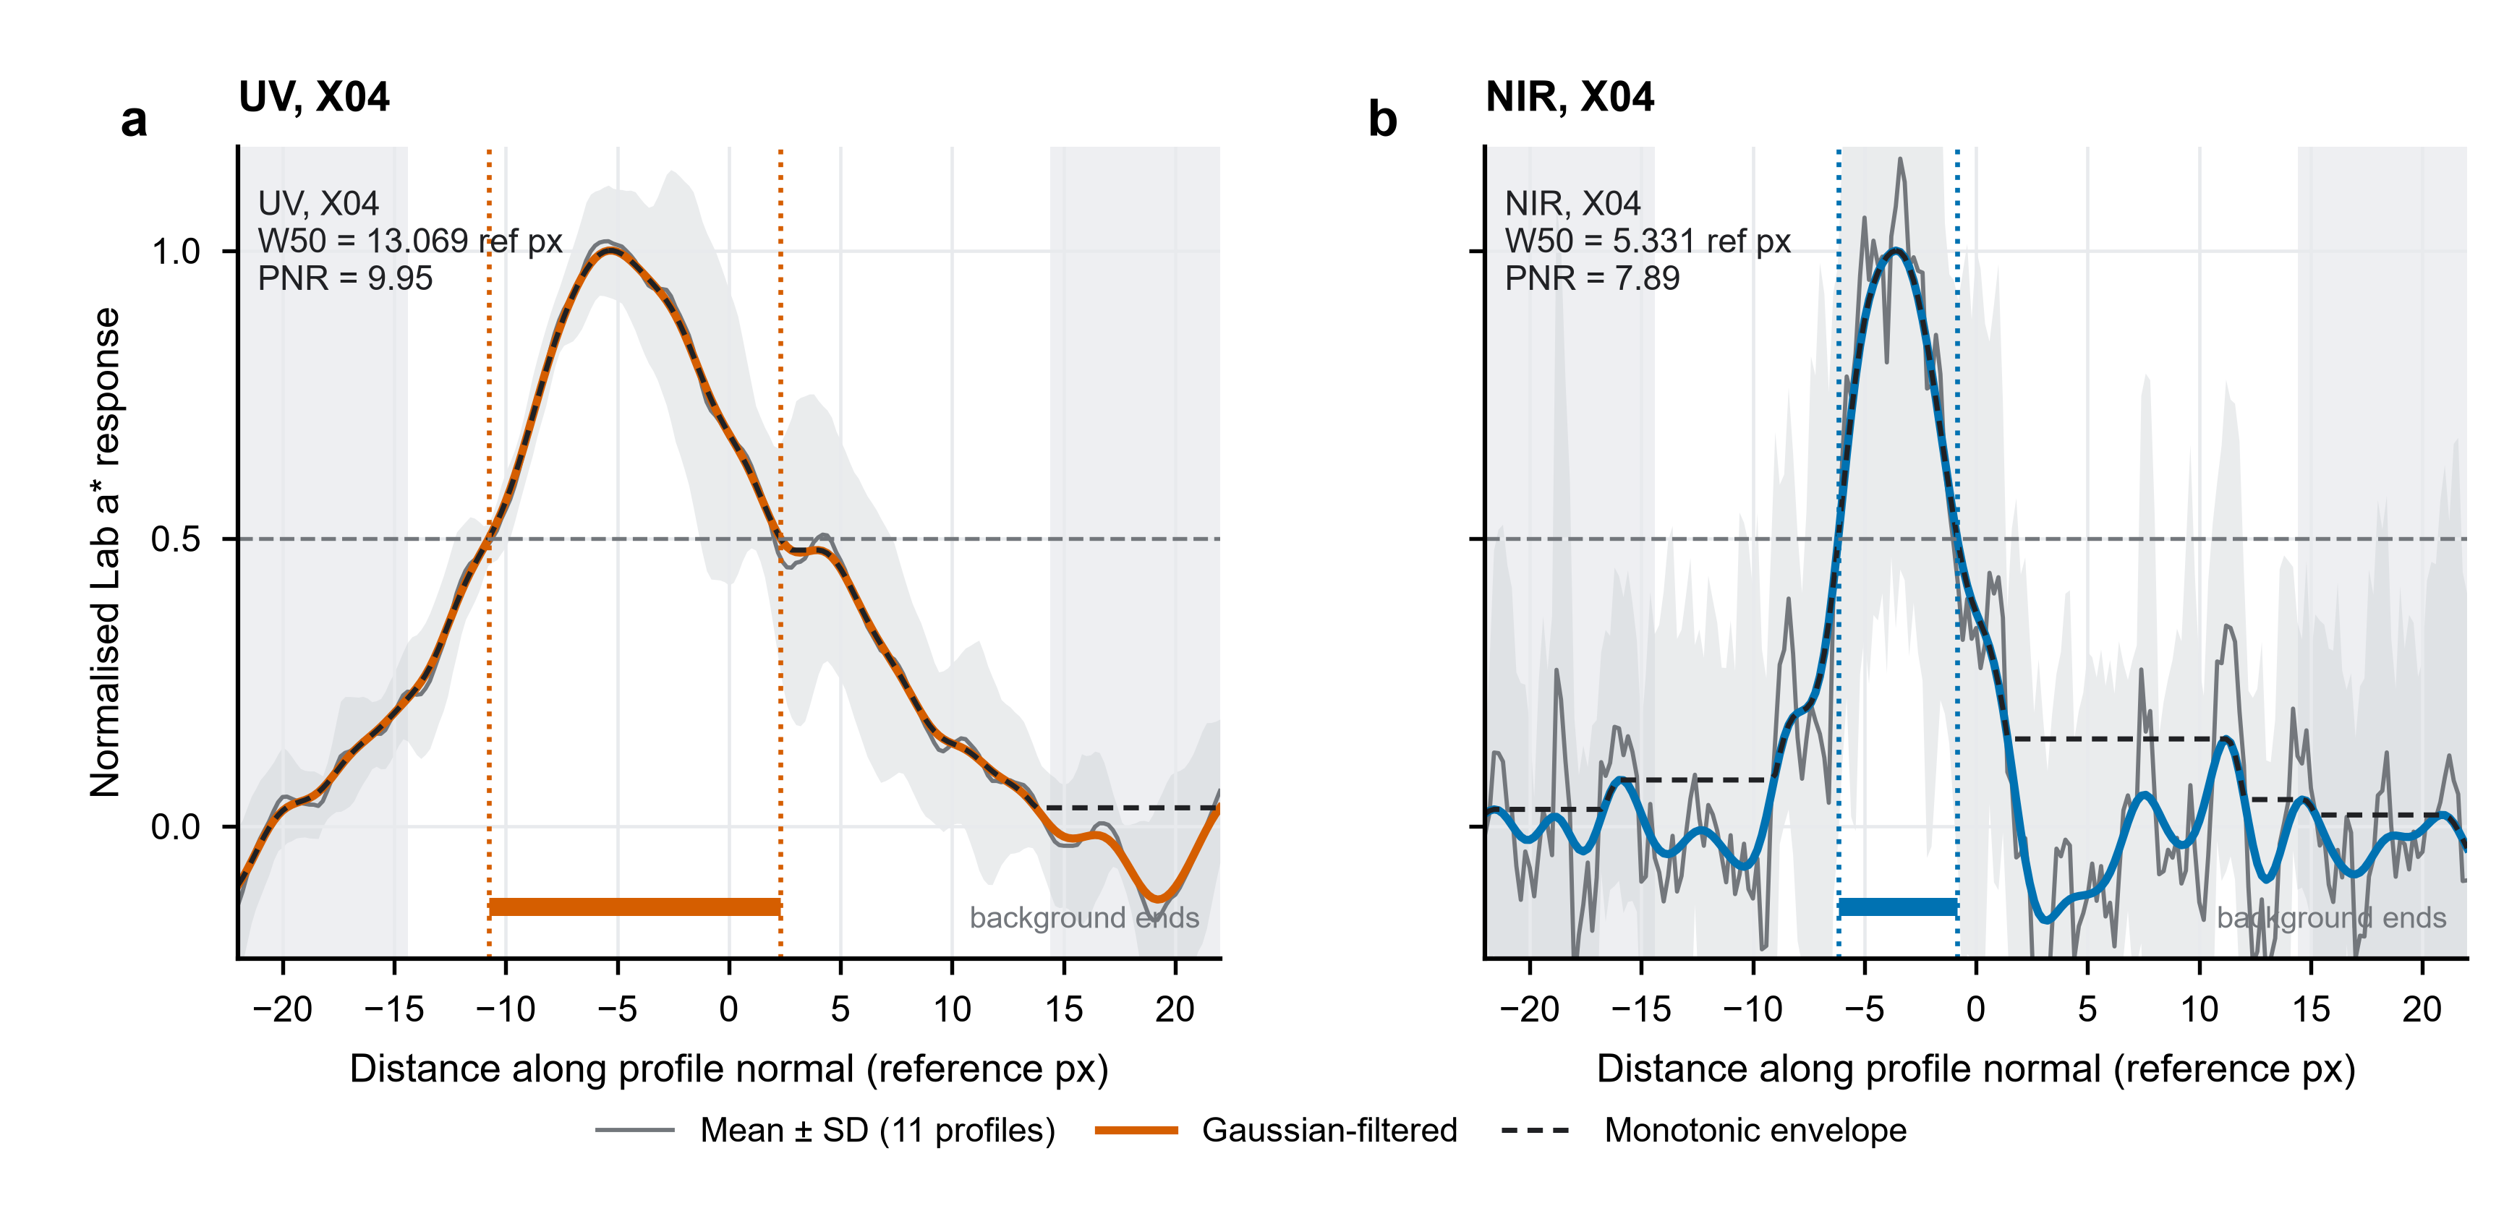
Figure S10. Representative apparent-W50 extraction at X04. Normalized UV and NIR profiles are shown with the half-maximum level and the linearly interpolated crossings used to calculate apparent W50. The plot defines the operational image-profile measurement used in this analysis.
W50 is the observed full width at half maximum of the normalized image profile. This operational definition reports image-profile width without separately estimating readout blur and written structure from an independently measured point-spread function [6].

Aggregation and statistical unit
One W50 value was obtained for each condition at each transect. All ten condition-by-transect measurements passed the stored validity rules; no values were excluded after computation. The X-direction width ratio Gx was defined as the ratio of the UV and NIR condition means, not as the arithmetic mean of the five local ratios.
The five transects provide technical spatial observations from one registered image pair and four parent spatial ROIs. Their means and sample standard deviations characterize within-pair spatial heterogeneity; the analysis is interpreted at the image-pair level without a hypothesis test.

Prespecified validity and robustness summaries
Two limited robustness summaries were calculated with the transect positions unchanged. First, apparent W50 was recomputed from each archived unfiltered Lab a* mean profile using Gaussian σ values of 0, 0.5, 0.75, and 1.0 reference pixel. Second, each of the four parent spatial ROIs was deleted in turn, with both transects removed for parent ROI M0_004. For every setting, UV and NIR were processed symmetrically and Gx remained the ratio of condition means. These summaries evaluate smoothing and parent-ROI dependence within this analysis pipeline.

Software and numerical reproducibility
The recomputation was executed in Python 3.12 using NumPy 2.5.2, pandas 3.0.1, SciPy 1.16.1, Matplotlib 3.10.5, Pillow 12.3.0, OpenCV 4.13.0, and scikit-image 0.25.2. The run verifies input hashes, requires ten valid condition-by-transect outputs, recalculates the summary, and checks Gx against the stored value with an absolute tolerance of 1 × 10⁻¹⁰.
The reduced package reproduces the stored five-transect configuration numerically. Evaluation of ROI-selection provenance requires the complete upstream candidate-generation and selection history.

Supplementary Results

Primary apparent-W50 results
All five paired transects had smaller apparent W50 values in the NIR condition. UV W50 ranged from 12.173 to 19.570 reference pixels, whereas NIR W50 ranged from 4.142 to 8.586 reference pixels. The mean decreased from 14.526 ± 2.923 reference pixels for UV to 6.051 ± 2.005 reference pixels for NIR (mean ± sample SD across technical transects; Table S3). All 10 condition-by-transect measurements met the prespecified validity criteria, as summarized in Figure S11.
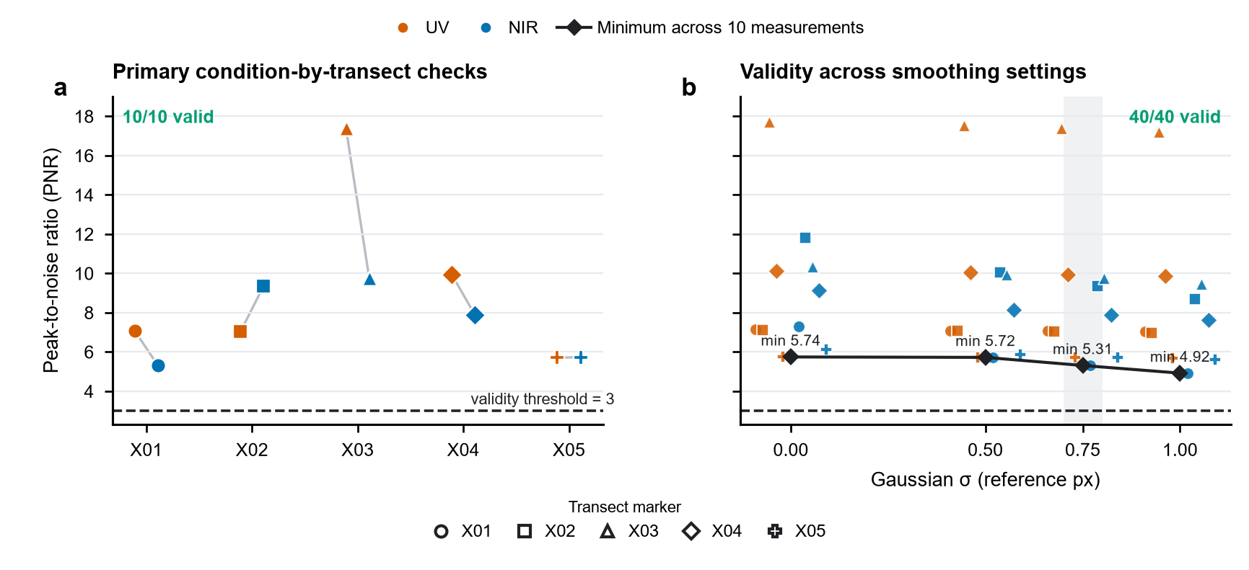
Figure S11. Peak-to-noise-ratio validity checks. (a) PNR for the 10 primary condition-by-transect measurements. (b) PNR for all 40 measurements across the four smoothing settings. Orange and blue identify UV and NIR, respectively; marker shape identifies transect. Black diamonds join the minimum PNR across the 10 condition-by-transect measurements at each smoothing setting. The horizontal dashed line marks the prespecified validity threshold (PNR = 3). All 10 primary and all 40 smoothing-sensitivity measurements were valid.
The ratio of condition means was Gx = 2.4006132325, corresponding to a 58.343977% reduction in apparent X-direction W50. The arithmetic mean of the five local UV/NIR ratios was 2.556692; it is reported only to describe heterogeneity and was not used to calculate Gx.
Table S3. Transect-resolved validity and apparent-W50 results
Transect | UV PNR | NIR PNR | UV W50 (ref px) | NIR W50 (ref px) | Local UV/NIR ratio
X01 | 7.071 | 5.311 | 14.300 | 4.442 | 3.219
X02 | 7.024 | 9.359 | 13.519 | 4.142 | 3.264
X03 | 17.378 | 9.742 | 12.173 | 7.753 | 1.570
X04 | 9.954 | 7.886 | 13.069 | 5.331 | 2.451
X05 | 5.704 | 5.737 | 19.570 | 8.586 | 2.279
Mean ± SD | - | - | 14.526 ± 2.923 | 6.051 ± 2.005 | Gx = 2.4006
PNR, peak-to-noise ratio. The final row reports the ratio of condition means; it is not the mean of the local ratios. All 10 measurements were valid.

Relationship to the primary archived analysis
The primary archived Figure S14 analysis and the present high-resolution sensitivity analysis use different image sources, signal channels, and ROI designs. The sensitivity analysis yielded Gx = 2.4006132325 under an alternative measurement configuration, complementing the primary archived estimate of 1.594 and illustrating the configuration dependence of the measured gain.
Table S4. Primary archived analysis and high-resolution sensitivity analysis
Analysis | Fixed configuration | UV mean W50 (ref px) | NIR mean W50 (ref px) | Ratio of means
Primary archived | ExR; 6 ROIs; registered common-grid images | 12.271 | 7.697 | 1.594
High-resolution sensitivity | Lab a*; 5 transects; native-grid sampling | 14.526 | 6.051 | 2.401
The two rows summarize related image-level measurements under distinct channel, ROI-design, and image-sampling configurations. Their side-by-side presentation clarifies the analytical context for each estimate.

Validity and limited robustness checks
Across Gaussian smoothing settings, Gx ranged from 2.288 to 2.607 (Figure S12 and Table S5). Across leave-one-parent-ROI-out summaries, it ranged from 2.260 to 2.687. NIR profiles were narrower in every evaluated setting, although the numerical ratio varied with smoothing and parent-ROI composition. The primary value, Gx = 2.4006132325, describes the prespecified configuration.
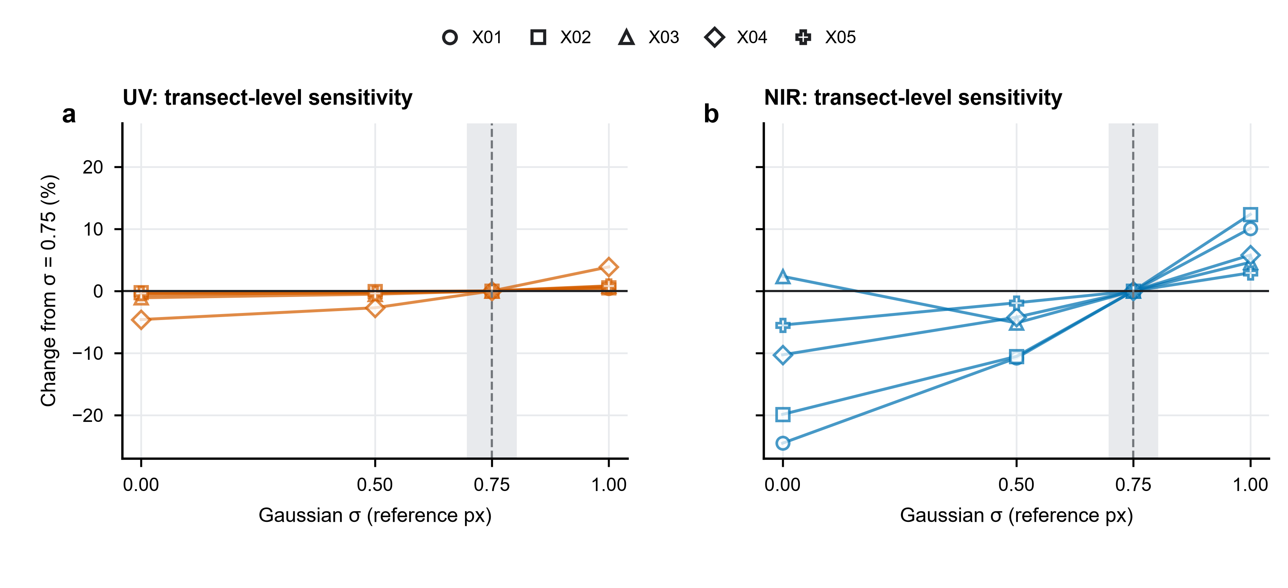
Figure S12. Transect-level sensitivity of apparent W50 to Gaussian smoothing. (a) UV and (b) NIR. Each line represents one of the five fixed transects, identified by marker shape. Values are expressed as the percentage change from the prespecified σ = 0.75 reference-pixel setting for the same condition and transect. The shaded band and dashed line mark that setting. This display isolates the effect of smoothing within the fixed analysis pipeline.
Table S5. Limited robustness summaries
Analysis | Paired transects | UV mean W50 (ref px) | NIR mean W50 (ref px) | Gx
Gaussian sigma = 0 ref px | 5 | 14.338 | 5.501 | 2.607
Gaussian sigma = 0.5 ref px | 5 | 14.420 | 5.710 | 2.525
Gaussian sigma = 0.75 ref px | 5 | 14.526 | 6.051 | 2.401
Gaussian sigma = 1.0 ref px | 5 | 14.703 | 6.426 | 2.288
Leave parent M0_001 out | 4 | 14.583 | 6.453 | 2.260
Leave parent M0_002 out | 4 | 14.778 | 6.528 | 2.264
Leave parent M0_003 out | 4 | 15.114 | 5.626 | 2.687
Leave parent M0_004 out | 3 | 13.331 | 5.446 | 2.448
All smoothing rows were recomputed from archived unfiltered Lab a* mean profiles with the same baseline, peak window, monotonic-envelope crossing rule, and 50% threshold. Parent M0_004 contains X04 and X05; both were deleted together. All evaluated rows were retained irrespective of whether Gx exceeded 2.3.

Conditional X-direction density proxy
Under the stated assumption that minimum addressable X-direction pitch scales linearly with apparent W50, the relative X-direction linear-density proxy equals Gx.
This proxy pertains specifically to X-direction apparent-width scaling. Direct storage-density estimation requires additional multidimensional spacing and error-rate measurements; accordingly, the analysis reports Gx as a linear-density proxy rather than as areal or volumetric capacity [8].

Measurement scope and interpretation
This dataset characterizes apparent W50 from technical spatial samples in one registered image pair. Its scope reflects the unequal input-file histories and reference-pixel reporting. The smoothing and parent-ROI summaries quantify configuration dependence of the reported ratio.
The data show narrower NIR profiles in the analyzed image pair. The result applies directly to this comparison of apparent profile width.

Data and code availability
The frozen analysis package contains the three image inputs, five-transect configuration, recomputation code, profile and measurement tables, figure source data, robustness-summary CSV, run manifest, and retained-file SHA-256 inventory. The final public archive should retain these files unchanged and add a version-pinned environment file that includes OpenCV and scikit-image. Adding the complete upstream candidate table and ROI-selection log would also allow selection provenance to be audited.

References
1. Guizar-Sicairos, M., Thurman, S. T. & Fienup, J. R. Efficient subpixel image registration algorithms. Optics Letters 33, 156–158 (2008). https://doi.org/10.1364/OL.33.000156
2. Lowe, D. G. Distinctive image features from scale-invariant keypoints. International Journal of Computer Vision 60, 91–110 (2004). https://doi.org/10.1023/B:VISI.0000029664.99615.94
3. Fischler, M. A. & Bolles, R. C. Random sample consensus: a paradigm for model fitting with applications to image analysis and automated cartography. Communications of the ACM 24, 381–395 (1981). https://doi.org/10.1145/358669.358692
4. McLaren, K. XIII—The development of the CIE 1976 (L*a*b*) uniform colour space and colour-difference formula. Journal of the Society of Dyers and Colourists 92, 338–341 (1976). https://doi.org/10.1111/j.1478-4408.1976.tb03301.x
5. Ahmad, R., Ding, Y. & Simonetti, O. P. Edge sharpness assessment by parametric modeling: application to magnetic resonance imaging. Concepts in Magnetic Resonance Part A 44, 138–149 (2015). https://doi.org/10.1002/cmr.a.21339
6. Cole, R. W., Jinadasa, T. & Brown, C. M. Measuring and interpreting point spread functions to determine confocal microscope resolution and ensure quality control. Nature Protocols 6, 1929–1941 (2011). https://doi.org/10.1038/nprot.2011.407
7. Vaux, D. L., Fidler, F. & Cumming, G. Replicates and repeats—what is the difference and is it significant? EMBO Reports 13, 291–296 (2012). https://doi.org/10.1038/embor.2012.36
8. Strickler, J. H. & Webb, W. W. Three-dimensional optical data storage in refractive media by two-photon point excitation. Optics Letters 16, 1780–1782 (1991). https://doi.org/10.1364/OL.16.001780

