数据集：

DAIC_stat_features_X_y_w10000_resample.csv

| *model_id* | *auc* | *logloss* | *aucpr* | *mean_per_class_error* | *rmse* | *mse* |
| --- | --- | --- | --- | --- | --- | --- |
| 0 | [StackedEnsemble_BestOfFamily_2_AutoML_1_20231025_134033](http://10.186.186.215:54321/flow/index.html) | 0.8103832442067737 | 0.5469180157377108 | 0.8253499524505044 | 0.23830213903743314 | 0.42523030634452663 | 0.18082081343385997 |
| 1 | [GBM_grid_1_AutoML_1_20231025_134033_model_1](http://10.186.186.215:54321/flow/index.html) | 0.8084893048128342 | 0.5460946394651067 | 0.8285305570028209 | 0.2667112299465241 | 0.42680539431073095 | 0.18216284461273852 |
| 2 | [DeepLearning_grid_1_AutoML_1_20231025_134033_model_323](http://10.186.186.215:54321/flow/index.html) | 0.8048685383244206 | 2.4443472071267784 | 0.8054212336498138 | 0.2447638146167558 | 0.47771775178292997 | 0.2282142503685371 |
| 3 | [StackedEnsemble_BestOfFamily_3_AutoML_1_20231025_134033](http://10.186.186.215:54321/flow/index.html) | 0.8029188948306595 | 0.5460669201403796 | 0.8083702134066003 | 0.27629233511586454 | 0.42379015392912506 | 0.17959809456727152 |
| 4 | [GBM_4_AutoML_1_20231025_134033](http://10.186.186.215:54321/flow/index.html) | 0.8014705882352942 | 0.5492678684502054 | 0.8297965956712878 | 0.30314171122994654 | 0.4301899831773347 | 0.18506342162611553 |
| 5 | [StackedEnsemble_AllModels_2_AutoML_1_20231025_134033](http://10.186.186.215:54321/flow/index.html) | 0.8003565062388592 | 0.5554157870017976 | 0.8245748594530627 | 0.2708333333333333 | 0.42945622823943685 | 0.18443265197364328 |
| 6 | [XRT_1_AutoML_1_20231025_134033](http://10.186.186.215:54321/flow/index.html) | 0.7998551693404635 | 0.5495534525195871 | 0.8174460437303862 | 0.2483288770053476 | 0.4300267180160569 | 0.18492297820766132 |
| 7 | [DeepLearning_grid_1_AutoML_1_20231025_134033_model_128](http://10.186.186.215:54321/flow/index.html) | 0.7978498217468805 | 3.9984342052378707 | 0.7725985992539869 | 0.23239750445632798 | 0.4728601541376264 | 0.2235967253710598 |
| 8 | [GBM_grid_1_AutoML_1_20231025_134033_model_7](http://10.186.186.215:54321/flow/index.html) | 0.7973484848484849 | 0.5505993493619172 | 0.8215234334311744 | 0.3499331550802139 | 0.4335738796969017 | 0.1879863091554234 |
| 9 | [GBM_grid_1_AutoML_1_20231025_134033_model_5](http://10.186.186.215:54321/flow/index.html) | 0.796680035650624 | 0.5687253758191 | 0.8162597284737435 | 0.27239304812834225 | 0.43817508148191564 | 0.1919974020316834 |
| 10 | [StackedEnsemble_BestOfFamily_1_AutoML_1_20231025_134033](http://10.186.186.215:54321/flow/index.html) | 0.7961229946524064 | 0.554888443987227 | 0.8195323959857336 | 0.2579099821746881 | 0.4301549202113922 | 0.18503325538206916 |
| 11 | [DeepLearning_grid_1_AutoML_1_20231025_134033_model_95](http://10.186.186.215:54321/flow/index.html) | 0.7959001782531195 | 3.8522864733934914 | 0.7714123265126006 | 0.20577094474153299 | 0.46767934217207086 | 0.21872396709450095 |
| 12 | [StackedEnsemble_AllModels_1_AutoML_1_20231025_134033](http://10.186.186.215:54321/flow/index.html) | 0.7952317290552585 | 0.5528155015906207 | 0.8219591268124777 | 0.2708333333333333 | 0.43010150499284244 | 0.18498730459710808 |
| 13 | [DeepLearning_grid_1_AutoML_1_20231025_134033_model_163](http://10.186.186.215:54321/flow/index.html) | 0.7933377896613191 | 4.0635155279499235 | 0.7707849708339166 | 0.2429812834224599 | 0.4841606832280517 | 0.23441156718385384 |
| 14 | [GBM_grid_1_AutoML_1_20231025_134033_model_8](http://10.186.186.215:54321/flow/index.html) | 0.7930035650623886 | 0.5533906308707847 | 0.8141807784593619 | 0.2757352941176471 | 0.43311812368066765 | 0.18759130906066213 |
| 15 | [GBM_grid_1_AutoML_1_20231025_134033_model_11](http://10.186.186.215:54321/flow/index.html) | 0.7918894830659536 | 0.5721686394230994 | 0.8136550357365346 | 0.27551247771836007 | 0.43734955975768985 | 0.1912746374202451 |
| 16 | [DeepLearning_grid_1_AutoML_1_20231025_134033_model_235](http://10.186.186.215:54321/flow/index.html) | 0.7917780748663101 | 3.785743246720473 | 0.7919199563526651 | 0.2667112299465241 | 0.5054832311215424 | 0.25551329694507463 |
| 17 | [DeepLearning_grid_1_AutoML_1_20231025_134033_model_313](http://10.186.186.215:54321/flow/index.html) | 0.7915552584670231 | 4.718392032193479 | 0.7751858732911624 | 0.22459893048128343 | 0.5060538497282753 | 0.25609049882480783 |
| 18 | [DeepLearning_grid_1_AutoML_1_20231025_134033_model_205](http://10.186.186.215:54321/flow/index.html) | 0.7901069518716578 | 3.305047397253533 | 0.7760897704044041 | 0.2253787878787879 | 0.4650368460007693 | 0.21625926813834317 |
| 19 | [GBM_2_AutoML_1_20231025_134033](http://10.186.186.215:54321/flow/index.html) | 0.7899955436720142 | 0.5619389859899818 | 0.8144193460578374 | 0.2589126559714795 | 0.4380199561057668 | 0.19186148194689787 |
| 20 | [DeepLearning_grid_1_AutoML_1_20231025_134033_model_234](http://10.186.186.215:54321/flow/index.html) | 0.7879901960784313 | 3.5125660150467586 | 0.7718987403749837 | 0.27061051693404636 | 0.48822466451790125 | 0.23836332304361724 |
| 21 | [GBM_grid_1_AutoML_1_20231025_134033_model_9](http://10.186.186.215:54321/flow/index.html) | 0.7849821746880571 | 0.5644004941291377 | 0.7954893461647023 | 0.33311051693404636 | 0.4380005677678908 | 0.1918444973649947 |
| 22 | [GBM_grid_1_AutoML_1_20231025_134033_model_12](http://10.186.186.215:54321/flow/index.html) | 0.7837566844919786 | 0.5739020301981204 | 0.7885453433542035 | 0.27807486631016043 | 0.4370047788314519 | 0.19097317672152617 |
| 23 | [DeepLearning_grid_1_AutoML_1_20231025_134033_model_308](http://10.186.186.215:54321/flow/index.html) | 0.7826983065953654 | 3.878422288315247 | 0.7757534449636329 | 0.27551247771836007 | 0.5034822825065055 | 0.25349440879796065 |
| 24 | [DeepLearning_grid_1_AutoML_1_20231025_134033_model_137](http://10.186.186.215:54321/flow/index.html) | 0.7810828877005348 | 4.732039668241292 | 0.7566586238750574 | 0.24944295900178254 | 0.49905412986984055 | 0.24905502454014367 |
| 25 | [DeepLearning_grid_1_AutoML_1_20231025_134033_model_167](http://10.186.186.215:54321/flow/index.html) | 0.7809714795008912 | 3.5965761422861857 | 0.7753935520608369 | 0.28353386809269165 | 0.5139844657147887 | 0.26418003099611687 |
| 26 | [DeepLearning_grid_1_AutoML_1_20231025_134033_model_246](http://10.186.186.215:54321/flow/index.html) | 0.7806929590017826 | 3.309811244454131 | 0.7713329758808014 | 0.29745989304812837 | 0.501430587597347 | 0.2514326341782207 |
| 27 | [DeepLearning_grid_2_AutoML_1_20231025_134033_model_11](http://10.186.186.215:54321/flow/index.html) | 0.7800245098039216 | 2.6678552354304985 | 0.7982246423128839 | 0.3137254901960784 | 0.5010766491042643 | 0.25107780827755805 |
| 28 | [DeepLearning_grid_1_AutoML_1_20231025_134033_model_149](http://10.186.186.215:54321/flow/index.html) | 0.7771836007130125 | 4.603132049355819 | 0.7422343807779166 | 0.22025401069518719 | 0.47114014956261363 | 0.22197304052988195 |
| 29 | [DeepLearning_grid_1_AutoML_1_20231025_134033_model_68](http://10.186.186.215:54321/flow/index.html) | 0.776849376114082 | 3.8293741406065154 | 0.7711876045096511 | 0.268270944741533 | 0.5131070270882702 | 0.2632788212473628 |
| 30 | [GBM_grid_1_AutoML_1_20231025_134033_model_10](http://10.186.186.215:54321/flow/index.html) | 0.7762923351158645 | 0.5814391216410048 | 0.7797709443843667 | 0.26927361853832443 | 0.4410129664965636 | 0.1944924366180991 |
| 31 | [DeepLearning_grid_1_AutoML_1_20231025_134033_model_210](http://10.186.186.215:54321/flow/index.html) | 0.775958110516934 | 4.468352707854276 | 0.7569900745175475 | 0.2576871657754011 | 0.5077763357980173 | 0.25783680719646085 |
| 32 | [DeepLearning_grid_1_AutoML_1_20231025_134033_model_102](http://10.186.186.215:54321/flow/index.html) | 0.7752339572192514 | 5.04633199865292 | 0.7425476207356861 | 0.23262032085561496 | 0.475182515701122 | 0.22579842322804708 |
| 33 | [DeepLearning_grid_1_AutoML_1_20231025_134033_model_9](http://10.186.186.215:54321/flow/index.html) | 0.7751225490196078 | 2.008759945707455 | 0.7963018931399438 | 0.3072638146167558 | 0.5339797001016185 | 0.2851343201206145 |
| 34 | [DeepLearning_grid_1_AutoML_1_20231025_134033_model_157](http://10.186.186.215:54321/flow/index.html) | 0.7750111408199644 | 3.1190610125166485 | 0.772037716646986 | 0.3103832442067736 | 0.5047596048950925 | 0.2547822587338499 |
| 35 | [DeepLearning_grid_1_AutoML_1_20231025_134033_model_150](http://10.186.186.215:54321/flow/index.html) | 0.7747883244206775 | 2.452322092066427 | 0.7536840563292371 | 0.2600267379679144 | 0.4868998074957685 | 0.23707142253941643 |
| 36 | [DRF_1_AutoML_1_20231025_134033](http://10.186.186.215:54321/flow/index.html) | 0.7746212121212122 | 0.5775859929929745 | 0.805994275069094 | 0.29512032085561496 | 0.4426723116597695 | 0.1959587755102041 |
| 37 | [DeepLearning_grid_1_AutoML_1_20231025_134033_model_253](http://10.186.186.215:54321/flow/index.html) | 0.772225935828877 | 3.4967961419003597 | 0.8024108816134593 | 0.29177807486631013 | 0.5495046846232423 | 0.30195539842288904 |
| 38 | [DeepLearning_grid_2_AutoML_1_20231025_134033_model_30](http://10.186.186.215:54321/flow/index.html) | 0.7719474153297683 | 2.9055207252591035 | 0.7648854523039827 | 0.28219696969696967 | 0.511806438961007 | 0.26194583096194696 |
| 39 | [DeepLearning_grid_1_AutoML_1_20231025_134033_model_32](http://10.186.186.215:54321/flow/index.html) | 0.7718360071301248 | 2.2899249585767256 | 0.7641108595088435 | 0.2628119429590018 | 0.49395834375629316 | 0.24399484536646027 |
| 40 | [DeepLearning_grid_1_AutoML_1_20231025_134033_model_70](http://10.186.186.215:54321/flow/index.html) | 0.7712232620320857 | 3.4965353547212006 | 0.7575772077527626 | 0.32408645276292336 | 0.5269092970852375 | 0.2776334073548591 |
| 41 | [DeepLearning_grid_1_AutoML_1_20231025_134033_model_287](http://10.186.186.215:54321/flow/index.html) | 0.7708333333333333 | 4.207694063460643 | 0.7470295804888947 | 0.25356506238859183 | 0.4955431220022062 | 0.2455629857636934 |
| 42 | [DeepLearning_grid_1_AutoML_1_20231025_134033_model_289](http://10.186.186.215:54321/flow/index.html) | 0.7708333333333333 | 3.8850448004130387 | 0.7682701280605617 | 0.2819741532976827 | 0.5176046906304733 | 0.26791461576266795 |
| 43 | [DeepLearning_grid_1_AutoML_1_20231025_134033_model_99](http://10.186.186.215:54321/flow/index.html) | 0.7706662210338681 | 2.9639365657359726 | 0.7547579543169887 | 0.2610294117647059 | 0.48553314945708087 | 0.23574243922171204 |
| 44 | [GBM_grid_1_AutoML_1_20231025_134033_model_13](http://10.186.186.215:54321/flow/index.html) | 0.7703877005347594 | 0.5750610881080713 | 0.7725208300295237 | 0.36775846702317294 | 0.442321578956498 | 0.1956483792105695 |
| 45 | [DeepLearning_grid_1_AutoML_1_20231025_134033_model_154](http://10.186.186.215:54321/flow/index.html) | 0.7703877005347594 | 4.7001671986784 | 0.7339987583481615 | 0.2608065953654189 | 0.4939938655627899 | 0.24402993921366775 |
| 46 | [DeepLearning_grid_1_AutoML_1_20231025_134033_model_153](http://10.186.186.215:54321/flow/index.html) | 0.7698863636363636 | 5.235020745453304 | 0.7417779959598456 | 0.2641488413547237 | 0.49431474893696065 | 0.24434707101661043 |
| 47 | [GBM_grid_1_AutoML_1_20231025_134033_model_3](http://10.186.186.215:54321/flow/index.html) | 0.7688279857397504 | 0.6100582177188838 | 0.7799852390644766 | 0.32586898395721925 | 0.4549409545629286 | 0.20697127213862865 |
| 48 | [DeepLearning_grid_1_AutoML_1_20231025_134033_model_228](http://10.186.186.215:54321/flow/index.html) | 0.7684380570409982 | 3.2314351443591467 | 0.7715094640695795 | 0.2690508021390374 | 0.5024576266946646 | 0.252463666623635 |
| 49 | [DeepLearning_grid_1_AutoML_1_20231025_134033_model_109](http://10.186.186.215:54321/flow/index.html) | 0.768048128342246 | 1.9892220043408542 | 0.7741969264728337 | 0.30314171122994654 | 0.4984235791613349 | 0.2484260642639955 |
| 50 | [DeepLearning_grid_1_AutoML_1_20231025_134033_model_140](http://10.186.186.215:54321/flow/index.html) | 0.7677696078431372 | 4.424550298096033 | 0.7477244930991414 | 0.2667112299465241 | 0.5068892831569943 | 0.2569367453794116 |
| 51 | [DeepLearning_grid_2_AutoML_1_20231025_134033_model_28](http://10.186.186.215:54321/flow/index.html) | 0.7672125668449198 | 2.2184672293519863 | 0.7787198143460591 | 0.2997994652406417 | 0.5106195054512339 | 0.2607322793472627 |
| 52 | [DeepLearning_grid_1_AutoML_1_20231025_134033_model_275](http://10.186.186.215:54321/flow/index.html) | 0.7665441176470588 | 3.45236959015179 | 0.7641877417717223 | 0.3160650623885918 | 0.5102805837172871 | 0.26038627411885523 |
| 53 | [DeepLearning_grid_1_AutoML_1_20231025_134033_model_164](http://10.186.186.215:54321/flow/index.html) | 0.7659870766488414 | 1.5853322284348006 | 0.7655849477422195 | 0.2837566844919786 | 0.497736092799016 | 0.24774121807483065 |
| 54 | [GBM_grid_1_AutoML_1_20231025_134033_model_6](http://10.186.186.215:54321/flow/index.html) | 0.7655971479500892 | 0.5698263796422588 | 0.7870285122457719 | 0.3628565062388592 | 0.4414833632919016 | 0.19490756006352916 |
| 55 | [DeepLearning_grid_1_AutoML_1_20231025_134033_model_7](http://10.186.186.215:54321/flow/index.html) | 0.7650958110516934 | 4.218379686767764 | 0.7572589500639104 | 0.3137254901960784 | 0.5355671772445284 | 0.2868322013416721 |
| 56 | [DeepLearning_grid_1_AutoML_1_20231025_134033_model_166](http://10.186.186.215:54321/flow/index.html) | 0.7650401069518717 | 4.565076229651145 | 0.743702107779206 | 0.2778520499108734 | 0.49407642466604373 | 0.24411151341078077 |
| 57 | [GBM_3_AutoML_1_20231025_134033](http://10.186.186.215:54321/flow/index.html) | 0.7650401069518717 | 0.5792716414377304 | 0.7994398260459467 | 0.31216577540106955 | 0.44814688870955965 | 0.20083563386005845 |
| 58 | [DeepLearning_grid_1_AutoML_1_20231025_134033_model_248](http://10.186.186.215:54321/flow/index.html) | 0.7649844028520498 | 3.739587565899357 | 0.7389934210940728 | 0.26024955436720143 | 0.4967314907727183 | 0.2467421739252871 |
| 59 | [DeepLearning_grid_1_AutoML_1_20231025_134033_model_124](http://10.186.186.215:54321/flow/index.html) | 0.7640931372549019 | 2.1063138489420936 | 0.7711710041367557 | 0.23495989304812837 | 0.5124713436444943 | 0.26262687805679336 |
| 60 | [DeepLearning_grid_1_AutoML_1_20231025_134033_model_230](http://10.186.186.215:54321/flow/index.html) | 0.7639817290552585 | 3.889371875331802 | 0.7439294653041085 | 0.27239304812834225 | 0.5104789143167171 | 0.26058872196197425 |
| 61 | [DeepLearning_grid_1_AutoML_1_20231025_134033_model_81](http://10.186.186.215:54321/flow/index.html) | 0.7638146167557932 | 4.079563183583983 | 0.7418601901734644 | 0.3264260249554367 | 0.5224695386847047 | 0.2729744188534082 |
| 62 | [DeepLearning_grid_1_AutoML_1_20231025_134033_model_46](http://10.186.186.215:54321/flow/index.html) | 0.762979055258467 | 3.8313757348442947 | 0.7512020916737643 | 0.25222816399286985 | 0.4995565295706997 | 0.24955672623672134 |
| 63 | [DeepLearning_grid_1_AutoML_1_20231025_134033_model_242](http://10.186.186.215:54321/flow/index.html) | 0.7627005347593584 | 1.9385279259324812 | 0.7908505883962352 | 0.3517156862745098 | 0.5045767758449198 | 0.2545977227220544 |
| 64 | [DeepLearning_grid_1_AutoML_1_20231025_134033_model_11](http://10.186.186.215:54321/flow/index.html) | 0.7623663101604279 | 2.8618477511190235 | 0.7598349962267741 | 0.2708333333333333 | 0.5023263132685664 | 0.2523317250019899 |
| 65 | [DeepLearning_grid_1_AutoML_1_20231025_134033_model_82](http://10.186.186.215:54321/flow/index.html) | 0.7623663101604279 | 4.666185001983812 | 0.7408053438267466 | 0.250445632798574 | 0.48596357167738635 | 0.23616059299744221 |
| 66 | [DeepLearning_grid_1_AutoML_1_20231025_134033_model_299](http://10.186.186.215:54321/flow/index.html) | 0.7620877896613191 | 4.5723589977237395 | 0.7462241582311436 | 0.2625891265597148 | 0.5009828881325771 | 0.25098385420165825 |
| 67 | [DeepLearning_grid_1_AutoML_1_20231025_134033_model_324](http://10.186.186.215:54321/flow/index.html) | 0.7615864527629234 | 2.2319616541308127 | 0.7390035733277969 | 0.27629233511586454 | 0.48634416101085515 | 0.2365306429493526 |
| 68 | [DeepLearning_grid_1_AutoML_1_20231025_134033_model_304](http://10.186.186.215:54321/flow/index.html) | 0.7612522281639929 | 4.514973426379802 | 0.7506707132440057 | 0.2635918003565062 | 0.5088830320928182 | 0.2589619403519802 |
| 69 | [DeepLearning_grid_1_AutoML_1_20231025_134033_model_74](http://10.186.186.215:54321/flow/index.html) | 0.7611408199643495 | 1.4889592655478707 | 0.7679422671069664 | 0.2819741532976827 | 0.5163475752616316 | 0.2666148184785662 |
| 70 | [DeepLearning_grid_1_AutoML_1_20231025_134033_model_236](http://10.186.186.215:54321/flow/index.html) | 0.7606951871657753 | 4.098506653428903 | 0.7466245943036169 | 0.27551247771836007 | 0.5363156880494045 | 0.2876345172479062 |
| 71 | [GBM_grid_1_AutoML_1_20231025_134033_model_15](http://10.186.186.215:54321/flow/index.html) | 0.7605837789661319 | 0.5935444845165938 | 0.770503120651321 | 0.28865864527629237 | 0.4501185778716856 | 0.20260673414522867 |
| 72 | [DeepLearning_grid_1_AutoML_1_20231025_134033_model_113](http://10.186.186.215:54321/flow/index.html) | 0.7600267379679143 | 2.4617382943133532 | 0.7536538133776087 | 0.27217023172905525 | 0.5213290844079571 | 0.27178401424963883 |
| 73 | [DeepLearning_grid_1_AutoML_1_20231025_134033_model_152](http://10.186.186.215:54321/flow/index.html) | 0.7600267379679143 | 1.940303955869376 | 0.7739094550336871 | 0.2749554367201426 | 0.516249228698842 | 0.26651326613214926 |
| 74 | [DeepLearning_grid_1_AutoML_1_20231025_134033_model_129](http://10.186.186.215:54321/flow/index.html) | 0.759024064171123 | 4.987881199163642 | 0.7430567213344255 | 0.2876559714795009 | 0.5099006221048471 | 0.2599986444229101 |
| 75 | [StackedEnsemble_AllModels_3_AutoML_1_20231025_134033](http://10.186.186.215:54321/flow/index.html) | 0.7582442067736185 | 0.563649608033054 | 0.7077440157724347 | 0.24532085561497327 | 0.432610886474617 | 0.18715217909635395 |
| 76 | [GBM_5_AutoML_1_20231025_134033](http://10.186.186.215:54321/flow/index.html) | 0.7575757575757577 | 0.6168028154221727 | 0.791917016579747 | 0.35249554367201424 | 0.45934296236502237 | 0.21099595707427435 |
| 77 | [DeepLearning_grid_1_AutoML_1_20231025_134033_model_312](http://10.186.186.215:54321/flow/index.html) | 0.7572972370766489 | 2.4328835303427403 | 0.7390352390582721 | 0.3201871657754011 | 0.5158765916611154 | 0.2661286578238893 |
| 78 | [DeepLearning_grid_1_AutoML_1_20231025_134033_model_303](http://10.186.186.215:54321/flow/index.html) | 0.7566844919786097 | 3.6150831668739793 | 0.7541831938679646 | 0.31684491978609625 | 0.5487038120326441 | 0.30107587333915514 |
| 79 | [DeepLearning_grid_1_AutoML_1_20231025_134033_model_219](http://10.186.186.215:54321/flow/index.html) | 0.7563502673796791 | 2.913727770970326 | 0.777338312548434 | 0.32486631016042783 | 0.5331772451328747 | 0.2842779747274815 |
| 80 | [DeepLearning_grid_1_AutoML_1_20231025_134033_model_301](http://10.186.186.215:54321/flow/index.html) | 0.7563502673796791 | 4.557781907700136 | 0.7535556707922574 | 0.30804367201426025 | 0.5202683286134849 | 0.2706791337582692 |
| 81 | [DeepLearning_grid_1_AutoML_1_20231025_134033_model_243](http://10.186.186.215:54321/flow/index.html) | 0.7562945632798573 | 4.1477033627237505 | 0.729314716305808 | 0.27217023172905525 | 0.5264079090047731 | 0.2771052866627775 |
| 82 | [DeepLearning_grid_1_AutoML_1_20231025_134033_model_319](http://10.186.186.215:54321/flow/index.html) | 0.7560160427807486 | 1.8732505764754876 | 0.7550200530276137 | 0.34759358288770054 | 0.5044066335099615 | 0.25442605192885265 |
| 83 | [DeepLearning_grid_1_AutoML_1_20231025_134033_model_209](http://10.186.186.215:54321/flow/index.html) | 0.7560160427807486 | 4.648055643436169 | 0.7328960163200414 | 0.2747326203208556 | 0.5119483203999449 | 0.26209108276032456 |
| 84 | [DeepLearning_grid_2_AutoML_1_20231025_134033_model_54](http://10.186.186.215:54321/flow/index.html) | 0.7555704099821746 | 1.3313041029064598 | 0.7578797593965204 | 0.2827540106951872 | 0.5023071738895842 | 0.252312496940941 |
| 85 | [DeepLearning_grid_1_AutoML_1_20231025_134033_model_106](http://10.186.186.215:54321/flow/index.html) | 0.7555147058823529 | 2.1616784955993604 | 0.7138772801770159 | 0.2964572192513369 | 0.5013805740039157 | 0.25138247998849594 |
| 86 | [DeepLearning_grid_1_AutoML_1_20231025_134033_model_178](http://10.186.186.215:54321/flow/index.html) | 0.755291889483066 | 2.8306197312800654 | 0.7286248773398519 | 0.2786319073083779 | 0.5045039393651252 | 0.25452422483492987 |
| 87 | [DeepLearning_grid_1_AutoML_1_20231025_134033_model_170](http://10.186.186.215:54321/flow/index.html) | 0.7551804812834224 | 4.706462589456309 | 0.7525525563069441 | 0.3015819964349376 | 0.5335901507234472 | 0.28471844894907106 |
| 88 | [DeepLearning_grid_1_AutoML_1_20231025_134033_model_67](http://10.186.186.215:54321/flow/index.html) | 0.7550133689839572 | 1.1961442564641669 | 0.7552133005064618 | 0.30804367201426025 | 0.4950751793783844 | 0.24509943323653952 |
| 89 | [DeepLearning_grid_1_AutoML_1_20231025_134033_model_258](http://10.186.186.215:54321/flow/index.html) | 0.7540663992869875 | 3.856891957480428 | 0.7708575539013454 | 0.29924242424242425 | 0.5472178031210198 | 0.2994473240525951 |
| 90 | [DeepLearning_grid_1_AutoML_1_20231025_134033_model_145](http://10.186.186.215:54321/flow/index.html) | 0.7533979500891266 | 3.7900116989321035 | 0.7385586758500925 | 0.2667112299465241 | 0.5073096869350671 | 0.2573631184581558 |
| 91 | [DeepLearning_grid_1_AutoML_1_20231025_134033_model_279](http://10.186.186.215:54321/flow/index.html) | 0.7527852049910874 | 2.038968705117672 | 0.7819450374213648 | 0.32174688057040995 | 0.5315636651668713 | 0.2825599301256376 |
| 92 | [DeepLearning_grid_1_AutoML_1_20231025_134033_model_202](http://10.186.186.215:54321/flow/index.html) | 0.7498885918003565 | 2.802755061441562 | 0.7434001525312539 | 0.3000222816399287 | 0.5111261538664303 | 0.2612499451662898 |
| 93 | [DeepLearning_grid_1_AutoML_1_20231025_134033_model_22](http://10.186.186.215:54321/flow/index.html) | 0.7496100713012478 | 2.5984363975710867 | 0.7513045004212123 | 0.30960338680926913 | 0.5206997375184712 | 0.27112821665180475 |
| 94 | [DeepLearning_grid_1_AutoML_1_20231025_134033_model_315](http://10.186.186.215:54321/flow/index.html) | 0.7492758467023173 | 3.3411496209967857 | 0.734992318641414 | 0.29901960784313725 | 0.5154066221638963 | 0.2656439861703974 |
| 95 | [DeepLearning_grid_1_AutoML_1_20231025_134033_model_37](http://10.186.186.215:54321/flow/index.html) | 0.7492758467023173 | 3.0258524642252853 | 0.7320229653722561 | 0.2569073083778966 | 0.5020708600794858 | 0.25207514854095453 |
| 96 | [DeepLearning_grid_1_AutoML_1_20231025_134033_model_322](http://10.186.186.215:54321/flow/index.html) | 0.7487745098039216 | 3.4137821355132 | 0.7413963772023189 | 0.303921568627451 | 0.5447093580890954 | 0.2967082847898343 |
| 97 | [DeepLearning_grid_1_AutoML_1_20231025_134033_model_317](http://10.186.186.215:54321/flow/index.html) | 0.7481617647058824 | 3.517740416052208 | 0.7535299426505386 | 0.31528520499108736 | 0.5496125815320022 | 0.30207398977827177 |
| 98 | [DeepLearning_grid_1_AutoML_1_20231025_134033_model_6](http://10.186.186.215:54321/flow/index.html) | 0.7480503565062389 | 2.333920654952184 | 0.7136458191604522 | 0.28119429590017825 | 0.4969704953546307 | 0.24697967325302703 |
| 99 | [DeepLearning_grid_1_AutoML_1_20231025_134033_model_267](http://10.186.186.215:54321/flow/index.html) | 0.7475490196078431 | 2.5215067000591 | 0.712626646439976 | 0.3135026737967915 | 0.5201027959113665 | 0.27050691831482065 |
| 100 | [DeepLearning_grid_1_AutoML_1_20231025_134033_model_17](http://10.186.186.215:54321/flow/index.html) | 0.7474933155080214 | 4.209686372809807 | 0.7320357256461398 | 0.29668003565062384 | 0.5211443985195435 | 0.2715914841082968 |
| 101 | [DeepLearning_grid_1_AutoML_1_20231025_134033_model_325](http://10.186.186.215:54321/flow/index.html) | 0.7473262032085561 | 1.8868680566528873 | 0.7252811886656537 | 0.32408645276292336 | 0.5060794994134795 | 0.25611645972659797 |
| 102 | [DeepLearning_grid_1_AutoML_1_20231025_134033_model_207](http://10.186.186.215:54321/flow/index.html) | 0.7472704991087344 | 4.005637564451387 | 0.7425104893250061 | 0.32486631016042783 | 0.548387677460233 | 0.30072904479022855 |
| 103 | [DeepLearning_grid_1_AutoML_1_20231025_134033_model_276](http://10.186.186.215:54321/flow/index.html) | 0.7464906417112299 | 6.2969388451095725 | 0.7178942000444346 | 0.2657085561497326 | 0.5248684445180054 | 0.2754868840507505 |
| 104 | [DeepLearning_grid_2_AutoML_1_20231025_134033_model_5](http://10.186.186.215:54321/flow/index.html) | 0.7458221925133689 | 3.2761993438710317 | 0.7448453983291847 | 0.3589572192513369 | 0.5602153599961189 | 0.3138412495755811 |
| 105 | [DeepLearning_grid_1_AutoML_1_20231025_134033_model_249](http://10.186.186.215:54321/flow/index.html) | 0.7452094474153298 | 3.5587398664780525 | 0.7412781085153248 | 0.3403520499108734 | 0.5453454344309174 | 0.29740164285464604 |
| 106 | [DeepLearning_grid_1_AutoML_1_20231025_134033_model_165](http://10.186.186.215:54321/flow/index.html) | 0.744930926916221 | 2.729089425831545 | 0.7518816109079499 | 0.27729500891265596 | 0.5129558301504341 | 0.26312368368532096 |
| 107 | [DeepLearning_grid_1_AutoML_1_20231025_134033_model_168](http://10.186.186.215:54321/flow/index.html) | 0.7444295900178254 | 1.7921040480440014 | 0.7217287274865882 | 0.25557040998217473 | 0.5096343572373411 | 0.2597271780767178 |
| 108 | [DeepLearning_grid_1_AutoML_1_20231025_134033_model_130](http://10.186.186.215:54321/flow/index.html) | 0.7443181818181818 | 2.9046623202725077 | 0.7527220946748978 | 0.28843582887700536 | 0.5251957279590339 | 0.2758305526664196 |
| 109 | [DeepLearning_grid_1_AutoML_1_20231025_134033_model_292](http://10.186.186.215:54321/flow/index.html) | 0.7436497326203209 | 1.9926572892020344 | 0.7500934992105283 | 0.2935606060606061 | 0.5276120929535768 | 0.27837452063085383 |
| 110 | [DeepLearning_grid_3_AutoML_1_20231025_134033_model_20](http://10.186.186.215:54321/flow/index.html) | 0.7434269162210339 | 1.5753713966971241 | 0.7542408591190876 | 0.32976827094474154 | 0.5384871749834769 | 0.2899684376216856 |
| 111 | [DeepLearning_grid_1_AutoML_1_20231025_134033_model_305](http://10.186.186.215:54321/flow/index.html) | 0.7429812834224598 | 2.869291559620992 | 0.7456369493096371 | 0.30626114081996436 | 0.5520104699669394 | 0.3047155589531213 |
| 112 | [DeepLearning_grid_1_AutoML_1_20231025_134033_model_284](http://10.186.186.215:54321/flow/index.html) | 0.7428698752228164 | 1.8436272821796234 | 0.7374624377776988 | 0.2643716577540107 | 0.4919427303082732 | 0.24200764990315837 |
| 113 | [DeepLearning_grid_1_AutoML_1_20231025_134033_model_307](http://10.186.186.215:54321/flow/index.html) | 0.7428141711229947 | 3.826895848709495 | 0.7494297648701611 | 0.28609625668449196 | 0.5437476910277842 | 0.2956615514980467 |
| 114 | [DeepLearning_grid_1_AutoML_1_20231025_134033_model_34](http://10.186.186.215:54321/flow/index.html) | 0.7425913547237076 | 2.947630960290257 | 0.750080678922561 | 0.3023618538324421 | 0.5439440149111842 | 0.2958750913576985 |
| 115 | [DeepLearning_grid_2_AutoML_1_20231025_134033_model_52](http://10.186.186.215:54321/flow/index.html) | 0.7424242424242423 | 1.3609618866257225 | 0.7754944717902752 | 0.2888814616755793 | 0.5107263421432976 | 0.2608413965590726 |
| 116 | [DeepLearning_grid_1_AutoML_1_20231025_134033_model_215](http://10.186.186.215:54321/flow/index.html) | 0.7422014260249554 | 1.9061587436286265 | 0.7489223708857125 | 0.3178475935828877 | 0.5062961609745086 | 0.25633580261752553 |
| 117 | [DeepLearning_grid_1_AutoML_1_20231025_134033_model_290](http://10.186.186.215:54321/flow/index.html) | 0.7420900178253119 | 2.8109047157624882 | 0.7203048511076788 | 0.29590017825311943 | 0.5186611165358119 | 0.2690093538061751 |
| 118 | [DeepLearning_grid_1_AutoML_1_20231025_134033_model_88](http://10.186.186.215:54321/flow/index.html) | 0.7418672014260249 | 1.8011637855875862 | 0.7207367644311877 | 0.2659313725490196 | 0.5100743877294831 | 0.260175881017607 |
| 119 | [DeepLearning_grid_1_AutoML_1_20231025_134033_model_198](http://10.186.186.215:54321/flow/index.html) | 0.7417000891265597 | 4.475140929007143 | 0.7334018401447939 | 0.30314171122994654 | 0.5271287587957109 | 0.27786472834950676 |
| 120 | [DeepLearning_grid_1_AutoML_1_20231025_134033_model_107](http://10.186.186.215:54321/flow/index.html) | 0.74075311942959 | 1.3632472953422365 | 0.7401976641032131 | 0.3160650623885918 | 0.5202775140013228 | 0.27068869157539666 |
| 121 | [DeepLearning_grid_1_AutoML_1_20231025_134033_model_19](http://10.186.186.215:54321/flow/index.html) | 0.7405860071301248 | 2.3517057818691742 | 0.7637738458389486 | 0.3532754010695187 | 0.5322947366287116 | 0.2833376866426294 |
| 122 | [DeepLearning_grid_1_AutoML_1_20231025_134033_model_94](http://10.186.186.215:54321/flow/index.html) | 0.7396390374331552 | 3.256854896027407 | 0.7267249086783631 | 0.3517156862745098 | 0.5285253890580038 | 0.27933908687891434 |
| 123 | [DeepLearning_grid_1_AutoML_1_20231025_134033_model_78](http://10.186.186.215:54321/flow/index.html) | 0.7393048128342247 | 2.274182499825803 | 0.7665734537404941 | 0.348596256684492 | 0.5477590655019497 | 0.3000399938395693 |
| 124 | [DeepLearning_grid_1_AutoML_1_20231025_134033_model_296](http://10.186.186.215:54321/flow/index.html) | 0.7389148841354725 | 3.208828798086557 | 0.7318423847939469 | 0.3411319073083779 | 0.5486118423841008 | 0.30097495360407744 |
| 125 | [DeepLearning_grid_1_AutoML_1_20231025_134033_model_182](http://10.186.186.215:54321/flow/index.html) | 0.73852495543672 | 1.7359492284896922 | 0.7092557613807335 | 0.32330659536541895 | 0.5113342557790106 | 0.2614627211330746 |
| 126 | [DeepLearning_grid_1_AutoML_1_20231025_134033_model_174](http://10.186.186.215:54321/flow/index.html) | 0.7381907308377896 | 2.275538452012471 | 0.7114623123326141 | 0.2659313725490196 | 0.5240851053397454 | 0.274665197638972 |
| 127 | [DeepLearning_grid_2_AutoML_1_20231025_134033_model_33](http://10.186.186.215:54321/flow/index.html) | 0.7381907308377896 | 2.2779019347248783 | 0.733061223507123 | 0.3403520499108734 | 0.5289651837392702 | 0.2798041656083198 |
| 128 | [DeepLearning_grid_1_AutoML_1_20231025_134033_model_188](http://10.186.186.215:54321/flow/index.html) | 0.7379679144385026 | 1.990809700943554 | 0.7138721868207324 | 0.31528520499108736 | 0.537339096792337 | 0.2887333049416046 |
| 129 | [DeepLearning_grid_1_AutoML_1_20231025_134033_model_142](http://10.186.186.215:54321/flow/index.html) | 0.7375222816399287 | 2.7360104529987845 | 0.7689882300965438 | 0.3196301247771836 | 0.541447657086028 | 0.29316556536394905 |
| 130 | [DeepLearning_grid_1_AutoML_1_20231025_134033_model_310](http://10.186.186.215:54321/flow/index.html) | 0.7360739750445634 | 1.9046218137784798 | 0.7158112916668391 | 0.29200089126559714 | 0.5089541445234644 | 0.2590343212276115 |
| 131 | [DeepLearning_grid_1_AutoML_1_20231025_134033_model_281](http://10.186.186.215:54321/flow/index.html) | 0.7359068627450981 | 3.613567403045437 | 0.7259185817708981 | 0.29745989304812837 | 0.5318360100815474 | 0.2828495416194597 |
| 132 | [DeepLearning_grid_1_AutoML_1_20231025_134033_model_285](http://10.186.186.215:54321/flow/index.html) | 0.7357397504456329 | 1.5037144628716654 | 0.7372176234149587 | 0.34759358288770054 | 0.524803491659214 | 0.2754187048577027 |
| 133 | [DeepLearning_grid_1_AutoML_1_20231025_134033_model_4](http://10.186.186.215:54321/flow/index.html) | 0.735684046345811 | 3.536521229691383 | 0.7598103112902972 | 0.36876114081996436 | 0.5626113002862317 | 0.31653147520976443 |
| 134 | [DeepLearning_grid_1_AutoML_1_20231025_134033_model_114](http://10.186.186.215:54321/flow/index.html) | 0.734569964349376 | 2.9858061187602583 | 0.7192951460336968 | 0.30492424242424243 | 0.5306530966789446 | 0.28159270901495326 |
| 135 | [DeepLearning_grid_1_AutoML_1_20231025_134033_model_318](http://10.186.186.215:54321/flow/index.html) | 0.7344585561497325 | 2.1151185503737704 | 0.7150160461744419 | 0.3354500891265597 | 0.5141644104477108 | 0.26436504097104196 |
| 136 | [DeepLearning_grid_1_AutoML_1_20231025_134033_model_195](http://10.186.186.215:54321/flow/index.html) | 0.7342914438502675 | 2.7990782844534765 | 0.7341052008621214 | 0.3072638146167558 | 0.5311329378216905 | 0.2821021976390997 |
| 137 | [DeepLearning_grid_1_AutoML_1_20231025_134033_model_272](http://10.186.186.215:54321/flow/index.html) | 0.7342357397504456 | 3.437258685848023 | 0.7330592595029359 | 0.3235294117647059 | 0.5327228659387204 | 0.2837936518939639 |
| 138 | [DeepLearning_grid_1_AutoML_1_20231025_134033_model_283](http://10.186.186.215:54321/flow/index.html) | 0.7334001782531195 | 1.378462190162888 | 0.7242232573726315 | 0.3235294117647059 | 0.5150174893653191 | 0.2652430143521566 |
| 139 | [DeepLearning_grid_1_AutoML_1_20231025_134033_model_297](http://10.186.186.215:54321/flow/index.html) | 0.7331773618538324 | 4.308521925422919 | 0.7296613112370631 | 0.32330659536541895 | 0.5685148545099443 | 0.3232091397984631 |
| 140 | [DeepLearning_grid_1_AutoML_1_20231025_134033_model_18](http://10.186.186.215:54321/flow/index.html) | 0.7331216577540107 | 3.892848761581175 | 0.7064720796277821 | 0.33311051693404636 | 0.5381702674592435 | 0.2896272367771537 |
| 141 | [DeepLearning_grid_1_AutoML_1_20231025_134033_model_280](http://10.186.186.215:54321/flow/index.html) | 0.733065953654189 | 1.9544141109526654 | 0.7420867108389894 | 0.3622994652406417 | 0.5294267959171233 | 0.28029273223507134 |
| 142 | [DeepLearning_grid_2_AutoML_1_20231025_134033_model_46](http://10.186.186.215:54321/flow/index.html) | 0.7329545454545454 | 1.9133501387497165 | 0.7373509597845983 | 0.33077094474153296 | 0.5440211741500734 | 0.2959590379236245 |
| 143 | [DeepLearning_grid_1_AutoML_1_20231025_134033_model_293](http://10.186.186.215:54321/flow/index.html) | 0.7327317290552585 | 1.2794110544002075 | 0.6867891670502692 | 0.29590017825311943 | 0.4860692341954991 | 0.23626330043139893 |
| 144 | [DeepLearning_grid_1_AutoML_1_20231025_134033_model_176](http://10.186.186.215:54321/flow/index.html) | 0.7318404634581106 | 2.1372083253768674 | 0.7319019819145751 | 0.3672014260249554 | 0.535577221007854 | 0.2868429596624956 |
| 145 | [DeepLearning_1_AutoML_1_20231025_134033](http://10.186.186.215:54321/flow/index.html) | 0.7318404634581106 | 0.7451750166321653 | 0.7341871956341184 | 0.3622994652406417 | 0.4745563540728831 | 0.22520373319094758 |
| 146 | [DeepLearning_grid_1_AutoML_1_20231025_134033_model_155](http://10.186.186.215:54321/flow/index.html) | 0.7316733511586453 | 2.0413749941443378 | 0.7183717733225717 | 0.32820855614973266 | 0.5340082515112011 | 0.28516481268205024 |
| 147 | [DeepLearning_grid_1_AutoML_1_20231025_134033_model_257](http://10.186.186.215:54321/flow/index.html) | 0.7309491978609626 | 1.9459261868453082 | 0.7316920671236891 | 0.3695409982174688 | 0.5293072912903182 | 0.2801662086130937 |
| 148 | [DeepLearning_grid_1_AutoML_1_20231025_134033_model_247](http://10.186.186.215:54321/flow/index.html) | 0.7308934937611408 | 2.0069079980945923 | 0.7246108915727333 | 0.29534313725490197 | 0.5386877914126639 | 0.2901845366170537 |
| 149 | [DeepLearning_grid_1_AutoML_1_20231025_134033_model_192](http://10.186.186.215:54321/flow/index.html) | 0.7297237076648841 | 1.7320310536342827 | 0.6983031385626401 | 0.33879233511586454 | 0.5231250674761442 | 0.27365983622192036 |
| 150 | [DeepLearning_grid_1_AutoML_1_20231025_134033_model_86](http://10.186.186.215:54321/flow/index.html) | 0.7293894830659536 | 2.0736940588947443 | 0.7172119625857177 | 0.3072638146167558 | 0.5157453439180472 | 0.2659932597731447 |
| 151 | [DeepLearning_grid_1_AutoML_1_20231025_134033_model_251](http://10.186.186.215:54321/flow/index.html) | 0.7282754010695188 | 4.580825190920444 | 0.7189138039645623 | 0.29668003565062384 | 0.5276200919599905 | 0.2783829614398688 |
| 152 | [DeepLearning_grid_1_AutoML_1_20231025_134033_model_261](http://10.186.186.215:54321/flow/index.html) | 0.7282196969696969 | 1.4321006911068828 | 0.7300712096561384 | 0.3728832442067736 | 0.5201553570866292 | 0.27056159550591874 |
| 153 | [DeepLearning_grid_1_AutoML_1_20231025_134033_model_12](http://10.186.186.215:54321/flow/index.html) | 0.7280525846702317 | 1.616162632524084 | 0.7019401986083318 | 0.33077094474153296 | 0.5234353646989425 | 0.27398458101751494 |
| 154 | [DeepLearning_grid_1_AutoML_1_20231025_134033_model_266](http://10.186.186.215:54321/flow/index.html) | 0.7272727272727273 | 3.7769318757210084 | 0.6989308932523931 | 0.3033645276292335 | 0.533586340817453 | 0.2847143831069591 |
| 155 | [DeepLearning_grid_1_AutoML_1_20231025_134033_model_108](http://10.186.186.215:54321/flow/index.html) | 0.7269385026737968 | 2.0413191729409514 | 0.7397595614788361 | 0.3532754010695187 | 0.5330025136207873 | 0.28409167952607756 |
| 156 | [DeepLearning_grid_1_AutoML_1_20231025_134033_model_97](http://10.186.186.215:54321/flow/index.html) | 0.7268827985739751 | 2.3211397155719373 | 0.7305307833561262 | 0.29690285204991085 | 0.520785456144826 | 0.2712174913319745 |
| 157 | [DeepLearning_grid_1_AutoML_1_20231025_134033_model_72](http://10.186.186.215:54321/flow/index.html) | 0.7262700534759359 | 2.7600977136265836 | 0.7522927639805521 | 0.2935606060606061 | 0.5436248286771164 | 0.2955279543542241 |
| 158 | [DeepLearning_grid_1_AutoML_1_20231025_134033_model_232](http://10.186.186.215:54321/flow/index.html) | 0.72576871657754 | 2.6232074198095763 | 0.7198451523341567 | 0.33645276292335113 | 0.5450972167189052 | 0.29713097567469715 |
| 159 | [DeepLearning_grid_1_AutoML_1_20231025_134033_model_38](http://10.186.186.215:54321/flow/index.html) | 0.7251559714795008 | 3.912842732433159 | 0.7288516622671367 | 0.3436942959001783 | 0.5656699674065185 | 0.3199825120256917 |
| 160 | [DeepLearning_grid_1_AutoML_1_20231025_134033_model_286](http://10.186.186.215:54321/flow/index.html) | 0.7251559714795008 | 1.6051908251327645 | 0.7435700817766387 | 0.3260918003565062 | 0.5268496487848042 | 0.27757055242467155 |
| 161 | [DeepLearning_grid_1_AutoML_1_20231025_134033_model_302](http://10.186.186.215:54321/flow/index.html) | 0.7242647058823529 | 1.3949993172209965 | 0.6810939466250264 | 0.29021836007130125 | 0.49689168745139484 | 0.24690134905829464 |
| 162 | [DeepLearning_grid_1_AutoML_1_20231025_134033_model_45](http://10.186.186.215:54321/flow/index.html) | 0.7237633689839572 | 1.330920615770949 | 0.6936982399303833 | 0.3346702317290553 | 0.5166150956268603 | 0.26689115702955 |
| 163 | [DeepLearning_grid_1_AutoML_1_20231025_134033_model_197](http://10.186.186.215:54321/flow/index.html) | 0.7237076648841355 | 1.6691671200654437 | 0.7268550219726934 | 0.3372326203208556 | 0.5389832683175342 | 0.2905029635262511 |
| 164 | [DeepLearning_grid_1_AutoML_1_20231025_134033_model_73](http://10.186.186.215:54321/flow/index.html) | 0.7227049910873441 | 3.5317122040595352 | 0.7200065942887656 | 0.33288770053475936 | 0.560490697143736 | 0.31414982158467125 |
| 165 | [DeepLearning_grid_1_AutoML_1_20231025_134033_model_172](http://10.186.186.215:54321/flow/index.html) | 0.7217580213903744 | 2.1953248142044384 | 0.72995236673906 | 0.37110071301247777 | 0.5526177061244603 | 0.3053863291222603 |
| 166 | [DeepLearning_grid_1_AutoML_1_20231025_134033_model_222](http://10.186.186.215:54321/flow/index.html) | 0.7214237967914439 | 1.8943355429484592 | 0.6882027070503938 | 0.35093582887700536 | 0.5251442240818786 | 0.27577645608655826 |
| 167 | [DeepLearning_grid_1_AutoML_1_20231025_134033_model_161](http://10.186.186.215:54321/flow/index.html) | 0.721368092691622 | 2.50490472532878 | 0.7112822206293008 | 0.35093582887700536 | 0.5243399544518427 | 0.2749323878345605 |
| 168 | [DeepLearning_grid_1_AutoML_1_20231025_134033_model_193](http://10.186.186.215:54321/flow/index.html) | 0.7205882352941176 | 2.248567539447293 | 0.7320877580194469 | 0.37522281639928695 | 0.5291686793629631 | 0.2800194912187424 |
| 169 | [DeepLearning_grid_2_AutoML_1_20231025_134033_model_10](http://10.186.186.215:54321/flow/index.html) | 0.7204768270944741 | 4.318802323293063 | 0.6924601938579595 | 0.3411319073083779 | 0.5388347721924217 | 0.29034291172365895 |
| 170 | [DeepLearning_grid_1_AutoML_1_20231025_134033_model_151](http://10.186.186.215:54321/flow/index.html) | 0.7199754901960784 | 1.3573096875718402 | 0.6892368661617578 | 0.339572192513369 | 0.5115763446928208 | 0.26171035644926777 |
| 171 | [DeepLearning_grid_1_AutoML_1_20231025_134033_model_250](http://10.186.186.215:54321/flow/index.html) | 0.7198083778966132 | 2.386498575858758 | 0.7016128149854632 | 0.35249554367201424 | 0.5638520135777467 | 0.3179290932156795 |
| 172 | [DeepLearning_grid_1_AutoML_1_20231025_134033_model_92](http://10.186.186.215:54321/flow/index.html) | 0.7196969696969697 | 2.6898444273814994 | 0.7089081320564596 | 0.38168449197860965 | 0.5446463331454674 | 0.2966396282088035 |
| 173 | [DeepLearning_grid_1_AutoML_1_20231025_134033_model_53](http://10.186.186.215:54321/flow/index.html) | 0.7195855614973262 | 1.8116228229879978 | 0.7513545256417159 | 0.39639037433155083 | 0.5335482703289524 | 0.28467375677101686 |
| 174 | [DeepLearning_grid_1_AutoML_1_20231025_134033_model_244](http://10.186.186.215:54321/flow/index.html) | 0.7192513368983957 | 1.4882936813909213 | 0.7654917778562808 | 0.3325534759358289 | 0.5243663814209635 | 0.27496010196451537 |
| 175 | [DeepLearning_grid_2_AutoML_1_20231025_134033_model_55](http://10.186.186.215:54321/flow/index.html) | 0.7190842245989305 | 1.961974172914782 | 0.7143564496964458 | 0.3090463458110517 | 0.5336613291123735 | 0.2847944141899851 |
| 176 | [DeepLearning_grid_1_AutoML_1_20231025_134033_model_61](http://10.186.186.215:54321/flow/index.html) | 0.7190842245989305 | 2.6220226007217278 | 0.7299369947632021 | 0.34057486631016043 | 0.5597054304466795 | 0.31327016887150283 |
| 177 | [DeepLearning_grid_1_AutoML_1_20231025_134033_model_256](http://10.186.186.215:54321/flow/index.html) | 0.7186385918003565 | 2.5853242554433638 | 0.7530425338077723 | 0.36564171122994654 | 0.5416616374319349 | 0.2933973294654449 |
| 178 | [DeepLearning_grid_2_AutoML_1_20231025_134033_model_49](http://10.186.186.215:54321/flow/index.html) | 0.7185828877005348 | 1.6894901249681882 | 0.7245316476826927 | 0.357397504456328 | 0.5372935224576357 | 0.28868432927493387 |
| 179 | [DeepLearning_grid_1_AutoML_1_20231025_134033_model_28](http://10.186.186.215:54321/flow/index.html) | 0.7181929590017826 | 2.0528403301904525 | 0.7137558210353631 | 0.3548351158645276 | 0.5508810965077228 | 0.3034699824895509 |
| 180 | [DeepLearning_grid_1_AutoML_1_20231025_134033_model_278](http://10.186.186.215:54321/flow/index.html) | 0.7179701426024955 | 2.295184097715038 | 0.7361594231982318 | 0.3292112299465241 | 0.5449324033915618 | 0.2969513242661039 |
| 181 | [DeepLearning_grid_1_AutoML_1_20231025_134033_model_311](http://10.186.186.215:54321/flow/index.html) | 0.7179144385026738 | 1.7306108740434567 | 0.7101343472211019 | 0.3313279857397505 | 0.5357783750649631 | 0.28705846718725225 |
| 182 | [DeepLearning_grid_1_AutoML_1_20231025_134033_model_229](http://10.186.186.215:54321/flow/index.html) | 0.7178030303030303 | 1.476072400027984 | 0.7171317024975293 | 0.40106951871657753 | 0.5249814374610768 | 0.2756055096786985 |
| 183 | [DeepLearning_grid_1_AutoML_1_20231025_134033_model_134](http://10.186.186.215:54321/flow/index.html) | 0.7177473262032086 | 3.357467724333383 | 0.7341337674117584 | 0.32586898395721925 | 0.5652749235575165 | 0.3195357392029561 |
| 184 | [DeepLearning_grid_1_AutoML_1_20231025_134033_model_295](http://10.186.186.215:54321/flow/index.html) | 0.7175802139037434 | 1.9756038898202295 | 0.7145331613718842 | 0.32820855614973266 | 0.540462803930238 | 0.2921000424321349 |
| 185 | [DeepLearning_grid_1_AutoML_1_20231025_134033_model_69](http://10.186.186.215:54321/flow/index.html) | 0.7175802139037434 | 3.5635828076538156 | 0.7098381835960985 | 0.3581773618538324 | 0.5537528768134182 | 0.3066422485791367 |
| 186 | [DeepLearning_grid_1_AutoML_1_20231025_134033_model_110](http://10.186.186.215:54321/flow/index.html) | 0.7172459893048129 | 1.2146542219467704 | 0.705363152730205 | 0.3938279857397505 | 0.5150295357789156 | 0.26525542272464536 |
| 187 | [DeepLearning_grid_1_AutoML_1_20231025_134033_model_271](http://10.186.186.215:54321/flow/index.html) | 0.7171902852049911 | 3.0619959784020363 | 0.7361796884020733 | 0.3204099821746881 | 0.5501600470348282 | 0.3026760773533644 |
| 188 | [DeepLearning_grid_1_AutoML_1_20231025_134033_model_98](http://10.186.186.215:54321/flow/index.html) | 0.7170788770053476 | 2.1953139813321894 | 0.7357830142722681 | 0.3470365418894831 | 0.5502047231597443 | 0.30272523738729096 |
| 189 | [DeepLearning_grid_1_AutoML_1_20231025_134033_model_13](http://10.186.186.215:54321/flow/index.html) | 0.7170231729055259 | 1.8882352455859497 | 0.6988563755596646 | 0.34291443850267384 | 0.5238914085610623 | 0.27446220796409393 |
| 190 | [DeepLearning_grid_1_AutoML_1_20231025_134033_model_262](http://10.186.186.215:54321/flow/index.html) | 0.7168003565062389 | 2.706676566694723 | 0.7018910637910319 | 0.3411319073083779 | 0.5563354734836151 | 0.30950915905623816 |
| 191 | [DeepLearning_grid_1_AutoML_1_20231025_134033_model_29](http://10.186.186.215:54321/flow/index.html) | 0.7164661319073083 | 2.0030330769319886 | 0.7171966076003696 | 0.32274955436720143 | 0.5489523035335682 | 0.30134863155481073 |
| 192 | [DeepLearning_grid_2_AutoML_1_20231025_134033_model_53](http://10.186.186.215:54321/flow/index.html) | 0.7159090909090909 | 1.5281359506907617 | 0.6948984048541847 | 0.366198752228164 | 0.5409091996182236 | 0.29258276223162727 |
| 193 | [DeepLearning_grid_1_AutoML_1_20231025_134033_model_23](http://10.186.186.215:54321/flow/index.html) | 0.7157419786096256 | 2.6919134511321325 | 0.6974366047203625 | 0.2927807486631016 | 0.5606809067465751 | 0.31436307919016165 |
| 194 | [DeepLearning_grid_1_AutoML_1_20231025_134033_model_122](http://10.186.186.215:54321/flow/index.html) | 0.7154077540106951 | 2.9223420071973014 | 0.7621313441158052 | 0.38680926916221037 | 0.5546795275832569 | 0.3076693783199851 |
| 195 | [DeepLearning_grid_2_AutoML_1_20231025_134033_model_15](http://10.186.186.215:54321/flow/index.html) | 0.7150735294117647 | 2.124926495936284 | 0.6995588007894515 | 0.36541889483065954 | 0.5388170778618931 | 0.2903238433956294 |
| 196 | [DeepLearning_grid_1_AutoML_1_20231025_134033_model_15](http://10.186.186.215:54321/flow/index.html) | 0.7146836007130125 | 1.730085662894529 | 0.7383851178447539 | 0.34135472370766484 | 0.5373479230255503 | 0.2887427903798728 |
| 197 | [DeepLearning_grid_1_AutoML_1_20231025_134033_model_27](http://10.186.186.215:54321/flow/index.html) | 0.7142379679144385 | 2.6803052895512094 | 0.7098189903235855 | 0.29924242424242425 | 0.5331787697099162 | 0.28427960046937983 |
| 198 | [DeepLearning_grid_1_AutoML_1_20231025_134033_model_39](http://10.186.186.215:54321/flow/index.html) | 0.713903743315508 | 2.3881765076415746 | 0.7080558426362792 | 0.29333778966131907 | 0.5517691953616132 | 0.30444924495000203 |
| 199 | [DeepLearning_grid_1_AutoML_1_20231025_134033_model_241](http://10.186.186.215:54321/flow/index.html) | 0.7138480392156863 | 1.8894946838263431 | 0.6939808792472733 | 0.3728832442067736 | 0.5448136447837015 | 0.29682190754250126 |
| 200 | [DeepLearning_grid_2_AutoML_1_20231025_134033_model_14](http://10.186.186.215:54321/flow/index.html) | 0.7137366310160428 | 2.2752821577084994 | 0.7284555492117429 | 0.3529411764705882 | 0.5258724074379384 | 0.2765417889045731 |
| 201 | [DeepLearning_grid_1_AutoML_1_20231025_134033_model_48](http://10.186.186.215:54321/flow/index.html) | 0.7136252228163993 | 2.7111332997345072 | 0.7240081251349737 | 0.3354500891265597 | 0.5431502327680094 | 0.2950121753559429 |
| 202 | [DeepLearning_grid_1_AutoML_1_20231025_134033_model_116](http://10.186.186.215:54321/flow/index.html) | 0.7135138146167558 | 2.250509800953576 | 0.6930571763851683 | 0.29122103386809267 | 0.5121512653655016 | 0.2622989186154844 |
| 203 | [DeepLearning_grid_1_AutoML_1_20231025_134033_model_204](http://10.186.186.215:54321/flow/index.html) | 0.7131795900178253 | 3.116375080359452 | 0.6940007812159535 | 0.35093582887700536 | 0.5389723610318093 | 0.2904912059562031 |
| 204 | [DeepLearning_grid_3_AutoML_1_20231025_134033_model_12](http://10.186.186.215:54321/flow/index.html) | 0.7123440285204992 | 0.8136981978339882 | 0.7396646800341702 | 0.42457664884135476 | 0.5124259027903595 | 0.26258030585051495 |
| 205 | [DeepLearning_grid_1_AutoML_1_20231025_134033_model_100](http://10.186.186.215:54321/flow/index.html) | 0.7122326203208557 | 2.063289528776157 | 0.7116983785077069 | 0.3201871657754011 | 0.5268513987375003 | 0.27757239635166053 |
| 206 | [DeepLearning_grid_1_AutoML_1_20231025_134033_model_294](http://10.186.186.215:54321/flow/index.html) | 0.7122326203208557 | 2.4573877125743215 | 0.7371687162628062 | 0.41811497326203206 | 0.5587045523402506 | 0.31215077680571984 |
| 207 | [DeepLearning_grid_1_AutoML_1_20231025_134033_model_231](http://10.186.186.215:54321/flow/index.html) | 0.71173128342246 | 3.221098338915447 | 0.7191544639807188 | 0.3268716577540107 | 0.5565214794943655 | 0.3097161571385975 |
| 208 | [DeepLearning_grid_1_AutoML_1_20231025_134033_model_233](http://10.186.186.215:54321/flow/index.html) | 0.7115084670231728 | 2.44403723715591 | 0.7312684365803187 | 0.38580659536541895 | 0.5551866694567773 | 0.3082322379425089 |
| 209 | [DeepLearning_grid_3_AutoML_1_20231025_134033_model_10](http://10.186.186.215:54321/flow/index.html) | 0.7111742424242424 | 2.4609427188498194 | 0.7470674184773971 | 0.38168449197860965 | 0.5653564865493637 | 0.31962795688344087 |
| 210 | [DeepLearning_grid_1_AutoML_1_20231025_134033_model_146](http://10.186.186.215:54321/flow/index.html) | 0.7106172014260249 | 2.933098086698157 | 0.7139003506765073 | 0.3493761140819964 | 0.5578069932358272 | 0.3111486417027941 |
| 211 | [DeepLearning_grid_1_AutoML_1_20231025_134033_model_65](http://10.186.186.215:54321/flow/index.html) | 0.7102272727272727 | 2.4746582018759504 | 0.7182890728774115 | 0.3431372549019608 | 0.5476458771640426 | 0.2999160067747736 |
| 212 | [DeepLearning_grid_1_AutoML_1_20231025_134033_model_77](http://10.186.186.215:54321/flow/index.html) | 0.7100601604278075 | 3.9941115234249334 | 0.7002052919696149 | 0.30592691622103385 | 0.5594786107082654 | 0.31301631584005085 |
| 213 | [DeepLearning_grid_1_AutoML_1_20231025_134033_model_44](http://10.186.186.215:54321/flow/index.html) | 0.7098930481283422 | 1.5711709975340742 | 0.7268029686408036 | 0.37778520499108736 | 0.5451654008913299 | 0.2972053143290045 |
| 214 | [DeepLearning_grid_1_AutoML_1_20231025_134033_model_239](http://10.186.186.215:54321/flow/index.html) | 0.7098930481283422 | 1.7046364180790943 | 0.6890131321708374 | 0.3235294117647059 | 0.5322558506823506 | 0.28329629058559275 |
| 215 | [DeepLearning_grid_1_AutoML_1_20231025_134033_model_43](http://10.186.186.215:54321/flow/index.html) | 0.7095588235294117 | 1.4405719430627986 | 0.689378118692232 | 0.3090463458110517 | 0.5206859567800424 | 0.27111386558794814 |
| 216 | [DeepLearning_grid_1_AutoML_1_20231025_134033_model_160](http://10.186.186.215:54321/flow/index.html) | 0.7093360071301248 | 1.635605902823116 | 0.7305895922584824 | 0.3607397504456328 | 0.5302491105380266 | 0.2811641192263683 |
| 217 | [DeepLearning_grid_1_AutoML_1_20231025_134033_model_223](http://10.186.186.215:54321/flow/index.html) | 0.7092245989304813 | 1.3432490033788473 | 0.699730634560505 | 0.34135472370766484 | 0.5140714023951469 | 0.264269406760513 |
| 218 | [DeepLearning_grid_1_AutoML_1_20231025_134033_model_226](http://10.186.186.215:54321/flow/index.html) | 0.7088903743315508 | 1.3496071240470722 | 0.6954149759418768 | 0.35505793226381466 | 0.5168188543503186 | 0.26710172821197586 |
| 219 | [DeepLearning_grid_1_AutoML_1_20231025_134033_model_41](http://10.186.186.215:54321/flow/index.html) | 0.7086675579322638 | 1.4141765307516545 | 0.7310593080326726 | 0.38168449197860965 | 0.547660414284789 | 0.2999319293745867 |
| 220 | [DeepLearning_grid_1_AutoML_1_20231025_134033_model_255](http://10.186.186.215:54321/flow/index.html) | 0.7083333333333334 | 1.548874773801887 | 0.7015151284448895 | 0.4188948306595366 | 0.5356939364467683 | 0.28696799354583424 |
| 221 | [DeepLearning_grid_1_AutoML_1_20231025_134033_model_300](http://10.186.186.215:54321/flow/index.html) | 0.7082219251336898 | 2.090529920941005 | 0.6800442379519753 | 0.33233065953654184 | 0.5420371135058077 | 0.2938042324177079 |
| 222 | [DeepLearning_grid_1_AutoML_1_20231025_134033_model_135](http://10.186.186.215:54321/flow/index.html) | 0.7079991087344029 | 1.6881245684576527 | 0.7187488041970597 | 0.3534982174688057 | 0.54301955696943 | 0.29487023925127614 |
| 223 | [DeepLearning_grid_1_AutoML_1_20231025_134033_model_187](http://10.186.186.215:54321/flow/index.html) | 0.7076091800356507 | 1.603392715379952 | 0.6874306747833216 | 0.366198752228164 | 0.532974748048548 | 0.28406208205741323 |
| 224 | [DeepLearning_grid_1_AutoML_1_20231025_134033_model_59](http://10.186.186.215:54321/flow/index.html) | 0.7074420677361855 | 1.479949668540849 | 0.6907157003336138 | 0.30570409982174684 | 0.5229275779972514 | 0.2734532518300715 |
| 225 | [DeepLearning_grid_1_AutoML_1_20231025_134033_model_50](http://10.186.186.215:54321/flow/index.html) | 0.7071078431372549 | 1.8298571075915153 | 0.7113148339943638 | 0.3612967914438503 | 0.5561783774739032 | 0.30933438756950354 |
| 226 | [DeepLearning_grid_1_AutoML_1_20231025_134033_model_147](http://10.186.186.215:54321/flow/index.html) | 0.7069964349376114 | 1.4571870075330278 | 0.7349242661095279 | 0.41009358288770054 | 0.5349549067090696 | 0.2861767522121094 |
| 227 | [DeepLearning_grid_2_AutoML_1_20231025_134033_model_41](http://10.186.186.215:54321/flow/index.html) | 0.7066622103386809 | 1.247665269683669 | 0.6930183609954278 | 0.3542780748663102 | 0.5184610839371214 | 0.2688018955572549 |
| 228 | [DeepLearning_grid_1_AutoML_1_20231025_134033_model_141](http://10.186.186.215:54321/flow/index.html) | 0.7059937611408199 | 1.6460852352612187 | 0.7086355985316791 | 0.33700980392156865 | 0.561629370691943 | 0.31542755002382794 |
| 229 | [DeepLearning_grid_1_AutoML_1_20231025_134033_model_298](http://10.186.186.215:54321/flow/index.html) | 0.705548128342246 | 1.4690133727243422 | 0.67749258218594 | 0.32820855614973266 | 0.507722617706916 | 0.25778225653116316 |
| 230 | [DeepLearning_grid_1_AutoML_1_20231025_134033_model_125](http://10.186.186.215:54321/flow/index.html) | 0.7054924242424243 | 2.0662681376348115 | 0.6992412480943438 | 0.40028966131907306 | 0.5474170925505034 | 0.2996654732164464 |
| 231 | [DeepLearning_grid_1_AutoML_1_20231025_134033_model_56](http://10.186.186.215:54321/flow/index.html) | 0.705102495543672 | 2.34093466495447 | 0.7133609142265399 | 0.402072192513369 | 0.5446554957695103 | 0.2966496090719311 |
| 232 | [DeepLearning_grid_1_AutoML_1_20231025_134033_model_60](http://10.186.186.215:54321/flow/index.html) | 0.7047682709447416 | 1.2329503384182354 | 0.7188193193444399 | 0.35093582887700536 | 0.5291858829558705 | 0.28003769871978434 |
| 233 | [DeepLearning_grid_3_AutoML_1_20231025_134033_model_15](http://10.186.186.215:54321/flow/index.html) | 0.7036541889483066 | 1.306496078706884 | 0.6974424495824398 | 0.357620320855615 | 0.5133586948802389 | 0.26353714960914215 |
| 234 | [DeepLearning_grid_1_AutoML_1_20231025_134033_model_76](http://10.186.186.215:54321/flow/index.html) | 0.7030414438502673 | 2.323452998078617 | 0.70432857503781 | 0.37366310160427807 | 0.5502908438929174 | 0.30282001287237914 |
| 235 | [DeepLearning_grid_1_AutoML_1_20231025_134033_model_5](http://10.186.186.215:54321/flow/index.html) | 0.7027072192513368 | 3.2029404901418004 | 0.7082615220452003 | 0.3382352941176471 | 0.5511905710593052 | 0.3038110456246831 |
| 236 | [DeepLearning_grid_1_AutoML_1_20231025_134033_model_185](http://10.186.186.215:54321/flow/index.html) | 0.7025401069518716 | 3.0586813619442985 | 0.7244286978752522 | 0.31706773618538325 | 0.5693622472246929 | 0.3241733685647523 |
| 237 | [DeepLearning_grid_2_AutoML_1_20231025_134033_model_3](http://10.186.186.215:54321/flow/index.html) | 0.7023172905525846 | 2.080271364198326 | 0.7050074504273478 | 0.32742869875222813 | 0.5476020987973852 | 0.2998680586073012 |
| 238 | [DeepLearning_grid_1_AutoML_1_20231025_134033_model_181](http://10.186.186.215:54321/flow/index.html) | 0.7022058823529412 | 1.9631882983509814 | 0.6868148127384321 | 0.36463903743315507 | 0.5447843243947691 | 0.296789960106265 |
| 239 | [DeepLearning_grid_1_AutoML_1_20231025_134033_model_194](http://10.186.186.215:54321/flow/index.html) | 0.7019830659536542 | 2.5319621814786957 | 0.677997017422354 | 0.3897058823529412 | 0.5529702729677474 | 0.30577612278602506 |
| 240 | [DeepLearning_grid_1_AutoML_1_20231025_134033_model_47](http://10.186.186.215:54321/flow/index.html) | 0.7014260249554367 | 2.981302457790176 | 0.7501531431222287 | 0.4506461675579323 | 0.5536883536321339 | 0.3065707929478629 |
| 241 | [DeepLearning_grid_1_AutoML_1_20231025_134033_model_291](http://10.186.186.215:54321/flow/index.html) | 0.7012032085561497 | 2.2622900545215034 | 0.7449396115791967 | 0.33177361853832443 | 0.560653026265593 | 0.31433181586076775 |
| 242 | [DeepLearning_grid_1_AutoML_1_20231025_134033_model_71](http://10.186.186.215:54321/flow/index.html) | 0.7004233511586453 | 1.3452396174470107 | 0.7159676013212217 | 0.3325534759358289 | 0.5325890613067997 | 0.2836511082236581 |
| 243 | [DeepLearning_grid_1_AutoML_1_20231025_134033_model_306](http://10.186.186.215:54321/flow/index.html) | 0.7003676470588235 | 1.9305478391803867 | 0.6529047682229916 | 0.312945632798574 | 0.5283255814553078 | 0.2791279200200891 |
| 244 | [DeepLearning_grid_1_AutoML_1_20231025_134033_model_184](http://10.186.186.215:54321/flow/index.html) | 0.7003676470588235 | 2.220390875141988 | 0.6827373394266669 | 0.37210338680926913 | 0.5421736280499745 | 0.29395224295287203 |
| 245 | [DeepLearning_grid_1_AutoML_1_20231025_134033_model_51](http://10.186.186.215:54321/flow/index.html) | 0.7003119429590018 | 1.77193398610349 | 0.7064559477632323 | 0.3356729055258467 | 0.5442123185869001 | 0.2961670477017297 |
| 246 | [DeepLearning_grid_1_AutoML_1_20231025_134033_model_133](http://10.186.186.215:54321/flow/index.html) | 0.6999777183600714 | 1.7879350395440687 | 0.6783782250712657 | 0.33879233511586454 | 0.5379440144201943 | 0.2893837626505143 |
| 247 | [DeepLearning_grid_1_AutoML_1_20231025_134033_model_159](http://10.186.186.215:54321/flow/index.html) | 0.6996434937611409 | 2.6201776413022038 | 0.7010588402888174 | 0.3638591800356506 | 0.5604660041332155 | 0.3141221417890535 |
| 248 | [DeepLearning_grid_1_AutoML_1_20231025_134033_model_227](http://10.186.186.215:54321/flow/index.html) | 0.6996434937611409 | 1.819165333873093 | 0.707139333125127 | 0.4651292335115864 | 0.5448224517382279 | 0.29683150391805363 |
| 249 | [DeepLearning_grid_1_AutoML_1_20231025_134033_model_80](http://10.186.186.215:54321/flow/index.html) | 0.6994206773618538 | 1.447507314758663 | 0.6932692577256725 | 0.37522281639928695 | 0.5477975444190903 | 0.3000821496715853 |
| 250 | [DeepLearning_grid_2_AutoML_1_20231025_134033_model_6](http://10.186.186.215:54321/flow/index.html) | 0.6990864527629234 | 1.4468449471281788 | 0.6953636798722201 | 0.34959893048128343 | 0.5303900194093724 | 0.2813135726890744 |
| 251 | [DeepLearning_grid_1_AutoML_1_20231025_134033_model_118](http://10.186.186.215:54321/flow/index.html) | 0.698306595365419 | 2.397403723973618 | 0.7249727651548205 | 0.39639037433155083 | 0.5588287466600562 | 0.3122895680936493 |
| 252 | [DeepLearning_grid_1_AutoML_1_20231025_134033_model_211](http://10.186.186.215:54321/flow/index.html) | 0.6978609625668449 | 1.4007027305852393 | 0.679564922130842 | 0.348596256684492 | 0.5282251642502128 | 0.2790218241471643 |
| 253 | [DeepLearning_grid_1_AutoML_1_20231025_134033_model_54](http://10.186.186.215:54321/flow/index.html) | 0.6976938502673797 | 2.4155778952091382 | 0.7215831541070266 | 0.3568404634581105 | 0.548174845235641 | 0.3004956609491189 |
| 254 | [DeepLearning_grid_1_AutoML_1_20231025_134033_model_199](http://10.186.186.215:54321/flow/index.html) | 0.6974153297682709 | 1.8763994406711324 | 0.6810067506390219 | 0.33233065953654184 | 0.5329710328813901 | 0.2840581218906559 |
| 255 | [DeepLearning_grid_2_AutoML_1_20231025_134033_model_35](http://10.186.186.215:54321/flow/index.html) | 0.6970811051693405 | 1.4272503264124827 | 0.6857435579364782 | 0.3374554367201426 | 0.5355464714393666 | 0.28681002307115633 |
| 256 | [DeepLearning_grid_1_AutoML_1_20231025_134033_model_127](http://10.186.186.215:54321/flow/index.html) | 0.6968582887700534 | 2.14328232924831 | 0.7088380593978602 | 0.34135472370766484 | 0.5665298765927358 | 0.3209561010721805 |
| 257 | [DeepLearning_grid_2_AutoML_1_20231025_134033_model_22](http://10.186.186.215:54321/flow/index.html) | 0.69674688057041 | 1.6141447085340406 | 0.7102018969106899 | 0.3824643493761141 | 0.554500487120066 | 0.3074707902163905 |
| 258 | [DeepLearning_grid_1_AutoML_1_20231025_134033_model_190](http://10.186.186.215:54321/flow/index.html) | 0.6960784313725491 | 1.9030601376056755 | 0.6865590646152239 | 0.410873440285205 | 0.5574803768340509 | 0.3107843705550354 |
| 259 | [DeepLearning_grid_2_AutoML_1_20231025_134033_model_7](http://10.186.186.215:54321/flow/index.html) | 0.6959670231729055 | 2.999481143789298 | 0.693055752340585 | 0.41811497326203206 | 0.5653555309389743 | 0.31962687636328957 |
| 260 | [DeepLearning_grid_1_AutoML_1_20231025_134033_model_268](http://10.186.186.215:54321/flow/index.html) | 0.6952985739750446 | 2.3080556992094667 | 0.6925117726775698 | 0.34547682709447414 | 0.5594084521832492 | 0.31293781637405865 |
| 261 | [DeepLearning_grid_1_AutoML_1_20231025_134033_model_83](http://10.186.186.215:54321/flow/index.html) | 0.6950757575757576 | 1.3684263261931844 | 0.6860649068614608 | 0.33489304812834225 | 0.5269668548317367 | 0.2776940660912526 |
| 262 | [DeepLearning_grid_1_AutoML_1_20231025_134033_model_177](http://10.186.186.215:54321/flow/index.html) | 0.6950757575757576 | 1.6491352009500584 | 0.6921229407133853 | 0.48295454545454547 | 0.5585335394532174 | 0.3119597146941387 |
| 263 | [DeepLearning_grid_3_AutoML_1_20231025_134033_model_19](http://10.186.186.215:54321/flow/index.html) | 0.6946301247771836 | 1.5971457721125022 | 0.6769370562152834 | 0.3333333333333333 | 0.5805189831912749 | 0.3370022898454317 |
| 264 | [DeepLearning_grid_1_AutoML_1_20231025_134033_model_33](http://10.186.186.215:54321/flow/index.html) | 0.69451871657754 | 1.6355423527574373 | 0.6677716882955415 | 0.36408199643493766 | 0.538497074295092 | 0.28997909902437374 |
| 265 | [DeepLearning_grid_3_AutoML_1_20231025_134033_model_13](http://10.186.186.215:54321/flow/index.html) | 0.6944073083778967 | 0.746722380395664 | 0.6697235892972235 | 0.35505793226381466 | 0.496515966668547 | 0.24652810515680168 |
| 266 | [DeepLearning_grid_1_AutoML_1_20231025_134033_model_85](http://10.186.186.215:54321/flow/index.html) | 0.6937388591800356 | 1.241628445163601 | 0.6743811658851471 | 0.31706773618538325 | 0.5142696507879049 | 0.26447327372151364 |
| 267 | [DeepLearning_grid_1_AutoML_1_20231025_134033_model_206](http://10.186.186.215:54321/flow/index.html) | 0.6937388591800356 | 3.7628298730380725 | 0.6908804274855307 | 0.42457664884135476 | 0.5627857654754576 | 0.31672781782179676 |
| 268 | [DeepLearning_grid_1_AutoML_1_20231025_134033_model_203](http://10.186.186.215:54321/flow/index.html) | 0.6936831550802139 | 2.203373743252508 | 0.6936451742300349 | 0.3891488413547237 | 0.5473527791515718 | 0.29959506484494935 |
| 269 | [DeepLearning_grid_3_AutoML_1_20231025_134033_model_14](http://10.186.186.215:54321/flow/index.html) | 0.6932932263814616 | 1.3800244493168192 | 0.6947846864271618 | 0.3971702317290553 | 0.5398325778988831 | 0.2914192121609536 |
| 270 | [DeepLearning_grid_1_AutoML_1_20231025_134033_model_105](http://10.186.186.215:54321/flow/index.html) | 0.6929590017825311 | 1.2660058146992998 | 0.7026164381903307 | 0.3672014260249554 | 0.5375172289991943 | 0.28892477147097234 |
| 271 | [DeepLearning_grid_1_AutoML_1_20231025_134033_model_121](http://10.186.186.215:54321/flow/index.html) | 0.6927361853832442 | 4.046534342912191 | 0.713382954234899 | 0.3723262032085562 | 0.5792326387473841 | 0.3355104497902575 |
| 272 | [DeepLearning_grid_2_AutoML_1_20231025_134033_model_2](http://10.186.186.215:54321/flow/index.html) | 0.6926247771836007 | 1.1672432361110028 | 0.6958068973986327 | 0.37934491978609625 | 0.5309694604971836 | 0.28192856798067023 |
| 273 | [DeepLearning_grid_2_AutoML_1_20231025_134033_model_36](http://10.186.186.215:54321/flow/index.html) | 0.6925133689839572 | 1.89453319138648 | 0.6800517758205862 | 0.33489304812834225 | 0.5646608108615956 | 0.3188418313228746 |
| 274 | [DeepLearning_grid_2_AutoML_1_20231025_134033_model_21](http://10.186.186.215:54321/flow/index.html) | 0.6922905525846702 | 0.9544310620902302 | 0.7407921870084092 | 0.44006238859180036 | 0.5170181635130805 | 0.2673077814024385 |
| 275 | [DeepLearning_grid_1_AutoML_1_20231025_134033_model_212](http://10.186.186.215:54321/flow/index.html) | 0.6921791443850268 | 3.323072178304599 | 0.6977465159208053 | 0.3679812834224599 | 0.555387019818264 | 0.3084547417826128 |
| 276 | [DeepLearning_grid_1_AutoML_1_20231025_134033_model_224](http://10.186.186.215:54321/flow/index.html) | 0.6912878787878788 | 1.5714207572497298 | 0.677901018920279 | 0.31706773618538325 | 0.542513553361179 | 0.2943209555805728 |
| 277 | [DeepLearning_grid_2_AutoML_1_20231025_134033_model_24](http://10.186.186.215:54321/flow/index.html) | 0.6912878787878788 | 1.4215644692892313 | 0.6806204400036159 | 0.34469696969696967 | 0.534773412442596 | 0.28598260265549885 |
| 278 | [DeepLearning_grid_1_AutoML_1_20231025_134033_model_57](http://10.186.186.215:54321/flow/index.html) | 0.6906194295900178 | 2.6558261523282827 | 0.6872971780628775 | 0.39226827094474154 | 0.5645665013665763 | 0.31873533446529634 |
| 279 | [DeepLearning_grid_3_AutoML_1_20231025_134033_model_17](http://10.186.186.215:54321/flow/index.html) | 0.6903966131907309 | 1.188760046482912 | 0.6985996413369453 | 0.38680926916221037 | 0.5234471223524623 | 0.2739968898990736 |
| 280 | [DeepLearning_grid_1_AutoML_1_20231025_134033_model_245](http://10.186.186.215:54321/flow/index.html) | 0.6900623885918004 | 2.9532479184670977 | 0.6753800069020117 | 0.33233065953654184 | 0.5644725556182185 | 0.31862926604616276 |
| 281 | [GLM_1_AutoML_1_20231025_134033](http://10.186.186.215:54321/flow/index.html) | 0.6899509803921569 | 0.6492457481565357 | 0.6782621686549537 | 0.3390151515151515 | 0.47649857060151407 | 0.2270508877852861 |
| 282 | [DeepLearning_grid_1_AutoML_1_20231025_134033_model_216](http://10.186.186.215:54321/flow/index.html) | 0.6897281639928698 | 1.6701698611436682 | 0.7171666550432043 | 0.3826871657754011 | 0.5500811761342442 | 0.30258930033723347 |
| 283 | [DeepLearning_grid_1_AutoML_1_20231025_134033_model_10](http://10.186.186.215:54321/flow/index.html) | 0.6893939393939393 | 1.3795221095932555 | 0.7064011451716332 | 0.3938279857397505 | 0.5512384198172423 | 0.3038637954826103 |
| 284 | [DeepLearning_grid_1_AutoML_1_20231025_134033_model_201](http://10.186.186.215:54321/flow/index.html) | 0.6890597147950089 | 1.3770800747021272 | 0.7206714938281967 | 0.37210338680926913 | 0.5410712791185079 | 0.2927581290869383 |
| 285 | [DeepLearning_grid_2_AutoML_1_20231025_134033_model_40](http://10.186.186.215:54321/flow/index.html) | 0.6890597147950089 | 1.8278398198040577 | 0.6955659654372566 | 0.31495098039215685 | 0.5486105596195031 | 0.30097354612602434 |
| 286 | [DeepLearning_grid_1_AutoML_1_20231025_134033_model_321](http://10.186.186.215:54321/flow/index.html) | 0.6890040106951871 | 3.7999779257946567 | 0.6880419393767919 | 0.3850267379679144 | 0.5749987343307669 | 0.3306235444819838 |
| 287 | [DeepLearning_grid_1_AutoML_1_20231025_134033_model_40](http://10.186.186.215:54321/flow/index.html) | 0.6889483065953654 | 1.30048932612248 | 0.6755503485236692 | 0.36408199643493766 | 0.5326931746638981 | 0.2837620183335023 |
| 288 | [DeepLearning_grid_1_AutoML_1_20231025_134033_model_1](http://10.186.186.215:54321/flow/index.html) | 0.6885026737967914 | 1.2285590810832958 | 0.7280393657337049 | 0.48707664884135476 | 0.5288018032660043 | 0.279631347137378 |
| 289 | [DeepLearning_grid_1_AutoML_1_20231025_134033_model_111](http://10.186.186.215:54321/flow/index.html) | 0.6878342245989305 | 2.0264585696863833 | 0.7052663488304066 | 0.3444741532976827 | 0.5661756169723355 | 0.3205548292540048 |
| 290 | [DeepLearning_grid_1_AutoML_1_20231025_134033_model_55](http://10.186.186.215:54321/flow/index.html) | 0.6873885918003565 | 1.8556143636301548 | 0.7025836267958888 | 0.41755793226381466 | 0.5415391859279658 | 0.29326468989552396 |
| 291 | [DeepLearning_grid_3_AutoML_1_20231025_134033_model_25](http://10.186.186.215:54321/flow/index.html) | 0.687277183600713 | 1.0754981931555647 | 0.717708721428217 | 0.34881907308377896 | 0.5309963682621702 | 0.2819571431076143 |
| 292 | [DeepLearning_grid_1_AutoML_1_20231025_134033_model_132](http://10.186.186.215:54321/flow/index.html) | 0.6871100713012478 | 2.4528010699585914 | 0.6929756003037667 | 0.40051247771836007 | 0.5605430814721913 | 0.31420854618633975 |
| 293 | [DeepLearning_grid_1_AutoML_1_20231025_134033_model_263](http://10.186.186.215:54321/flow/index.html) | 0.6866644385026738 | 2.133807027431256 | 0.6918110293812064 | 0.39204545454545453 | 0.571894966143103 | 0.3270638522998209 |
| 294 | [DeepLearning_grid_1_AutoML_1_20231025_134033_model_169](http://10.186.186.215:54321/flow/index.html) | 0.6866087344028521 | 1.476366324492326 | 0.6844156250931401 | 0.3607397504456328 | 0.5491228167845904 | 0.3015358679134429 |
| 295 | [DeepLearning_grid_1_AutoML_1_20231025_134033_model_3](http://10.186.186.215:54321/flow/index.html) | 0.6866087344028521 | 1.75510870667721 | 0.6903334271781096 | 0.4359402852049911 | 0.5473626642288626 | 0.29960588619171863 |
| 296 | [DeepLearning_grid_1_AutoML_1_20231025_134033_model_220](http://10.186.186.215:54321/flow/index.html) | 0.6863302139037434 | 3.4048452946296774 | 0.7146484108474865 | 0.36564171122994654 | 0.5970797848662336 | 0.35650426949590774 |
| 297 | [DeepLearning_grid_2_AutoML_1_20231025_134033_model_4](http://10.186.186.215:54321/flow/index.html) | 0.6862745098039216 | 1.4129664491749427 | 0.6912461892459241 | 0.3897058823529412 | 0.5645329882239707 | 0.3186974947930858 |
| 298 | [DeepLearning_grid_3_AutoML_1_20231025_134033_model_30](http://10.186.186.215:54321/flow/index.html) | 0.6860516934046346 | 0.7434710382951429 | 0.718418649441285 | 0.3625222816399287 | 0.49472444315839154 | 0.2447522746583806 |
| 299 | [DeepLearning_grid_1_AutoML_1_20231025_134033_model_103](http://10.186.186.215:54321/flow/index.html) | 0.6850490196078431 | 2.8427380883049396 | 0.7051969541660555 | 0.39327094474153296 | 0.5803144203706175 | 0.3367648264900858 |
| 300 | [DeepLearning_grid_1_AutoML_1_20231025_134033_model_264](http://10.186.186.215:54321/flow/index.html) | 0.6849376114081996 | 2.5640514178040896 | 0.6752248254055452 | 0.34135472370766484 | 0.5401504706017961 | 0.29176253089134185 |
| 301 | [DeepLearning_grid_1_AutoML_1_20231025_134033_model_104](http://10.186.186.215:54321/flow/index.html) | 0.6848262032085561 | 1.5102871890146907 | 0.6872025013321741 | 0.3625222816399287 | 0.5453804571892441 | 0.29743984308394894 |
| 302 | [DeepLearning_grid_1_AutoML_1_20231025_134033_model_259](http://10.186.186.215:54321/flow/index.html) | 0.6847704991087343 | 2.4419004281813956 | 0.6664058741856929 | 0.34781639928698754 | 0.5695466039900187 | 0.3243833341165631 |
| 303 | [DeepLearning_grid_1_AutoML_1_20231025_134033_model_79](http://10.186.186.215:54321/flow/index.html) | 0.6847147950089126 | 1.9580159702265345 | 0.6952246334160096 | 0.38580659536541895 | 0.562937959468759 | 0.31689914621085014 |
| 304 | [DeepLearning_grid_1_AutoML_1_20231025_134033_model_131](http://10.186.186.215:54321/flow/index.html) | 0.6846033868092691 | 2.3609331202401664 | 0.6761393660125659 | 0.3284313725490196 | 0.5594468378228987 | 0.3129807643500407 |
| 305 | [DeepLearning_grid_3_AutoML_1_20231025_134033_model_11](http://10.186.186.215:54321/flow/index.html) | 0.6844919786096256 | 2.042647755367007 | 0.6632423353477855 | 0.3824643493761141 | 0.5543936345636168 | 0.30735230204465713 |
| 306 | [DeepLearning_grid_1_AutoML_1_20231025_134033_model_189](http://10.186.186.215:54321/flow/index.html) | 0.6841020499108734 | 2.4081782920772747 | 0.6653677563005739 | 0.3791221033868093 | 0.5701234860557136 | 0.3250407893523195 |
| 307 | [DeepLearning_grid_2_AutoML_1_20231025_134033_model_16](http://10.186.186.215:54321/flow/index.html) | 0.6837121212121212 | 1.328453890125193 | 0.6936203439366565 | 0.39639037433155083 | 0.5448025096899468 | 0.29680977456446456 |
| 308 | [DeepLearning_grid_1_AutoML_1_20231025_134033_model_171](http://10.186.186.215:54321/flow/index.html) | 0.6835450089126559 | 1.63606176045061 | 0.6804776263647483 | 0.3834670231729055 | 0.5539492828738175 | 0.3068598079964167 |
| 309 | [DeepLearning_grid_1_AutoML_1_20231025_134033_model_96](http://10.186.186.215:54321/flow/index.html) | 0.6834893048128342 | 2.2821866984242765 | 0.6916516188229725 | 0.34135472370766484 | 0.5783772441770888 | 0.33452023658188385 |
| 310 | [DeepLearning_grid_1_AutoML_1_20231025_134033_model_183](http://10.186.186.215:54321/flow/index.html) | 0.6829322638146168 | 1.6457776624707974 | 0.6683518715696901 | 0.34681372549019607 | 0.5479847888967355 | 0.30028732886219983 |
| 311 | [DeepLearning_grid_2_AutoML_1_20231025_134033_model_23](http://10.186.186.215:54321/flow/index.html) | 0.6828208556149732 | 1.3616555167266162 | 0.6655684846380031 | 0.419897504456328 | 0.522671964515993 | 0.2731859824910074 |
| 312 | [DeepLearning_grid_2_AutoML_1_20231025_134033_model_47](http://10.186.186.215:54321/flow/index.html) | 0.6824866310160428 | 1.413259686562281 | 0.7231839952337511 | 0.3713235294117647 | 0.5446903196220684 | 0.29668754428999095 |
| 313 | [DeepLearning_grid_1_AutoML_1_20231025_134033_model_58](http://10.186.186.215:54321/flow/index.html) | 0.6823752228163993 | 1.3746017518518119 | 0.6788163685223914 | 0.3783422459893048 | 0.5393995886655617 | 0.2909519162525772 |
| 314 | [DeepLearning_grid_1_AutoML_1_20231025_134033_model_117](http://10.186.186.215:54321/flow/index.html) | 0.6820967023172906 | 2.6779399375715984 | 0.674538193028495 | 0.38658645276292336 | 0.5653932605579278 | 0.3196695390843248 |
| 315 | [DeepLearning_grid_1_AutoML_1_20231025_134033_model_240](http://10.186.186.215:54321/flow/index.html) | 0.6814282531194297 | 1.7696111618952288 | 0.6616633802248311 | 0.35583778966131907 | 0.5393392220288492 | 0.29088679641868426 |
| 316 | [DeepLearning_grid_1_AutoML_1_20231025_134033_model_225](http://10.186.186.215:54321/flow/index.html) | 0.6804255793226381 | 1.6983053335548777 | 0.7076762911250543 | 0.41499554367201424 | 0.5594050159401772 | 0.31293397185902994 |
| 317 | [DeepLearning_grid_1_AutoML_1_20231025_134033_model_126](http://10.186.186.215:54321/flow/index.html) | 0.6802584670231728 | 1.8552410400479504 | 0.7012339085156835 | 0.41009358288770054 | 0.5663399365444326 | 0.3207409237251519 |
| 318 | [DeepLearning_grid_1_AutoML_1_20231025_134033_model_24](http://10.186.186.215:54321/flow/index.html) | 0.6799799465240641 | 2.2740613535912164 | 0.6828897677066893 | 0.3534982174688057 | 0.5616496279422859 | 0.3154503045677082 |
| 319 | [DeepLearning_grid_1_AutoML_1_20231025_134033_model_49](http://10.186.186.215:54321/flow/index.html) | 0.6795900178253119 | 1.7250629969492308 | 0.6750210198631668 | 0.3589572192513369 | 0.5595536724557619 | 0.31310031235873015 |
| 320 | [DeepLearning_grid_2_AutoML_1_20231025_134033_model_25](http://10.186.186.215:54321/flow/index.html) | 0.6792557932263814 | 1.3953528942983486 | 0.660739995105028 | 0.4061942959001783 | 0.5273359260775803 | 0.2780831789320993 |
| 321 | [DeepLearning_grid_1_AutoML_1_20231025_134033_model_282](http://10.186.186.215:54321/flow/index.html) | 0.6789772727272727 | 4.772972025692461 | 0.6768076689347088 | 0.35505793226381466 | 0.5911713384394077 | 0.3494835513922407 |
| 322 | [DeepLearning_grid_3_AutoML_1_20231025_134033_model_18](http://10.186.186.215:54321/flow/index.html) | 0.6789215686274509 | 1.033123241438652 | 0.7363503661250677 | 0.42401960784313725 | 0.5276527457202275 | 0.278417420066095 |
| 323 | [DeepLearning_grid_1_AutoML_1_20231025_134033_model_63](http://10.186.186.215:54321/flow/index.html) | 0.6789215686274509 | 2.3286499460710255 | 0.6693388320218284 | 0.4067513368983957 | 0.5781440141700993 | 0.33425050112071597 |
| 324 | [DeepLearning_grid_2_AutoML_1_20231025_134033_model_29](http://10.186.186.215:54321/flow/index.html) | 0.6779188948306595 | 1.4492752764918888 | 0.6795203743747124 | 0.3470365418894831 | 0.5250302449489688 | 0.2756567581111742 |
| 325 | [DeepLearning_grid_1_AutoML_1_20231025_134033_model_84](http://10.186.186.215:54321/flow/index.html) | 0.6771390374331551 | 2.0741564385195366 | 0.6862247360617307 | 0.410873440285205 | 0.5508034675120802 | 0.3033844598233312 |
| 326 | [DeepLearning_grid_1_AutoML_1_20231025_134033_model_314](http://10.186.186.215:54321/flow/index.html) | 0.6770276292335116 | 2.0547484134596163 | 0.6968197453324636 | 0.3891488413547237 | 0.5748844945459326 | 0.33049218206933245 |
| 327 | [DeepLearning_grid_1_AutoML_1_20231025_134033_model_221](http://10.186.186.215:54321/flow/index.html) | 0.6765262923351159 | 1.9616246958286572 | 0.6568187165408587 | 0.36564171122994654 | 0.5547953667380845 | 0.30779789895404563 |
| 328 | [DeepLearning_grid_1_AutoML_1_20231025_134033_model_180](http://10.186.186.215:54321/flow/index.html) | 0.6761363636363636 | 1.3586203971811632 | 0.6734519136139071 | 0.35995989304812837 | 0.5702187464416671 | 0.32514941879350634 |
| 329 | [DeepLearning_grid_1_AutoML_1_20231025_134033_model_309](http://10.186.186.215:54321/flow/index.html) | 0.6760249554367201 | 2.029755513373481 | 0.6795941029418405 | 0.3155080213903743 | 0.5655929768357763 | 0.31989541544595496 |
| 330 | [DeepLearning_grid_2_AutoML_1_20231025_134033_model_51](http://10.186.186.215:54321/flow/index.html) | 0.6760249554367201 | 1.4649471618715368 | 0.6623945008898059 | 0.35995989304812837 | 0.5421605043714994 | 0.2939380125003586 |
| 331 | [DeepLearning_grid_1_AutoML_1_20231025_134033_model_191](http://10.186.186.215:54321/flow/index.html) | 0.6759135472370766 | 2.054896396989481 | 0.672671690280188 | 0.3875891265597148 | 0.5596466092532133 | 0.31320432724861885 |
| 332 | [DeepLearning_grid_1_AutoML_1_20231025_134033_model_213](http://10.186.186.215:54321/flow/index.html) | 0.6754679144385026 | 2.343372266510766 | 0.6543840812489287 | 0.37934491978609625 | 0.5568078543006544 | 0.3100349866108988 |
| 333 | [DeepLearning_grid_1_AutoML_1_20231025_134033_model_277](http://10.186.186.215:54321/flow/index.html) | 0.6752450980392157 | 1.3790334826065873 | 0.6705728233239973 | 0.3938279857397505 | 0.5466309349664932 | 0.29880537906234245 |
| 334 | [DeepLearning_grid_1_AutoML_1_20231025_134033_model_36](http://10.186.186.215:54321/flow/index.html) | 0.6749108734402852 | 3.2292478961600493 | 0.6789369915977654 | 0.36876114081996436 | 0.5869614958809592 | 0.3445237976468133 |
| 335 | [DeepLearning_grid_1_AutoML_1_20231025_134033_model_320](http://10.186.186.215:54321/flow/index.html) | 0.6748551693404635 | 2.6291879092937736 | 0.666291069997557 | 0.38112745098039214 | 0.5713620255780305 | 0.32645456427263003 |
| 336 | [DeepLearning_grid_1_AutoML_1_20231025_134033_model_143](http://10.186.186.215:54321/flow/index.html) | 0.6746880570409982 | 2.211614912445565 | 0.6561461808369882 | 0.3783422459893048 | 0.6012978376645296 | 0.36155908958003896 |
| 337 | [DeepLearning_grid_2_AutoML_1_20231025_134033_model_8](http://10.186.186.215:54321/flow/index.html) | 0.6744652406417112 | 2.64484790888771 | 0.6859050390322274 | 0.4522058823529412 | 0.5723958666119683 | 0.3276370281144662 |
| 338 | [DeepLearning_grid_1_AutoML_1_20231025_134033_model_186](http://10.186.186.215:54321/flow/index.html) | 0.6742424242424243 | 1.7609484881261728 | 0.6411945694234397 | 0.38324420677361853 | 0.562571000789534 | 0.3164861309293379 |
| 339 | [DeepLearning_grid_1_AutoML_1_20231025_134033_model_162](http://10.186.186.215:54321/flow/index.html) | 0.6739639037433155 | 2.833386581032915 | 0.6664344180716905 | 0.34959893048128343 | 0.5773380094006638 | 0.33331917709872094 |
| 340 | [DeepLearning_grid_1_AutoML_1_20231025_134033_model_316](http://10.186.186.215:54321/flow/index.html) | 0.6732397504456328 | 1.6289549960120129 | 0.6785600239003063 | 0.39226827094474154 | 0.5519546859241574 | 0.30465397531363525 |
| 341 | [GBM_grid_1_AutoML_1_20231025_134033_model_16](http://10.186.186.215:54321/flow/index.html) | 0.6730726381461675 | 0.7537327816680268 | 0.6685660556249676 | 0.3824643493761141 | 0.5079351042642768 | 0.25799807014396176 |
| 342 | [DeepLearning_grid_1_AutoML_1_20231025_134033_model_120](http://10.186.186.215:54321/flow/index.html) | 0.6725155971479501 | 2.1285524646534157 | 0.6626119821237627 | 0.35505793226381466 | 0.5516317811869612 | 0.3042976220154995 |
| 343 | [DeepLearning_grid_1_AutoML_1_20231025_134033_model_175](http://10.186.186.215:54321/flow/index.html) | 0.6722927807486632 | 3.427059029879164 | 0.653922158155018 | 0.3987299465240642 | 0.555809316247513 | 0.3089239960275279 |
| 344 | [DeepLearning_grid_1_AutoML_1_20231025_134033_model_112](http://10.186.186.215:54321/flow/index.html) | 0.6719028520499108 | 2.1023763962729496 | 0.713885715943188 | 0.4061942959001783 | 0.5563108204190756 | 0.30948172891534503 |
| 345 | [DeepLearning_grid_2_AutoML_1_20231025_134033_model_27](http://10.186.186.215:54321/flow/index.html) | 0.6719028520499108 | 1.2370110874688554 | 0.6777135346555545 | 0.4126559714795009 | 0.5368540646650132 | 0.28821228674734617 |
| 346 | [DeepLearning_grid_1_AutoML_1_20231025_134033_model_20](http://10.186.186.215:54321/flow/index.html) | 0.6718471479500892 | 2.905030780636912 | 0.7156114854050313 | 0.4571078431372549 | 0.5691136983833432 | 0.32389040168756705 |
| 347 | [DeepLearning_grid_2_AutoML_1_20231025_134033_model_19](http://10.186.186.215:54321/flow/index.html) | 0.6717914438502673 | 2.174383368948596 | 0.7045321736788963 | 0.4139928698752228 | 0.5943451025600491 | 0.3532461009371153 |
| 348 | [DeepLearning_grid_1_AutoML_1_20231025_134033_model_288](http://10.186.186.215:54321/flow/index.html) | 0.6713458110516934 | 2.395797680972294 | 0.655503428762113 | 0.35973707664884136 | 0.5750600237768135 | 0.3306940309461893 |
| 349 | [DeepLearning_grid_3_AutoML_1_20231025_134033_model_8](http://10.186.186.215:54321/flow/index.html) | 0.6700089126559715 | 1.1526748016167374 | 0.6530428513087738 | 0.3568404634581105 | 0.5181902397083719 | 0.26852112452901994 |
| 350 | [DeepLearning_grid_2_AutoML_1_20231025_134033_model_39](http://10.186.186.215:54321/flow/index.html) | 0.669674688057041 | 1.5806278874564352 | 0.6597482669739441 | 0.32375222816399285 | 0.5419941648297064 | 0.29375767470945097 |
| 351 | [DeepLearning_grid_1_AutoML_1_20231025_134033_model_136](http://10.186.186.215:54321/flow/index.html) | 0.6696189839572193 | 2.245887279688209 | 0.6691587323940572 | 0.3762254901960784 | 0.5630774282978201 | 0.3170561902584868 |
| 352 | [DeepLearning_grid_3_AutoML_1_20231025_134033_model_27](http://10.186.186.215:54321/flow/index.html) | 0.6693961675579323 | 3.206320653728957 | 0.7007829120584712 | 0.4263591800356506 | 0.5904087309121736 | 0.34858246953732347 |
| 353 | [DeepLearning_grid_1_AutoML_1_20231025_134033_model_158](http://10.186.186.215:54321/flow/index.html) | 0.6685606060606061 | 1.85542432890543 | 0.6768040196318622 | 0.3803475935828877 | 0.5560245652807221 | 0.30916331719561596 |
| 354 | [DeepLearning_grid_1_AutoML_1_20231025_134033_model_42](http://10.186.186.215:54321/flow/index.html) | 0.6682263814616756 | 1.812525648554089 | 0.6402251400611654 | 0.43025846702317294 | 0.5507226008762103 | 0.3032953831158576 |
| 355 | [DeepLearning_grid_1_AutoML_1_20231025_134033_model_218](http://10.186.186.215:54321/flow/index.html) | 0.6681706773618538 | 2.4066431681808886 | 0.6492823902190792 | 0.39148841354723707 | 0.5746927914049365 | 0.33027180449279786 |
| 356 | [DeepLearning_grid_2_AutoML_1_20231025_134033_model_50](http://10.186.186.215:54321/flow/index.html) | 0.6662210338680926 | 1.0134322642404046 | 0.6998081027840591 | 0.3979500891265597 | 0.5415388619492024 | 0.29326433900123733 |
| 357 | [DeepLearning_grid_3_AutoML_1_20231025_134033_model_23](http://10.186.186.215:54321/flow/index.html) | 0.6661096256684492 | 1.6084381906538472 | 0.6649857386569813 | 0.4359402852049911 | 0.5524405896135082 | 0.30519060505252055 |
| 358 | [DeepLearning_grid_1_AutoML_1_20231025_134033_model_254](http://10.186.186.215:54321/flow/index.html) | 0.6658311051693405 | 2.80012461959219 | 0.6330886425005247 | 0.3436942959001783 | 0.5820479146487949 | 0.3387797749470108 |
| 359 | [DeepLearning_grid_1_AutoML_1_20231025_134033_model_273](http://10.186.186.215:54321/flow/index.html) | 0.665719696969697 | 2.819708881499637 | 0.65887245243672 | 0.3431372549019608 | 0.5526152537812916 | 0.3053836187117613 |
| 360 | [DeepLearning_grid_1_AutoML_1_20231025_134033_model_269](http://10.186.186.215:54321/flow/index.html) | 0.6652183600713012 | 3.2123703917678985 | 0.6523995319103 | 0.3284313725490196 | 0.5683227711565118 | 0.3229907722150168 |
| 361 | [DeepLearning_grid_1_AutoML_1_20231025_134033_model_2](http://10.186.186.215:54321/flow/index.html) | 0.6649955436720143 | 2.072862189317573 | 0.6681699587669072 | 0.3462566844919786 | 0.5620446306111434 | 0.3158941667988166 |
| 362 | [DeepLearning_grid_1_AutoML_1_20231025_134033_model_62](http://10.186.186.215:54321/flow/index.html) | 0.6647727272727273 | 1.6630066344198395 | 0.6582490349363033 | 0.428698752228164 | 0.5562813483381484 | 0.30944893850890837 |
| 363 | [DeepLearning_grid_1_AutoML_1_20231025_134033_model_326](http://10.186.186.215:54321/flow/index.html) | 0.6644942067736186 | 3.3554719180071113 | 0.6389547051284644 | 0.3517156862745098 | 0.5644675471849477 | 0.3186236118249912 |
| 364 | [DeepLearning_grid_1_AutoML_1_20231025_134033_model_274](http://10.186.186.215:54321/flow/index.html) | 0.6644385026737968 | 1.8636994505166489 | 0.6602178061340414 | 0.3498217468805704 | 0.5500612334404078 | 0.3025673605339828 |
| 365 | [DeepLearning_grid_1_AutoML_1_20231025_134033_model_90](http://10.186.186.215:54321/flow/index.html) | 0.6641042780748663 | 2.1470586725643845 | 0.6492106751457299 | 0.36664438502673796 | 0.5560343329814934 | 0.3091741794541743 |
| 366 | [DeepLearning_grid_2_AutoML_1_20231025_134033_model_31](http://10.186.186.215:54321/flow/index.html) | 0.6636029411764706 | 1.7888100959755768 | 0.6726093913661118 | 0.3609625668449198 | 0.5628533003661988 | 0.31680383773312243 |
| 367 | [DeepLearning_grid_1_AutoML_1_20231025_134033_model_21](http://10.186.186.215:54321/flow/index.html) | 0.662878787878788 | 3.020078711926022 | 0.6452851935257196 | 0.42223707664884136 | 0.582355298899971 | 0.33913769415687445 |
| 368 | [DeepLearning_grid_2_AutoML_1_20231025_134033_model_42](http://10.186.186.215:54321/flow/index.html) | 0.6624331550802139 | 1.5991406714425571 | 0.6464963164937154 | 0.43025846702317294 | 0.5680138611353449 | 0.3226397464418829 |
| 369 | [DeepLearning_grid_1_AutoML_1_20231025_134033_model_179](http://10.186.186.215:54321/flow/index.html) | 0.6623774509803921 | 2.7026321648843328 | 0.6644885669483787 | 0.3292112299465241 | 0.5782120248540136 | 0.3343291456857784 |
| 370 | [DeepLearning_grid_1_AutoML_1_20231025_134033_model_200](http://10.186.186.215:54321/flow/index.html) | 0.6622103386809269 | 2.3939143716187234 | 0.6701378243846972 | 0.3770053475935829 | 0.5771482111867949 | 0.3331000576761172 |
| 371 | [DeepLearning_grid_1_AutoML_1_20231025_134033_model_93](http://10.186.186.215:54321/flow/index.html) | 0.6618761140819964 | 2.57400939494923 | 0.6621136406658181 | 0.4263591800356506 | 0.5782147841995579 | 0.3343323366669413 |
| 372 | [DeepLearning_grid_1_AutoML_1_20231025_134033_model_260](http://10.186.186.215:54321/flow/index.html) | 0.6616532976827094 | 1.679058522418015 | 0.6793410536129546 | 0.4036319073083779 | 0.5514487931497912 | 0.30409577146636124 |
| 373 | [DeepLearning_grid_1_AutoML_1_20231025_134033_model_31](http://10.186.186.215:54321/flow/index.html) | 0.661541889483066 | 1.9498177888375916 | 0.6559535405532926 | 0.419897504456328 | 0.5557971197903335 | 0.3089104383672303 |
| 374 | [DeepLearning_grid_2_AutoML_1_20231025_134033_model_44](http://10.186.186.215:54321/flow/index.html) | 0.6613190730837789 | 2.359575227746087 | 0.7025732276355304 | 0.4506461675579323 | 0.5777060347956089 | 0.33374426263926527 |
| 375 | [DeepLearning_grid_3_AutoML_1_20231025_134033_model_26](http://10.186.186.215:54321/flow/index.html) | 0.6613190730837789 | 1.1752537618948515 | 0.6692345448342337 | 0.40051247771836007 | 0.5405994665282697 | 0.29224778321064987 |
| 376 | [DeepLearning_grid_2_AutoML_1_20231025_134033_model_45](http://10.186.186.215:54321/flow/index.html) | 0.6612076648841355 | 1.239093045346729 | 0.65932423809362 | 0.39739304812834225 | 0.5453894192172096 | 0.29744961859408525 |
| 377 | [DeepLearning_grid_1_AutoML_1_20231025_134033_model_265](http://10.186.186.215:54321/flow/index.html) | 0.6612076648841355 | 1.2817078273417157 | 0.6685032231224846 | 0.428698752228164 | 0.553117323949574 | 0.3059387740531381 |
| 378 | [DeepLearning_grid_1_AutoML_1_20231025_134033_model_89](http://10.186.186.215:54321/flow/index.html) | 0.6599821746880571 | 1.648835142992327 | 0.6529235503483634 | 0.402072192513369 | 0.5453531798854283 | 0.29741009081114833 |
| 379 | [DeepLearning_grid_1_AutoML_1_20231025_134033_model_75](http://10.186.186.215:54321/flow/index.html) | 0.6595365418894831 | 1.416910311388361 | 0.6633395244793066 | 0.4061942959001783 | 0.5485295888941957 | 0.3008847098924353 |
| 380 | [DeepLearning_grid_2_AutoML_1_20231025_134033_model_37](http://10.186.186.215:54321/flow/index.html) | 0.6590909090909091 | 1.4855124716640062 | 0.6449725053242615 | 0.4214572192513369 | 0.5497442201689524 | 0.3022187076091696 |
| 381 | [DeepLearning_grid_2_AutoML_1_20231025_134033_model_12](http://10.186.186.215:54321/flow/index.html) | 0.658868092691622 | 1.0438413016969208 | 0.6302740075680915 | 0.3145053475935829 | 0.5185427938463796 | 0.26888662905000893 |
| 382 | [DeepLearning_grid_1_AutoML_1_20231025_134033_model_270](http://10.186.186.215:54321/flow/index.html) | 0.6584781639928698 | 2.813912717503056 | 0.6644247542315511 | 0.4165552584670232 | 0.5806083321617223 | 0.3371060353756168 |
| 383 | [DeepLearning_grid_2_AutoML_1_20231025_134033_model_18](http://10.186.186.215:54321/flow/index.html) | 0.6580325311942959 | 2.018624891785226 | 0.6807696127112615 | 0.3723262032085562 | 0.569830965522765 | 0.32470732926860657 |
| 384 | [DeepLearning_grid_1_AutoML_1_20231025_134033_model_16](http://10.186.186.215:54321/flow/index.html) | 0.6573083778966132 | 2.1199410350819137 | 0.6583634949127825 | 0.4124331550802139 | 0.5662460718210075 | 0.3206346138527216 |
| 385 | [DeepLearning_grid_2_AutoML_1_20231025_134033_model_34](http://10.186.186.215:54321/flow/index.html) | 0.6564171122994652 | 1.00997480562164 | 0.7000369044422549 | 0.40853386809269165 | 0.5449606916319584 | 0.2969821554239824 |
| 386 | [DeepLearning_grid_1_AutoML_1_20231025_134033_model_217](http://10.186.186.215:54321/flow/index.html) | 0.6558600713012478 | 2.1616076263153943 | 0.662349514816493 | 0.428698752228164 | 0.579057666860907 | 0.33530778155039714 |
| 387 | [DeepLearning_grid_1_AutoML_1_20231025_134033_model_208](http://10.186.186.215:54321/flow/index.html) | 0.6553587344028521 | 2.5333124318351556 | 0.6588013728597846 | 0.4126559714795009 | 0.5639397791889625 | 0.3180280745516958 |
| 388 | [DeepLearning_grid_1_AutoML_1_20231025_134033_model_237](http://10.186.186.215:54321/flow/index.html) | 0.6543003565062389 | 2.148533648583788 | 0.6456997711569832 | 0.3971702317290553 | 0.5735784089867595 | 0.3289921912557824 |
| 389 | [DeepLearning_grid_3_AutoML_1_20231025_134033_model_3](http://10.186.186.215:54321/flow/index.html) | 0.6538547237076648 | 1.4850757091322238 | 0.6489136803166329 | 0.41343582887700536 | 0.5629258683361459 | 0.31688553324200386 |
| 390 | [DeepLearning_grid_3_AutoML_1_20231025_134033_model_1](http://10.186.186.215:54321/flow/index.html) | 0.6522950089126559 | 0.8037503550839205 | 0.6457112140521911 | 0.42791889483065954 | 0.5175020532926794 | 0.2678083751621392 |
| 391 | [DeepLearning_grid_3_AutoML_1_20231025_134033_model_2](http://10.186.186.215:54321/flow/index.html) | 0.651626559714795 | 1.7334235961786608 | 0.625411179180528 | 0.4206773618538324 | 0.5924218879139332 | 0.35096369327950894 |
| 392 | [DeepLearning_grid_1_AutoML_1_20231025_134033_model_14](http://10.186.186.215:54321/flow/index.html) | 0.6511252228163993 | 2.229962491036719 | 0.6434583089471317 | 0.3617424242424242 | 0.5786915829190752 | 0.33488394814138484 |
| 393 | [DeepLearning_grid_1_AutoML_1_20231025_134033_model_238](http://10.186.186.215:54321/flow/index.html) | 0.6506238859180036 | 2.3980031631781635 | 0.6684543101117308 | 0.42301693404634577 | 0.5776557809697437 | 0.33368620128776444 |
| 394 | [DeepLearning_grid_2_AutoML_1_20231025_134033_model_17](http://10.186.186.215:54321/flow/index.html) | 0.6500668449197861 | 1.4774073974508621 | 0.6811015158781044 | 0.40385472370766484 | 0.5683638652915898 | 0.32303748336919647 |
| 395 | [DeepLearning_grid_1_AutoML_1_20231025_134033_model_214](http://10.186.186.215:54321/flow/index.html) | 0.6499554367201426 | 2.2601539615200705 | 0.6841139617598802 | 0.43025846702317294 | 0.5988781788422983 | 0.3586550730934679 |
| 396 | [DeepLearning_grid_1_AutoML_1_20231025_134033_model_64](http://10.186.186.215:54321/flow/index.html) | 0.6495098039215687 | 2.9137881622227013 | 0.6805614379371996 | 0.39327094474153296 | 0.5888225311789824 | 0.3467119732240237 |
| 397 | [DeepLearning_grid_2_AutoML_1_20231025_134033_model_43](http://10.186.186.215:54321/flow/index.html) | 0.6485071301247772 | 1.731652008123993 | 0.680718425720023 | 0.38992869875222813 | 0.5729558622250865 | 0.3282784200580924 |
| 398 | [DeepLearning_grid_1_AutoML_1_20231025_134033_model_52](http://10.186.186.215:54321/flow/index.html) | 0.6479500891265597 | 2.4683091408386204 | 0.6384882202357237 | 0.3801247771836007 | 0.5731337832456835 | 0.3284823334975101 |
| 399 | [DeepLearning_grid_2_AutoML_1_20231025_134033_model_13](http://10.186.186.215:54321/flow/index.html) | 0.6478386809269162 | 1.0509876889080427 | 0.6483352233533151 | 0.4263591800356506 | 0.5354398244111579 | 0.28669580556545154 |
| 400 | [DeepLearning_grid_1_AutoML_1_20231025_134033_model_25](http://10.186.186.215:54321/flow/index.html) | 0.6467245989304813 | 2.1698523563004213 | 0.6392201012846741 | 0.3938279857397505 | 0.5817577996377322 | 0.3384421374393358 |
| 401 | [DeepLearning_grid_1_AutoML_1_20231025_134033_model_66](http://10.186.186.215:54321/flow/index.html) | 0.6456105169340464 | 2.033650892060358 | 0.6302268120773523 | 0.402072192513369 | 0.5832010318085977 | 0.340123443502613 |
| 402 | [DeepLearning_grid_2_AutoML_1_20231025_134033_model_26](http://10.186.186.215:54321/flow/index.html) | 0.6451091800356507 | 2.0918104658410295 | 0.6685434883878324 | 0.4772727272727273 | 0.5828178952367773 | 0.33967669900822706 |
| 403 | [DeepLearning_grid_2_AutoML_1_20231025_134033_model_1](http://10.186.186.215:54321/flow/index.html) | 0.642602495543672 | 2.2736914766502414 | 0.6248082008210936 | 0.37210338680926913 | 0.6121211078393003 | 0.37469225066241235 |
| 404 | [DeepLearning_grid_2_AutoML_1_20231025_134033_model_9](http://10.186.186.215:54321/flow/index.html) | 0.6418226381461675 | 2.317620623672816 | 0.639082315128878 | 0.3971702317290553 | 0.6004825912792546 | 0.36057934242944834 |
| 405 | [DeepLearning_grid_1_AutoML_1_20231025_134033_model_119](http://10.186.186.215:54321/flow/index.html) | 0.6418226381461675 | 2.5635564914341127 | 0.6305438933977094 | 0.44574420677361853 | 0.580420524798705 | 0.3368879856076041 |
| 406 | [DeepLearning_grid_3_AutoML_1_20231025_134033_model_22](http://10.186.186.215:54321/flow/index.html) | 0.6413770053475936 | 0.7619631111245869 | 0.689757216192827 | 0.44730392156862747 | 0.5096005097810239 | 0.25969267956907943 |
| 407 | [DeepLearning_grid_1_AutoML_1_20231025_134033_model_26](http://10.186.186.215:54321/flow/index.html) | 0.640819964349376 | 1.917828911851358 | 0.6263739064598123 | 0.402072192513369 | 0.5648858545029916 | 0.3190960286175749 |
| 408 | [DeepLearning_grid_1_AutoML_1_20231025_134033_model_139](http://10.186.186.215:54321/flow/index.html) | 0.639093137254902 | 2.7607178507389407 | 0.6249781148701401 | 0.42301693404634577 | 0.5795177146520141 | 0.3358407815954932 |
| 409 | [DeepLearning_grid_1_AutoML_1_20231025_134033_model_115](http://10.186.186.215:54321/flow/index.html) | 0.6377562388591801 | 2.9294558744172394 | 0.6442192507404546 | 0.42713903743315507 | 0.5999001938921537 | 0.3598802426318435 |
| 410 | [DeepLearning_grid_3_AutoML_1_20231025_134033_model_32](http://10.186.186.215:54321/flow/index.html) | 0.6377005347593583 | 1.1199699584310248 | 0.6298709252447368 | 0.4263591800356506 | 0.5483992115839974 | 0.30074169526594996 |
| 411 | [DeepLearning_grid_3_AutoML_1_20231025_134033_model_31](http://10.186.186.215:54321/flow/index.html) | 0.6374777183600714 | 1.0320374313204719 | 0.6247855291478857 | 0.3785650623885918 | 0.537072314412465 | 0.2884466709083616 |
| 412 | [DeepLearning_grid_1_AutoML_1_20231025_134033_model_173](http://10.186.186.215:54321/flow/index.html) | 0.6373106060606061 | 2.3020491122668156 | 0.6613901861690551 | 0.42401960784313725 | 0.6000469671395511 | 0.36005636277337344 |
| 413 | [DeepLearning_grid_3_AutoML_1_20231025_134033_model_16](http://10.186.186.215:54321/flow/index.html) | 0.6372549019607843 | 1.139357031252247 | 0.6331886323836649 | 0.3738859180035651 | 0.5515632617907477 | 0.3042220317572489 |
| 414 | [DeepLearning_grid_1_AutoML_1_20231025_134033_model_8](http://10.186.186.215:54321/flow/index.html) | 0.6364750445632799 | 1.6005308109922385 | 0.6656067319609604 | 0.4083110516934046 | 0.5754070144050298 | 0.33109323222651027 |
| 415 | [DeepLearning_grid_3_AutoML_1_20231025_134033_model_21](http://10.186.186.215:54321/flow/index.html) | 0.6364193404634582 | 2.4250931992210156 | 0.6140551981059774 | 0.38736631016042783 | 0.5978937838879699 | 0.3574769768118744 |
| 416 | [DeepLearning_grid_1_AutoML_1_20231025_134033_model_123](http://10.186.186.215:54321/flow/index.html) | 0.6359180035650623 | 2.057509608215731 | 0.6273477257019973 | 0.3971702317290553 | 0.5940585759475644 | 0.3529055916568481 |
| 417 | [DeepLearning_grid_3_AutoML_1_20231025_134033_model_7](http://10.186.186.215:54321/flow/index.html) | 0.6354723707664884 | 0.8150930369329866 | 0.6472813121040234 | 0.45298573975044565 | 0.5201201740931916 | 0.27052499549873193 |
| 418 | [DeepLearning_grid_1_AutoML_1_20231025_134033_model_101](http://10.186.186.215:54321/flow/index.html) | 0.6353609625668449 | 1.5010559188264165 | 0.6713884388982674 | 0.42791889483065954 | 0.5727718067980431 | 0.32806754266269483 |
| 419 | [DeepLearning_grid_3_AutoML_1_20231025_134033_model_9](http://10.186.186.215:54321/flow/index.html) | 0.6350267379679144 | 1.6065725109089395 | 0.67739036414305 | 0.4232397504456328 | 0.5828006863593891 | 0.33965664002097506 |
| 420 | [DeepLearning_grid_3_AutoML_1_20231025_134033_model_5](http://10.186.186.215:54321/flow/index.html) | 0.6349153297682709 | 1.0094676953293957 | 0.6950654393607756 | 0.4943181818181818 | 0.5478167307683662 | 0.30010317050974067 |
| 421 | [DeepLearning_grid_2_AutoML_1_20231025_134033_model_38](http://10.186.186.215:54321/flow/index.html) | 0.6321301247771836 | 1.2533383067441166 | 0.6221252341384074 | 0.44574420677361853 | 0.5611092258215261 | 0.31484356330203234 |
| 422 | [DeepLearning_grid_1_AutoML_1_20231025_134033_model_252](http://10.186.186.215:54321/flow/index.html) | 0.6306261140819964 | 2.6001579074872674 | 0.6285024361860385 | 0.40519162210338683 | 0.5997759084260862 | 0.3597311403283369 |
| 423 | [DeepLearning_grid_1_AutoML_1_20231025_134033_model_156](http://10.186.186.215:54321/flow/index.html) | 0.6304590017825311 | 1.7623222431341385 | 0.650278655536211 | 0.48295454545454547 | 0.5952047588866501 | 0.35426870500131535 |
| 424 | [DeepLearning_grid_2_AutoML_1_20231025_134033_model_32](http://10.186.186.215:54321/flow/index.html) | 0.6280080213903744 | 1.7722795251878054 | 0.6494380734642345 | 0.48863636363636365 | 0.5771855003059698 | 0.33314310176345263 |
| 425 | [DeepLearning_grid_1_AutoML_1_20231025_134033_model_138](http://10.186.186.215:54321/flow/index.html) | 0.6267825311942959 | 2.07061596924123 | 0.6384102939320577 | 0.42401960784313725 | 0.5844412035390267 | 0.34157152039414607 |
| 426 | [DeepLearning_grid_2_AutoML_1_20231025_134033_model_20](http://10.186.186.215:54321/flow/index.html) | 0.6232174688057041 | 2.212163298931609 | 0.5996910088433921 | 0.37934491978609625 | 0.5705848186361049 | 0.3255670352579967 |
| 427 | [DeepLearning_grid_1_AutoML_1_20231025_134033_model_148](http://10.186.186.215:54321/flow/index.html) | 0.6198752228163993 | 2.0094736141284417 | 0.6358545864512877 | 0.4173351158645276 | 0.6040094262807792 | 0.3648273870360361 |
| 428 | [DeepLearning_grid_3_AutoML_1_20231025_134033_model_4](http://10.186.186.215:54321/flow/index.html) | 0.6133021390374331 | 0.9185578532209815 | 0.6123100010055526 | 0.3889260249554367 | 0.5451860604295521 | 0.2972278404866952 |
| 429 | [DeepLearning_grid_1_AutoML_1_20231025_134033_model_91](http://10.186.186.215:54321/flow/index.html) | 0.6110739750445633 | 1.6672193639349326 | 0.6096504868442699 | 0.446524064171123 | 0.5777287695537054 | 0.33377053117003846 |
| 430 | [DeepLearning_grid_1_AutoML_1_20231025_134033_model_35](http://10.186.186.215:54321/flow/index.html) | 0.6061720142602496 | 1.9753708251640894 | 0.5929771547862362 | 0.4369429590017825 | 0.5819295614975771 | 0.3386420145447624 |
| 431 | [DeepLearning_grid_1_AutoML_1_20231025_134033_model_196](http://10.186.186.215:54321/flow/index.html) | 0.6046122994652406 | 2.1169957791492693 | 0.6260201544614376 | 0.4943181818181818 | 0.5913568693308753 | 0.34970294690481396 |
| 432 | [DeepLearning_grid_1_AutoML_1_20231025_134033_model_87](http://10.186.186.215:54321/flow/index.html) | 0.6039438502673797 | 2.7450168974028926 | 0.6383288649661653 | 0.4943181818181818 | 0.6078081048735108 | 0.36943069234992865 |
| 433 | [DeepLearning_grid_3_AutoML_1_20231025_134033_model_29](http://10.186.186.215:54321/flow/index.html) | 0.6020499108734403 | 1.296583897692403 | 0.6282210117771557 | 0.4878565062388592 | 0.5686441705612957 | 0.32335619271334387 |
| 434 | [DeepLearning_grid_1_AutoML_1_20231025_134033_model_30](http://10.186.186.215:54321/flow/index.html) | 0.6016042780748663 | 1.600006639852547 | 0.5976755752817827 | 0.375445632798574 | 0.5837498356594003 | 0.3407638706323769 |
| 435 | [DeepLearning_grid_3_AutoML_1_20231025_134033_model_28](http://10.186.186.215:54321/flow/index.html) | 0.5928030303030303 | 0.9482344109561248 | 0.6310500566069215 | 0.5 | 0.5431336944267857 | 0.294994210021689 |
| 436 | [DeepLearning_grid_3_AutoML_1_20231025_134033_model_24](http://10.186.186.215:54321/flow/index.html) | 0.5831105169340464 | 0.8238797743812202 | 0.6140752907791834 | 0.482174688057041 | 0.52706169797257 | 0.2777940334697286 |
| 437 | [DeepLearning_grid_3_AutoML_1_20231025_134033_model_6](http://10.186.186.215:54321/flow/index.html) | 0.5817736185383244 | 0.9718710002028202 | 0.593917630492646 | 0.44908645276292336 | 0.5457393461253555 | 0.2978314339093305 |
| 438 | [DeepLearning_grid_2_AutoML_1_20231025_134033_model_48](http://10.186.186.215:54321/flow/index.html) | 0.5798796791443851 | 3.101631544600934 | 0.6097869289166854 | 0.4943181818181818 | 0.6176016337255779 | 0.3814317779805028 |
| 439 | [DeepLearning_grid_1_AutoML_1_20231025_134033_model_144](http://10.186.186.215:54321/flow/index.html) | 0.5659536541889483 | 2.2578276135140114 | 0.5938510194477209 | 0.419897504456328 | 0.6052063220581653 | 0.36627469225917164 |

StackedEnsemble_BestOfFamily_2_AutoML_1_20231025_134033

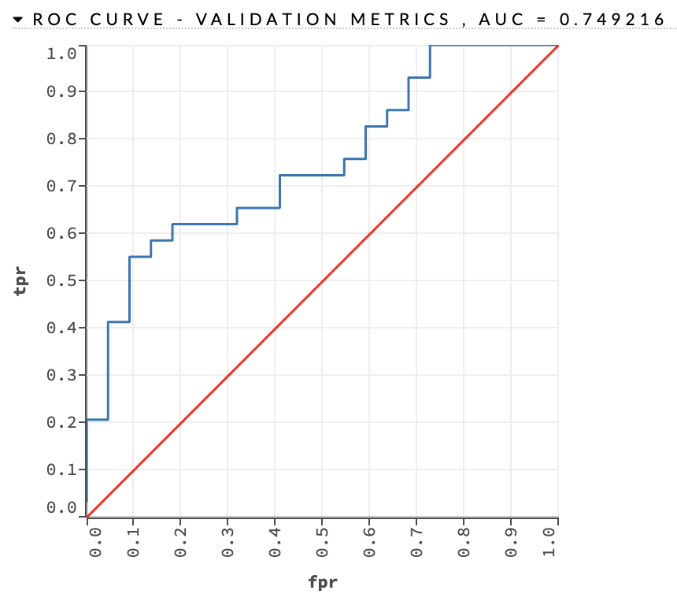

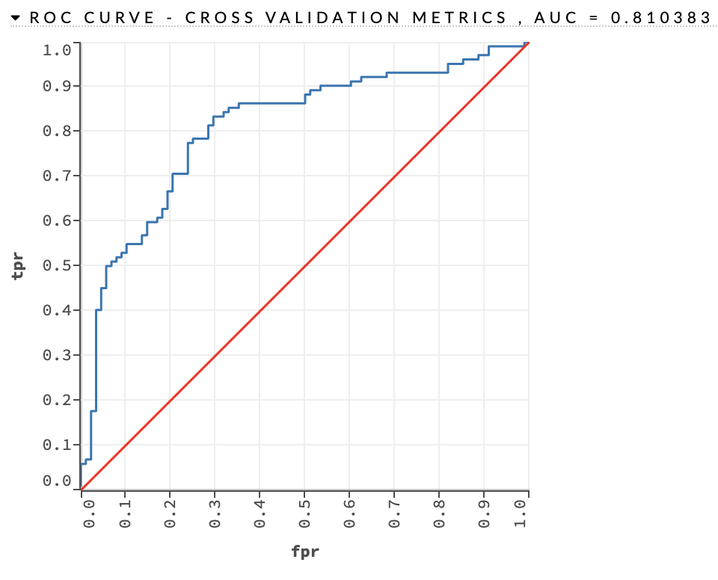

GBM_4_AutoML_1_20231025_134033

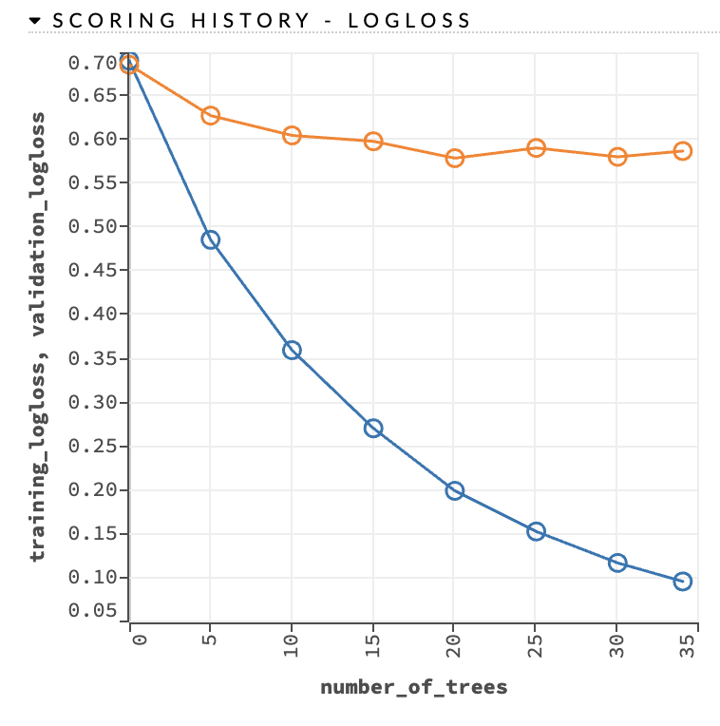

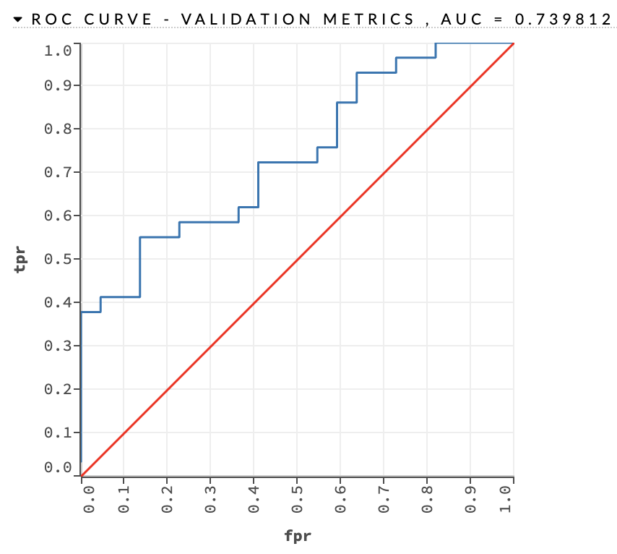

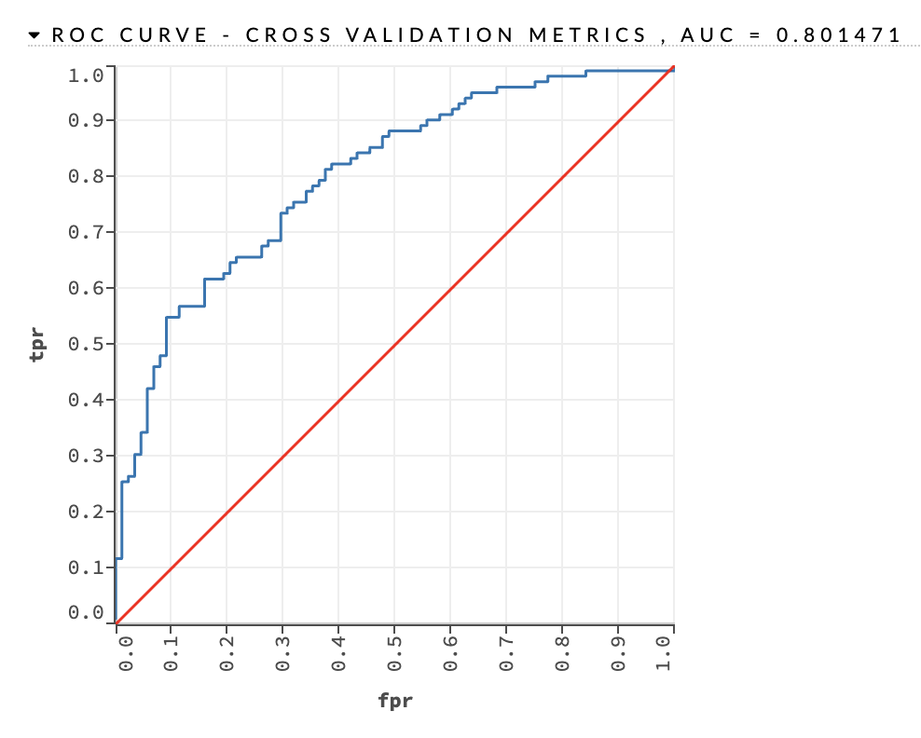

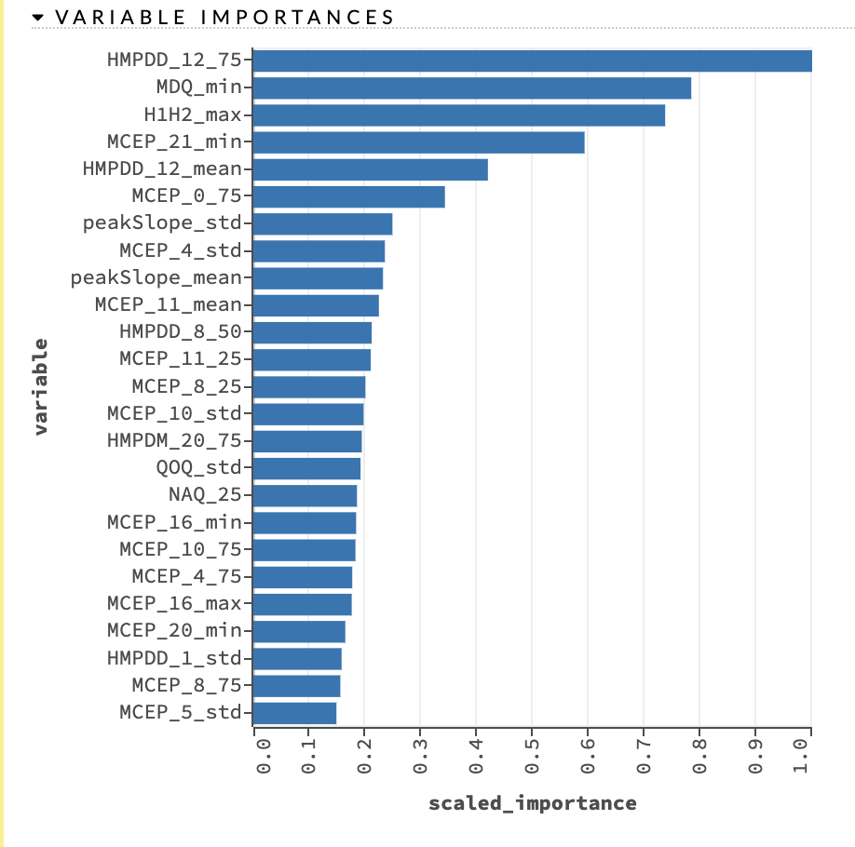

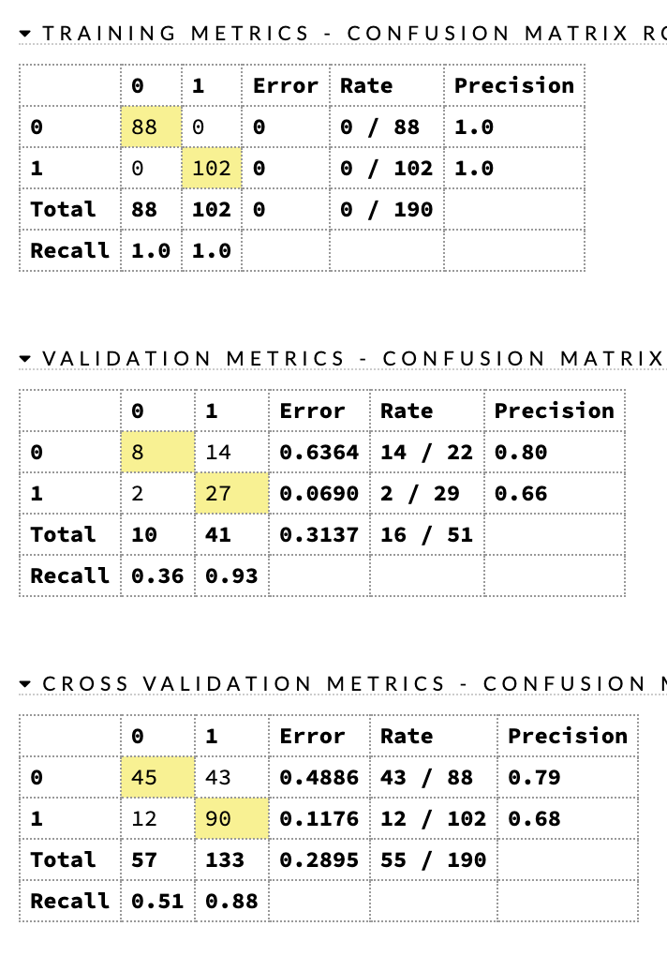

DeepLearning_1_AutoML_1_20231025_134033

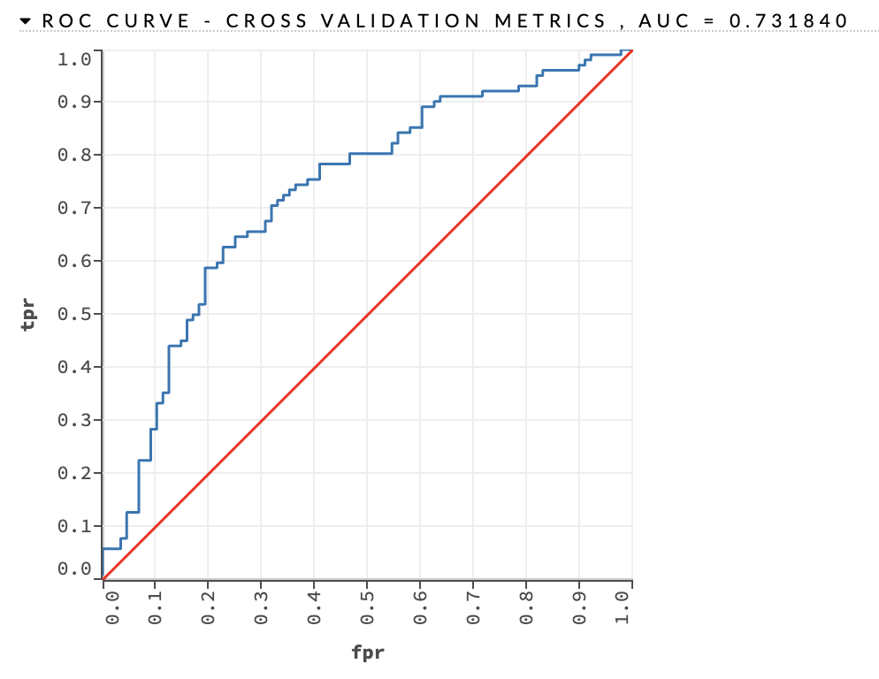

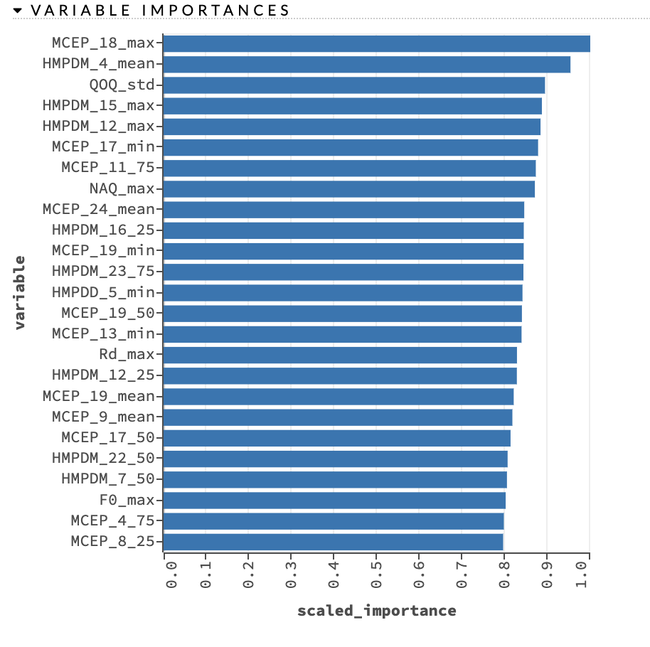

GBM_grid_1_AutoML_1_20231025_134033_model_1

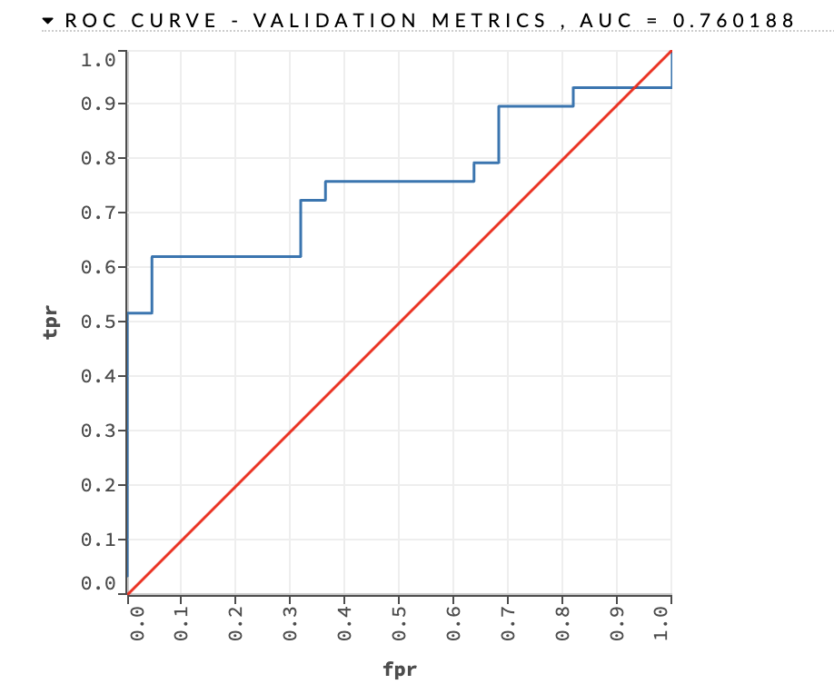

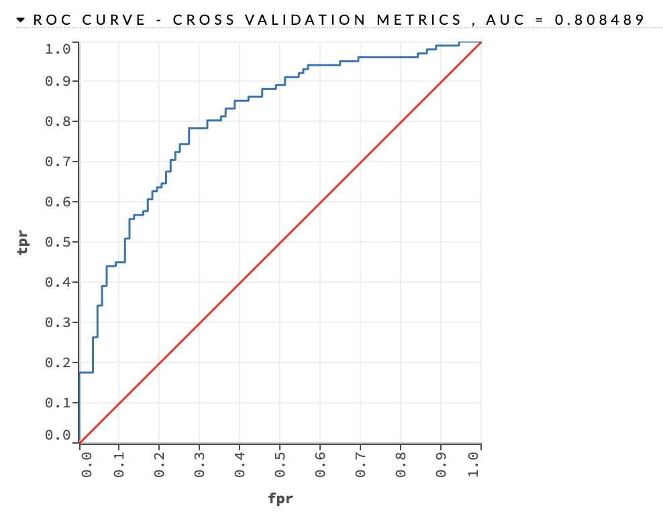

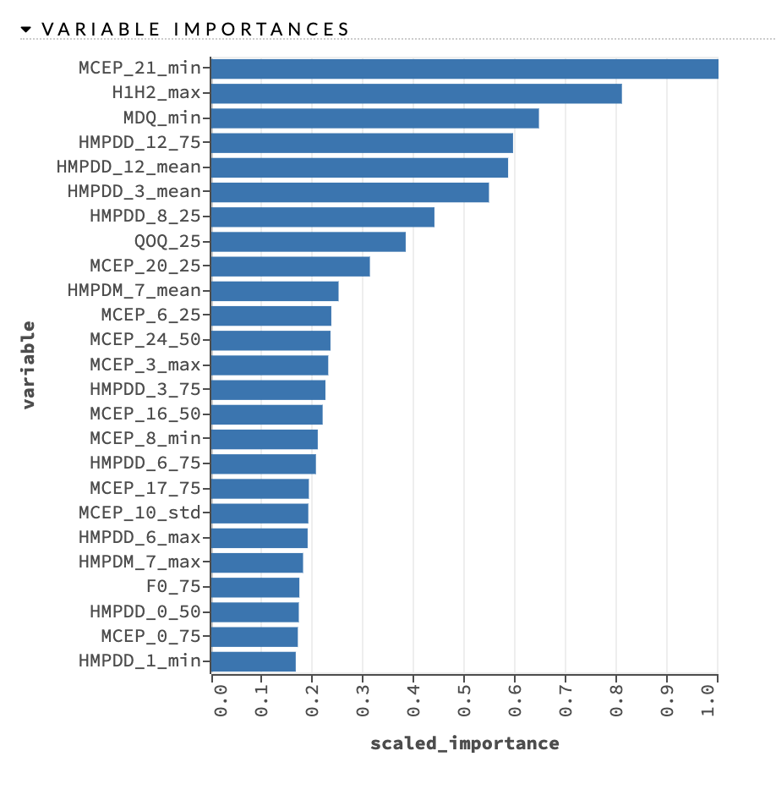

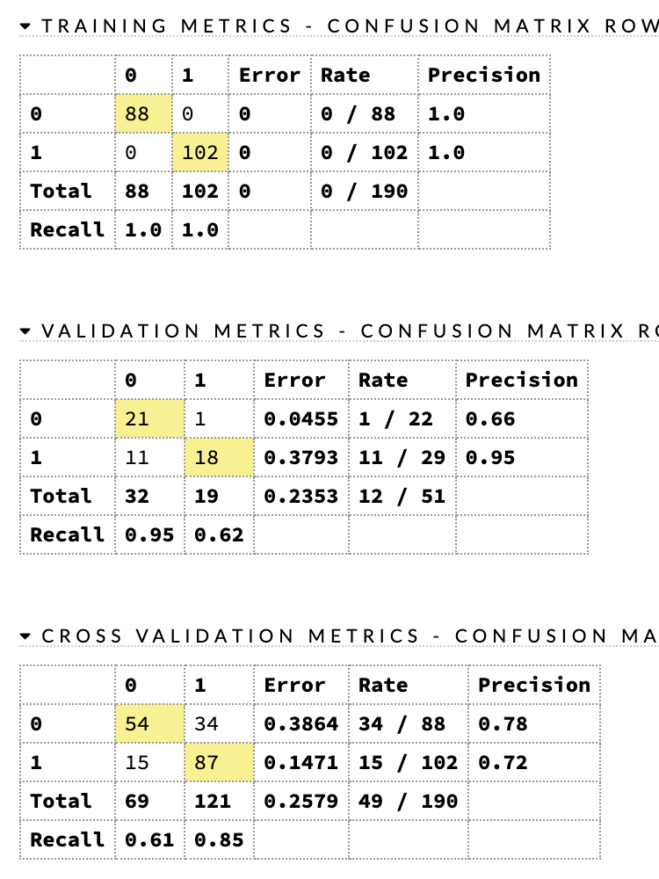

DRF_1_AutoML_1_20231025_134033

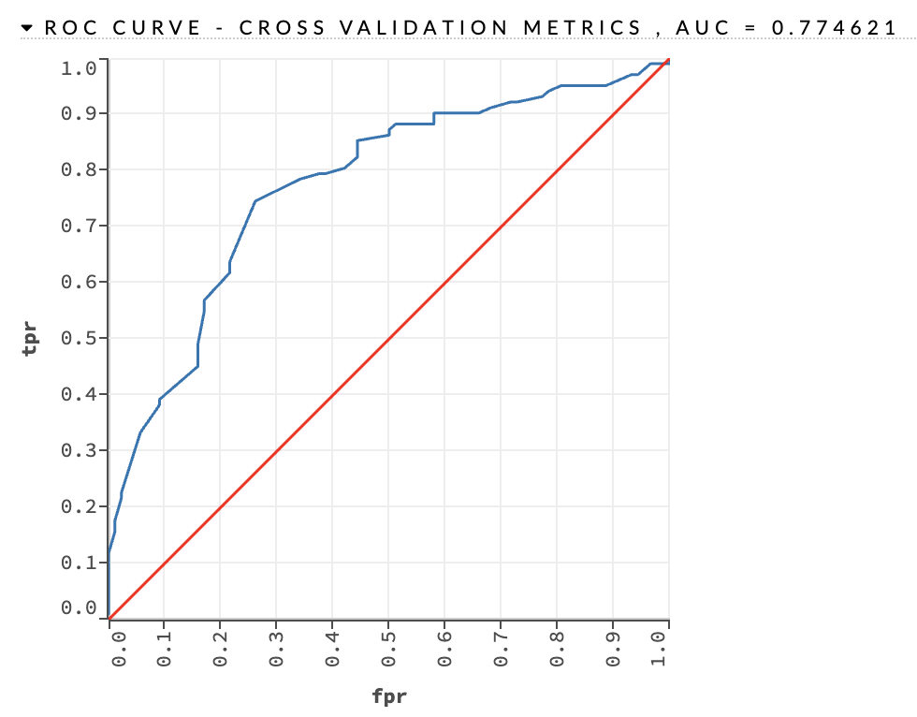

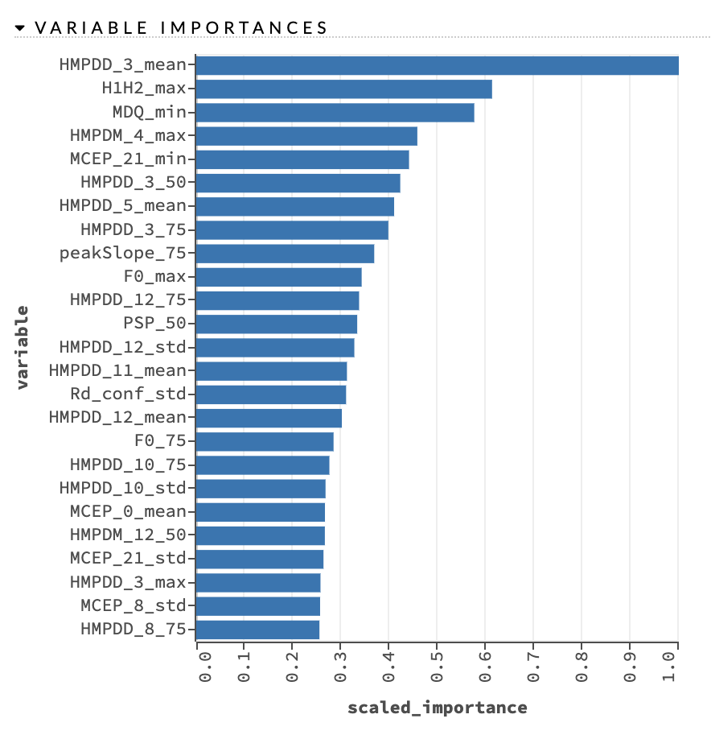

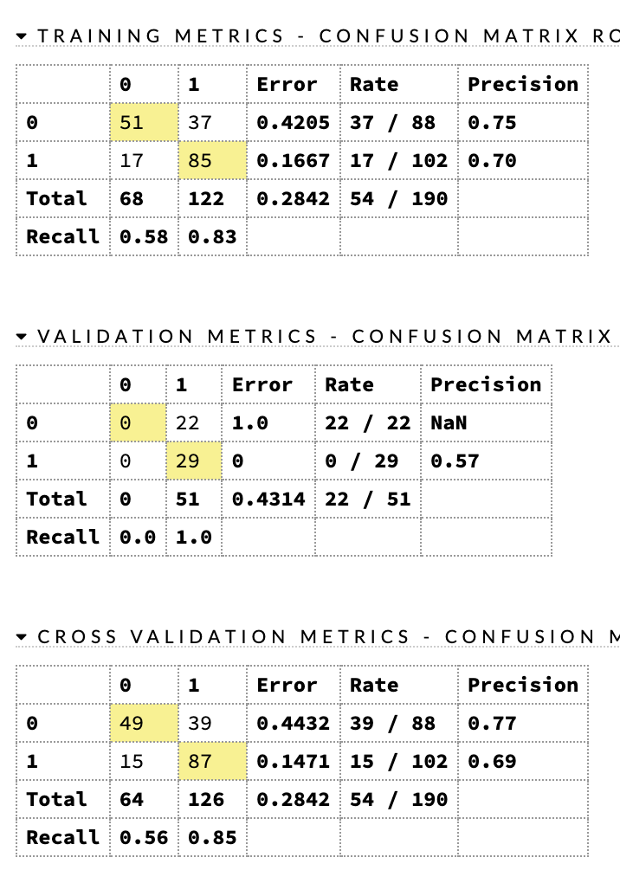

XRT_1_AutoML_1_20231025_134033

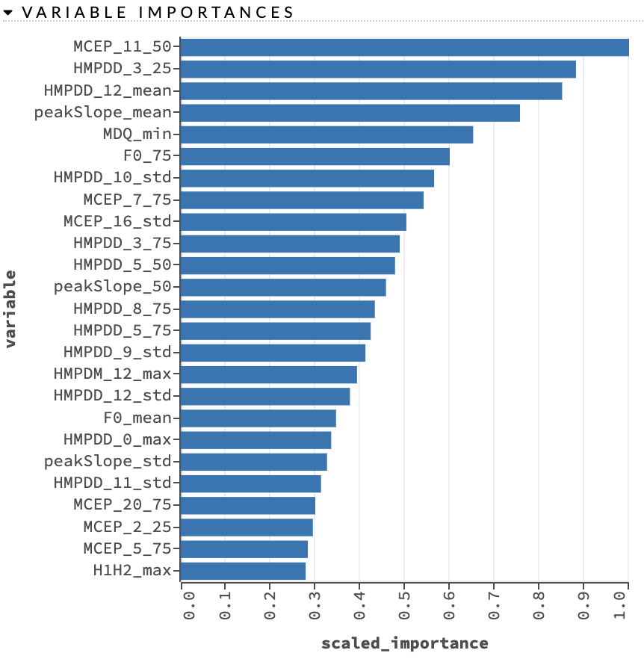

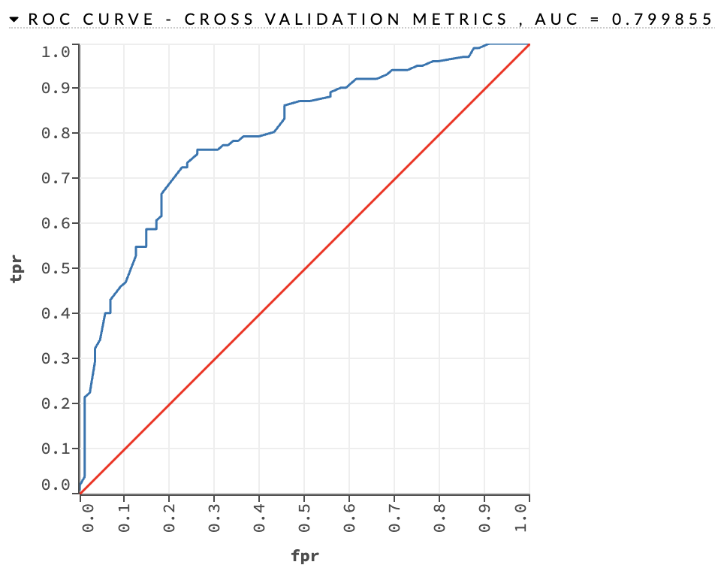

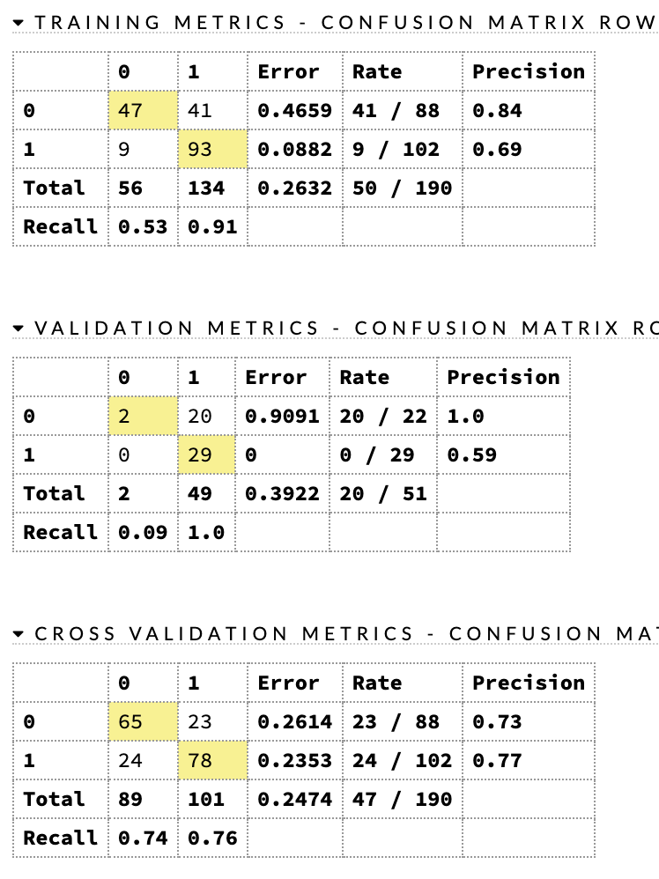

metalearner_AUTO_StackedEnsemble_BestOfFamily_2_AutoML_1_20231025_134033

