BMI6319 Binary Classification to Predict Reoccurrence of Breast Cancer

Submitted in Partial Fulfillment
For
SBMI Ph.D. student Qualification Examination writing test

Fall 2019
Jingqi Wang

December 19, 2019

Introduction
As a Ph.D. student in SBMI, I was exposed to the predictive modeling task to detect the reoccurrence of breast cancer. After exploring the dataset, I decided to use the binary-classification algorithm for this task. In this project, I will first load the data set and prepare the dataset for the machine learning toolkit, which is 'Liblinear' in this case. To make sure all the works are reproducible, I also create a self-contained docker image to run the whole experiment.
Experiment design
- Status of the Dataset: The dataset is stored as a CSV file. There are 286 record in total, with 201 as negative cases and 85 as positive cases. The distribution quite balanced. As a result, a regular binary classification algorithm is a good start.
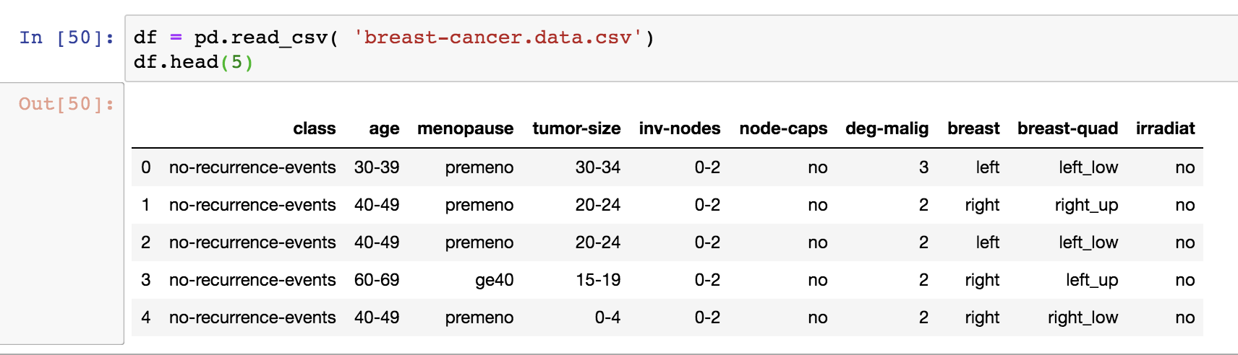
Figure 1. Sample of the input dataset
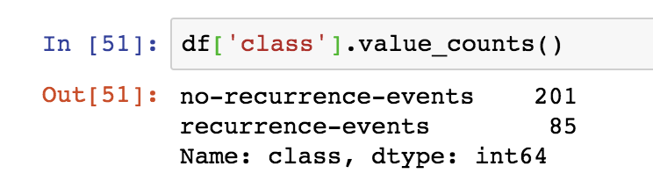
Figure 2. Status of the data labels.
- Feature columns: There are 9 columns which can be utilized as features. Most of them are category data, except for the ‘Degree of malignancy’. As a result, I’ll collect all the possible values of each feature and index them to build the machine learning model. For example, the ‘no-recurrence-events’ will be encoded as ‘0’; and the ‘premeno’ will be encoded as feature index ‘4:1’.
no-recurrence-events,40-49,premeno,20-24,0-2,no,2,left,left_low,no
will be converted into
- 2:1 4:1 5:1 7:1 8:1 9:1 10:1 11:1 12:1
Figure 3. Example of the data convertion
- Split data into train and test for ML: In this experiment, I split the dataset into two parts, 90% of the whole records collected as training dataset and the remaining 10% is used as testset. The model is trained on the training set and evaluated on the testset.
Preliminary Results
- Accuracy with default parameters: The overall accuracy is 61.29%; Table 1 shows the precision, recall and f-sore of the individual label.
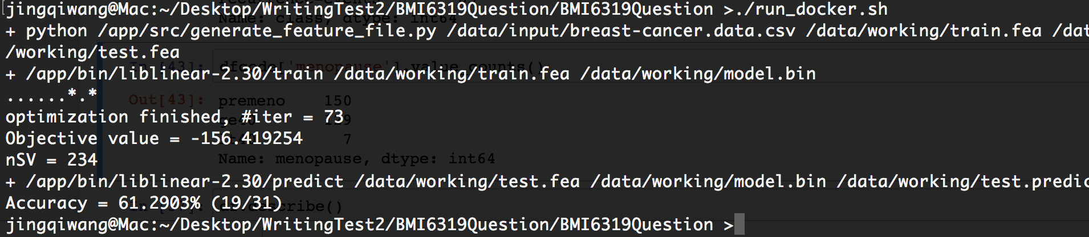
Figure 4. Execution result with default liblinear parameters
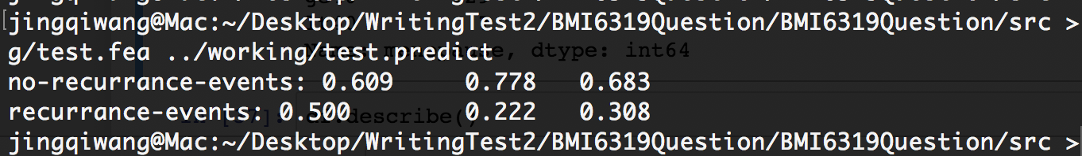
Figure 5. Evaluation on individual labels
- Accuracy with hyper-parameter optimization: I tried the cost (-c) in the classifier and get some improvents on (c>=0.5). As shown in Figure 6.
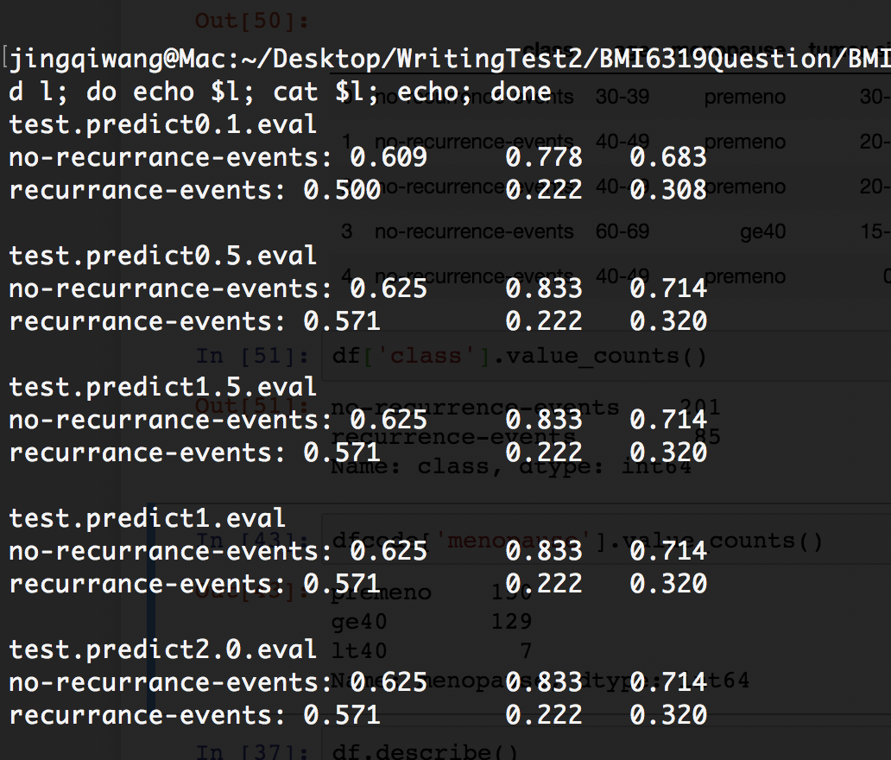
Figure 6. hyper-parameter optimization

Package structure and Usage
Fiture 7 shows the folder structure of the source code. ‘Liblinear’ package is located in the ‘bin’ folder and python codes are in the ‘src’ folder. All the tools and experiment settings are connected with the ‘run.sh’ script.
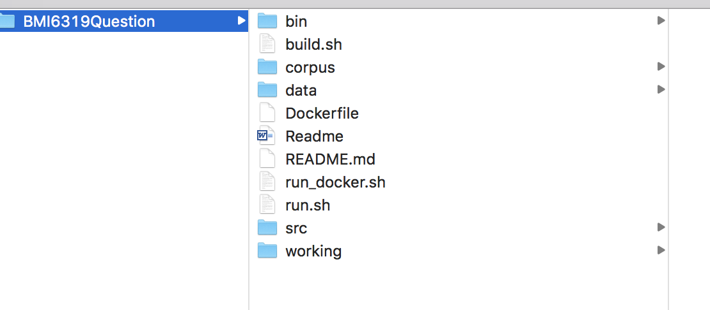
Figure 7. Source code folder structure

Conclusion

References

