Source:

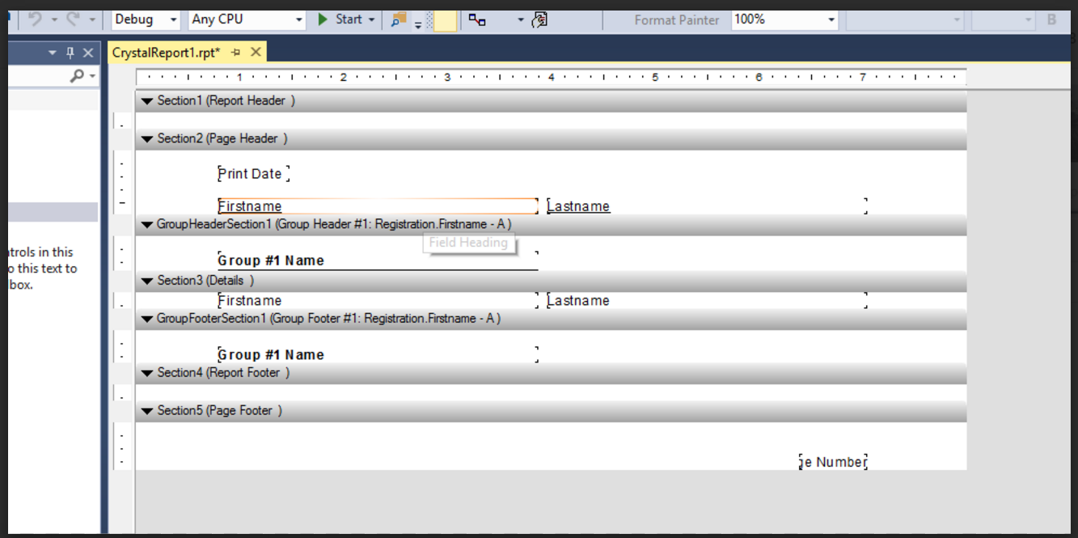

Screenshoot:

Showing the results from the database Student, and set up a filter that only pick up the firstname=’OSY’

In the report.

