Localization
All self-driving cars go through the same series of steps to safely navigate through the world.
You’ve been working on the first step: localization. Before cars can safely navigate, they first use sensors and other collected data to best estimate where they are in the world.

Kalman Filter
Let’s review the steps that a Kalman filter takes to localize a car.

1. Initial Prediction
First, we start with an initial prediction of our car’s location and a probability distribution that describes our uncertainty about that prediction.
Below is a 1D example, we know that our car is on this one lane road, but we don't know its exact location.
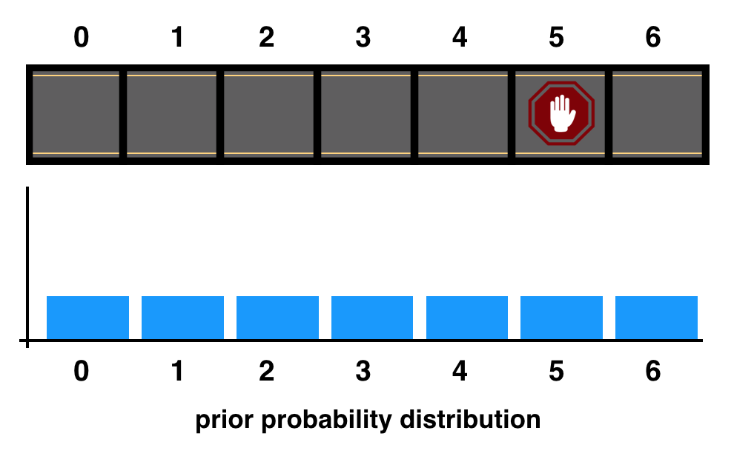
A one lane one and an initial, uniform probability distribution.

2. Measurement Update
We then sense the world around the car. This is called the measurement update step, in which we gather more information about the car’s surroundings and refine our location prediction.
Say, we measure that we are about two grid cells in front of the stop sign; our measurement isn't perfect, but we have a much better idea of our car's location.
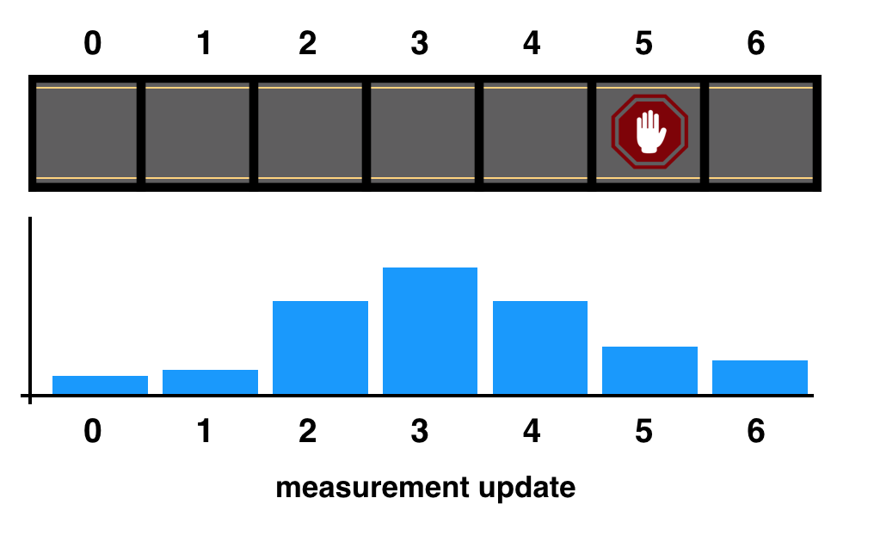
Measurement update step.

3. Prediction (or Time Update)
The next step is moving. Also called the time update or prediction step; we predict where the car will move, based on the knowledge we have about its velocity and current position. And we shift our probability distribution to reflect this movement.
In the next example, we shift our probability distribution to reflect a one cell movement to the right.
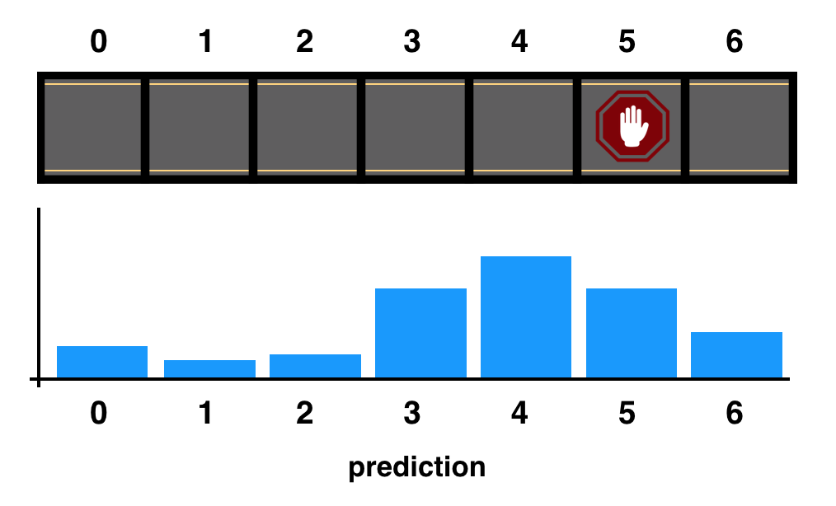
Prediction step.

4. Repeat
Then, finally, we’ve formed a new estimate for the position of the car! The Kalman Filter simply repeats the sense and move (measurement and prediction) steps to localize the car as it’s moving!
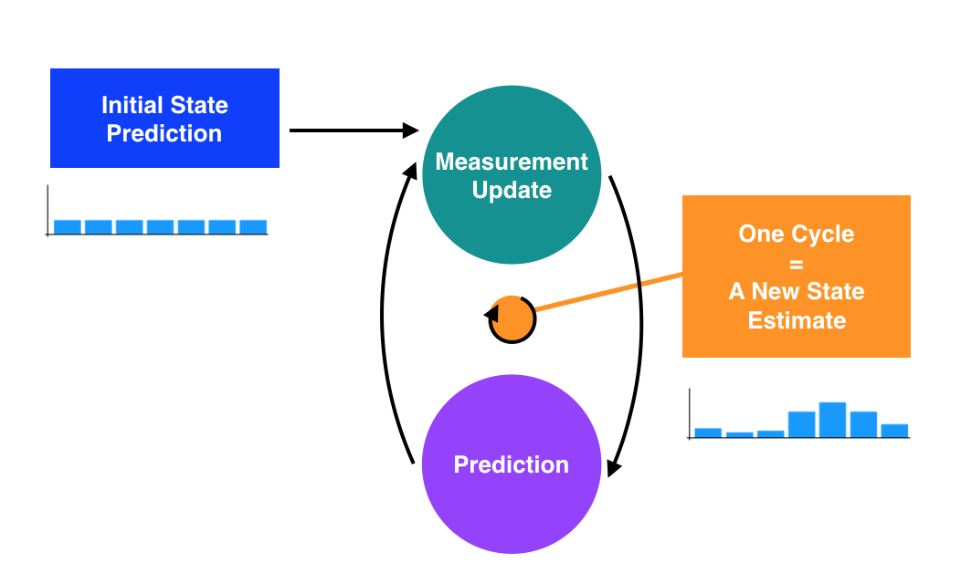
Kalman Filter steps.

The Takeaway
The beauty of Kalman filters is that they combine somewhat inaccurate sensor measurements with somewhat inaccurate predictions of motion to get a filtered location estimate that is better than any estimates that come from only sensor readings or only knowledge about movement.

Kalman Equation Reference
We're just including this here in case you want to refer back to the Kalman Filter equations at any time. Feel free to move along :)

Variable Definitions
​x​^​​ - state vector
F - state transition matrix
P - error covariance matrix
Q - process noise covariance matrix
R - measurement noise covariance matrix
S - intermediate matrix for calculating Kalman gain
K - Kalman gain
​y​~​​ - difference between predicted state and measured state
z - measurement vector (lidar data or radar data, etc.)
I - Identity matrix

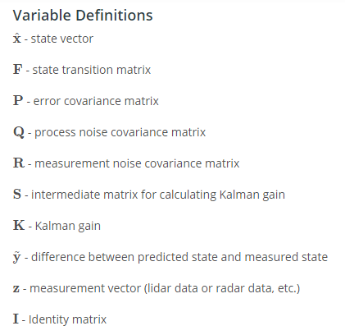
Prediction Step Equations
PREDICT STATE VECTOR AND ERROR COVARIANCE MATRIX
​x​^​​​k∣k−1​​=F​k​​​x​^​​​k−1∣k−1​​
P​k∣k−1​​=F​k​​P​k−1∣k−1​​F​k​​​T​​+Q​k​​
Update Step Equations
KALMAN GAIN
S​k​​=H​k​​P​k∣k−1​​H​k​​​T​​+R​k​​
K​k​​=P​k∣k−1​​H​k​​​T​​S​k​​​−1​​
UPDATE STATE VECTOR AND ERROR COVARIANCE MATRIX
​y​k​​​~​​=z​k​​−H​k​​​x​^​​​k∣k−1​​
​x​^​​​k∣k​​=​x​^​​​k∣k−1​​+K​k​​​y​k​​​~​​
P​k∣k​​=(I−K​k​​H​k​​)P​k∣k−1​​
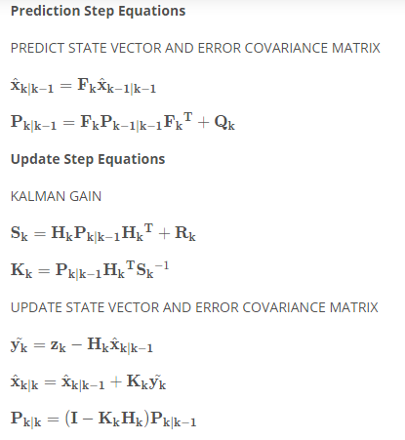

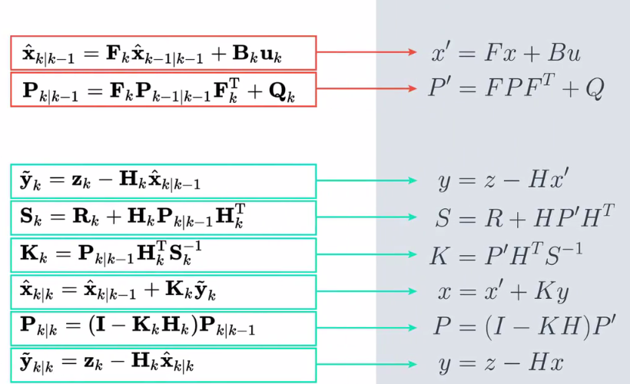
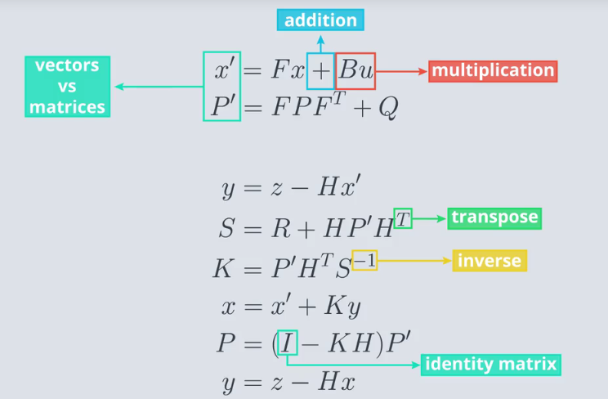

Implementing a Matrix Class
In this project you will implement a Matrix class in Python. Specifically, you will implement the following methods:
class Matrix:
def determinant(self):
# your code

def trace(self):
# your code

def inverse(self):
# your code

def transpose(self):
# your code

# Overloaded operators

def __add__(self,other):
# your code

def __sub__(self,other):
# your code

def __mul__(self,other):
# your code
When your class is working properly you will be able to manipulate matrices in code as if they were regular numbers (for the most part). For example:
> A = Matrix([
[2,4],
[3,1]
])
> print( A.transpose())
2.0 3.0
4.0 1.0
>
> I = Matrix([
[1,0],
[0,1]
])
>
> print(A*I)
2.0 4.0
3.0 1.0
>
> print(A * A.inverse())
1.0 0.0
0.0 1.0

Project Instructions
Your project workspace will contain several files. On the next page, you will see something like this:
We recommend that you open all of these files in new tabs (except datagenerator.py and test.py, which you won't need to modify) so that your browser looks something like this:
- matrix.py - This contains the beginnings of a Matrix class (which you will complete) as well as some helper functions zeroes and identity. This is the file you will be doing most of your work in.
- matrix_playground.ipynb - A notebook that imports your Matrix class and calls the test code. You may find it useful to use this notebook as a place to use the matrix math code you will write in matrix.py.
- matrix_cheat_sheet.ipynb - A Jupyter notebook with a glossary, explanation of matrix notation and list of matrix equations. Use this as a reference when filling out the methods in the Matrix class!
- kalman_filter_demo.ipynb - You don't need to do anything with this notebook but you may find it interesting. Once your matrix class is working properly, the KF implemented here will actually work!
Other Files (feel free to ignore).
- test.py - Contains test code which demonstrates the expected functionality of your code.
- datagenerator.py - this just contains some helper code which is used by the Kalman Filter.

