Progress Report: Long-Term Oil Price Forecast Evaluation
UCB Energy Project
This report summarizes the current status of our project on the reliability of long-term oil price forecasts for upstream investment planning. The objective is to evaluate whether widely used institutional forecasts are informative at planning horizons relevant for capital allocation, whether they exhibit systematic bias, and whether simple econometric models can improve upon them.

Research Question
Our central question is whether long-horizon oil price forecasts provide decision-relevant information for upstream oil and gas firms. Following the project proposal, we focus on 3-year-ahead and 5-year-ahead forecasts of annual average Brent prices, because these horizons are closely aligned with project screening, development timing, and final investment decisions.

Data and Current Scope
The current implementation uses EIA Annual Energy Outlook (AEO) Table 12 vintages as the core institutional forecast source. We extracted Brent Spot forecasts from publicly available AEO releases spanning 2013 to 2026, excluding 2024 because no corresponding AEO vintage exists. Realized Brent prices are taken from FRED series DCOILBRENTEU and aggregated to annual averages. To ensure comparability across vintages, all forecasts and realizations are converted into real 2025 U.S. dollars using CPIAUCSL. We also downloaded World Bank commodity forecast archives as supplementary material and incorporated Brent front-month futures (BZ=F) as a public market-information proxy for model extension.
In the current realized evaluation sample, we use 11 EIA publication years and 20 forecast observations across the 3-year and 5-year horizons.

Methodology
We evaluate forecast performance using Mean Error (ME), Mean Absolute Error (MAE), Root Mean Squared Error (RMSE), and Mean Absolute Percentage Error (MAPE). ME is especially important because it captures the direction of bias: a positive ME indicates systematic overprediction, while a negative ME indicates underprediction. As a benchmark, we use a random-walk forecast equal to the most recently completed annual Brent price available at the time of release.
To assess whether forecast accuracy can be improved, we also implemented two rolling out-of-sample models: (i) a rolling autoregressive specification based on lagged annual Brent prices, and (ii) a rolling AR model augmented with a market-information proxy derived from Brent front-month futures around the forecast release month.

Current Findings
The main result to date is that EIA long-horizon Brent forecasts outperform the random-walk benchmark in RMSE at both the 3-year and 5-year horizons. This suggests that the EIA forecasts contain economically meaningful information and are not equivalent to a naive carry-forward rule.
At the same time, EIA forecasts display a strong positive Mean Error in the realized sample. This indicates an optimistic bias: on average, projected Brent prices are above realized outcomes. From a capital budgeting perspective, this result is important because systematically optimistic oil price assumptions may translate into overstated project cash flows, inflated NPV and IRR calculations, and a tendency toward overinvestment.

Benchmark Comparison
model | horizon_years | n_forecasts | ME | MAE | RMSE | MAPE
EIA | 3 | 11 | 20.439 | 26.006 | 34.974 | 0.388
EIA | 5 | 9 | 26.641 | 28.087 | 34.322 | 0.381
Random Walk | 3 | 11 | 17.251 | 31.657 | 42.989 | 0.438
Random Walk | 5 | 9 | 13.795 | 38.902 | 47.342 | 0.512

The rolling econometric models have not yet outperformed the EIA forecast. In the current specification, both the rolling AR model and the AR-plus-futures model produce larger RMSE values than the institutional forecast benchmark. This does not imply that model-based improvement is impossible; rather, it suggests that our current reduced-form implementation remains too simple relative to the information embedded in the EIA outlook.

Rolling Model Comparison
model | horizon_years | n_forecasts | ME | MAE | RMSE | MAPE
Rolling AR | 3 | 26 | 10.132 | 35.328 | 48.952 | 0.447
Rolling AR | 5 | 24 | -5.407 | 35.948 | 51.238 | 0.379
Rolling AR + Futures | 3 | 9 | 17.960 | 40.110 | 52.511 | 0.549
Rolling AR + Futures | 5 | 7 | 7.572 | 36.614 | 53.230 | 0.539

Interpretation
The evidence so far supports a nuanced conclusion. Institutional long-term forecasts appear useful in the sense that they outperform a naive benchmark, but they should not be taken at face value because their positive bias may distort investment decisions if used mechanically. A practical implication is that an upstream firm may want to treat institutional forecasts as informative baseline inputs while applying conservative adjustments or explicit bias corrections in project valuation.

Limitations and Next Steps
Three limitations remain. First, the main analysis currently centers on EIA because it provides the cleanest public vintage structure; IEA historical long-horizon Brent forecasts have not yet been integrated into a machine-readable panel. Second, the World Bank archive is supplementary because its oil series is defined as 'Crude oil, avg' rather than exact Brent. Third, the futures extension currently uses a front-month public proxy rather than a full long-dated Brent futures curve.
The next stage of the project will focus on strengthening the institutional comparison, refining the market-information component, and developing a clearer bias-correction framework that can be translated into decision guidance for capital allocation.

Figure 1. Benchmark comparison
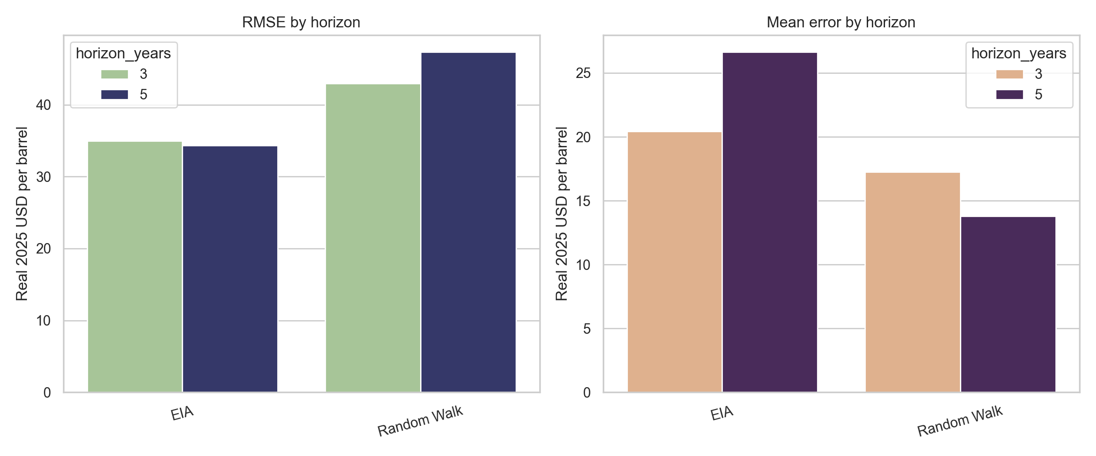

Figure 2. EIA forecast vintages versus realized Brent
