ART 3870 PROJECT SUBMISSION TEMPLATE
Complete this template for every assignment!
Export to pdf and submit on blackboard. Include your sketches and screenshots in this document. Do not upload any other files to blackboard.
Your code should be hosted on GITHUB and the pages should be published on GITHUB.IO

Personal Information
NAME: Jing Wang
NET ID: qt9376
COURSE: YEAR (2017)/ QUARTER (FA, WI, SP) /SECTION (01, 02)

Project Information
Project Title: Animation Lab

Project Description: Designing an animation based simple website

Project URL on github.com: https://github.com/jingwang19
Project URL on github.io: https://jingwang19.github.io/animation/

Project Documentation
Scanned Project Sketches, Branding worksheets, style tiles and other prep work:
(one for each page in the project – scaled to take the whole page width, not distorted/stretched)

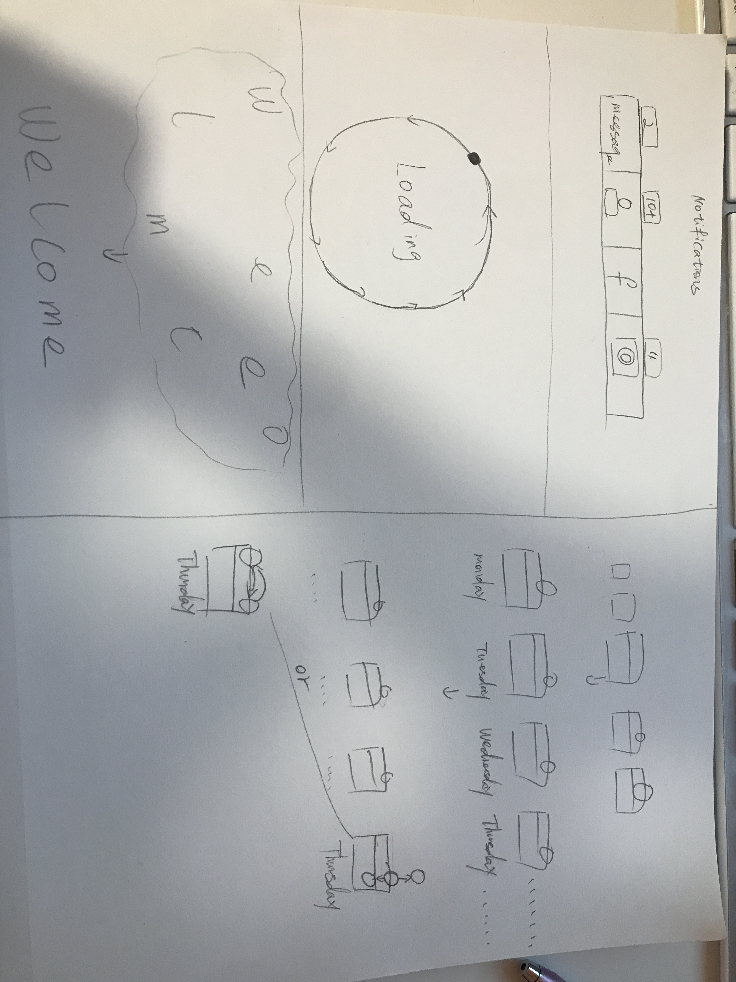

Project Screenshots:
(one for each page in the project – scaled to take the whole page width, not distorted/stretched) _ USE http://www.awesomescreenshot.com/ to help get the best results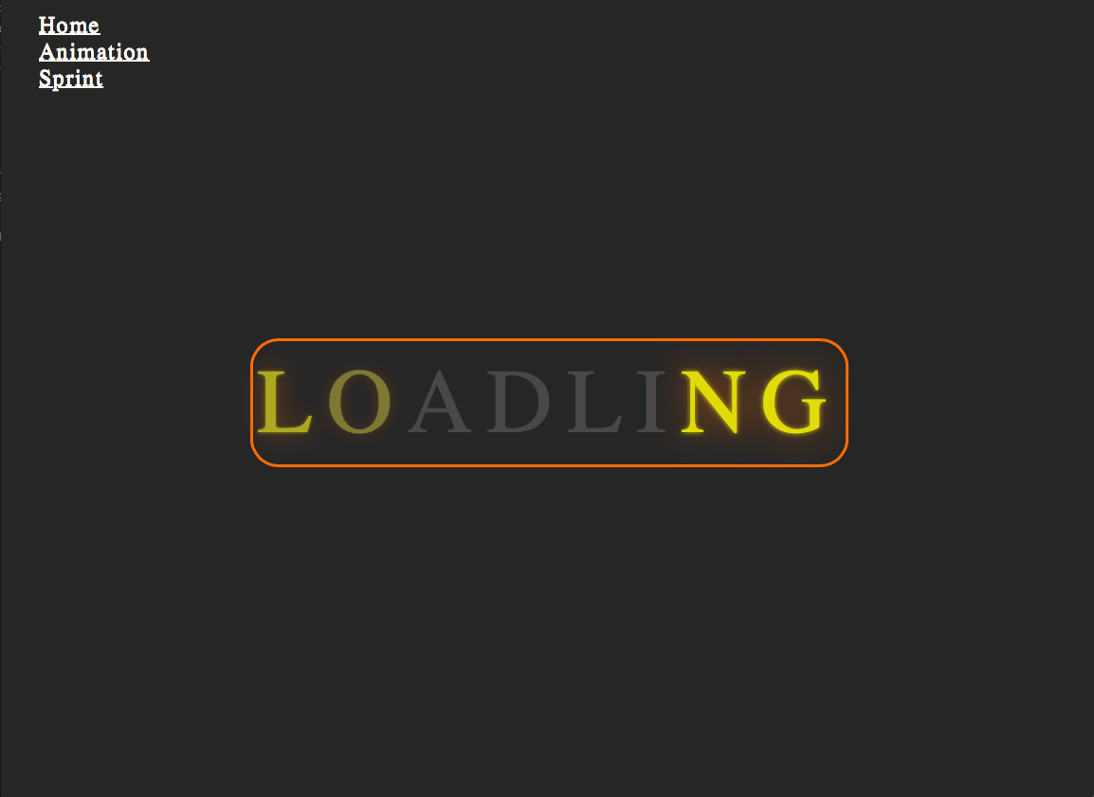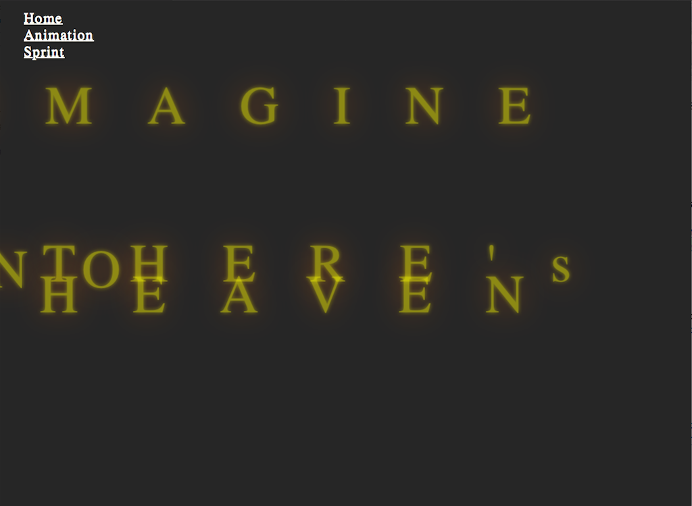
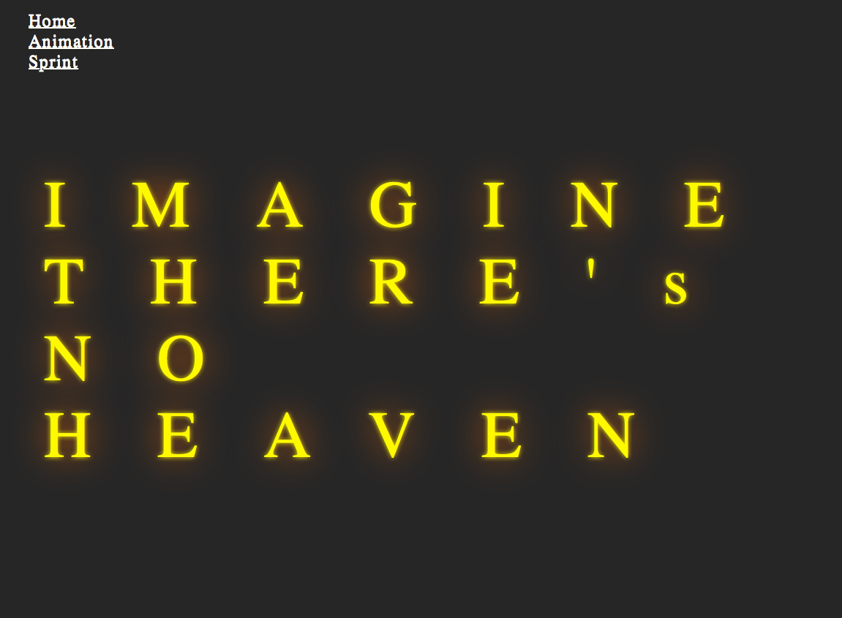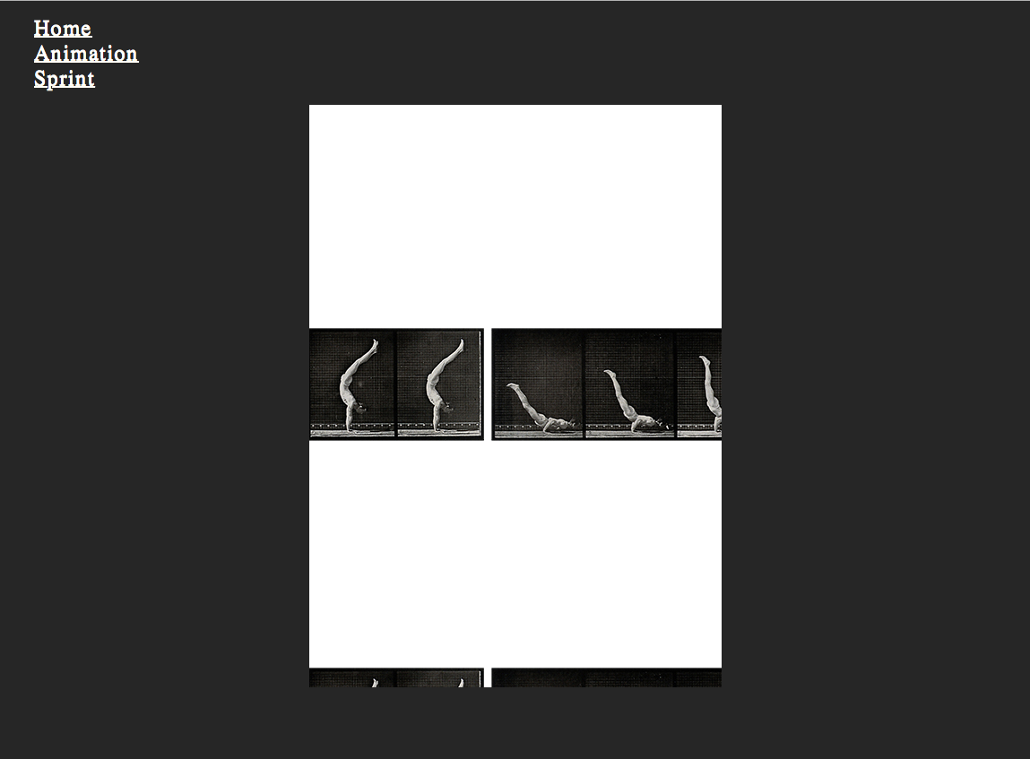

Project Reflection:
(250 words – reflective writing –What was the most challenging part? What was the most exciting part now that the project is done? What did you learn in this assignment, what is your biggest takeaway?)

Before started to work on this project, I thought it won’t be too difficult, but I was wrong. It is a great challenge for me. First of all, I have use CSS for positioning for a long time, and a lot of the rules I just don’t remember and even forgot the searching title of it. It took me a while to just figuring out how to center the text in my animation page because I tried text-align, which it did not work. The rule that works on centering the text was margin: 0 auto;. Second, I wanted to use the rain drop effects of a emoji as a surface on my animation page to creating this rain effect, but due to the image I couldn’t get the smooth drop effects. I played around with the background-position rule still couldn’t achieve the effects that I wanted, so I gave up. Lastly, and the most confused one was the sprit animation. Because no matter what I did, I just couldn’t see the image that I insert in the CSS, near the end you told us that the pixels number need to match to the width of the image.
The most excited part was that I learned some great animation tricks in the class and on Youtube, which I can apply to my personal portfolio and future web design pages. I think I learned most from this assignment was how to play make some movement animation on a webpage to make it more creative and fun, and also refreshed my mind of how to use CSS.

