Recent changes to the DEBOT model code
RP: 2024/07/11

Changes to debot.F90 … name change to debot_AHdep.F90
- allows depths to be selected from GEBCO2023.nc, as well as GEBCO.bin
(GEBCO2023.nc is 15-arcsecond, GEBCO.bin is 1-minute)
- allows change to ncelle depending on whether using GEBCO or GEBCO2023 dataset
- allows choice between A_H constant and A_H depth dependent
- removed code which sets depths < 100 to depth+20m and replaced by setting depths < 10 to be 10 (breakerB in cpp.h)
!adjust b in depths < 100m ... why?
!where(b < 100) b = b + 20._DP
replaced by
where(b > 0._DP .and. b < breakerB) b = breakerB !just set minimum depth to be breakerB

Changes to cpp.h …
- additional flag GEBCO2023 to select GEBCO2023.nc dataset (and code sections)
- changed flag GEBCO to GEBCO1min to select the GEBCO.bin dataset
- A_H can be specified as <=10 for depth dependency or >10 for constant value

Consequences
- introducing the new bathymetry required adding new sections
  - to read in this new data (subroutine readGEBCO2023)
  - to interpolate this data on to a coarser grid (because I was not happy with the existing approach for the 1-minute data, but this code is not removed and still used if GEBCO.bin data is used). Use of the new code is implemented if the GEBCO2023 flag is activated. The main differences between the ‘old’ code and the ‘new’ code are
    - new code easier to follow
    - in the old code all the elements of the GEBCO data are used (averaged) to define the new coarser depth point irrespective if sea or land points; in the new code only sea points are considered and must represent > 55% (currently a hard-wired value) of the total number of elements for the point to be considered sea. This results in a different nearshore spatial configuration and depths (when the new breakerB condition is enacted) as shown for the Irish Sea at 1/12 degree resolution below – left is old way with GEBCO and +20m for depths < 100m, right is new way with GEBCO2023 and min depth 10m. Revised code shown in appendix.

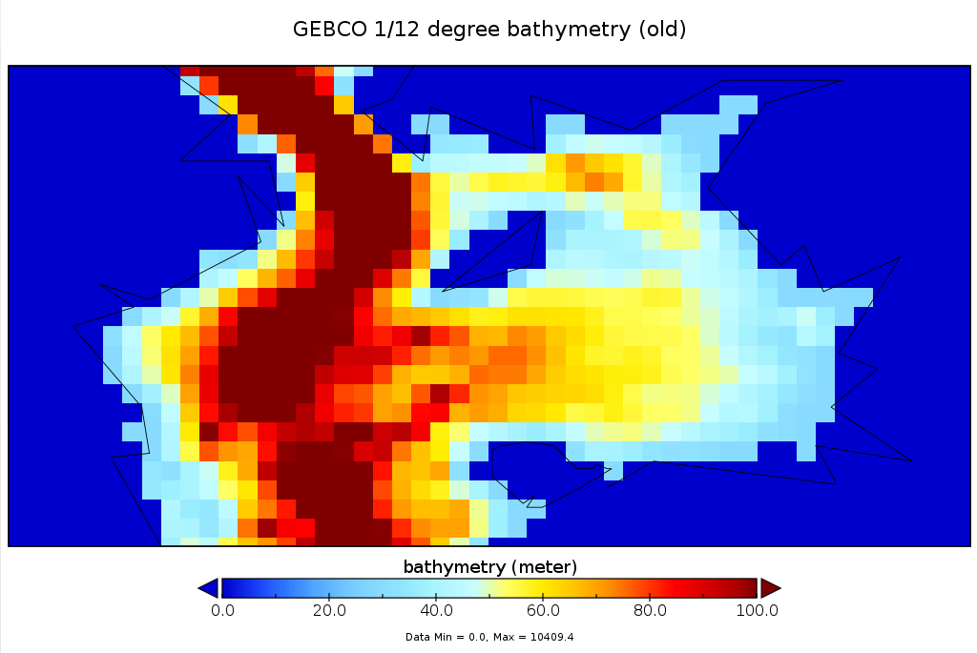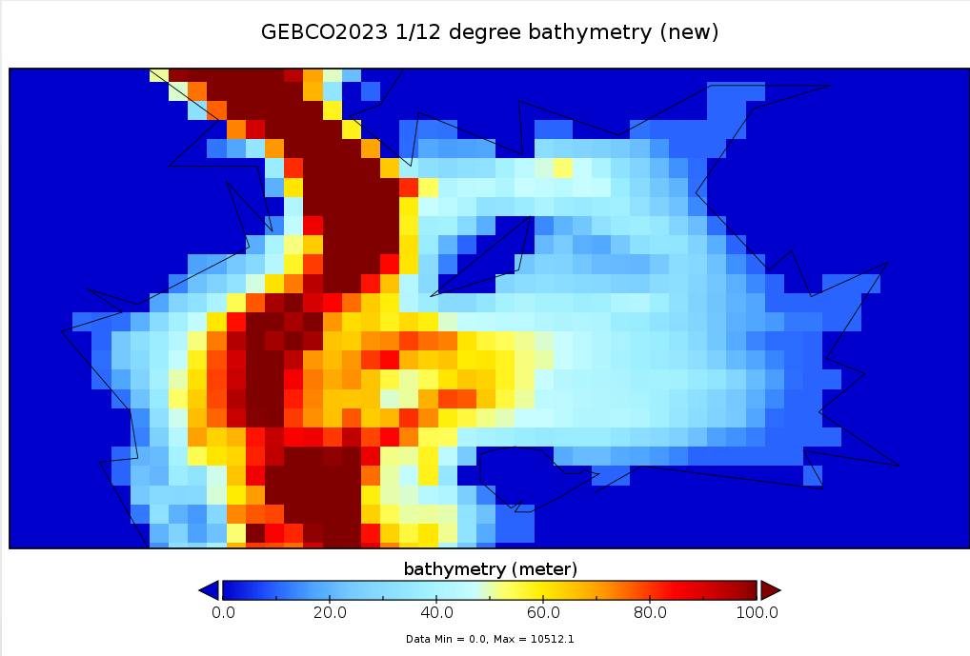

- Enabling choice of A_H required extensive re-ordering of elements of the code. In the original code A_H is incorporated in the terms vax3 and vay3 as follows:
  - vax3(j)=A_H/(a**2*cos_u(j))
  - vay3(j)=A_H/(a**2*cos_v(j)) … note vax3, vay3 are 1-dimensional latitude dependent (j) arrays
- To accommodate depth dependency these terms are changed to 2-dimensional terms
  - do i=0,IMAX+1
if(A_H>10) then
vax3(i,j) = A_H/(a**2*cos_u(j))
else
vax3(i,j) = A_H*hx(i,j)/(a**2*cos_u(j))
endif
enddo
  - do i=0,IMAX+1
if(A_H>10) then
vay3(i,j) = A_H/(a**2*cos_v(j))
else
vay3(i,j) = A_H*hy(i,j)/(a**2*cos_v(j))
endif
enddo
With the calculations of mask_u, mask_v, hx and hy moved above these lines of code. vax3 and vay3 are now revised in subsequent code
- vax4(j)*(e_pl(i,j+1)+e_pl(i,j)))*vax3(i,j)&
- vay4(j)*(e_llpp(i,j)+e_llpp(i,j-1)))*vay3(i,j)&

Results of these changes yet to be demonstrated, current GEBCO2023 1/6 degree test run has A_H = 5 x depth, r = 0.0025 (coef_sal=0.1_DP, kappa=1.4_DP)

Appendix – revised bathymetry code in debot_Ahdep.F90

#if defined etopo || defined GEBCO1min

… old code ...

! endif of etopo || GEBCO1min
#endif

#if defined GEBCO2023
print *,nla1,nla2,imax,nph1,nph2,jmax

nceli = ncelle * KLAM / 60
ncelj = ncelle * KPHI / 60
print *,'nceli,ncelj',nceli,ncelj

do i = 1,IMAX
i1 = (i-1)*nceli+1
i2 = i1 + nceli - 1
do j = 1,JMAX
j1 = (j-1)*ncelj +1 + ncelle*5 ! recall that lat starts at -85 degrees, gebco starts at -90 degree
j2 = j1 + ncelj - 1
k = 0
b1=0._DP
do ii = i1,i2
do jj = j1,j2
if(topo(ii,jj) > 0) then ! only at sea points, remember depths positive if gebco2023
k = k + 1
b1=b1+topo(ii,jj)
endif
enddo
enddo

! only make sea if more than half cells have depths
if (k > nceli*ncelj*0.55 ) then
b1=b1/k ! average over (i1,i2).(j1,j2) where depths > 0
b(i,j)=b1
endif

if (b(i,j)>0._DP) then !mask out sea - here inverse (sea=0), reverse below
mask_z(i,j)=0
endif

if (b(i,j)>0._DP .and. b(i,j)<breakerB) then ! set minimum depth
b(i,j)=breakerB
endif

#ifdef tidedrag
! BATHYMETRIC VARIATIONS FOR INTERNAL TIDE DRAG !
if (b1 > breakerIT) then
b2=0._DP
k = 0
do jj = j1,j2
do ii = i1,i2
if ( topo(ii,jj) > 0) then
b2=b2+(topo(ii,jj) - b1)**2
k = k + 1
endif
enddo
enddo
if (k > 0 ) then
b2=b2/k
roughh(i,j)=b2
endif
endif
#endif

enddo
enddo

!reverse land/sea mask values (a bit odd I agree … needs resolving)
where (mask_z == 1) mask_z = 2
where (mask_z == 0) mask_z = 1
where (mask_z == 2) mask_z = 0

! endif of GEBCO2023
# endif

