Guide for Users

Jingwen Yang

2018-11-07

## Pacakge Installation

*AnceTran* is an *R* package that performs analyses of transcriptome evolution based on *RNA-seq* expression data or *ChIP-seq* TF binding data. Here, we use HNF4A-binding data for 4 mice species as an example to show how *AnceTran* works. A convenient way to install package from github is through *devtools* package:

install.packages('devtools')  
devtools::install_github("jingwyang/AnceTran")

After installation, *AnceTran* can be loaded in the usual way:

library('AnceTran')

### Input Format:

*AnceTran* package takes binding score data in certain format:

* Binding score file should be a text file in the matrix shape, Rows correspond to orthologous. Columns correspond to sample names. Sample names are in format of “TaxaName_SubtaxaName_ReplicatesName”.

The example files are included in the AnceTran package, which can be found in extdata folder in the package. One can load them in to take a look:

BindingScore.table =read.table(system.file('extdata','HNF4A_meanIntensity_4Mouse.txt',package = 'AnceTran'), header = T)  
  
head(BindingScore.table[,1:5])

## GeneID BL6_HNF4A CAST_HNF4A SPRET_HNF4A CAR_HNF4A  
## 1 ENSMUSG00000000001 244.6250 338.4167 159.0 96.5000  
## 2 ENSMUSG00000000003 0.0000 41.0000 0.0 0.0000  
## 3 ENSMUSG00000000028 184.5000 199.6875 289.4 107.0000  
## 4 ENSMUSG00000000037 0.0000 0.0000 41.0 20.0000  
## 5 ENSMUSG00000000049 224.2632 179.7917 191.5 120.1875  
## 6 ENSMUSG00000000056 266.2500 317.0769 141.4 204.8333

### Construction:

The construction function TFconstruct loads in the BindingScore data file, and wraps them in a list of *taxonTF* objects (one *taxaTF* object).

library('AnceTran')  
taxa.objects = tTFConstruct(BSFile=system.file('extdata','HNF4A_meanIntensity_4Mouse.txt',package = 'AnceTran'), taxa="all", tf="all",verbose = TRUE)

The construction process takes **several minutes** on a desktop computer depending on data size and hardware performance. Specify **“taxa”** and **“subtaxa”** options in the function when using partial of your data. The construction process will be faster. If you are hesitated to test the *AnceTran*, the package has already bundled a constructed object and you can load the object through:

data(TF.objects)

## Data filtering and normalization

We excluded genes whose TF binding score equals to 0 in all species. To account for differences in sequencing depths between species, we quantile-normalized these binding score values across species and also log-transformed the values for the further analysis.

library('limma')  
TF_table = TFtab(objects = TF.objects, taxa = "all", tf = "all",rowindex = NULL, filtering = FALSE, normalize = FALSE, logrithm = FALSE)   
keep<-rowSums((TF_table == 0)) < ncol(TF_table)  
TF_table<-TF_table[keep,]  
TF_table<-data.frame(log2(normalizeQuantiles(TF_table[,])+1))

### Distance matrix

First, we generate an TF-binding distance matrix of these mice species using *sOU* method:

library('ape')  
dismat <- TFdist.sou(bsMat = TF_table)  
colnames(dismat)=colnames(TF_table)  
rownames(dismat)=colnames(dismat)  
dismat

## BL6_HNF4A CAST_HNF4A SPRET_HNF4A CAR_HNF4A  
## BL6_HNF4A 0.0000000 0.0000000 0.0000000 0  
## CAST_HNF4A 0.3588558 0.0000000 0.0000000 0  
## SPRET_HNF4A 0.4497102 0.4869901 0.0000000 0  
## CAR_HNF4A 0.6862219 0.7693106 0.6649105 0

## TF-binding tree building

After the TF-binding distance matrix is created, you can construct character tree by Neighbor-Joining method, and bootstrap values based on re-sampling orthologous genes with replacements can also be generated by boot.phylo function:

tf_tree <- NJ(dismat)  
tf_tree <- root(tf_tree, outgroup = "CAR_HNF4A", resolve.root = T)  
tf_tree <- no0br(tf_tree)  
  
f <- function(xx) {  
   
 mat <- TFdist.sou(t(xx))  
 # the distance metrics here should be the same as you specified   
 # when you created the TF-binding distance matrix   
   
 colnames(mat) <- rownames(xx)  
 rownames(mat) <- colnames(mat)  
   
 root(NJ(mat), "CAR_HNF4A", resolve.root = T)  
   
}  
bs <- boot.phylo(tf_tree, t(TF_table), f, B = 100)

##   
Running bootstraps: 100 / 100  
## Calculating bootstrap values... done.

tf_tree$node.label = bs  
plot(tf_tree, show.node.label = TRUE)

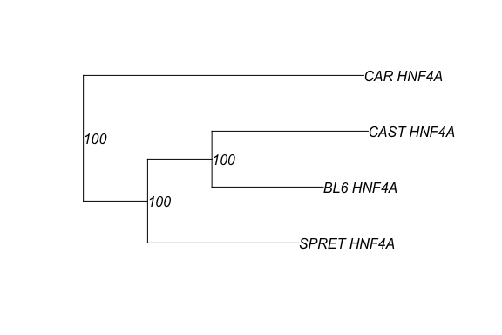

By now, an TF-binding character tree is successfully constructed.

### Creating variance co-variance matrix

var_mat <- varMatInv(dismat,TF_table,phy = tf_tree)

### Ancestral TF-binding state estimation

Here, we extract the TF-binding values of gene *MUP20* as an example:

mup20_binding <- TF_table[which(rownames(TF_table) == "ENSMUSG00000078672"),]

Then we infer the TF-binding scores at ancestral nodes of the TF-binding tree:

mup20_anc <- aee(mup20_binding, tf_tree, var_mat, select = "all")

Finally, we map these estimations on the 4 mice species tree to give a direct presentation of these values:

tf_tree$node.label <- sprintf("%.4f",mup20_anc$est)  
tf_tree$tip.label <- paste0(tf_tree$tip.label, " ", sprintf("%.4f", mup20_binding))  
plot(tf_tree, edge.color = "grey80", edge.width = 4,show.node.label = T,align.tip.label = T,main="Ancestial HNF4A-Binding Estimation of Gene MUP20")

