Hello R Markdown

Frida Gomam

2015-07-23T21:13:14-05:00

# R Markdown

This is an R Markdown document. Markdown is a simple formatting syntax for authoring HTML, PDF, and MS Word documents. For more details on using R Markdown see <http://rmarkdown.rstudio.com>.

You can embed an R code chunk like this:

summary(cars)  
## speed dist   
## Min. : 4.0 Min. : 2.00   
## 1st Qu.:12.0 1st Qu.: 26.00   
## Median :15.0 Median : 36.00   
## Mean :15.4 Mean : 42.98   
## 3rd Qu.:19.0 3rd Qu.: 56.00   
## Max. :25.0 Max. :120.00  
fit <- lm(dist ~ speed, data = cars)  
fit  
##   
## Call:  
## lm(formula = dist ~ speed, data = cars)  
##   
## Coefficients:  
## (Intercept) speed   
## -17.579 3.932

# Including Plots

You can also embed plots. See Figure @ref(fig:pie) for example:1234567

par(mar = c(0, 1, 0, 1))  
pie(  
 c(280, 60, 20),  
 c('Sky', 'Sunny side of pyramid', 'Shady side of pyramid'),  
 col = c('#0292D8', '#F7EA39', '#C4B632'),  
 init.angle = -50, border = NA  
)

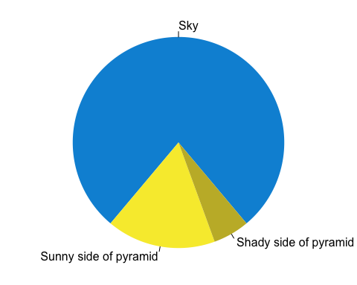

A fancy pie chart.