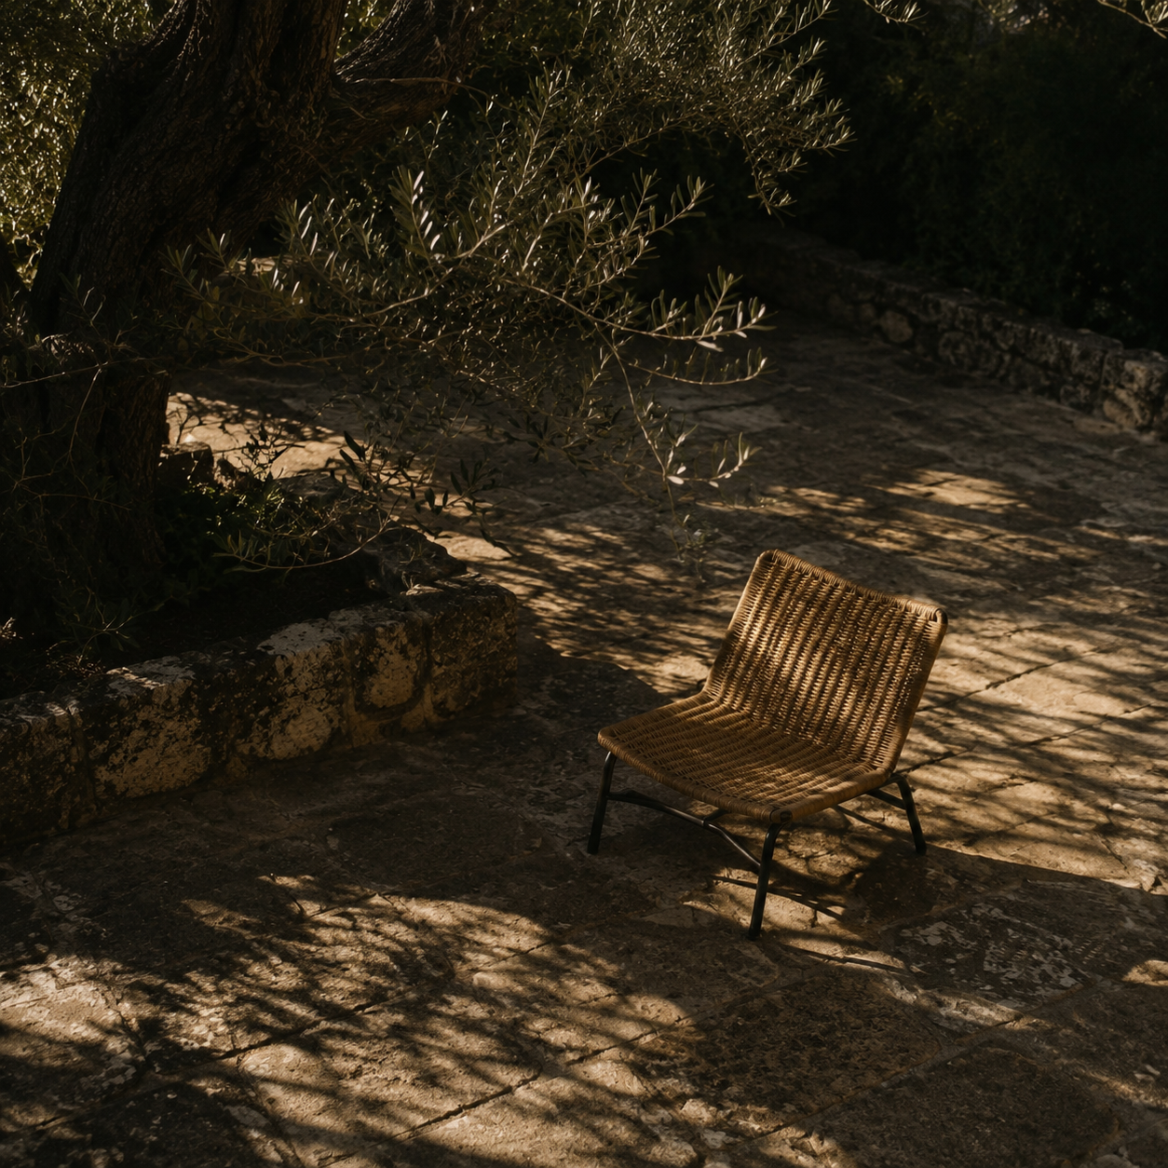

AI Original Script Page Optimization
Three-card quick choices, complete prompt selection, and theme consistency |  | Prepared by Codex  July 2026

Contents

Executive summary 2
At a glance 2
Design context 2
Key findings 3
Constraints 3
Evidence patterns 3
Implications 3
Recommendations 4
Conclusion 4
Appendix 5
Verification 5
Sources and files 5

Executive summary
This optimization focused on first-screen usability in the AI Original Script page. The previous layout showed only three oversized scenario cards, used an unnecessarily tall prompt area, and applied a pure-black local background that conflicted with the workspace theme.
The revised page presents three compact quick-choice cards in one horizontal row, keeps all ten script scenarios in the in-editor selector, loads a distinct AI prompt for each selection, and keeps all core controls visible at a 1127 x 690 viewport.

At a glance
- Three primary scenarios are visible as quick choices; all ten scenarios remain available in the prompt-area selector.
- Scenario cards, prompt editor, configuration controls, and the generate action now fit within one screen without internal scrolling.
- Front- and admin-side defaults include Product Overview; older configurations are merged with missing built-ins while their maintained prompts are preserved.

Design context
The request called for a complete single-page view, smaller top choices, removal of the explanatory sentence near the editor, and a background color aligned with the system workspace. The page also needed ten selectable script types.
The implementation covers front-end scenario data, prompt switching, and page styling, plus the admin default configuration so that each option has a distinct prompt source.

Key findings
The issue was not font size alone. Vertical density and a local theme override pushed essential controls below the first screen. The final hierarchy uses three prominent quick choices and a complete ten-option selector for the long tail.

Constraints
The existing React, Ant Design, and site-configuration data flow remain intact. The generation API was not changed; work was limited to scenario defaults, missing-item merging, visible choices, and local page styles.

Evidence patterns
Code review found 28 px card text, 150 px card height, and a 260 px prompt box. Browser verification confirmed three cards on the same top coordinate with 14 px gaps, ten selector options, and scrollHeight equal to the 588 px clientHeight.

Key takeaway. Three quick choices plus a complete selector balance focus, discoverability, and visual consistency.

Implications
The page shifts from a showcase layout to a task-oriented layout. Three frequent scenarios stay immediately visible, while the prompt-area selector provides the complete catalog and keeps the prompt directly editable.
Theme | Observation | Implication
Layout density | Three large cards dominated | Three compact cards in one row
Information | Guidance and choice were split | Cards and in-editor select align
Theme | Pure black overrode system | Workspace background inherited

Recommendations
Current release status meets the requested page outcome. Future iterations should use small, evidence-led refinements around real viewport sizes, configuration stability, and prompt quality.
- Keep scenario names stable. Treat built-in IDs as the contract and use admin configuration mainly for subtitles and prompts, preventing older data from changing front-end labels.
- Retest compact viewports. After sidebar or top-bar changes, repeat the 1127 x 690 single-screen check.
- Measure prompt outcomes. Track generation quality, edit rate, and conversion-goal coverage for each of the ten scenarios before revising prompts.

Conclusion
The page now uses three compact, evenly spaced quick choices in one horizontal row and retains the complete ten-scenario selector inside the prompt area. Users get a focused top section without losing access to any script type.
Front- and admin-side production builds passed. Browser testing produced no console errors, and selecting Product Overview loaded its dedicated prompt, confirming the independent prompt-switching path.

Appendix

Verification
The front web app passed TypeScript and Vite production builds. The admin web app passed its TypeScript and Vite production build as well.
At 1127 x 690, three quick cards shared the same top coordinate with 14 px gaps; the selector exposed all ten types; clientHeight and scrollHeight were both 588 px; browser error logs were empty.

Sources and files
- User-provided interface screenshot and change request, July 2026.
- Front end: web/front-web/src/pages/Workspace/ScriptGenerator/ScriptGeneratorPanel.tsx.
- Styles: web/front-web/src/pages/Workspace/ScriptGenerator/script-generator-panel.css.
- Admin: web/admin-web/src/pages/System/SiteConfigPage.tsx.

Verification note. Implementation, production builds, target-size layout, and scenario prompt switching passed review.

