geoserver文档

（一）Geoserver安装：

官网网址：<http://geoserver.org/download/>

（二）Geoserver添加mysql数据源：

1、在mysql数据库中建表

-- ----------------------------

-- Table structure for points

-- ----------------------------

DROP TABLE IF EXISTS `points`;

CREATE TABLE `points` (

`id` int(11) UNSIGNED NOT NULL AUTO_INCREMENT,

`name` varchar(20) CHARACTER SET utf8 COLLATE utf8_general_ci NOT NULL DEFAULT '',

`x` varchar(255) CHARACTER SET utf8 COLLATE utf8_general_ci NOT NULL,

`y` varchar(255) CHARACTER SET utf8 COLLATE utf8_general_ci NOT NULL,

`location` point NOT NULL,

PRIMARY KEY (`id`) USING BTREE,

SPATIAL INDEX `sp_index`(`location`)

) ENGINE = MyISAM AUTO_INCREMENT = 9 CHARACTER SET = utf8 COLLATE = utf8_general_ci ROW_FORMAT = Dynamic;

-- ----------------------------

-- Records of points

-- ----------------------------

INSERT INTO `points` VALUES (1, '圆明园', '116.310558', '40.014033', ST_GeomFromText('POINT(116.311 40.014)'));

INSERT INTO `points` VALUES (2, '清华大学', '116.335279', '40.010497', ST_GeomFromText('POINT(116.335 40.0105)'));

INSERT INTO `points` VALUES (3, '颐和园', '116.277787', '116.277787', ST_GeomFromText('POINT(116.278 40.0065)'));

INSERT INTO `points` VALUES (4, '天安门', '116.404844', '39.915378', ST_GeomFromText('POINT(116.405 39.9154)'));

INSERT INTO `points` VALUES (5, '北京站', '116.434164', '39.910065', ST_GeomFromText('POINT(116.434 39.9101)'));

INSERT INTO `points` VALUES (6, '卢沟桥', '116.224895', '39.85647', ST_GeomFromText('POINT(116.225 39.8565)'));

INSERT INTO `points` VALUES (7, '北京西站', '116.32723', '39.901652', ST_GeomFromText('POINT(116.327 39.9025)'));

INSERT INTO `points` VALUES (8, '北京首都国际机场', '116.612388', '40.085613', ST_GeomFromText('POINT(116.612 39.9025)'));

2、安装mysql插件：

下载插件网址：https://zh.osdn.net/projects/sfnet_geoserver/releases/

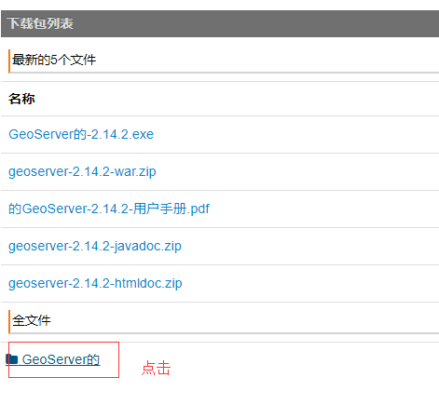

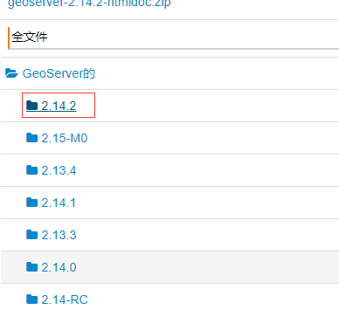

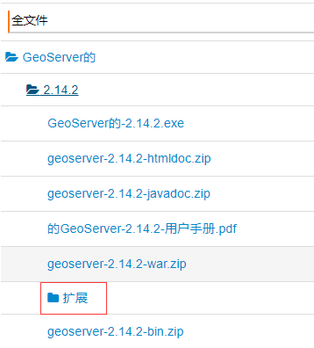

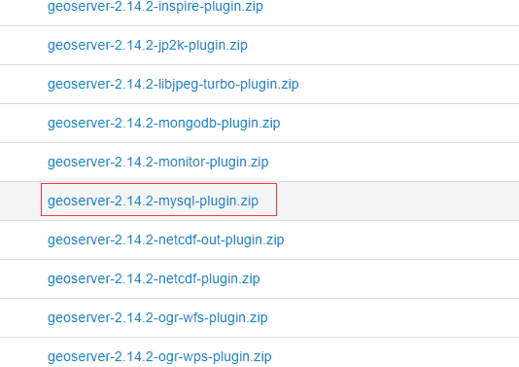

将下载好的插件压缩包解压后，将其中的所有jar包，放入geoserver/webapps/WEB-INF/lib目录下

3、启动geoserver，点击geoserver的bin目录下startup.bat

登录地址：[http://localhost:8090/geoserver/web/](http://localhost:8090/geoserver/web/，默认的用户名是admin，密码geoserver)

[默认的用户名是admin，密码geoserver](http://localhost:8090/geoserver/web/，默认的用户名是admin，密码geoserver)

（1）添加工作区

点击数据栏 工作区 -> 添加新的工作区

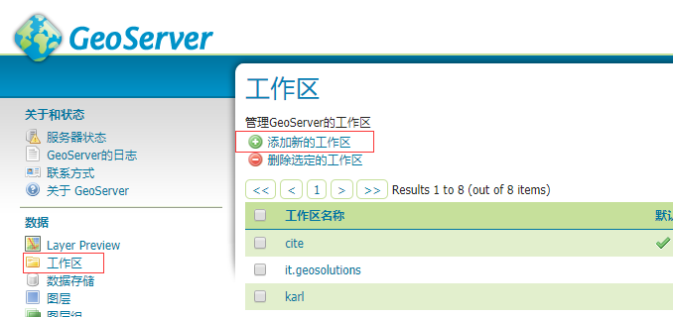

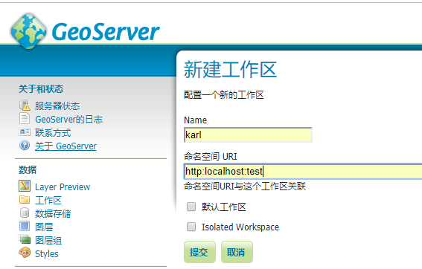

(2)添加数据存储

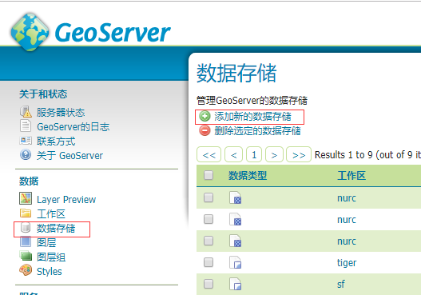

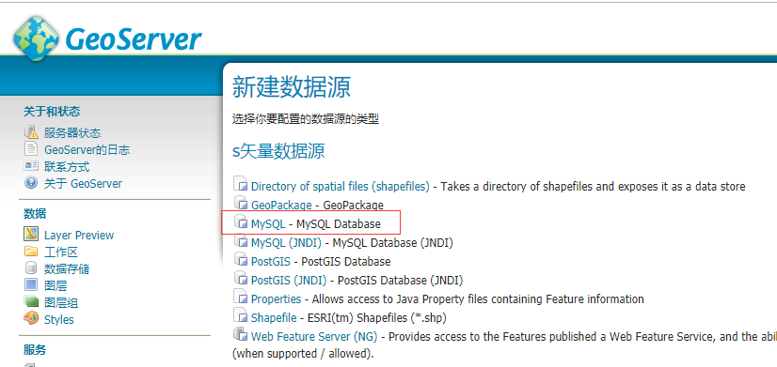

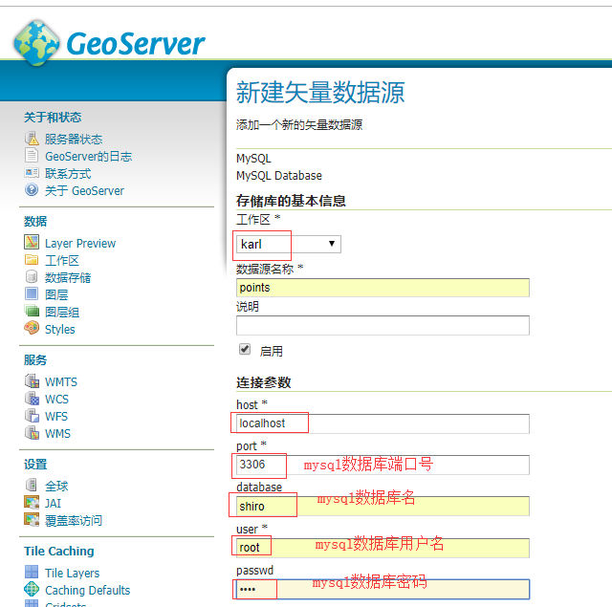

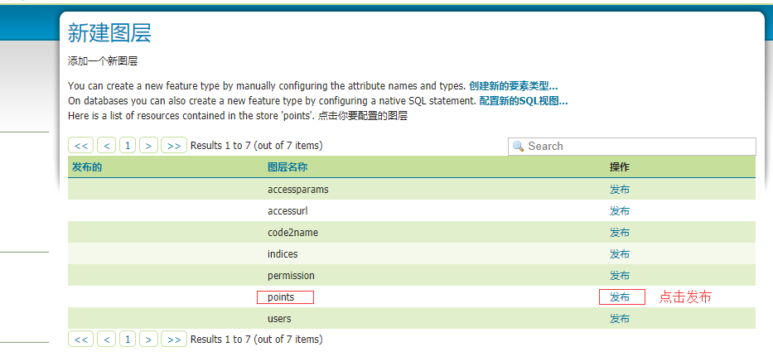

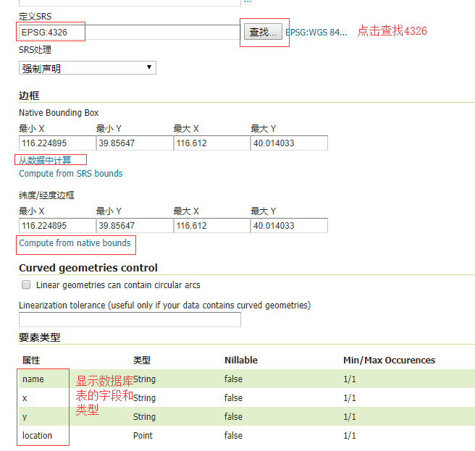

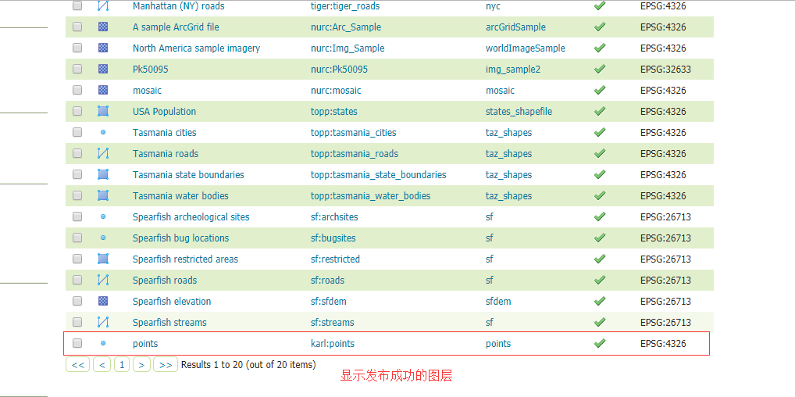

（3）用openlayers发布

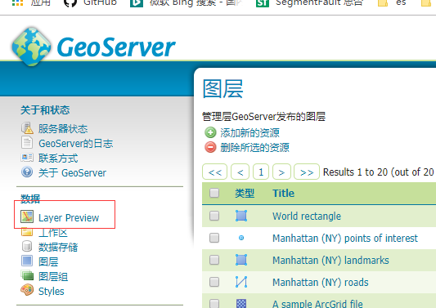

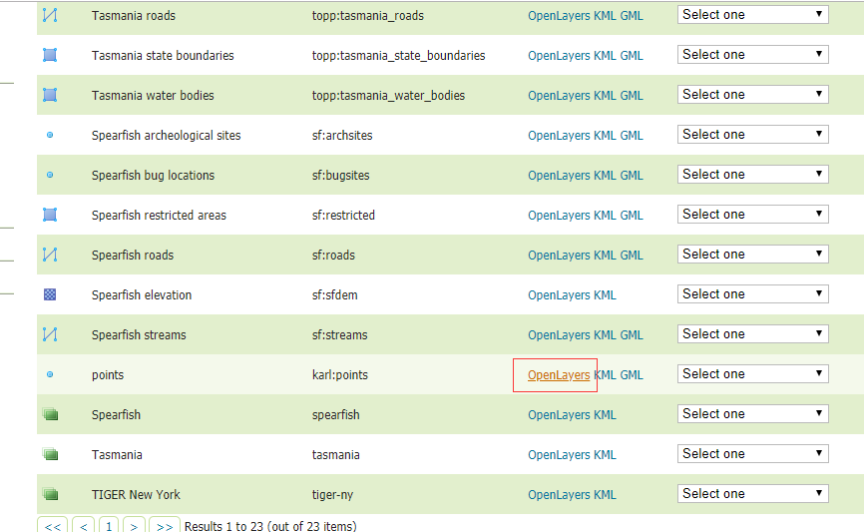

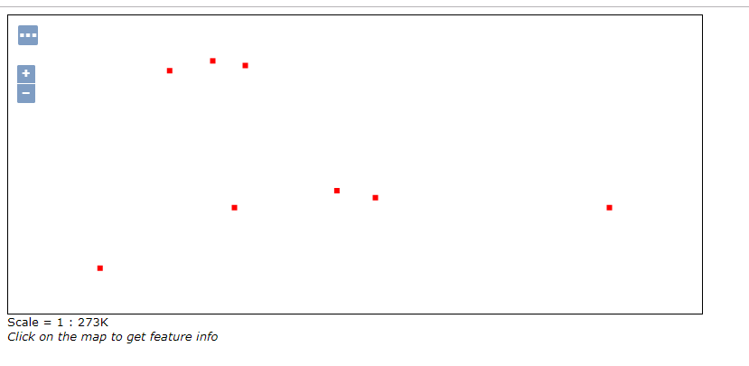

4、使用openlayers发布geoserver图层，并显示点的详细信息

引入ol.css文件，ol.js文件，下载地址https://openlayers.org/download/

代码：

<!doctype html>

<html>

<head>

<link rel="stylesheet" href="ol.css" charset="utf-8" type="text/css">

<style>

.map {

height: 768;

width: 330;

}

</style>

<script src="ol.js" type="text/javascript" charset="utf-8"></script>

<title>OpenLayers example</title>

</head>

<body>

<div id="map" class="map">

</div>

<div id="content" >&nbsp;</div>

<script type="text/javascript">

var content = document.getElementById('content');

var osmLayer = new ol.layer.Tile({//构造图层实例为底图

source: new ol.source.OSM()

});

var wmsLayer = new ol.layer.Tile({

source: new ol.source.TileWMS({

url: 'http://localhost:9999/geoserver/karl/wms',

params: {

'LAYERS': 'karl:points',//可以是单个图层名称，也可以是图层组名称，或多个图层名称，中间用“，”隔开

'TILED': false,

},

serverType: 'geoserver' //服务器类型

})

});

var layers = [osmLayer, wmsLayer];

var view = new ol.View({

extent: [115,39,116,40],

//初始化地图显示参数

projection: 'EPSG:4326',

center: [116.5, 40],

zoom: 10

});

var map = new ol.Map({

layers: layers, //图层属性

target: 'map', //地图容器dom

view: view,

});

map.on('singleclick', function(evt) {

content.innerHTML = '';

var viewResolution = /** @type {number} */ (view.getResolution());

var url = wmsLayer.getSource().getGetFeatureInfoUrl(

evt.coordinate, viewResolution, 'EPSG:4326',

{'INFO_FORMAT': 'text/html'});

if (url) {

content.innerHTML =

'<iframe seamless src="' + url + '"></iframe>';

}

});

map.on('pointermove', function(evt) {

if (evt.dragging) {

return;

}

var pixel = map.getEventPixel(evt.originalEvent);

var hit = map.forEachLayerAtPixel(pixel, function() {

return true;

});

map.getTargetElement().style.cursor = hit ? 'pointer' : '';

});

</script>

</body>

</html>

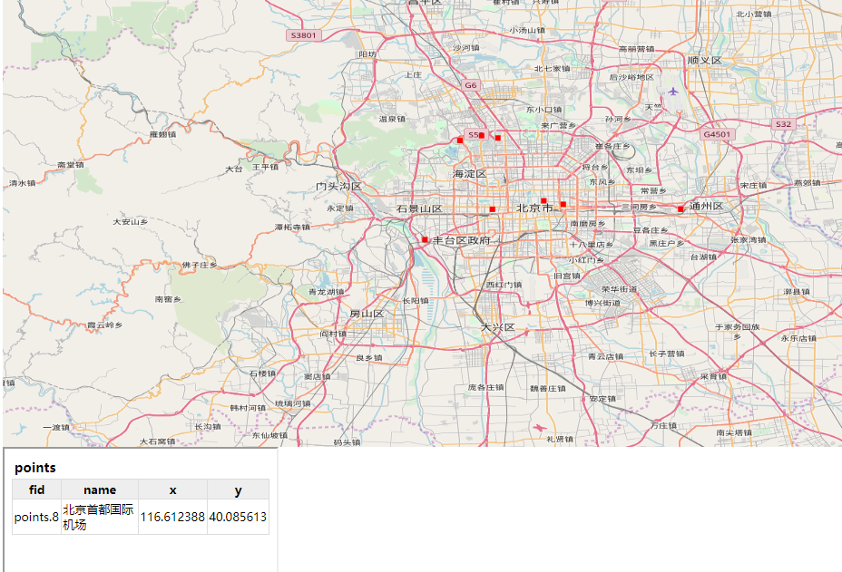

Openlayers官网实例：

官网地址: <https://openlayers.org/en/v4.6.5/examples/index.html>

5、Openlayers支持的底图和数据格式

底图类: 百度地图层,Bing中文地图层,高德地图层,google地图层,Open Street Map 地图层,yahoo地图层

支持格式：GeoJSON,WKT,KML,GML,TopoJSON