重复文章第一篇：
High-Quality Genome Assembly of Oleaginous Red Yeast Sporobolomyces roseus CGMCC 2.4355

准备工作：
- 安装软件
conda、mamba、sra-tools、jellyfish、genomescope2（常规mamba安装，不提）
mamba install -y sra-tools jellyfish genomescope2 samtools minimap2 fastp fastqc multiqc sambamba seqkit bwa
mamba install -y jellyfish genomescope2 fastqc multiqc
如果同个环境装不了，请创建虚拟环境！

ropebwt2：
git clone https://github.com/lh3/ropebwt2.git
cd ropebwt2
make
加入PATH中

fmlrc2:
cargo install fmlrc
加入PATH中

wtdbg2:
git clone https://github.com/ruanjue/wtdbg2.git
cd wtdbg2
make
加入PATH中

- 看数据在哪里？

登录NCBI查看SRA数据
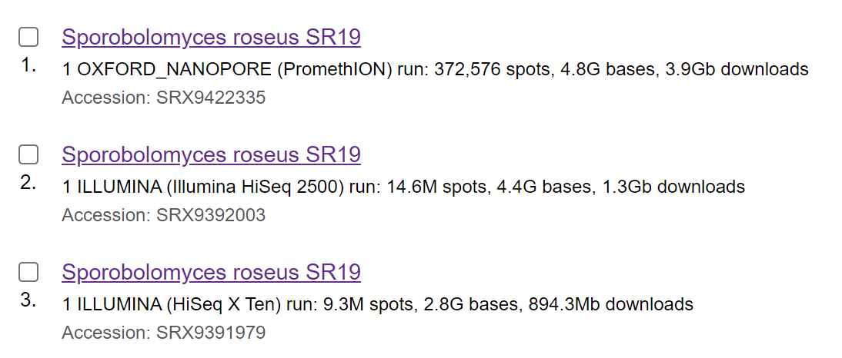
- 看方法中的软件
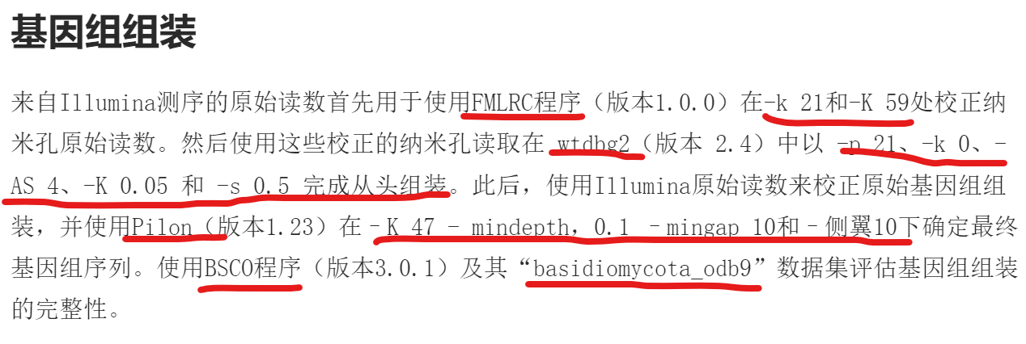
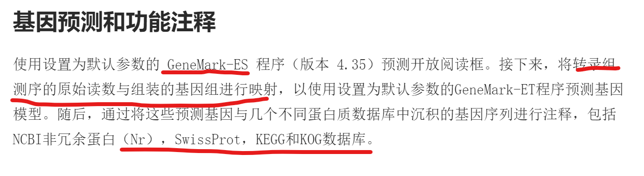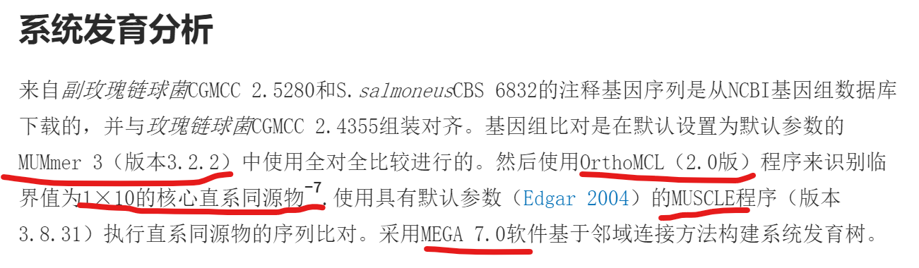
- 按照方法的参数以及流程进行重复
- 下载数据
conda activate assemble
mkdir -p workplace && cd workplace
WORK=`pwd`
mkdir -p 01.rawdata && cd 01.rawadata
axel -n 100 -o ./nanopore.sra /
https://sra-pub-run-odp.s3.amazonaws.com/sra/SRR12969964/SRR12969964
axel -n 100 -o ./rna-seq.sra /
https://sra-pub-run-odp.s3.amazonaws.com/sra/SRR12927900/SRR12927900
axel -n 100 -o ./illumina.sra /
https://sra-pub-run-odp.s3.amazonaws.com/sra/SRR12927876/SRR12927876
2、数据转化为fastq.gz格式
for i in `ls *.sra;do fastq-dump --split-files --gzip $i;done
cd $WORK && mkdir -p 02.cleandata
fastp -w 10 -i ./01.rawdata/illumina_1.fastq.gz -I ./01.rawdata/illumina_2.fastq.gz -o ./02.cleandata/illumina_1.clean.fq.gz -O ./02.cleandata/illumina_2.clean.fq.gz -D -z 4 -q 20 -u 30 -h ./02.cleandata/illumina_clean.html -j ./02.cleandata/illumina_clean.json
fastp -w 10 -i ./01.rawdata/rna-seq_1.fastq.gz -I ./01.rawdata/rna-seq_2.fastq.gz -o ./02.cleandata/rna-seq_1.clean.fq.gz -O ./02.cleandata/rna-seq_2.clean.fq.gz -D -z 4 -q 20 -u 30 -h ./02.cleandata/rna-seq_clean.html -j ./02.cleandata/rna-seq_clean.json
mkdir -p 03.fastqc
fastqc -o 03.fastqc ./02.cleandata/*.fq.gz
multiqc 03.fastqc -o 03.fastqc
3、纠错nanopore.fastq
mkdir 04.correction
gunzip -c 02.cleandata/illumina_1.clean.fq.gz 02.cleandata/illumina_2.clean.fq.gz | \
awk 'NR % 4 == 2' | \
sort | \
tr NT TN | \
ropebwt2 -LR | \
tr NT TN | \
fmlrc2-convert ./correction/comp_msbwt.npy
fmlrc2 -t 2 -C 10 ./04.correction/comp_msbwt.npy ./01.rawdata/nanopore_1.fastq.gz ./04.correction/nanopore.fa
4、评估基因组大小
mkdir -p 05.assessment
unpigz -p 20 ./02.cleandata/illumina_1.clean.fq.gz ./02.cleandata/illumina_2.clean.fq.gz
jellyfish count -C -s 5G -m 21 -t 30 -o ./05.assessment/kmer_counts.jf ./02.cleandata/illumina_1.clean.fq ./02.cleandata/illumina_2.fastq
jellyfish histo -h 65535 -f -t 30 -o ./05.assessment/kmer.freq.stat.2colum ./05.assessment/kmer_counts.jf
genomescope2 -i ./05.assessment/kmer.freq.stat.2colum -o ./05.assessment/genomescope -k 21 -p 1 -m 100000
- 组装
mkdir 06.assemble && cd 06.assemble
mkdir wtdbg2
perl wtdbg2.pl -t 12 -x ccs -g 22m -o wtdbg2/wtdbg2 ../04.correction/nanopore.fa
#polish
mkdir polish && cd polish
wget https://github.com/broadinstitute/pilon/releases/download/v1.23/pilon-1.23.jar
bwa index -p genome ../wtdbg2/wtdbg2.cns.fa
bwa mem -t 30 genome $WORK/02.cleandata/illumina_1.clean.fq.gz $WORK/02.cleandata/illumina_2.clean.fq.gz | samtools view -@ 30 -Sb - > align1.bam
samtools sort -@ 30 -o align1.sorted.bam align1.bam
samtools index -@ 30 align1.sorted.bam
sambamba markdup -t 30 align1.sorted.bam align1.sorted.markup.bam
rm align1.bam align1.sorted.bam -rf
samtools view -@ 30 -q 30 -b align1.sorted.markup.bam > align1.sorted.markup.filter.bam
samtools index -@ 30 align1.sorted.markup.filter.bam
java -Xms100g -Xmx100g -XX:ParallelGCThreads=30 -jar pilon-1.23.jar --genome ../wtdbg2/cns.fa --threads 30 --frags align1.sorted.markup.filter.bam --fix all --changes --output pilon_polished1 --vcf &> pilon1.log

#plion2
bwa index pilon_polished1.fasta
bwa mem -t 30 pilon_polished1.fasta $WORK/02.cleandata/illumina_1.clean.fq.gz $WORK/02.cleandata/illumina_2.clean.fq.gz | samtools view -@ 30 -Sb - > align2.bam
samtools sort -@ 30 -o align2.sorted.bam align2.bam
samtools index -@ 30 align2.sorted.bam
sambamba markdup -t 30 align2.sorted.bam align2.sorted.markup.bam
rm align2.bam align2.sorted.bam
samtools view -@ 30 -q 30 -b align2.sorted.markup.bam > align2.sorted.markup.filter.bam
samtools index -@ 30 align2.sorted.markup.filter.bam
java -Xms100g -Xmx100g -XX:ParallelGCThreads=30 -jar pilon-1.23.jar --genome ./pilon_polished1.fasta --threads 30 --frags align2.sorted.markup.filter.bam --fix all --changes --output pilon_polished2 --vcf &> pilon2.log

#plion3
bwa index pilon_polished2.fasta
bwa mem -t 30 pilon_polished2.fasta $WORK/02.cleandata/illumina_1.clean.fq.gz $WORK/02.cleandata/illumina_2.clean.fq.gz | samtools view -@ 30 -Sb - > align3.bam
samtools sort -@ 30 -o align3.sorted.bam align3.bam
samtools index -@ 30 align3.sorted.bam
sambamba markdup -t 30 align3.sorted.bam align3.sorted.markup.bam
rm align3.bam align3.sorted.bam
samtools view -@ 30 -q 30 -b align3.sorted.markup.bam > align3.sorted.markup.filter.bam
samtools index -@ 30 align3.sorted.markup.filter.bam
java -Xms100g -Xmx100g -XX:ParallelGCThreads=30 -jar pilon-1.23.jar --genome ./pilon_polished2.fasta --threads 30 --frags align3.sorted.markup.filter.bam --fix all --changes --output pilon_polished3 --vcf &> pilon3.log
mv pilon_polished3.fasta genome_1.fasta
#由大到小按照序列排序
seqkit sort -r --by-length pilon_polished3.fasta -o genome_1.fasta
#seqkit替换id为指定字符串(直接按照序列顺序，把序列id替换为Chr01,Chr02)
seqkit replace --ignore-case --pattern .+ -r "Scaffold{nr}" --nr-width 2 genome_1.fasta -o genome.fa
Genome=`pwd`/genome.fa
- 重复序列-ncRNA注释
Cd $WORK
mkdir -p 07.genomefeature/repeat/RepeatModeler
cd 07.genomefeature/repeat/RepeatModeler
conda activate repeat
BuildDatabase -name mydb $Genome > genome.fasta.log
RepeatModeler -database mydb -pa 7 -LTRStruct > run.out
#查看物种在RepeatMaskerLib.h5中的情况
#进入RepeatMasker目录中
cd /home/data/ssy28/miniconda3/envs/repeat/share/RepeatMasker/
./famdb.py -i Libraries/RepeatMaskerLib.h5 lineage -ad Rhodotorula > Rhodotorula-families.txt
#查找并导出红酵母及其上祖先节点、其下所有类群的repeat families
./famdb.py -i Libraries/RepeatMaskerLib.h5 families -f embl -ad Rhodotorula > Rhodotorula_ad.embl
#只查找并导出红酵母及其上祖先节点（可以避免衍生节点物种分布不均匀问题。当有多个物种需要注释，并且需要对比注释的比例及总量时，这样可以控制变量）：
./famdb.py -i Libraries/RepeatMaskerLib.h5 families -f embl -a Rhodotorula > Rhodotorula_a.embl
#将embl格式转化为fasta格式，方便后期与RepeatModeler2结果合并
cd util
./buildRMLibFromEMBL.pl ../Rhodotorula_ad.embl > Rhodotorula_ad.fasta
./buildRMLibFromEMBL.pl ../Rhodotorula_a.embl > Rhodotorula_a.fasta
#合并RepeatModeler2结果
Cd $WORK
cat /home/data/ssy28/miniconda3/envs/repeat/share/RepeatMasker/util/Rhodotorula_ad.fasta ./07.genomefeature/repeat/RepeatModeler/mydb-families.fa > ./07.genomefeature/repeat/RepeatModeler/all_Rhodotorula_final.fasta
cd 07.genomefeature/repeat
mkdir RepeatMasker -p
RepeatMasker -nolow -no_is -norna -parallel 7 -s -gff -lib ./RepeatModeler/all_Rhodotorula_final.fasta -dir ./RepeatMasker $Genome
Conda deactivate
#ncRNA注释
conda activate ncrna
cd $WORK
mkdir -p 07.genomefeature/ncrna/tRNA
cd 07.genomefeature/ncrna
tRNAscan-SE -o ./tRNA/tRNA.out -f ./tRNA/tRNA.ss -m ./tRNA/tRNA.stats -j ./tRNA/tRNA.gff --thread 30 $Genome
vi convert_tRNAScanSE_to_gff3.pl
写入脚本
chmod 700 convert_tRNAScanSE_to_gff3.pl
perl convert_tRNAScanSE_to_gff3.pl -i ./tRNA/tRNA.out > ./tRNA/tRNAscan.gff3
mkdir -p rRNA
barrnap --kingdom euk --threads 30 --quiet --outseq rRNA/rRNA.fa $Genome > rRNA/rrna.gff3
#--kingdom参数指定物种类型，bac代表细菌，arc代表古菌，euk代表真核生物，mito代表后生动物线粒体；--threads指定并行的线程数。
#--quiet 安静模式 --outseq 输出rrna的序列
#预测结果以GFF3格式保存
#其他ncRNA注释http://t.zoukankan.com/jessepeng-p-15392809.html
genome_total=22396975 #基因组大小esl-seqstat $Genome
CMnumber=`grep "ACC" /home/data/ssy28/workplace/db/ncrna/Rfam.cm | wc -l`
Z=`echo $genome_total*2*$CMnumber/1000000 | bc`
#echo $Z
cmscan -Z $Z --cut_ga --rfam --nohmmonly --tblout genome.tblout --fmt 2 --cpu 30 --clanin /home/data/ssy28/workplace/db/ncrna/Rfam.clanin /home/data/ssy28/workplace/db/ncrna/Rfam.cm $Genome > genome.cmscan
vi infernal-tblout2gff.pl
写入脚本
chmod 700 infernal-tblout2gff.pl
perl infernal-tblout2gff.pl --cmscan --fmt2 genome.tblout >genome.infernal.ncRNA.gff3

- 基因注释
mkdir -p 08.genepredict/rna-seq/his-str-trans/index
rna_seq=08.genepredict/rna-seq
cd 08.genepredict/rna-seq/his-str-trans/
mkdir -p bam
#第一个方法基于HISAT2 + StringTie+TransDecoder,推荐屏蔽重复序列的基因组
conda activate his-string-trans
hisat2-build $Genome index/genome -p 20
hisat2 --dta -p 20 -x index/genome -1 $WORK/02.cleandata/rna-seq_1.clean.fq.gz -2 $WORK/02.cleandata/rna-seq_1.clean.fq.gz | samtools sort -@ 20 > bam/rna-seq.bam
#多个转录组数据则：samtools merge -@ 20 bam/merged.bam bam/*.bam
stringtie -p 20 -o bam/merged.gtf bam/rna-seq.bam
gtf_genome_to_cdna_fasta.pl bam/merged.gtf $Genome > transcripts.fasta
gtf_to_alignment_gff3.pl bam/merged.gtf > transcripts.gff3
TransDecoder.LongOrfs -t transcripts.fasta
diamond blastp --threads 30 -d /home/data/ssy28/workplace/db/uniprot_sprot/uniprot_sprot.fasta -q transcripts.fasta.transdecoder_dir/longest_orfs.pep --evalue 1e-5 --max-target-seqs 20 --out blast.xml --outfmt 5 --sensitive --id 20 --tmpdir /dev/shm --index-chunks 1
parsing_blast_result.pl --no-header --max-hit-num 20 --query-coverage 0.2 --subject-coverage 0.1 blast.xml > blastp.outfmt6
hmmscan --cpu 45 --domtblout pfam.domtbl -E 1e-5 --domE 1e-5 /home/data/ssy28/workplace/db/Pfam-A/Pfam-A.hmm transcripts.fasta.transdecoder_dir/longest_orfs.pep
TransDecoder.Predict -t transcripts.fasta --retain_pfam_hits pfam.domtbl --retain_blastp_hits blastp.outfmt6
cdna_alignment_orf_to_genome_orf.pl transcripts.fasta.transdecoder.gff3 transcripts.gff3 transcripts.fasta > transcripts.fasta.transdecoder.genome.gff3
#最后结果transcripts.fasta.transdecoder.gff3用于提供给EvidenceModeler

#第二个方法基于STAR+ StringTie+gffread
#maker预测，若利用MAKER进行预测，在利用转录组时，推介使用STAR + StringTie + gffread 获取转录本，如果是StringTie组装的GTF文件，需要做如下的转换
#gffread -E sample.gtf -o - | sed -e "s#transcript#match#g" -e "s#exon#match_part#g" > sample.gff
cd $rna_seq
mkdir -p STAR && cd STAR
THREADS=35
fq1=$WORK/02.cleandata/rna-seq_1.clean.fq
#多个转录组数据可以用，隔开
fq2=$WORK/02.cleandata/rna-seq_2.clean.fq
prefix=sample
# 建立索引
STAR \
--runThreadN $THREADS \
--runMode genomeGenerate \
--genomeDir STAR \
--genomeFastaFiles $ref
#比对
STAR \
--genomeDir STAR \
--runThreadN $THREADS \
--readFilesIn $fq1 $fq2 \
--readFilesCommand zcat \
--outFileNamePrefix $prefix\
--outSAMtype BAM SortedByCoordinate \
--outBAMsortingThreadN $THREADS \
--outSAMstrandField intronMotif \
--outFilterIntronMotifs RemoveNoncanonical
--outWigType wiggle
输出BAM文件时，STAR还可以对BAM进行一些预处理，"--bamRemoveDuplicatesType"用于去重("UniqueIdentical","UniqueIdenticalNotMulti")

如果你希望输出信号文件(Wig格式),那么需要额外增加--outWigType参数，如--outWigType wiggle read2, 还可以用--outWigStrand指定是否将两条链合并(Stranded, Unstranded), 默认--outWigNorm RPM，也就是用RPM进行标准化，可以选择None.

如果你在建立索引或者比对的时候增加了注释信息，那么STAR还能帮你进行基因计数。参数为--quantMode, 分为转录本水平(TranscriptomeSAM)和基因水平(GeneCounts)，在计数的时候还允许指定哪些哪些read不参与计数，"IndelSoftclipSingleend"和"Singleend"

对于非链特异性RNA-seq，同时为了保证能和Cufflinks兼容，需要添加--outSAMstrandField intronMotif在SAM中增加XS属性，并且建议加上--outFilterIntronMotifs RemoveNoncanonical。如果是链特异性数据，那么就不需要特别的参数，Cufflinks用--library-type声明类型即可=
# 拼接转录本
stringtie ${prefix}Aligned.sortedByCoord.out.bam -p 30 -o qry.gtf
# GTF 转成 GFF3
gffread qry.gtf -o qry.gff
# 提取cdna
gffread qry.gff -g $ref -w qry.fa
#如果是StringTie组装的GTF文件，需要做如下的转换
gffread -E qry.gtf -o - | sed -e "s#transcript#match#g" -e "s#exon#match_part#g" > sample.gff
#最后结果可以传入TransDecoder进行预测cds然后按照方法一后半部分进行，最最终的结果和方法一一样transcripts.fasta.transdecoder.gff3用于提供给EvidenceModeler。
#方法一与方法二对比只是转录组比对的软件不一样，其他的无太多区别
#STAR的参数比HISAT2多，也就意味着STAR更加灵活，用户可以根据自己的需求灵活的改变参数，而且#用户不用考虑让人头疼的链特异性问题，因为STAR可以自动判断是否为链特异性测序。而且STAR众多
#的输出文件可以满足不同的需求。HISAT2因为索引的优势，可以相对轻松比对跨区域的reads（可变剪#切)，而Tophat2耗时久，STAR耗内存，HISAT2克服了两个的缺点。

#方法三使用Trinity进行De novo组装以及genome-guieded组装,PASA构建转录组数据库，供给AUGUSTUS模型训练。
cd $rna_seq && mkdir -p Trinity && cd Trinity
#基于Trinity进行De novo组装，不支持gz文件
Trinity --seqType fq --max_memory 150G --left $fq1 --right $fq2 --CPU 35 --output Trinity_Denovo &> trinity_denovo.log
#统计Trinity 组装结果:
TrinityStats.pl Trinity_Denovo/Trinity.fasta >Trinity_Denovo/Trinity.fasta.stats
#提取最长的 Unigene:
extract_longest_isoforms_from_TrinityFasta.pl Trinity_Denovo/Trinity.fasta > Trinity_Denovo/unigene.longest.fasta

#基于Trinity进行genome-guieded组装
Trinity --max_memory 150G --CPU 35 --jaccard_clip --genome_guided_bam $rna_seq/his-str-trans/bam/rna-seq.bam --genome_guided_max_intron 10000 --output Trinity_GenomeGuided --inchworm_cpu 30 --bflyHeapSpaceMax 150G --bflyHeapSpaceInit 150G --bflyGCThreads 30 --bflyCPU 30 --bflyCalculateCPU --grid_node_CPU 30 --grid_node_max_memory 150G &> trinity_genomeGuided.log
TrinityStats.pl Trinity_GenomeGuided/Trinity-GG.fasta > Trinity_GenomeGuided/Trinity-GG.fasta.stat
#利用PASA构建RNA-Seq综合转录组数据库
cat Trinity_Denovo/Trinity.fasta Trinity_GenomeGuided/Trinity-GG.fasta > transcript.fasta
perl -e 'while (<>) { print "$1\n" if />(\S+)/ }' Trinity_Denovo/Trinity.fasta > tdn.accs
/home/data/ssy28/miniconda3/envs/tri-pasa-aug/opt/pasa-2.5.2/bin/seqclean transcript.fasta -v /home/data/ssy28/workplace/db/UniVec/UniVec
cp /home/data/ssy28/miniconda3/envs/tri-pasa-aug/opt/pasa-2.5.2/pasa_conf/pasa.alignAssembly.Template.txt ./alignAssembly.config
vi alignAssembly.config
#DATABASE=./mydb.sqlite
#validate_alignments_in_db.dbi:--MIN_PERCENT_ALIGNED=80
#validate_alignments_in_db.dbi:--MIN_AVG_PER_ID=80
/home/data/ssy28/miniconda3/envs/tri-pasa-aug/opt/pasa-2.5.2/Launch_PASA_pipeline.pl -c alignAssembly.config -C -R -g $Genome -t transcript.fasta.clean -T -u transcript.fasta --ALIGNERS blat,gmap --CPU 35 --TDN tdn.accs
/home/data/ssy28/miniconda3/envs/tri-pasa-aug/opt/pasa-2.5.2/scripts/build_comprehensive_transcriptome.dbi -c alignAssembly.config -t transcript.fasta.clean
cd compreh_init_build
/home/data/ssy28/miniconda3/envs/tri-pasa-aug/opt/pasa-2.5.2/scripts/pasa_asmbls_to_training_set.dbi --pasa_transcripts_fasta compreh_init_build.fasta --pasa_transcripts_gff3 compreh_init_build.gff3
#最后会生成一系列文件,如下<prefix>.assemblies.fasta.transdecoder.cds/pep/gff3/bed: 虽然不再基因组上，但是根据转录本信息，有可能是编码区的结果
<prefix>.assemblies.fasta.transdecoder.genome.bed/gff3: 对应基因组序列的基因模型
我们需要的是后者。PASA组装的GFF3文件的属性一栏分为：
complete:
5primer_partial: 缺少起始密码子，翻译到5'端为止
3primer_partial: 缺少终止密码子，翻译到3'端为止
internal: 缺少起始密码子和终止密码子

#基于genewise的同源注释
cd $WORK
mkdir -p 08.genepredict/genewise
cd 08.genepredict/genewise
#到NCBI准备近缘物种注释好的蛋白质序列，合并到protein-all.fasta
#perl -p -i -e 'if (m/^>/) {s/\s+.*//; s/\./_/g; }' protein-all.fasta
homolog_genewise --cpu 30 --coverage_ratio 0.4 --evalue 1e-9 --max_gene_length 20000 protein-all.fasta $Genome
homolog_genewiseGFF2GFF3 --genome $Genome --min_score 15 --gene_prefix genewise genewise.gff > genewise.gff3

#基于预测模型的从头注释
#1.Augustus
#对基因模型进行取冗余处理
cd $WORK
mkdir -p 08.genepredict/denovo/augustus
cd 08.genepredict/denovo/augustus
mkdir raw && cd raw
cp ~/workplace/practice/08.genepredict/rna-seq/Trinity/compreh_init_build/compreh_init_build.fasta.transdecoder.genome.gff3 ./Training.gff3
geneModels2AugusutsTrainingInput --cpu 20 --min_evalue 1e-9 --min_identity 0.7 --min_coverage_ratio 0.7 --min_cds_num 1 --min_cds_length 450 --min_cds_exon_ratio 0.4 --keep_ratio_for_excluding_too_long_gene 0.99 Training.gff3 $Genome
格式转换
我们基于geneModels2AugusutsTrainingInput的结果，将GFF3格式转换成Genbank格式
cd .. && mkdir train && cd train
gff2gbSmallDNA.pl ../raw/out.filter2.gff3 $Genome 1000 trans.gene.raw.gb
# output
#这一步的gff2gbSmallDNA会忽略掉UTR序列,后续根据<prefix>.gene.raw.gb进行AUGUSTUS模型训练。
#创建物种初始化hmm文件
new_species.pl --species=for_bad_genes_removing --AUGUSTUS_CONFIG_PATH=/home/data/ssy28/miniconda3/envs/tri-pasa-aug/config/
#训练，捕捉错误
etraining --species=for_bad_genes_removing --stopCodonExcludedFromCDS=false trans.gene.raw.gb 2> train.err
#过滤错误
cat train.err | perl -pe 's/.*in sequence (\S+): .*/$1/' > badgenes_list.txt
filterGenes.pl badgenes_list.txt trans.gene.raw.gb > trans.genes.gb
randomSplit.pl trans.genes.gb 200 #200是测试集的loci数
new_species.pl --species=Rhodotorula_mucilaginosa_new --AUGUSTUS_CONFIG_PATH=/home/data/ssy28/miniconda3/envs/tri-pasa-aug/config/species
etraining --species=Rhodotorula_mucilaginosa_new trans.genes.gb.train > train.out
修改密码子表：
perl -e 'open IN, "train.out"; while (<IN>) { $tag = $1 if m/tag:.*\((.*)\)/; $taa = $1 if m/taa:.*\((.*)\)/;$tga = $1 if m/tga:.*\((.*)\)/; } while (<>) { s#/Constant/amberprob.x#/Constant/amberprob $tag#; s#/Constant/ochreprob.*#/Constant/ochreprob $taa#; s#/Constant/opalprob.*#/Constant/opalprob $tga#;print }' ~/miniconda3/envs/tri-pasa-aug/config/species/Rhodotorula_mucilaginosa_new/Rhodotorula_mucilaginosa_new_parameters.cfg > 11
mv 11 ~/miniconda3/envs/tri-pasa-aug/config/species/Rhodotorula_mucilaginosa_new/Rhodotorula_mucilaginosa_new_parameters.cfg
augustus --species=Rhodotorula_mucilaginosa_new trans.genes.gb.test | tee firsttest.out

grep -A 22 Evaluation firsttest.out #查看报告

#由于trans.genes.gb.train有2022个，所以

randomSplit.pl trans.genes.gb.train 222

ln -s trans.genes.gb.train.train training.gb.onlytrain

optimize_augustus.pl --species=Rhodotorula_mucilaginosa_new --rounds=5 --cpus=35 --kfold=35 --onlytrain=training.gb.onlytrain trans.genes.gb.train.test > optimize.out
etraining --species=Rhodotorula_mucilaginosa_new trans.genes.gb.train
augustus --species=Rhodotorula_mucilaginosa_new trans.genes.gb.test | tee secondtest.out

CRF模式
etraining --species=Rhodotorula_mucilaginosa_new --CRF=1 trans.genes.gb.train
augustus --species=Rhodotorula_mucilaginosa_new trans.genes.gb.test | tee secondtest.out.withoutCRF

ls *.fastq.gz|paste - - |perl -lane 'print qq{fastp -w 2 -i $F[0] -I $F[1] -o $F[0].clean -O $F[1].clean}'|perl -lpe 's/.fastq.gz.clean/.clean.fq.gz/g'|while read line; do echo $line;done

